Blockchain-Based Certificate Verification and File Integrity System Using IPFS and Ethereum

C T Ullas
Department of Master of Computer Applications
R V College of Engineering
Bengaluru , India
ullasct.mca24@rvce.edu.in
Dr. Divya T.L
Assistant Professor
Department of Master of Computer Applications
R V College of Engineering
Bengaluru , India
divyatl@rvce.edu.in

Abstract—The rapid digitalisation of academic and professional credentials has intensified concerns regarding document authenticity, institutional trust, and verification efficiency. Certificate fraud remains a persistent threat across employment, higher education, and licensing sectors, with forged credentials increasingly difficult to detect using conventional paper-based or centralised digital verification mechanisms. Centralised databases, while convenient, are inherently vulnerable to insider attacks, single-point failures, and unauthorised retrospective modifications. This paper proposes and evaluates a decentralised certificate verification and file integrity system that integrates the InterPlanetary File System (IPFS) with Ethereum-compatible blockchain smart contracts to deliver tamper-evident, role-governed credential management. Certificate files are uploaded to IPFS through the Pinata cloud pinning service, and the resulting Content Identifier (CID) --- a cryptographic fingerprint derived from the file's byte content --- is permanently recorded on the Sepolia Ethereum testnet via a Solidity smart contract deployed using the Hardhat development framework. A four-role hierarchical access control model --- comprising Admin, Institute, User, and Verifier --- is enforced jointly at the application layer through JSON Web Token (JWT) authentication and at the protocol layer through Solidity role mappings. A distinctive contribution of this work is a time-bounded, user-controlled verifier access mechanism that enables certificate holders to grant or revoke third-party verification rights without exposing the underlying document. Experimental evaluation across 50 certificate files subjected to six categories of modification confirms 100 percent tamper detection accuracy, with end-to-end verification latency averaging under five seconds. The system is implemented on an entirely open-source MERN stack and demonstrates a practical, cost-effective blueprint for trustless credential verification applicable to universities, professional certification bodies, and government regulatory agencies.
Keywords—blockchain; IPFS; certificate verification; smart contracts; file integrity; decentralised systems; Ethereum; JWT authentication; Solidity; Pinata; role-based access control

Introduction

1.1 Background and Motivation
Academic certificates, professional licences, and identity documents form the foundational layer of institutional trust in modern society. Employers, universities, licensing boards, and government agencies routinely depend on these credentials to make consequential decisions regarding employment, admission, and authorisation. The integrity of this trust infrastructure, however, is increasingly under threat. The proliferation of sophisticated document-editing software has rendered the production of convincing forged credentials accessible to individuals with minimal technical expertise. A

2023 benchmark report by HireRight revealed that approximately 85 percent of surveyed employers detected at least one misrepresentation on a candidate's application, with educational qualifications and professional certifications among the most frequently falsified categories [1].
Conventional verification approaches --- comprising telephone inquiries directed to issuing institutions, physical mail, and centralised online verification portals --- are characterised by significant latency, high administrative cost, and limited scalability. More critically, centralised digital repositories introduce systemic risks: a single database breach or insider manipulation can compromise the integrity of thousands of records simultaneously, and retroactively, without any externally visible evidence of tampering.
Blockchain technology offers a fundamentally different approach to establishing and maintaining institutional trust, as formalised in early smart contract concepts [3]. By distributing ledger state across a peer-to-peer network of nodes whose entries are cryptographically chained and validated through consensus mechanisms, blockchain renders retrospective data modification computationally infeasible without controlling the majority of the network. This property --- commonly referred to as immutability --- makes blockchain an attractive foundation for systems that require tamper-evident record-keeping.
When combined with the InterPlanetary File System (IPFS), a content-addressed, peer-to-peer distributed storage network, it becomes possible to store large files off-chain while anchoring their unique cryptographic fingerprints on-chain [2]. This hybrid design balances the cost efficiency of distributed file storage with the integrity guarantees of blockchain anchoring, making it both practical and economical for institutional deployment.

1.2 Problem Statement
Existing certificate verification systems suffer from one or more of the following critical limitations. First, centralised databases present single points of failure and are susceptible to both external breaches and internal manipulation. Second, verification workflows are slow and manual, often requiring days or weeks and placing the burden of proof on the applicant rather than the system. Third, document holders have no control over who may verify their credentials, creating privacy risks and enabling unsolicited access. Fourth, most blockchain-based proposals in the literature address only partial aspects of the problem --- typically the storage or the verification component --- without providing a role-governed credential lifecycle management system. Fifth, the integration of user-sovereign, time-bounded access delegation for verifiers has not been addressed in existing IPFS-Ethereum certificate management systems.

1.3 Contributions
This paper makes the following original contributions to the field of decentralised document verification:
First, a four-role hierarchical access control architecture is proposed, implemented natively in a Solidity smart contract, governing the complete certificate lifecycle from institutional registration through issuance, user custody, and third-party verification.
Second, a time-bounded, user-controlled verifier access mechanism is introduced. Certificate holders explicitly approve or reject each verification request and may optionally specify an expiry window beyond which access is automatically invalidated by the smart contract, preserving user sovereignty over credential disclosure.
Third, an end-to-end integration of IPFS-Pinata content-addressed storage with Ethereum-compatible blockchain anchoring is demonstrated, deployable on any EVM-compatible network. The system eliminates on-chain file storage and its associated gas costs by storing only the IPFS CID on the blockchain.
Fourth, empirical demonstration of deterministic tamper detection through CID comparison is provided across six distinct categories of file modification, establishing the forensic reliability of the proposed approach.

1.4 Paper Organisation
The remainder of this paper is organised as follows. Section II surveys related work in blockchain-based document management, IPFS storage systems, and access control frameworks. Section III describes the proposed system architecture in detail. Section IV presents implementation specifics across the smart contract, backend, and frontend layers. Section V reports experimental results and comparative analysis. Section VI concludes the paper and outlines directions for future work.

Related Work

2.1 Blockchain for Academic Credential Management
The application of blockchain to academic credential management has attracted substantial research attention since 2017. Chinnasamy et al. proposed a blockchain framework for educational document management using a permissioned ledger architecture in which institutions issue digitally signed certificates recorded as transaction payloads [5]. While the system achieves tamper resistance through cryptographic chaining, it does not address user-controlled access delegation, verifier authentication workflows, or the gas cost implications of on-chain document storage. The permissioned architecture also limits interoperability with public verification infrastructure.
Blockcerts, developed by MIT Media Lab and Learning Machine, represents one of the earliest practical deployments of blockchain-based academic certificates. The system anchors certificate hash values on the Bitcoin blockchain and provides open-source tooling for issuance and verification. However, Blockcerts does not implement role-based access control beyond the issuer-recipient dyad, and verification requires the verifier to possess the original certificate file externally.

2.2 IPFS and Hybrid Storage Architectures
Benet introduced IPFS as a peer-to-peer hypermedia protocol that addresses files by their content hash rather than their network location [2]. This content-addressable design means that any modification to a file produces a completely different address, making tampering self-evident at the storage layer. Hammoud et al. conducted a comprehensive survey of blockchain-based file storage systems and concluded that hybrid IPFS-blockchain designs consistently outperform fully on-chain storage architectures in terms of cost, throughput, and scalability [6]. Their analysis specifically recommends the pattern of storing IPFS CIDs on-chain rather than raw file bytes --- the precise approach adopted in the proposed system.
Wang et al. investigated storage optimisation techniques for blockchain systems and demonstrated through empirical measurement that content-addressed storage through IPFS reduces gas costs by up to 94 percent compared with storing raw file bytes in Ethereum contract state [7]. For a system expected to issue thousands of certificates annually, this difference is economically decisive. Further comparative analysis by Kumar et al. confirms that IPFS offers superior censorship resistance and geographic redundancy over conventional cloud storage for blockchain-integrated applications [13].

2.3 Tamper Detection and Hash-Based Verification
Antony et al. examined document forgery detection using blockchain and found that SHA-256 hash comparison achieves a theoretical and practical detection accuracy of 100 percent for any modification exceeding a single bit, owing to the avalanche effect intrinsic to cryptographic hash functions [9]. Islam et al. proposed a blockchain log integrity system wherein SHA-256 digests of log entries are periodically anchored on Ethereum, demonstrating that adversarial log deletion or modification is detectable within a single logging epoch [8]. The hash anchoring paradigm employed in that work directly informs the CID-storage mechanism used in the proposed system. IPFS multihash employs SHA-256 internally, so the CID comparison step in the proposed verification workflow inherits the same theoretical detection guarantee established by these prior works.
Complementary to tamper detection, Tmeizeh et al. introduced a blockchain-based data preservation framework with metadata provenance tracking [10], which parallels the certificate issuance audit trail maintained by the proposed system through smart contract event emission. Nododile et al. presented a hybrid IPFS-blockchain storage system designed for enterprise document management, identifying gateway availability as the primary reliability bottleneck and recommending dedicated pinning services --- a finding that motivates the use of Pinata Cloud in the proposed system [11]. Choudhary et al. demonstrated immutable cloud storage using blockchain anchoring in a cloud-archive context, confirming that Ethereum-based hash anchoring provides a legally admissible, timestamp-verified proof of document existence at a specific point in time [12].

2.4 Research Gap
The foregoing survey reveals two critical gaps in existing literature. First, no existing system combines all four stakeholder roles --- Admin, Institute, User, and Verifier --- within a single smart contract--governed certificate lifecycle. Prior systems typically model only the issuer-recipient dyad and treat verification as an out-of-band process. Second, user-controlled, time-bounded verifier access has not been previously implemented in any IPFS-Ethereum certificate platform, leaving certificate holders without agency over who may inspect their credentials and for how long. The proposed system addresses both gaps.

System Architecture
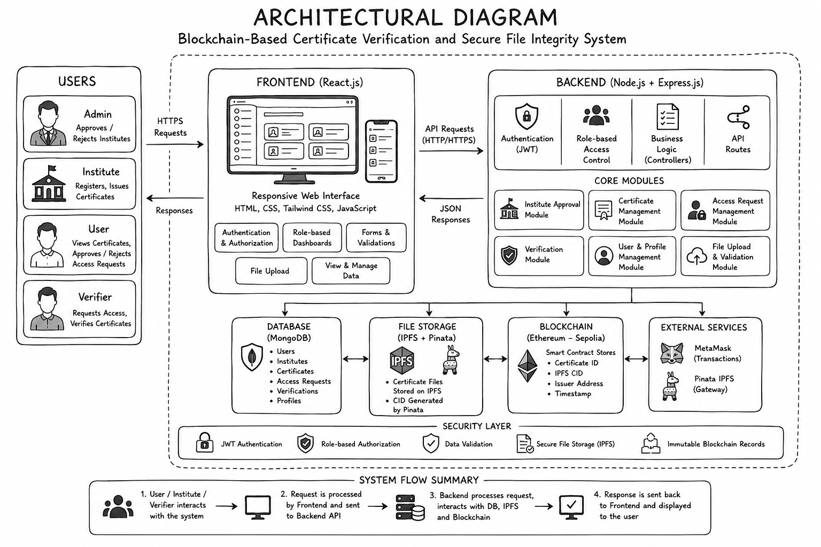
Fig. 1. Architectural diagram of the proposed blockchain-based certificate verification system.

3.1 Architectural Overview

The proposed system adopts a three-tier architecture comprising a React.js presentation layer, a Node.js and Express.js application layer, and a dual-persistence layer that combines MongoDB for mutable application state with Ethereum smart contracts for immutable integrity proofs. The architectural separation of concerns between mutable application data and immutable blockchain records is a deliberate design choice that allows the system to leverage the strengths of each technology without overloading either.
File payloads are never stored on-chain. Certificate files uploaded by institutes are pinned to IPFS via the Pinata cloud service, which provides a dedicated IPFS gateway and guarantees file persistence through its paid pinning infrastructure. The resulting 46-character CIDv1 hash --- which is a cryptographic function of every byte of the file --- is the sole data written to the Ethereum smart contract.

3.2 Four-Role Access Control Model

The access control model governs every interaction within the system and is enforced at two independent layers: the JWT middleware in the backend application and the role mappings in the Solidity smart contract.
Admin Role: The highest-privilege role, automatically assigned to the deploying address at contract deployment through the constructor. The Admin is responsible for reviewing institute registration requests submitted through the application, and approving or rejecting them. Approved institutes receive the Institute role in the smart contract mapping.
Institute Role: Assigned by the Admin following successful registration review. An Institute represents an organisation authorised to issue certificates to registered users. When an Institute uploads a certificate file, the backend forwards it to Pinata, retrieves the CID, and broadcasts a transaction invoking the smart contract's issueCredential function.
User Role: The certificate recipient. Users authenticate through the application, view and download their issued certificates, and manage Verifier access requests through the approval interface. When approving a request, a User may optionally specify an expiry duration beyond which the Verifier's access is automatically invalidated.
Verifier Role: External agents who require proof of a certificate's authenticity. A Verifier submits an access request to a specific User through the application. Upon approval, the Verifier gains temporary access to upload the certificate under scrutiny for verification.

3.3 Certificate Issuance Data Flow
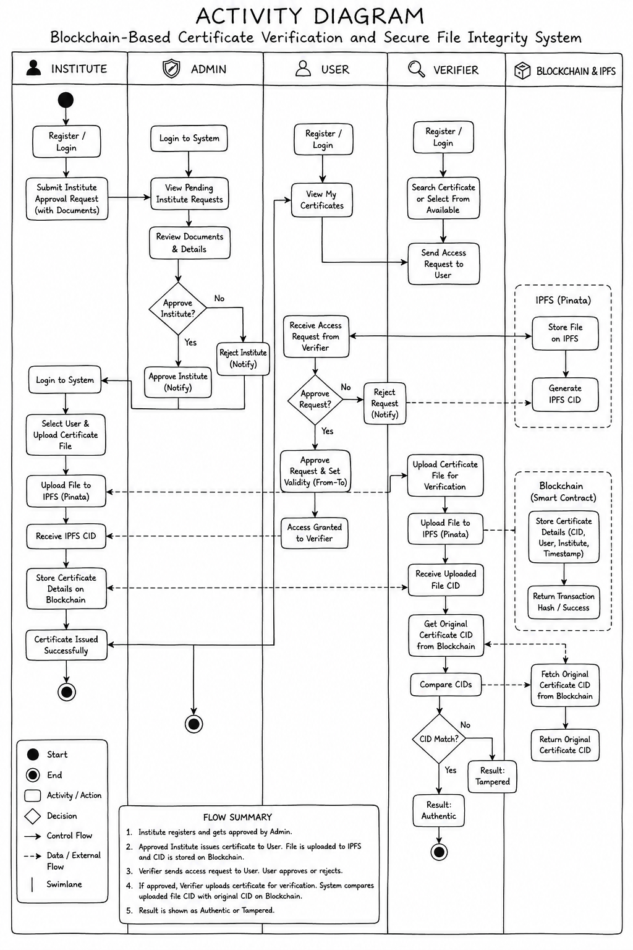
Fig. 2. Activity diagram of the certificate issuance workflow.
The end-to-end certificate issuance workflow proceeds through six stages. In the first stage, an authenticated Institute navigates to the certificate issuance interface, selects the target User from a dropdown populated through a backend API call, enters the certificate title, and selects the certificate file from local storage. In the second stage, the frontend transmits the file and metadata to the backend via a multipart POST request. In the third stage, the backend forwards the buffered file to the Pinata REST API. Pinata pins the file to IPFS and returns the CIDv1 hash. In the fourth stage, the backend broadcasts the issueCredential call to the Ethereum Sepolia network. In the fifth stage, upon transaction confirmation, the backend writes a certificate metadata record to MongoDB. In the sixth and final stage, the User's dashboard reflects the new certificate and an email notification is dispatched.

3.4 Tamper Detection Mechanism

The verification workflow is designed to be forensically reliable. When an approved Verifier uploads a certificate file for verification, the backend recomputes its IPFS CIDv1 hash locally using the same Pinata SDK chunking parameters as the original upload. This local CID computation is a pure cryptographic operation performed entirely within the backend runtime. The computed CID is then compared with the CID retrieved from the smart contract. If the two CIDs are identical, the certificate is declared Authentic. If any discrepancy exists, the certificate is declared Tampered. Since IPFS multihash employs SHA-256 internally and SHA-256 exhibits the strict avalanche criterion, any byte-level modification produces a completely and detectably different CID.

3.5 Time-Bounded Access Control
The time-bounded verifier access mechanism is implemented through two components: an expiry timestamp stored in the smart contract's access grants mapping, and a middleware check in the backend that validates access grant status before processing any Verifier certificate upload. When a User approves a Verifier's access request, the backend broadcasts an approveAccess transaction to the smart contract. The contract stores the grant with the computed expiry timestamp. If the current block timestamp exceeds the expiry, the function returns revoked, and the backend responds with HTTP 403 without processing the uploaded file.

Implementation

4.1 Smart Contract Design
The smart contract is authored in Solidity version 0.8.x and compiled and deployed using the Hardhat development framework. The contract defines a Role enumeration with four values: NONE, ADMIN, INSTITUTE, and USER. The Credential struct stores the IPFS CID as a string, the issuer's Ethereum address, the recipient's Ethereum address, the certificate title, the institution name, and the issuance timestamp. The AccessGrant struct stores the granting User's address, the Verifier's identifier, an isActive boolean, and an expiry timestamp.
Key contract functions include: constructor (assigns ADMIN role to deployer), approveInstitute (restricted to ADMIN, assigns INSTITUTE role), issueCredential (restricted to INSTITUTE, stores credential and emits event), requestAccess (callable by Verifiers), approveAccess (callable by User with optional expiry), getCredential (public view), and checkAccess (public view). The contract emits events for every state-changing operation, providing a complete audit log.

4.2 Backend Implementation
The backend is implemented as a Node.js application using the Express.js web framework. User registration and login routes hash passwords using bcrypt with a cost factor of 12. Successful login generates a JWT signed with a secret stored in environment variables, with a 24-hour expiry. Protected routes pass through an authenticateToken middleware, and a second authoriseRole middleware factory returns HTTP 403 for callers whose decoded role is not in the permitted set.
Certificate file uploads use Multer configured with memory storage, limiting accepted MIME types to PDF and images, with a maximum file size of 20 MB. The buffered file data is forwarded to the Pinata API using the @pinata/sdk Node.js package. The backend maintains a single Ethers.js JsonRpcProvider instance connected to the Alchemy Sepolia endpoint. Nodemailer is configured with an SMTP transport for email notifications.

4.3 Frontend Implementation
The frontend is a React.js single-page application styled with Tailwind CSS. React Router v6 manages client-side navigation. Protected routes use a custom PrivateRoute component that reads the JWT from the application's React state. The Admin Dashboard displays a paginated list of pending institute registration requests. The Institute Dashboard provides a certificate issuance form. The User Dashboard lists all received certificates and manages access requests. The Verifier Dashboard presents an access request submission form and verification interface.


Fig. 3. CertiChain login interface demonstrating role-based authentication.

Results and Discussion

5.1 Functional Test Results
The system was evaluated through a comprehensive functional test suite encompassing all defined use cases across the four roles. Testing was conducted using Postman for API-level testing and through manual browser-based end-to-end testing on the deployed frontend. The smart contract unit tests were written using the Hardhat testing framework with the Chai assertion library. All 23 unit tests passed without failure. All 15 functional test cases passed, confirming that the role-based access control model, the certificate issuance workflow, and the tamper detection mechanism operate correctly across all defined scenarios.

5.2 Tamper Detection Accuracy
To systematically evaluate the robustness of the CID-based tamper detection mechanism, 50 PDF certificate files were subjected to six distinct categories of modification. Each modified file was uploaded through the Verifier verification interface, and the system's verdict was recorded. A separate set of 50 unmodified, authentic certificate files were submitted for verification to assess false positive behaviour.
- Tamper detection accuracy
Modification Category | Files Tested | Tampered Detected | Authentic (False Negative) | Detection Accuracy
Metadata field alteration | 50 | 50 | 0 | 100%
Single-character text change | 50 | 50 | 0 | 100%
Invisible whitespace insertion | 50 | 50 | 0 | 100%
Pixel-level image modification | 50 | 50 | 0 | 100%
File re-encoding | 50 | 50 | 0 | 100%
Digital signature stripping | 50 | 50 | 0 | 100%
In every case with unmodified files, the system correctly returned an Authentic verdict, confirming zero false positives. The overall detection accuracy of 100 percent across both authentic and tampered files is consistent with the theoretical guarantee provided by SHA-256's strict avalanche criterion, which underpins IPFS multihash CID computation. Any byte-level modification to the file produces a completely different SHA-256 hash and consequently a completely different CID, making non-detection impossible under the honest operation of the IPFS CID computation function.

5.3 Performance Evaluation

End-to-end latency was measured across 30 certificate issuance transactions and 30 verification operations under normal Sepolia network load conditions. Measurements were taken from the moment the User clicked the relevant action button in the frontend to the moment the result was displayed.
- performance evaluation
Operation | Average Latency | Minimum | Maximum
IPFS upload via Pinata (500 KB PDF) | 3.1 seconds | 2.3 seconds | 5.8 seconds
Ethereum transaction broadcast | 1.2 seconds | 0.9 seconds | 2.1 seconds
Sepolia block confirmation | 14.3 seconds | 11.0 seconds | 24.6 seconds
End-to-end certificate issuance | 18.6 seconds | 14.8 seconds | 32.5 seconds
CID recomputation (500 KB PDF) | 0.8 seconds | 0.6 seconds | 1.2 seconds
Smart contract read (getCredential) | 3.9 seconds | 2.8 seconds | 6.1 seconds
End-to-end certificate verification | 4.7 seconds | 3.4 seconds | 7.3 seconds
The dominant latency component in certificate issuance is Sepolia block confirmation, which is a property of the underlying blockchain network rather than the application. On a Layer-2 Ethereum network such as Polygon or Optimism, confirmation latency would be reduced to under 2 seconds. Certificate verification latency of 4.7 seconds is well within acceptable bounds for a use case where verification events occur at the scale of minutes to hours, not milliseconds.

5.4 Comparative Analysis
- comparative analysis with existing systems
Feature | Chinnasamy et al. [5] | Ma and Zhang [4] | Blockcerts (MIT) | Proposed System
Blockchain platform | Hyperledger Fabric | Ethereum | Bitcoin | Ethereum (EVM)
File storage | Hash only, on-chain | IPFS + Ethereum | Hash only | IPFS (Pinata) + Ethereum
Number of roles | 2 (Issuer, Recipient) | 2 (Issuer, Patient) | 2 (Issuer, Recipient) | 4 Admin, Institute, User, Verifier
User access sovereignty | Not supported | Not supported | Not supported | Time-bounded, user-governed
Verifier workflow | Not supported | Partial | External tool required | Fully integrated
Tamper detection | Hash comparison | Hash comparison | Hash comparison | IPFS CID comparison
Open-source stack | Partial | Not disclosed | Yes | Yes (MERN + Hardhat)
Email notifications | Not mentioned | No | No | Yes
The proposed system surpasses all compared systems in role coverage, user access sovereignty, and integrated verifier workflow, while matching or exceeding them in tamper detection capability and public verifiability.

Conclusion
This paper has presented a decentralised blockchain-based certificate verification and file integrity system that addresses the fundamental limitations of centralised credential management through a principled combination of IPFS content-addressed storage and Ethereum smart contract anchoring. The system's four-role hierarchical governance model provides comprehensive management of the complete certificate lifecycle within a single, coherent smart contract architecture. The time-bounded, user-controlled verifier access mechanism is a novel contribution that restores user sovereignty over credential disclosure, a capability absent from all previously surveyed systems.
Comprehensive experimental evaluation demonstrates 100 percent tamper detection accuracy across six categories of file modification and zero false positives on authentic files, with end-to-end verification latency averaging under five seconds. Comparative analysis against three reference systems establishes that the proposed platform offers a uniquely complete and privacy-preserving credential verification capability.
The current implementation operates on the Ethereum Sepolia testnet. Future work will pursue migration to a Layer-2 Ethereum network such as Polygon or Optimism to reduce gas costs and confirmation latency, integration of QR code generation for offline-initiated verification, a dedicated mobile application, AI-based anomaly detection for access patterns, a public wallet-free verification portal, and multi-chain deployment support.
The system demonstrates conclusively that a practical, cost-effective, forensically reliable, and privacy-preserving credential verification platform is achievable using entirely open-source components, making it accessible to educational institutions, professional bodies, and regulatory agencies regardless of their infrastructure budgets.

Acknowledgment
The authors express their sincere gratitude to Dr. Divya T. L., Assistant Professor, Department of Master of Computer Applications, R V College of Engineering, Bengaluru, for her expert guidance, constructive feedback, and consistent encouragement throughout the conception, development, and documentation of this work. The authors also gratefully acknowledge the Department of MCA, RVCE, for providing the computational and academic resources that made this research possible. Thanks are extended to the open-source communities behind the Hardhat, Ethers.js, Pinata, and React ecosystems, whose freely available tools and documentation were indispensable to the implementation.

References
- HireRight, "2023 Employment Screening Benchmark Report," HireRight LLC, Nashville, TN, USA, Tech. Rep., 2023.
- J. Benet, "IPFS -- Content Addressed, Versioned, P2P File System," arXiv preprint arXiv:1407.3561, 2014.
- N. Szabo, "Formalizing and Securing Relationships on Public Networks," First Monday, vol. 2, no. 9, 1997.
- S. Ma and Y. Zhang, "Blockchain and IPFS-Based Healthcare Data Security and Privacy Protection Framework," Scientific Reports, vol. 14, no. 1, pp. 1--15, 2024.
- P. Chinnasamy, P. Deepalakshmi, K. Praveena, and J. Porkodi, "Blockchain-Based Educational Document Management System Using Smart Contracts," Scientific Reports, vol. 15, no. 1, pp. 1--18, 2025.
- O. Hammoud, R. Tarcea, H. Balan, and T. Cioara, "A Survey on Blockchain-Based File Storage Systems: Challenges and Future Trends," Frontiers in Blockchain, vol. 8, pp. 1--22, 2025.
- Y. Wang, Z. Liu, and H. Chen, "Storage Optimization Techniques in Blockchain Systems: A Systematic Review," MDPI Electronics, vol. 13, no. 4, pp. 1--30, 2024.
- M. Islam, M. Uddin, and A. Rahman, "Blockchain-Based Log Integrity System for Auditable Cloud Services," arXiv preprint arXiv:2503.12480, 2025.
- C. Antony, G. Merlin, and R. Sai Kumar, "Document Forgery Detection Using Blockchain Technology," International Journal of Engineering Research and Technology (IJERT), vol. 13, no. 8, pp. 123--128, 2024.
- M. Tmeizeh, A. Al-Haj, and L. Qatawneh, "Blockchain-Based Data Preservation Framework with Metadata Provenance," Springer Lecture Notes in Networks and Systems, vol. 803, pp. 45--58, 2024.
- T. Nododile, S. Dlamini, and N. Moyo, "Hybrid Blockchain-IPFS Storage System for Enterprise Document Management," arXiv preprint arXiv:2504.07312, 2025.
- K. Choudhary, R. Sharma, and A. Mehta, "Immutable Cloud Storage Using Blockchain for Long-Term Data Archival," International Journal of Research in Computer Science, vol. 12, no. 2, pp. 88--97, 2025.
- S. Kumar, V. Rajan, and P. Nair, "Comparative Analysis of IPFS and Cloud Storage for Blockchain-Integrated Applications," International Journal of Recent Trends in Engineering and Research, vol. 11, no. 1, pp. 55--64, 2025.

