

SECTION 01
About Affidex Academy

Registered Name | Affidex Academy Limited
Registration Number | RC - 9316934 (CAC, incorporated 12 February 2026)
Tax Identification Number | 2620322622930
SMEDAN Number | SUID-5998-5813-3500-9105 (Certified 19 March 2026)
Company Type | Private Limited Liability Company
Business Category | Vocational Education & Training Services
Headquarters | Udo Udoma Avenue, Uyo, Akwa Ibom State
Multi-State Presence | Akwa Ibom State | Cross River State | Lagos | Abia State
Primary Email | contact@affidexacademy.com.ng
Phone / WhatsApp | +234 813 398 5352
Website | www.affidexacademy.com.ng

Executive Summary
Affidex Academy Limited is a Nigerian vocational, technical, and digital skills institution headquartered in Uyo, Akwa Ibom State, incorporated under the Corporate Affairs Commission of Nigeria (RC: 9316934) and certified by the Small and Medium Enterprises Development Agency of Nigeria (SMEDAN). We are a verified Microsoft AI Cloud Partner, an active UNESCO-UNEVOC global TVET network participant, and a registered NYSC SAED Training Partner.
We exist to close the digital and vocational skills gap across Southern Nigeria by delivering practical, nationally benchmarked, industry-aligned training to youth, women, corps members, and underserved community members. Our model operates on a 70% hands-on laboratory and project work / 30% guided theory structure - ensuring every graduate leaves with demonstrated, portfolio-backed skills and a credible pathway to income within 90 days of graduation.
Affidex currently operates two fully equipped training centres in Uyo, Akwa Ibom State, with an active and growing delivery footprint across Akwa Ibom, Cross River, Abia, and Lagos States. We deliver ten structured training tracks spanning ICT, digital creative media, vocational hardware services, office technology, and business productivity - all aligned with the Nigeria Skills Qualifications (NSQ) framework and NBTE/TVET national standards.
Despite being incorporated in February 2026, Affidex has secured verified international and federal institutional registrations - including Microsoft AI Cloud Partner status, UNESCO-UNEVOC participation, NYSC SAED registration, FME TVET initial approval, SMEDAN certification, two NUPRC Oil Industry Service Permits (Major Category: Consultancy Training/Manpower Development, and General Category: Supply), a Tax Clearance Certificate, and a Bureau of Public Procurement (BPP) Interim Registration Report - that typically take established institutions years to achieve. We are operationally ready for immediate programme delivery at scale, and actively positioned for government, donor, and corporate partnership engagement across Southern Nigeria and beyond.

SECTION 02
Our Facilities & Training in Action

A glimpse into Affidex Academy's working training centres; where structured, industry-aligned instruction meets hands-on practice.
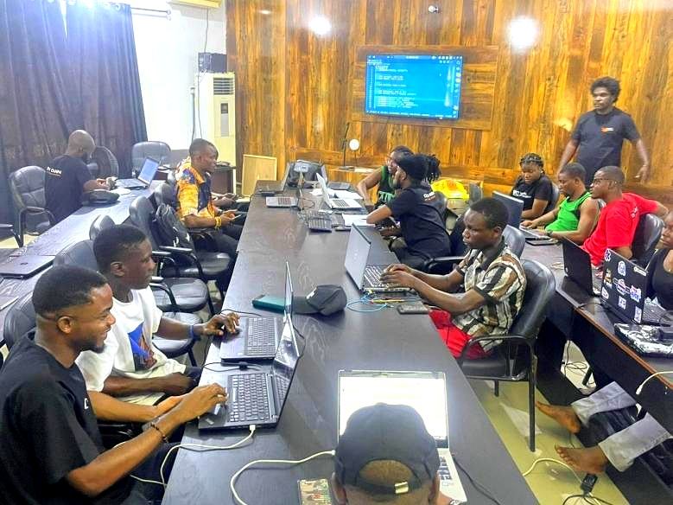  Live coding & software training - Uyo training centre | 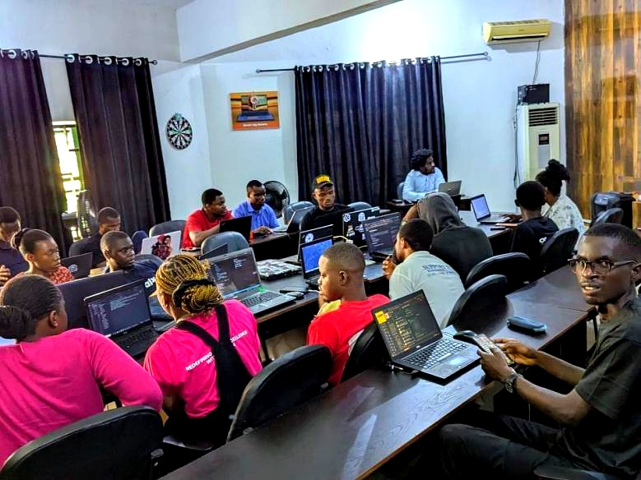  Cohort in session - practical, hands-on lab work
  Computer Training Unit - equipped ICT & hardware lab | 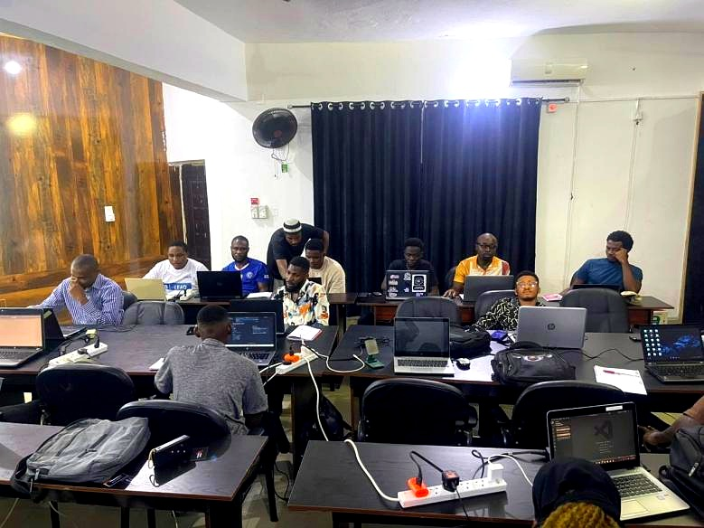  Instructor-led group session in progress

SECTION 03
Specialised Workshops & Equipment

Dedicated workshop stations supporting our GSM repair, computer hardware, photography, and office technology tracks - equipped for real, hands-on skill building.
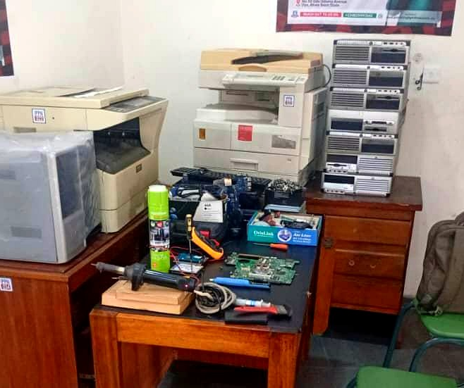  Computer hardware repair bench - component-level diagnostics | 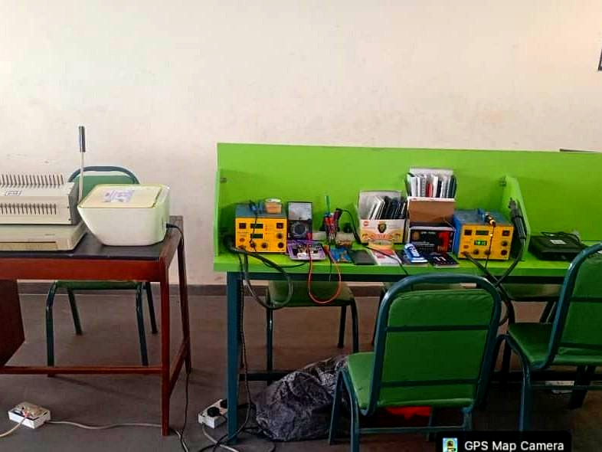  GSM & mobile device tools
  Photography studio lighting equipment and Office Management equipments | 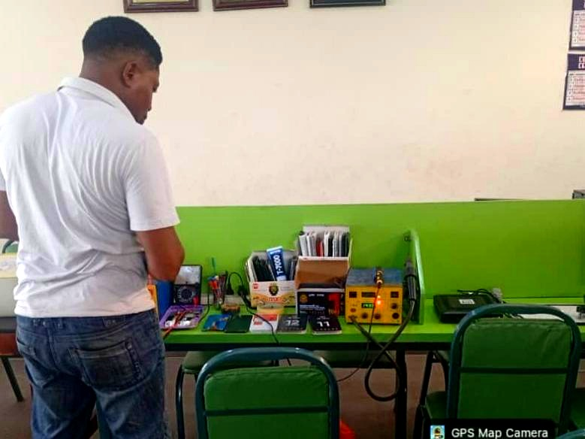  GSM & mobile device repair - technician at the rework station

SECTION 04
Vision, Mission & Core Values

To become the leading practical technology and vocational training institution in Southern Nigeria; a trusted pipeline of digital talent, women-led enterprises, and community-level economic transformation across Akwa Ibom, Cross River, Abia, Delta, and beyond. | To deliver practical, affordable, and market-linked vocational and ICT training that transitions young Nigerians; especially women, youth, and underserved communities; from exclusion to dignified, sustainable digital livelihoods.
  VISION
  MISSION

CORE VALUES
Practicality - We teach what works in the real market, not what looks good on paper. Every session is lab-first, project-driven.
Inclusion - We actively serve those excluded by cost, location, and systemic barriers. Our minimum 75% female participation target is by design.
Excellence - Our graduates represent Affidex everywhere they go. We protect that standard through rigorous curriculum and continuous assessment.
Integrity - Full transparency toward every student, partner, donor, regulator, and community we serve. No hidden fees, no false promises.
Impact - We measure success in incomes earned, businesses launched, and lives changed ; not in certificates printed.

SECTION 04B
Quality Policy Statement

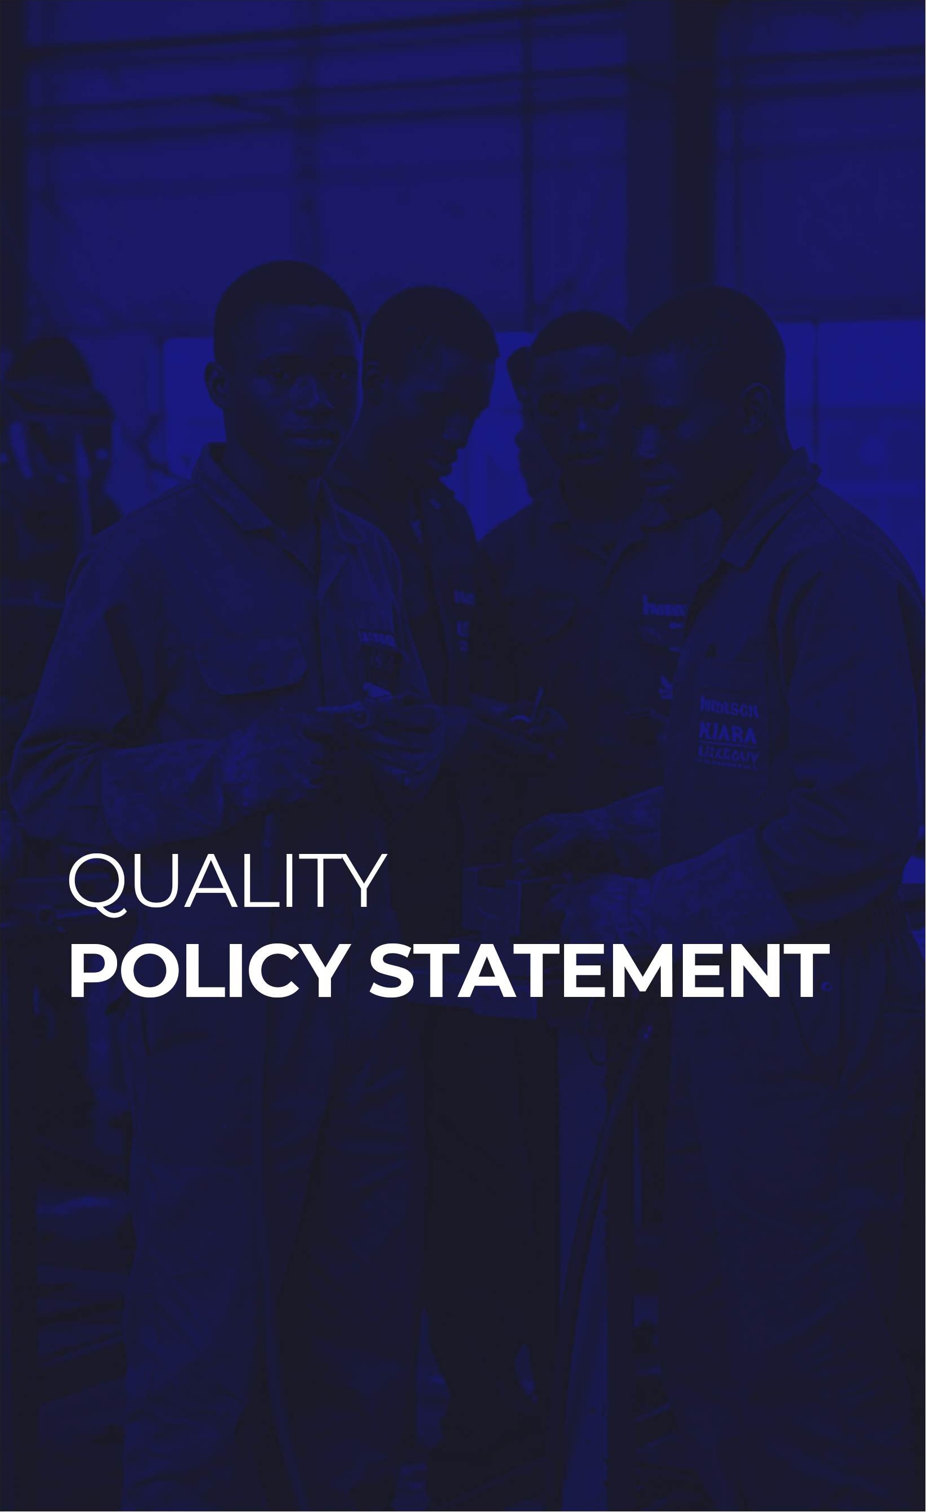 | Affidex Academy Limited is committed to delivering world-class digital and vocational skills training, consultancy, and supply services that meet and exceed the expectations of our trainees, clients, partners, and stakeholders. We ensure all programmes are industry-relevant, competency-based, and aligned with national and international standards. We uphold the highest levels of professionalism, safety, and ethical practice while continuously improving our systems through regular reviews, feedback, and innovation. Our goal is to produce skilled, employable, and entrepreneurial graduates, and to deliver projects and supplies on time, to specification, and with measurable impact on Southern Nigeria's digital and economic growth.

SECTION 04C
Quality Objectives

1. Deliver training with at least 90% trainee satisfaction and alignment to competency standards.

2. Review and update curricula and training materials annually for industry relevance.

3. Ensure 100% of instructors receive periodic technical, digital, and pedagogical upgrades.

4. Achieve zero reportable accidents in training labs and workshops through strict HSE implementation.

5. Support internship or job placement for at least 70% of graduates within six months.

6. Deliver consultancy projects on time, within scope, and with ≥90% client satisfaction.

7. Maintain ≥95% on-time delivery of certified educational materials and equipment.

8. Use feedback to implement measurable improvements in all services every year.

SECTION 05
Legal & Institutional Standing

Corporate Registration
CAC Registration | Corporate Affairs Commission - RC: 9316934
Date of Incorporation | 12 February 2026
Company Type | Private Limited Liability Company (Ltd)
Tax Identification Number (TIN) | 2620322622930
SMEDAN Certificate | SUID-5998-5813-3500-9105 - Issued 19 March 2026
Tax Clearance Certificate | TCC No: TCC-20260724-0088 - Issued 24 July 2026 (UYO ETO)

Federal Programme Registrations
NYSC SAED | Registered Training Partner - Akwa Ibom & Cross River States
FME TVET | NBTE Skill Training Center (STC) approval secured (July 2026) via sister company IPPN - Affidex is the implementation partner delivering the three approved trades; qualifying for federal training delivery contracts
3MTT | Applied Training Provider - Q3 2026 commencement confirmed with the National Programme Director
NITDA IICP | Indigenous ICT Company Programme - registration in process
CPN | Computer Professionals Registration Council of Nigeria - corporate registration in process
BPP | Interim Registration Report (IRR) issued - registered in the National Database of Contractors, Consultants & Service Providers - Reg. No: 9316934 - NRS & NSITF compliant, with PenCom and ITF MSME/statutory threshold exemptions - valid till 31 December 2026
KBS-ICSS | ICSS-TFC Certification & BDSP Accreditation - Kaduna Business School (application in process)
NUPRC | Permit to Operate as an Oil Industry Service Company (General Category - Supply: minor computer accessories/consumables) - Permit No: NUPRC/OGISP/26/6454855/N496344 - valid till 6 August 2027
NUPRC | Permit to Operate as an Oil Industry Service Company (Major Category - Consultancy: Training/Manpower Development, Soft Skills Training) - Permit No: NUPRC/OGISP/26/5843412/N469749 - issued 11 August 2026, valid till 11 August 2027 (see Annex VI)

International Affiliations
Microsoft AI Cloud Partner | Verified global partner status - Partner ID: 7086455 (PartnerGlobal) & 7086456 (PartnerLocation)
UNESCO-UNEVOC | Active participant - UNESCO's global TVET community spanning 167 countries
ACTD (USA) | American Council of Training & Development - Institutional Accreditation application submitted
GIZ TVET Academy | Registered on tvet-academy.de - active engagement with GIZ's global TVET learning platform
Cisco Networking Academy | Institutional partner application submitted and under review
Oracle Academy | Institutional membership application in process - free software, curriculum & certifications
ILO-ITCILO | International Labour Organization Training Centre - institutional partnership engagement initiated

SECTION 06
Institutional Partnerships & Training Engagements

CLIENT / PARTNER | TYPE | PERIOD | SCOPE
NYSC SAED Programme | Federal Government - Training Partner | 2026 (Active) | Digital skills & ICT training for NYSC corps members across Akwa Ibom and Cross River States
Google Developer Groups on Campus, Uyo (GDG) | Technology Community Partnership | 2026 (Active) | Digital skills activation, developer community engagement, and campus technology training sessions in Uyo
Institute of Practising Professionals Nigeria Ltd (IPPN) | Sister Company & NBTE/FME TVET Implementation Partner | 2026 (Active) | Affidex led IPPN's NBTE Skill Training Center (STC) application - approved July 2026 for Social Media Communications, Creative Media, and Computer Hardware Repair & Maintenance - and delivers 100% of NBTE/FME TVET training under it at IPPN's Uyo centre; NABTEB certifies via the Sectoral Awarding Body
KBS - Kaduna Business School (ICSS) | BDSP Accreditation & Certification | 2026 (In process) | ICSS-TFC Certification and Business Development Service Provider (BDSP) accreditation

SECTION 07
Our Services and Training Programmes

Affidex Academy Limited delivers structured, hands-on training that produces competent, industry-ready graduates. Programmes blend classroom instruction, guided lab practice, and real-world project work, aligned with the National Skills Qualification (NSQ) framework, NBTE standards, and NiTDA digital economy frameworks.

01  Training Programmes | We offer courses, certificates, and bespoke trainings in:

• Automobile Maintenance & Repairs – diagnostics, servicing and repairs on modern engines, transmissions, and electronic systems.
• Auto-Mechatronics Technology – integrated training on mechanical, electrical, electronic and computer systems, including sensors, actuators, and hybrid systems.
• Electrical Installation & Maintenance – wiring, fault detection, safety compliance, and preventive maintenance.
• Welding & Fabrication – structural welding, pipe and pressure vessel welding, and specialist underwater welding to international standards.
• ICT & Digital Skills for Technicians – CAD, diagnostic software, and digital tools for improved efficiency.
• Entrepreneurship & Business Skills – business planning, costing, marketing, customer service, and financial management for self-employment.
• Electric Vehicle (EV) Manufacturing and Maintenance – assembly, diagnostics, repair, and maintenance of electric and hybrid vehicles.
• Solar Energy Systems Installation and Maintenance – design, installation, and management of solar photovoltaic (PV) systems for homes, businesses, and industries.
• Compressed Natural Gas (CNG) Conversion and Maintenance Training – hands-on training on conversion of petrol-powered vehicles to CNG systems, and maintenance of conversion kits and fueling systems.
• Web Development & Coding Foundations – HTML5, CSS3, Tailwind, JavaScript, Git/GitHub, and an introduction to React for building and deploying live, professional websites.
• Digital Marketing & Sales Operations – social media management, content creation, SEO, email marketing, e-commerce operations, and paid advertising for immediate freelance and business income.
• UI/UX & Product Design – user research, wireframing, Figma mastery, design systems, prototyping, and usability testing for a professional product-design portfolio.
• Data & AI Productivity for Business – advanced Excel/Google Sheets, data visualisation, AI productivity tools, prompt engineering, and introductory Power BI for business decision-making.
• ICT Support, Hardware & Technical Services – computer hardware diagnostics, operating-system installation, networking, data recovery, and technical support for immediate technician or micro-enterprise income.
• GSM Repairs & Mobile Device Servicing – motherboard-level mobile phone diagnosis, component-level repair, software flashing, and customer-facing device servicing as a structured business.
• Creative Media Production & Photography – camera operation, studio and location lighting, Adobe Lightroom and Photoshop editing, videography basics, and the business of creative freelancing.

All programmes are competency-based and aligned with recognised occupational standards, ensuring that graduates are workplace-ready and capable of performing effectively upon completion.
02  Consultancy Services | Affidex Academy helps government agencies, donor organisations, corporate employers, and educational institutions strengthen their digital and vocational skills systems. Services include:

• Curriculum design and review, aligned to the NSQ framework and NBTE/TVET standards.
• Training-of-Trainers (ToT) programmes to upgrade instructors' technical, digital, and pedagogical skills.
• Design of digital labs, ICT training centres, and vocational workshop spaces.
• Accreditation and quality-assurance support for institutions pursuing NBTE and SMEDAN recognition.
• Digital and vocational skills-gap analysis and labour-market studies across Southern Nigeria.
• Advisory on apprenticeship systems, certification frameworks, and public-private partnerships for TVET delivery.

This positions Affidex as a trusted partner for organisations implementing or scaling digital and vocational skills initiatives across Southern Nigeria.
03  Procurement & Supply | Affidex Academy offers end-to-end procurement solutions for institutions needing modern digital and vocational training tools, including:

• Sourcing and supplying computers, laptops, and ICT training equipment.
• Supplying and installing GSM/mobile-repair tools, computer-hardware components, and photography and office-technology equipment.
• After-sales support, maintenance, and user training for all supplied equipment.
• Customised procurement packages aligned with client curricula or project objectives.

By combining training expertise with consultancy and supply capacity, Affidex provides a one-stop solution for building and sustaining effective digital and vocational skills programmes across Southern Nigeria and beyond.
Our training blends classroom instruction, hands-on lab sessions in fully equipped workshops, and industrial attachments with Other Partner Industries.

 |  | 

SECTION 08
Facilities

• Modern automobile workshops with diagnostic tools
• Mechatronics laboratories
• ICT and digital training labs
• Welding and fabrication workshops
• Vehicle body building and vulcanizing workshops
• Hostel accommodation for students and trainers
• Administrative offices
• Safe and conducive learning environment

SECTION 09
Core Leadership Team

 | Mr. Utibe-Abasi Emmanuel Samuel, FIPPN  Chairman & Chief Executive Officer  A technology entrepreneur, institutional builder, and vocational education advocate based in Uyo, Akwa Ibom State. Utibe-Abasi is the founder and driving force behind Affidex Academy Limited - a visionary who identified the structural gap in vocational and digital skills access across Southern Nigeria and built an institution from the ground up to close it.  He holds deep strategic expertise in institutional development, government and donor engagement, technology partnerships, and multi-state programme delivery. In under 90 days from incorporation, he led Affidex from a blank registration to a fully credentialed institution with verified Microsoft AI Cloud Partner status, UNESCO-UNEVOC participation, NYSC SAED registration, SMEDAN certification across 6 programmes, FME TVET initial approval, and active engagement with GIZ, 3MTT, World Bank IDEAS, AWIF, and multiple federal and state agencies.  His approach is rooted in the belief that impact precedes funding - that institutions earn their partnerships by demonstrating readiness and results before resources arrive. Under his leadership, Affidex operates not as a start-up in waiting but as a fully functional institution ready to deliver at scale.  samuel.utibe@affidexacademy.com.ng | +234 813 398 5352

 | Mr. Edidiong Samuel  Managing Director / Head, Training and Curriculum Development  Mr. Edidiong Samuel serves as the Managing Director of Affidex Academy Limited and the institutional head responsible for all training delivery, academic programming, and curriculum development across the organisation's ten vocational and digital skills tracks.  A disciplined and detail-oriented education leader, Edidiong brings a deep commitment to learning quality and practical outcomes that is reflected in every aspect of Affidex's curriculum design. He oversees the end-to-end academic lifecycle - from the development and review of NSQ-aligned course content, to the recruitment, supervision, and professional development of facilitators, to the monitoring of learning outcomes across all active cohorts and training centres.  His approach to curriculum is firmly rooted in the principle that vocational training must produce income, not just certificates. Under his direction, Affidex's 70% practical / 30% theory delivery model is rigorously maintained across all ten tracks. As Managing Director, Edidiong works in close coordination with the Chairman & CEO to translate Affidex's strategic vision into operational excellence.

 | Barr. Glory Samuel  Company Legal Representative  Barr. Glory Samuel serves as the Company Legal Representative of Affidex Academy Limited, bringing formal legal expertise, governance oversight, and institutional compliance leadership to the organisation's management structure.  A trained and qualified legal practitioner, Barr. Glory Samuel is responsible for ensuring that all of Affidex Academy's operations, partnerships, regulatory engagements, and contractual agreements are conducted within the full framework of Nigerian law and institutional best practice. Her role spans the review and execution of MOUs, partnership agreements, grant contracts, and regulatory submissions.  As a member of the management team, she also contributes to Board-level governance - ensuring accountability, ethical conduct, and the protection of the rights and interests of all Affidex stakeholders including students, staff, community beneficiaries, and funding partners.

 | Mr. Edikan Michael  Head, Partnerships and Business Development  Mr. Edikan Michael leads Affidex Academy's Partnerships and Business Development function, serving as the organisation's primary relationship builder, opportunity developer, and ecosystem connector across government, corporate, donor, and community stakeholder channels.  Edikan is the engine behind Affidex's growing institutional network - responsible for identifying, initiating, and managing strategic partnerships with federal and state government agencies, development finance institutions, international organisations, private sector employers, and community-level stakeholders. His work spans the full partnership lifecycle: from prospecting and proposal development, to negotiation and MOU execution, to ongoing relationship management and partner performance reporting.  His mandate is directly tied to Affidex's impact mission, playing a central role in Affidex's pipeline of proposals and engagements including GIZ SKYE II, 3MTT, FME TVET, NYSC SAED, AWIF, World Bank IDEAS, SMEDAN programmes, and state government TVET initiatives.

SECTION 09B
Governance & Organizational Structure

Corporate Governance
Affidex Academy Limited operates a governance framework that separates oversight from day-to-day management. The Board of Directors, chaired by the Chairman, sets strategic direction, approves major policies and budgets, and ensures compliance with statutory regulations.
A Company Secretary & Legal Adviser supports the board with corporate filings and compliance. Statutory Auditors provide independent assurance on the academy's finances and internal controls.
The Managing Director/CEO implements board policies and manages overall operations. Reporting directly to the CEO are three functional heads:
• Director, Technical & Training – oversees all training programmes and technical supervisors.
• Director, Finance & Commercial – manages finance, costing, billing, treasury, procurement, and stores.
• Registrar & Administrative Manager – handles admissions, student affairs, HR, health and safety, and general administration.

This structure promotes transparency, accountability, and effective decision-making while allowing the academy to run efficiently and deliver high-quality training services.
Organogram
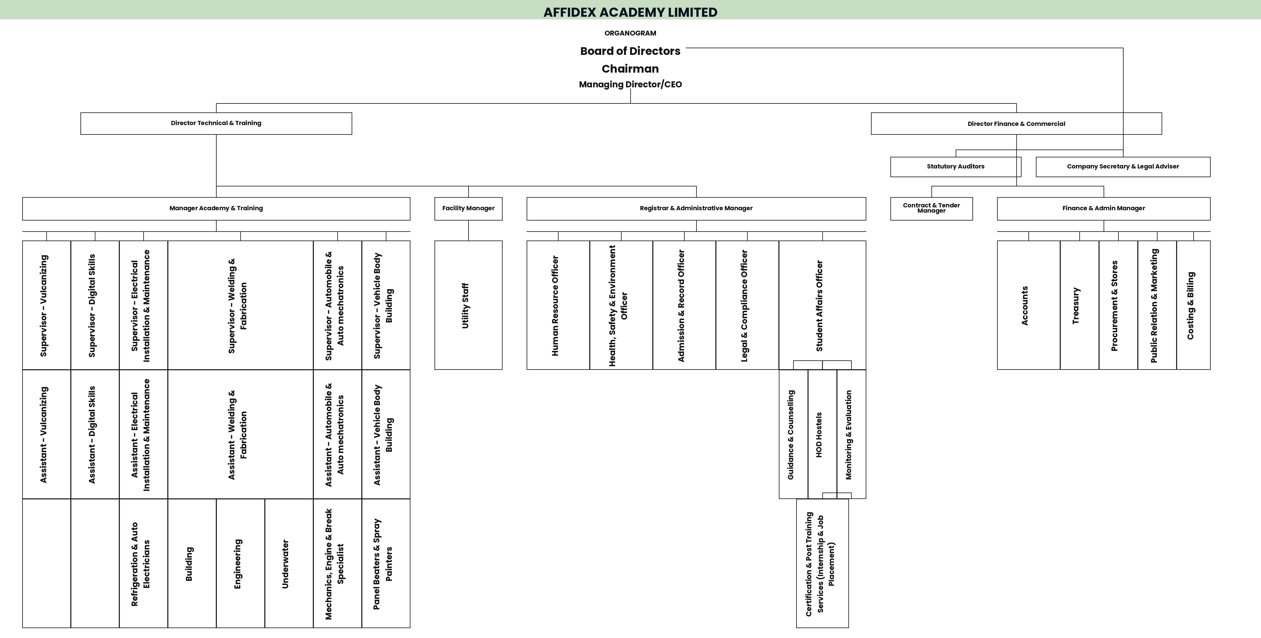
Figure: Affidex Academy Limited – Organogram
Organogram Overview
Beneath the functional heads are supervisors for each training area, Automobile & Auto-Mechatronics, Welding & Fabrication, Vehicle Body Building, Vulcanizing, Digital Skills, etc. supported by instructors, assistants, and utility staff who deliver day-to-day training. Support units such as Legal & Compliance, Public Relations & Marketing, Certification & Post-Training Services (internship/job placement), and Student Affairs also feed into the system.
Our tiered organogram ensures clear reporting lines and communication from the board level down to trainers and support staff, enabling Affidex to maintain global standards in training delivery.

SECTION 09C
Future Plans

Affidex Academy Limited is committed to sustained growth and innovation in digital and vocational education. Our strategic priorities over the next few years include:

• Expanding and Modernising Training Infrastructure – establishing additional training centres across Cross River, Abia, and Lagos states, including state-of-the-art digital labs and fully equipped workshops, within the next five years.
• Introducing Advanced Programmes – launching specialised courses in artificial intelligence, cloud computing, and other emerging technologies to prepare trainees for evolving industries.
• Establishing R&D and Innovation Hubs – setting up dedicated research and product-development hubs for digital and vocational skills to foster innovation and local solutions.
• Strengthening Partnerships – deepening collaborations with government agencies, donor organisations, and Other Partner Industries for technology transfer, trainer upskilling, and equipment exchange.
• Scaling Youth & Professional Training – training thousands of additional youths and professionals across Southern Nigeria over the next five years to drive digital inclusion and reduce unemployment.

SECTION 09D
Partnerships & Accreditation

Affidex Academy Limited works closely with a wide network of industry, government, and international partners to ensure our training, consultancy, and supply services meet global standards and provide real opportunities for our trainees:

• Institute of Practising Professionals Nigeria Ltd (IPPN): Sister company and NBTE/FME TVET implementation partner – Affidex delivers 100% of NBTE/FME TVET training under IPPN's Skill Training Center accreditation.
• Federal and State Governments: Youth empowerment initiatives, technical teacher training programmes, and support for workforce development.
• National Youth Service Corps (NYSC) SAED Programme: Registered training partner delivering digital skills and ICT training for corps members across Akwa Ibom and Cross River States.
• National Information Technology Development Agency (NITDA): Indigenous ICT Company Programme (IICP) registration in process.
• Small and Medium Enterprises Development Agency of Nigeria (SMEDAN): Certified partner supporting enterprise development and youth capacity building.
• Microsoft: Verified Microsoft AI Cloud Partner, supplying cloud technology and AI tools for our digital skills training.
• UNESCO-UNEVOC: Active participant in UNESCO's global TVET network spanning 167 countries.
• GIZ TVET Academy: Registered on the global TVET learning platform, engaging with international best practice.
• Google Developer Groups on Campus, Uyo (GDG): Technology community partnership for digital skills activation and developer training.
• International Partners (Cisco Networking Academy, Oracle Academy, ILO-ITCILO): Institutional partnership and membership applications in progress for curriculum, certification, and technical exchange.

This network of partnerships and accreditations enables Affidex to deliver industry-relevant, globally benchmarked training and services, and to give our graduates a direct pathway to employment, certification, and entrepreneurship.

SECTION 10
SDG & Development Framework Alignment

Affidex Academy's work is deliberately aligned with global, continental, and national development frameworks - making us a compelling partner for international donors, development finance institutions, and impact investors:
SDG 4: Quality Education - Practical, inclusive, lifelong learning opportunities that are affordable and accessible regardless of geography or gender
SDG 5: Gender Equality - Women-first programme design; minimum 75% female participation target; women-focused enterprise development embedded in all tracks
SDG 8: Decent Work & Economic Growth - Education-to-income transition target of 65%+ graduates earning within 90 days; micro-enterprise support for top performers
SDG 10: Reduced Inequalities - Deliberate focus on underserved communities, low-income youth, persons with disabilities, and geographically excluded populations in Southern Nigeria
SDG 9: Industry, Innovation & Infrastructure - Digital skills delivery as infrastructure investment; positioning Southern Nigeria youth in the global digital economy
AU Agenda 2063: Digital Africa pillar - TVET and youth digital employment pipeline for continental transformation
GIZ SKYE II Mandate - Youth employment (15–35), TVET quality improvement, private sector engagement, and gender-responsive skills delivery
Nigeria NEDS 2021–2025 - National Economic Development Strategy - digital economy and skills infrastructure development
NITDA Digital Economy Policy - Aligned to Nigeria's national target of training 3 million tech talents (3MTT programme)

For partnership, collaboration, or investment enquiries
contact@affidexacademy.com.ng | +234 813 398 5352 | www.affidexacademy.com.ng

SECTION 11
Annex I - Certificate Of Incorporation



SECTION 12
Annex II - SMEDAN Certificate



SECTION 13
Annex III - Microsoft AI Cloud Partner

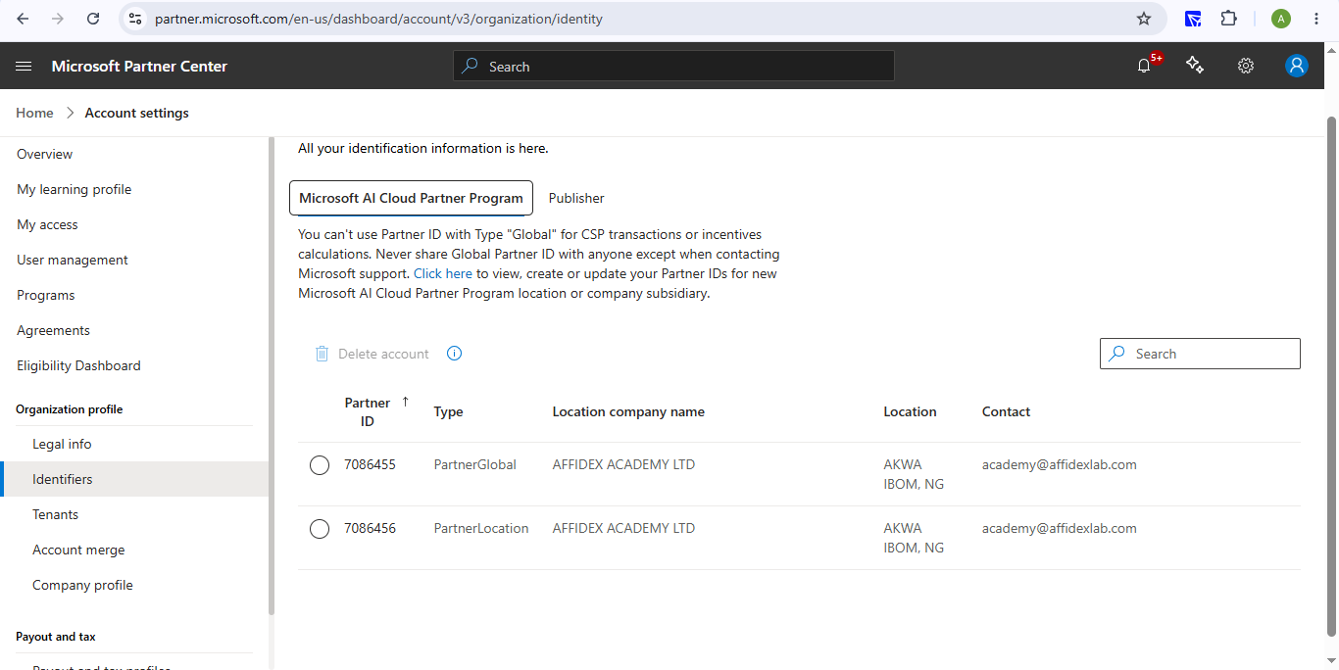

SECTION 14
Annex IV - NBTE Skill Training Center Approval (IPPN)

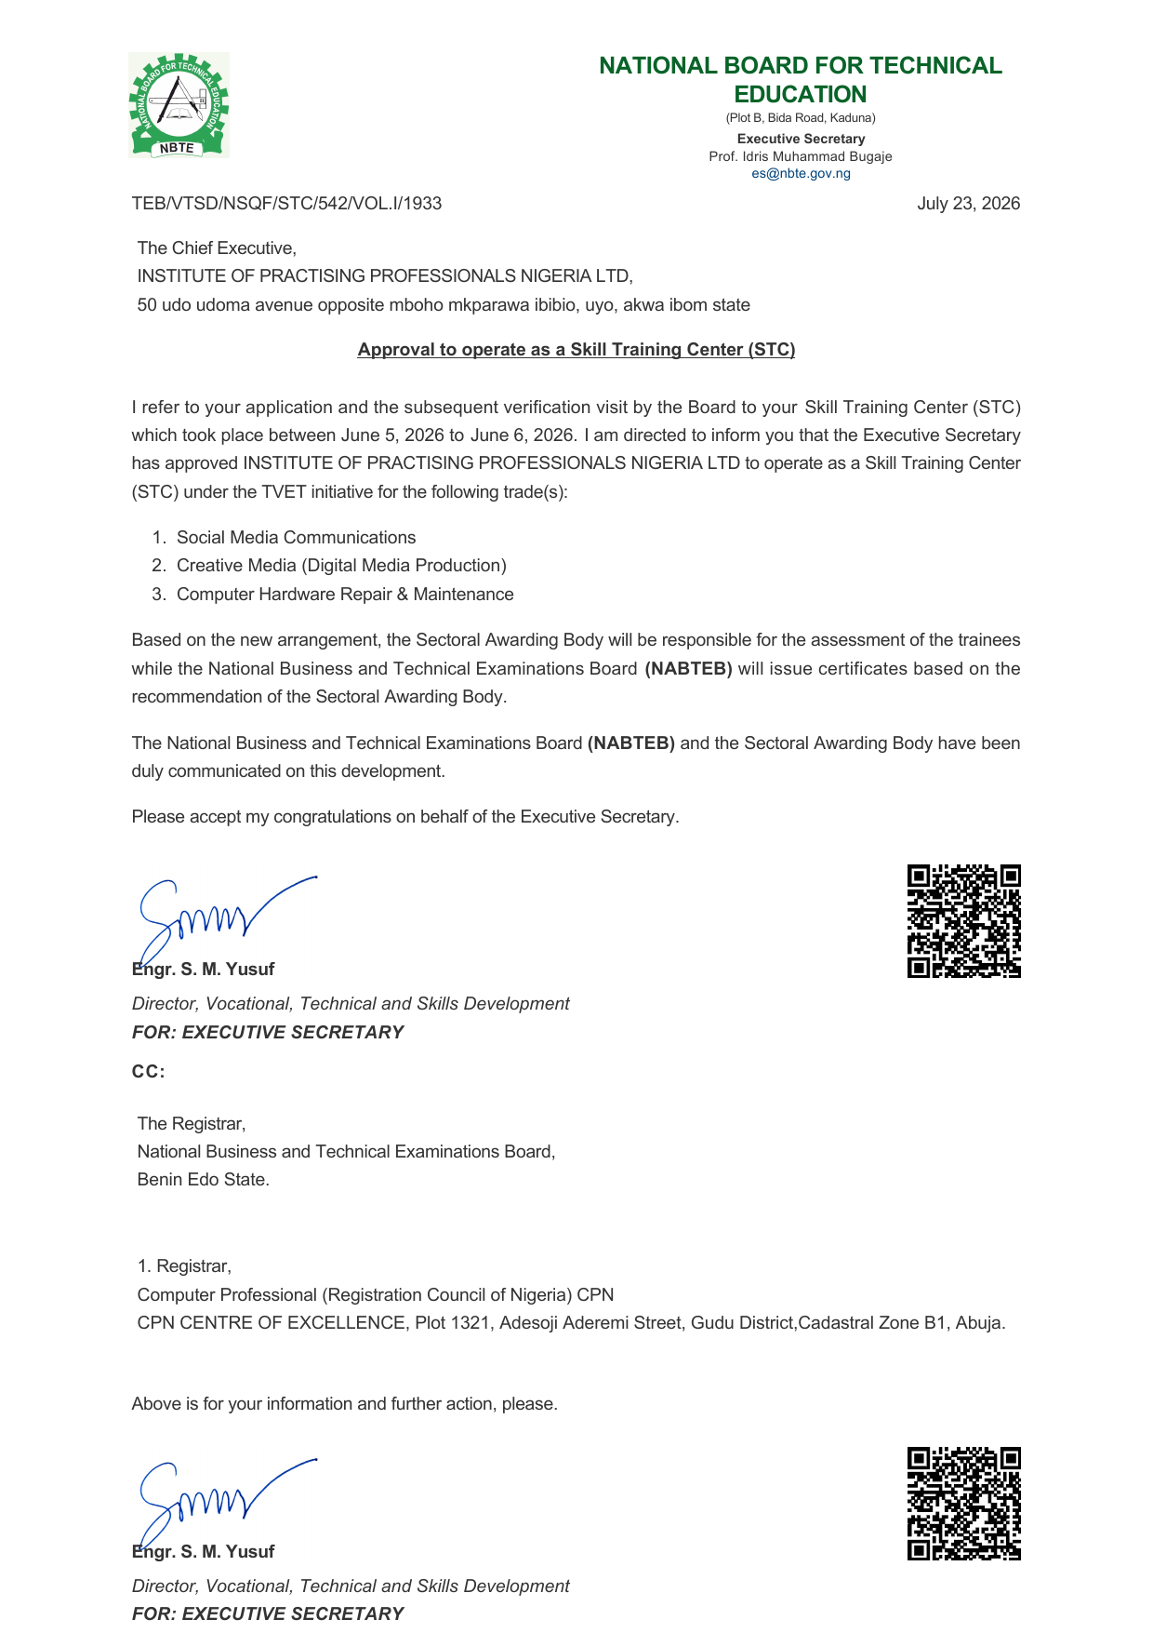

SECTION 15
Annex V - NUPRC Oil Industry Service Permit



SECTION 16
Annex VI - NUPRC Oil Industry Service Permit (Major Category: Training & Manpower Development)



SECTION 17
Annex VII - Tax Clearance Certificate

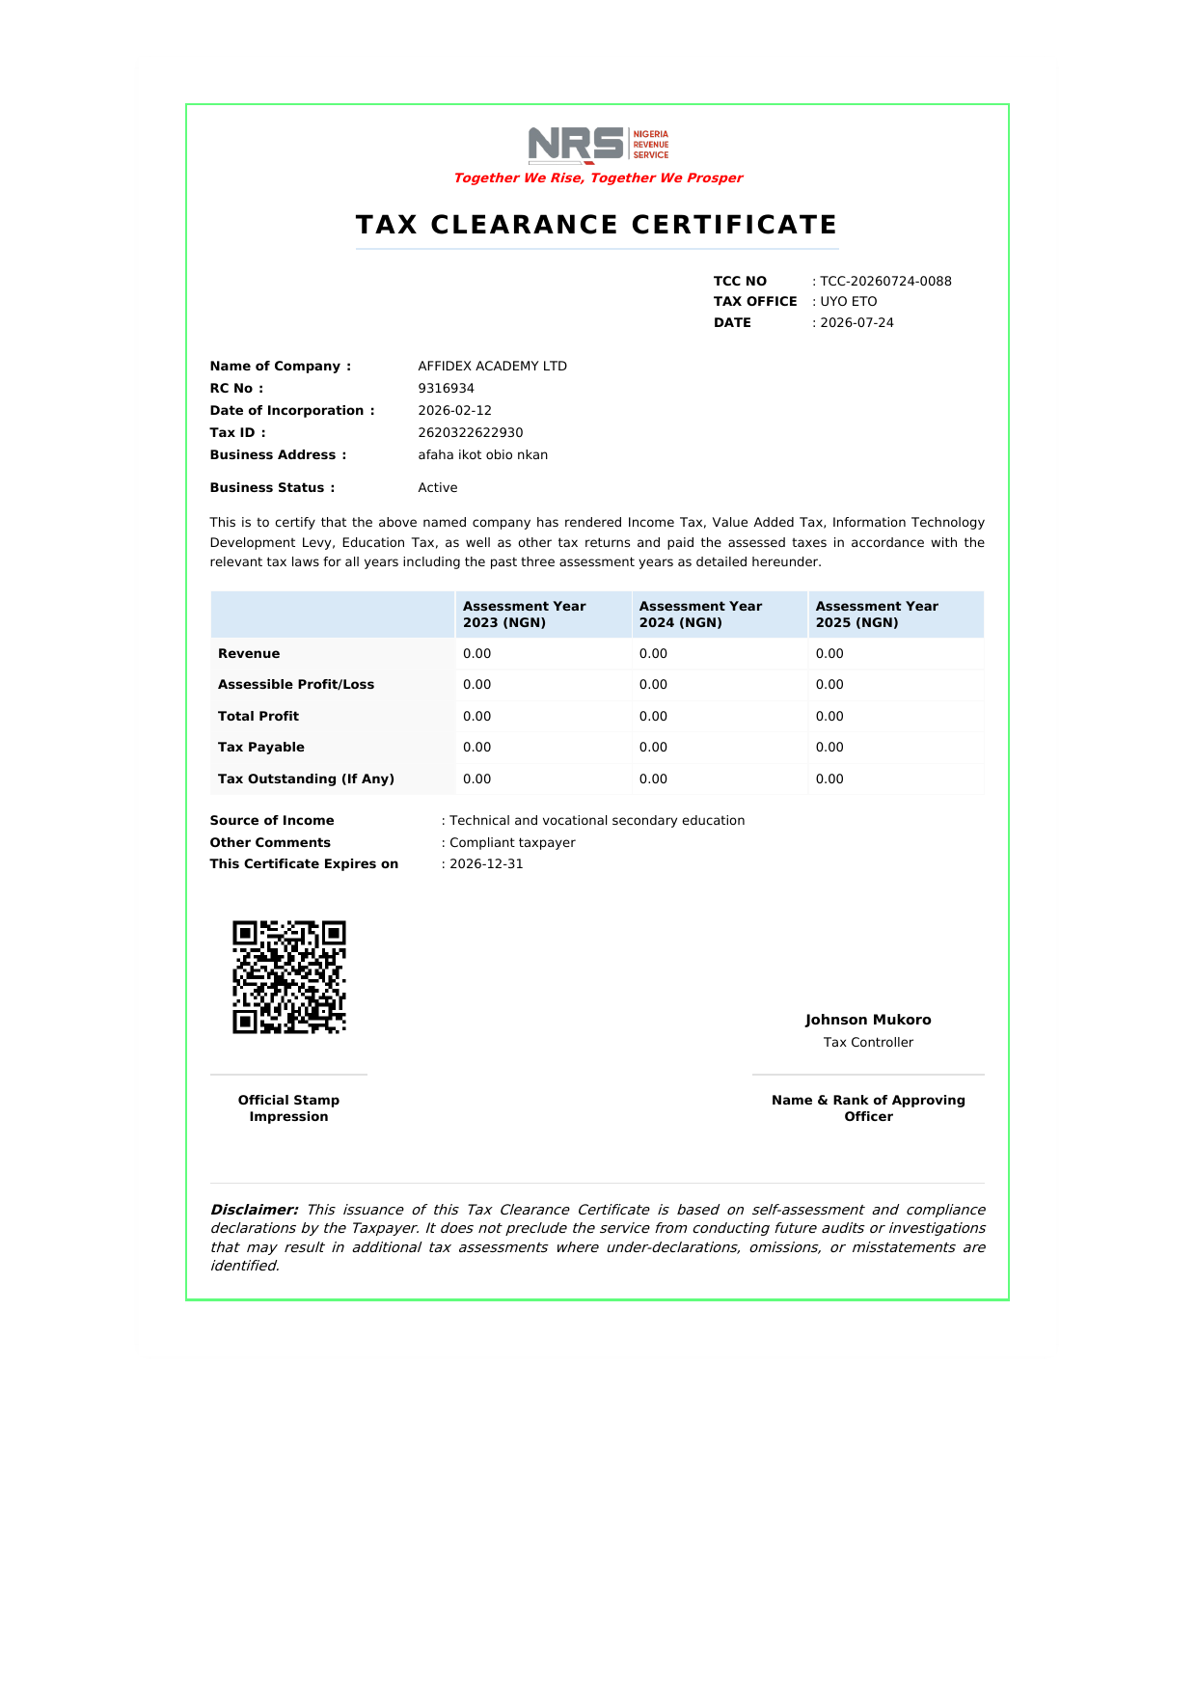

SECTION 18
Annex VIII - Bureau of Public Procurement (BPP) Registration



