Magic Quadrant for Data Science and Machine Learning Platforms
- Market Definition/Description
  - This Magic Quadrant evaluates vendors of data science and machine learning (DSML).
  - DSML platform as a core product and supporting portfolio of coherently integrated products, components, libraries and frameworks.
  - It supports variously skilled data scientists in multiple tasks across the data and analytics pipeline, including all the following areas: Data ingestion, Data preparation, Data exploration, Feature engineering, Model creation and training, Model testing, Deployment, Monitoring, Maintenance, Collaboration.
  - Quadrant does assess the availability of some pre-packaged content, such as templates and samples.
  - It does not assess service providers that can help jump-start or extend DSML projects throughout an organization.
  - It does not assess specialized vendors of industry-, domain- or function-specific solutions.
  - Readers of Magic Quadrant should understand that:
    - This market features a diverse range of vendors.
    - Platforms aimed primarily at application developers and business analysts are explicitly excluded
    - A Leader may not be the best choice.
    - Only vendors with commercially licensable products are included.
    - Platforms must support not only model building but also model operationalization.
      - **Operationalization (often referred to as MLOps) extends to ongoing review and adjustment of models to ensure their relevancy over time as the business and its objectives change.
      - **MLOps also includes key functionality such as drift detection, catalogs, governance, explainability and business impact analysis.
    - AI is overhyped and inescapable.

 | Vendor | Strength | Caution
1. | Altair | - Ease of use and balance of coder and noncoder appeal  - Customer satisfaction  - Potential in new industries and development with other Altair products | - Second acquisition of product portfolio in two years  - Gaps in vision and current offering  - Slower adoption compared to competitors
2. | Alteryx | - Market perception and execution  - No-code approach  - A robust, growing community | - Pricing  - Linux support  - Streaming/Internet of Things (IoT) capabilities
3. | Anaconda | - Python and open-source support  - Active community  - Scalable development for open-source libraries | - Designed for experts  - Open-source shortcomings  - Automation and operationalization
4. | Databricks | - Strong execution, expansion and partnerships  - Commitment to customer success  - Databricks is pushing the envelope of scalability | - Heavy slant toward technical audience  - No generally available on-premises offering  - Tight association with Spark plays down Databricks as a DSML platform
5. | Dataiku | - Collaboration across data science roles  - Ease of use  - Data governance | - Advanced analytics  - Precanned solutions  - Streaming and the IoT
6. | DataRobot | - Augmented analytics thought leadership and appeal for broad mix of users  - Increasing market traction  - Hands-on onboarding and support | - Perceived as introductory, elementary tool for nonexperts  - AI Success Plan approach is resource-heavy  - Cost concerns
7. | Domino | - Center of the enterprise ML ecosystem  - Business enablement and collaboration  - Governance and audit | - Partnership strategy  - Domino is geared toward large teams  - Inflexible pricing
8. | Google | - Emphasis on cutting-edge data science problems  - Innovation  - Scalability | - Big footprint and learning curve  - Still largely incoherent ML pipeline and lack of project management support  - Persistent beta and limited on-premises capabilities
9. | H2O.ai | - Augmentation (automation)  - Explainability  - High-performance ML components | - Limited cohesion between H2O Driverless AI and open-source platform  - Lack of certain data access and preparation capabilities  - Other advanced analytics
10. | IBM | - Execution of Watson Studio strategy  - Product deployment and business value  - Collaboration and appeal to multiple levels of expertise | - Product bundling and configuration  - Ongoing need for innovation after catching up in key areas  - Brand restoration and keeping up with stiff competition
11. | KNIME | - Open-source with commercial support for enterprise-grade capabilities  - Enablement and support for multiple skill levels  - Mature augmented analytics vision | - Subdued visibility and slow relative growth  - Training shortcomings  - Performance issues
12. | MathWorks | - Production-focused environment  - Platform coherence and integration  - Prebuild solutions | - MLOps  - Center for data science and project collaboration  - Interpretable AI
13. | Microsoft | - Appeal and mature functionality for multiple skill levels and analytics personas  - Pace of development  - Compute power and control | - On-premises, hybrid and multicloud are not first-class citizens  - Coherence  - Solid but not leading augmented DSML
14. | RapidMiner | - End-to-end augmented data science life cycle management  - Flexibility, agility and modern scalability  - Model governance | - Slow relative growth and increased competition  - Sales innovation  - Licensing and service customizations
15. | SAS | - Recognized and trusted brand  - Model ops  - Ease of use and augmentation | - Pricing and sales execution  - Coherence  - Marketing strategy
16. | TIBCO Software | - Edge analytics and streaming  - Openness  - End-to-end platform | - MLOps  - Interpretable AI  - Augmented ML

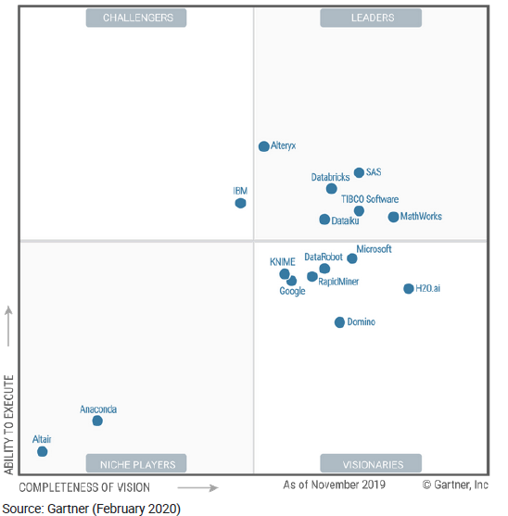
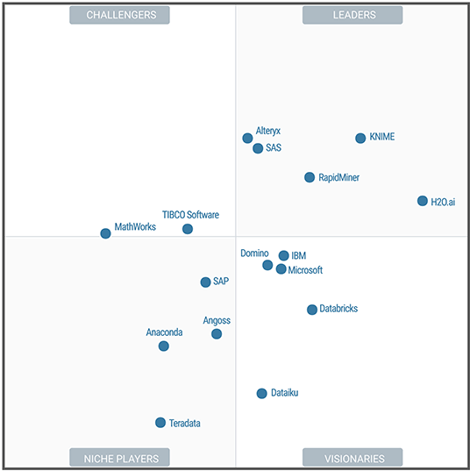

Ability to Execute | Challengers | Leaders
Ability to Execute | - IBM (2019)  - MathWorks (2018)  - TIBCO Software (2018) | - Alteryx (2019, 2018)  - SAS (2019, 2018)  - Databricks (2019)  - TIBCO Software (2019)  - Dataiku (2019)  - MathWorks (2019)  - RapidMiner (2018)  - KNIME (2018)  - H20.ai (2018)
Ability to Execute | Niche Players | Visionaries
Ability to Execute | - Anaconda (2019, 2018)  - Altair (2019)  - SAP (2018)  - Angoss (2018)  - Teradata (2018) | - Microsoft (2019, 2018)  - Domino (2019, 2018)  - DataRobot (2019)  - KNIME (2019)  - RapidMiner (2019)  - Google (2019)  - H20.ai (2019)  - IBM (2018)  - Databricks (2018)  - Dataiku (2018)
 | Completeness of Vision

- Azure Databricks (Microsoft) vs Databricks: What are the differences?
  - What is Azure Databricks?
    - Fast, easy, and collaborative Apache Spark–based analytics service. Accelerate big data analytics and artificial intelligence (AI) solutions with Azure Databricks, a fast, easy and collaborative Apache Spark–based analytics service.
  - What is Databricks?
    - A unified analytics platform powered by Apache Spark. Databricks Unified Analytics Platform, from the original creators of Apache Spark™, unifies data science and engineering across the Machine Learning lifecycle from data preparation to experimentation and deployment of ML applications.
  - Azure Databricks and Databricks can be categorized as "General Analytics" tools.
    - Some of the features offered by Azure Databricks are:
      - Optimized Apache Spark environment
      - Autoscale and auto terminate
      - Collaborative workspace
    - On the other hand, Databricks provides the following key features:
      - Built on Apache Spark and optimized for performance
      - Reliable and Performant Data Lakes
      - Interactive Data Science and Collaboration

- Inclusion and Exclusion Criteria
  - Business exploration
    - This is the classic scenario of exploring the unknown and forming hypotheses that requires extensive data preparation, exploration and visualization capabilities.
    - This scenario could also include the incorporation of augmented capabilities to guide the data preparation, use of visualization and analysis.
  - Advanced prototyping
    - This scenario describes when data science, especially novel ML techniques, is used to significantly improve traditional analytic approaches. Traditional approaches can be the use of human judgment, exact solutions, long-established heuristic approaches or legacy data mining approaches.
    - Advanced prototyping utilizes some or all of the following: Many more data sources, Novel analytic approaches (such as deep neural nets, transfer learning and reinforcement learning), Large-scale computing infrastructure, Specialized computer science and ML skills.

  - Production refinement
    - In this scenario, the organization has numerous data science solutions implemented and delivered into the business, but the focus now shifts to making refinements, improvements and updates to the existing models.
    - The activities and functionality of MLOps also fall primarily within the production refinement use case, wherein the platform supports the release activation, monitoring, performance tracking, management, reuse, maintenance and governance of models.
  - Augmented data science and machine learning
    - This use case has been renamed from “nontraditional data science.” This is the scenario where ML/AI is used to automate and accelerate key aspects of data science, such as feature engineering and model selection, as well as model operationalization, model explanation, model tuning and management.
    - This reduces the requirement for specialized skills to generate, operationalize and manage an advanced analytics model.
    - It opens up DSML content creation to citizen data scientists and (application) developers. Highly skilled data scientists can also be more productive and have more time to focus on other tasks.
- 15 critical capabilities to score the vendors’ capabilities across the four use-case scenarios:
  - Data access
  - Data preparation
  - Data exploration and visualization
  - Automation and augmentation
  - User interface (UI)
  - Machine learning (ML)
  - Other advanced analytics
  - Flexibility, extensibility and openness
  - Performance and scalability
  - Delivery
  - Platform and project management
  - Model management
  - Precanned solutions
  - Collaboration
  - Coherence
- Ability to execute criteria
 | Evaluation Criteria | Weighting
1. | Product or Service | High
2. | Overall Viability | Medium
3. | Sales Execution/Pricing | Low
4. | Market Responsiveness/Record | Medium
5. | Marketing Execution | Low
6. | Customer Experience | Medium
7. | Operations | Medium

- Completeness of Vision Evaluation Criteria
 | Evaluation Criteria | Weighting
1. | Marketing Understanding | Medium
2. | Marketing Strategy | Low
3. | Sales Strategy | Low
4. | Offering (Product) Strategy | High
5. | Business Model | Not Rated
6. | Vertical/Industry Strategy | Not Rated
7. | Innovation | High
8. | Geographic Strategy | Not Rated

