Sparkling Water Installation in Jupyter Notebook
- Requirements
  - A system running Windows 10
  - A user account with administrator privileges (required to install software, modify file permissions, and modify system PATH)
  - Command Prompt or Powershell
  - A tool to extract .tar files, such as 7-Zip
- Install Java 8
  - Open the command line by clicking Start > type cmd > click Command Prompt.
  - Type the following command in the command prompt:
java -version
  - If Java is installed, it will respond with the following output:
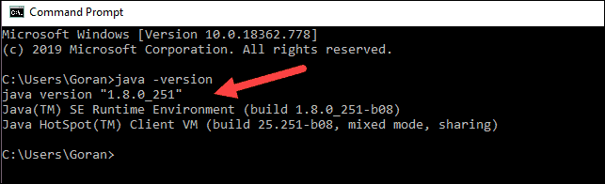
  - Your version may be different. The second digit is the Java version – in this case, Java 8.
    - Other Java version is not compatible with Spark as for the time being.
  - If you don’t have Java installed, open a browser window, and navigate to https://java.com/en/download/.
  - Difference between JDK and JRE
    - The Java Development Kit (JDK) is a software development environment used for developing Java applications and applets.
    - It includes the Java Runtime Environment (JRE), an interpreter/loader (Java), a compiler (javac), an archiver (jar), a documentation generator (Javadoc) and other tools needed in Java development.
    - Java Runtime Environment (JRE) provides the minimum requirements for executing a Java application
    - It consists of the Java Virtual Machine (JVM), core classes, and supporting files.
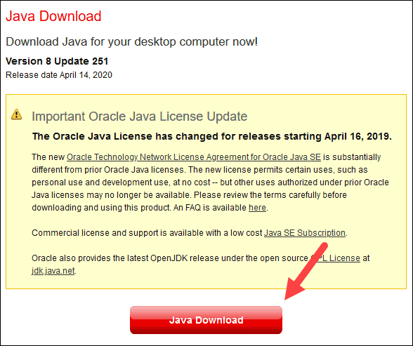
  - Click the Java Download button and save the file to a location of your choice.
  - Once the download finishes double-click the file to install Java.
- Install Anaconda
  - To install the Python package manager, navigate to https://www.anaconda.com/products/individual#windows in your web browser.
  - Mouse over the Download menu option and select
    - 64-Bit Graphical Installer (466 MB).
  - Once the download finishes, run the file.
  - Click Next.
  - Read the licensing terms and click I Agree.
  - Select an install for Just Me and click Next.
  - Select a destination folder to install Anaconda and click the Next button.
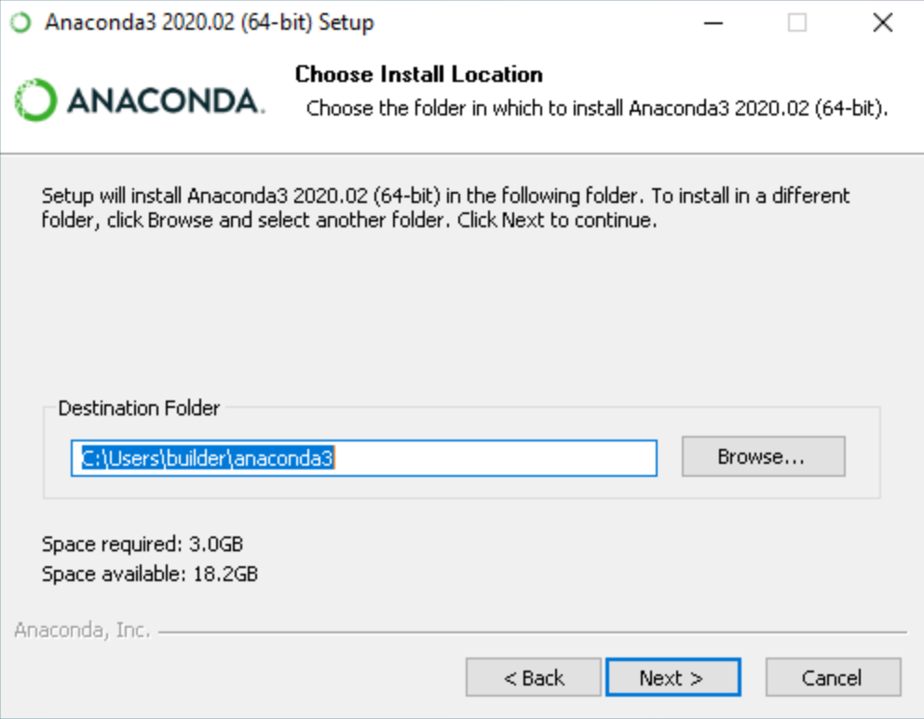
  - Choose whether to add Anaconda to your PATH environment variable.
    - We recommend not adding Anaconda to the PATH environment variable, since this can interfere with other software.
  - Choose whether to register Anaconda as your default Python.
    - Unless you plan on installing and running multiple versions of Anaconda or multiple versions of Python, accept the default and leave this box checked.
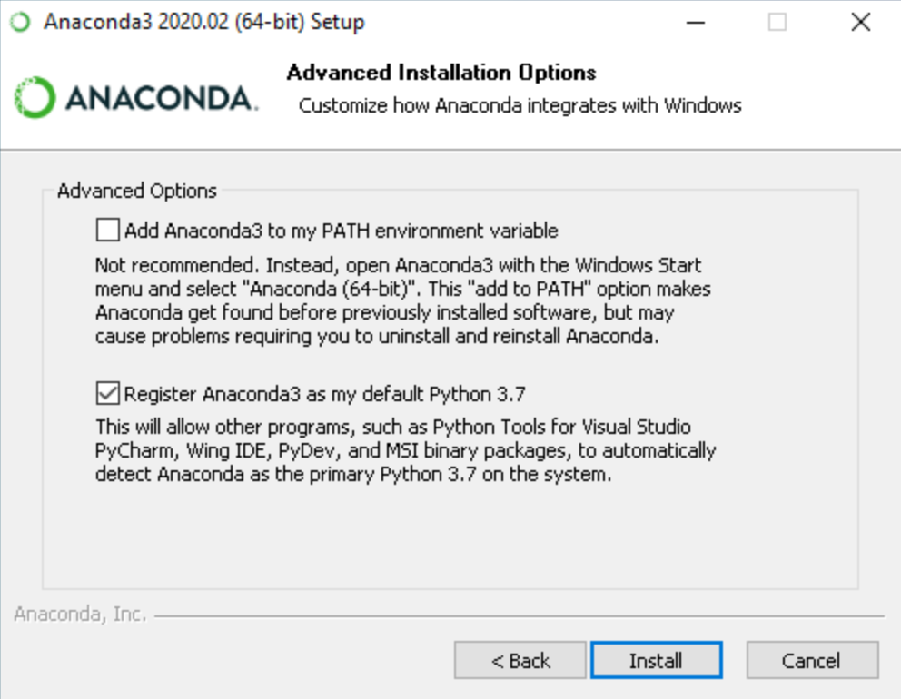
  - Click the Install button and then click Next.
  - After a successful installation you will see the “Thanks for installing Anaconda” dialog box:
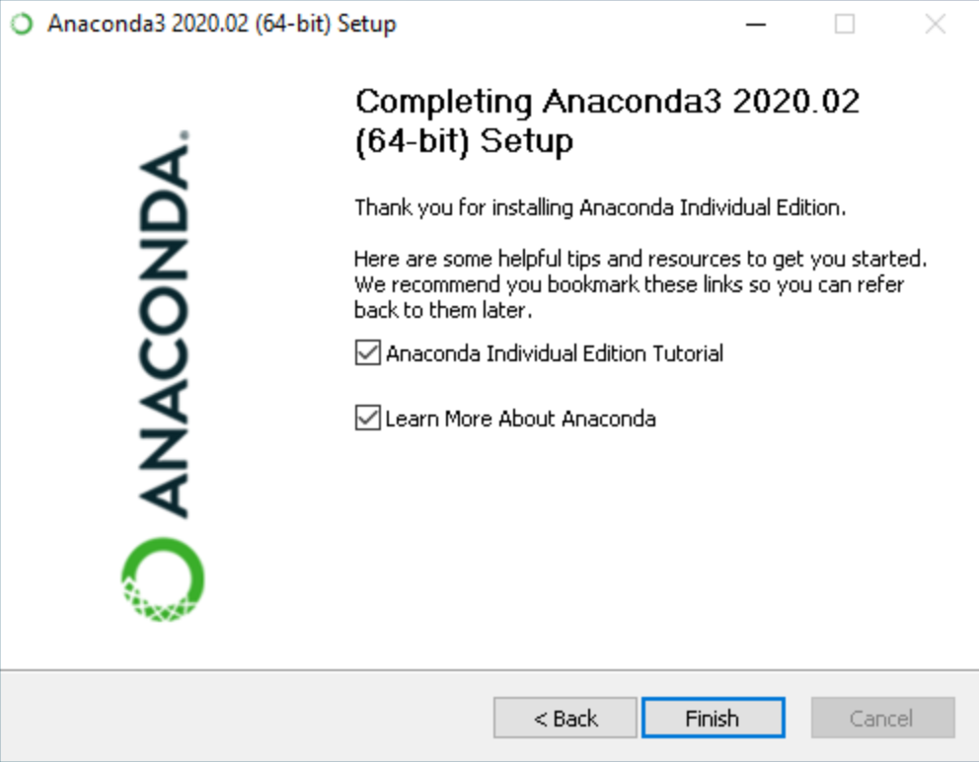
- Download Apache Spark
  - Open a browser and navigate to https://spark.apache.org/downloads.html.
    - Under the Download Apache Spark heading, there are two drop-down menus. Use the current non-preview version.
    - In our case, in Choose a Spark release drop-down menu select 2.4.5 (Feb 05 2020). (or use the latest version of the time).
    - In the second drop-down Choose a package type, leave the selection Pre-built for Apache Hadoop 2.7.
  - Click the spark-2.4.5-bin-hadoop2.7.tgz link. (or the latest version of the time).
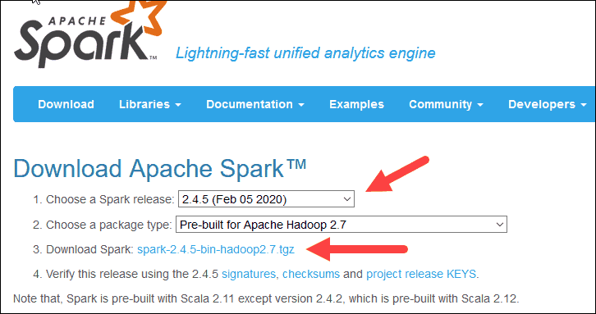
  - A page with a list of mirrors loads where you can see different servers to download from. Pick any from the list and save the file to your Downloads folder.
- Verify Spark Software file
  - Verify the integrity of your download by checking the checksum of the file. This ensures you are working with unaltered, uncorrupted software.
  - Navigate back to the Spark Download page and open the Checksum link, preferably in a new tab.
  - Next, open a command line and enter the following command:
certutil -hashfile c:\users\username\Downloads\spark-2.4.5-bin-hadoop2.7.tgz SHA512
  - Change the username to your username. The system displays a long alphanumeric code, along with the message Certutil: -hashfile completed successfully.
  - Compare the code to the one you opened in a new browser tab. If they match, your download file is uncorrupted.
- Install Apache Spark
  - Installing Apache Spark involves extracting the downloaded file to the desired location. Create a new folder named Spark in the root of your C:\ drive. From a command line, enter the following:
cd \
mkdir Spark
  - In Explorer, locate the Spark file you downloaded.
  - Right-click the file and extract it to C:\Spark using the tool you have on your system (e.g., 7-Zip).
  - Now, your C:\Spark folder has a new folder spark-2.4.5-bin-hadoop2.7 with the necessary files inside.
    - For example, C:\Spark\spark-2.4.5-bin-hadoop2.7.
- Add winutils.exe File
  - Download the winutils.exe file for the underlying Hadoop version for the Spark installation you downloaded.
  - Navigate to this URL https://github.com/cdarlint/winutils and inside the bin folder, locate winutils.exe, and click it.
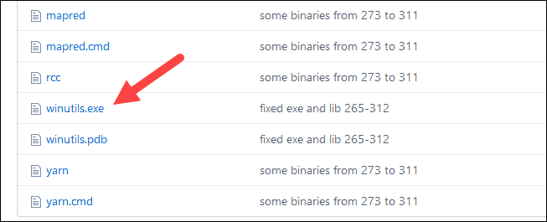
  - Find the Download button on the right side to download the file.
  - Now, create new folders Hadoop and bin on C:\ using Windows Explorer or the Command Prompt.
  - Copy the winutils.exe file from the Downloads folder to C:\hadoop\bin.
    - For example, C:\hadoop\bin\winutils.exe.
- Configure Environment Variables
  - This step adds the Spark and Hadoop locations to your system PATH. It allows you to run the spark-shell directly from a command prompt window.
  - Click Start and type environment.
  - Select the result labelled Edit the system environment variables.
  - A System Properties dialog box appears. In the lower-right corner, click Environment Variables and then click New in the next window.
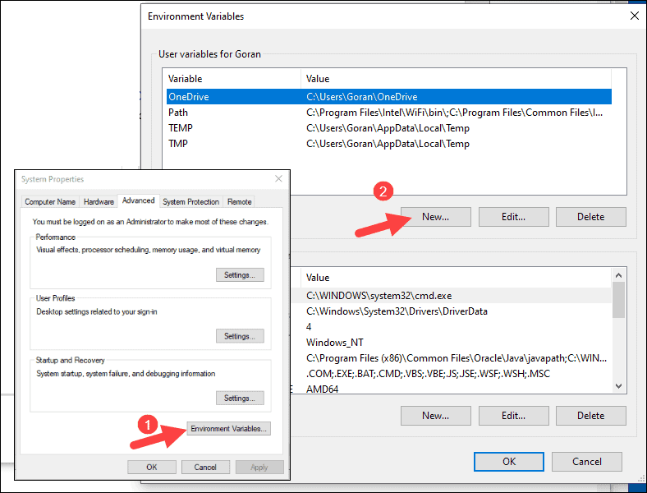
  - For Variable Name type SPARK_HOME.
  - For Variable Value type C:\Spark\spark-2.4.5-bin-hadoop2.7 and click OK. If you changed the folder path, use that one instead.
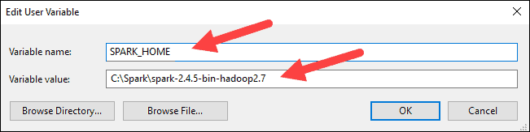
  - In the top box, click the Path entry, then click Edit. Be careful with editing the User Variable path. Avoid deleting any entries already on the list.

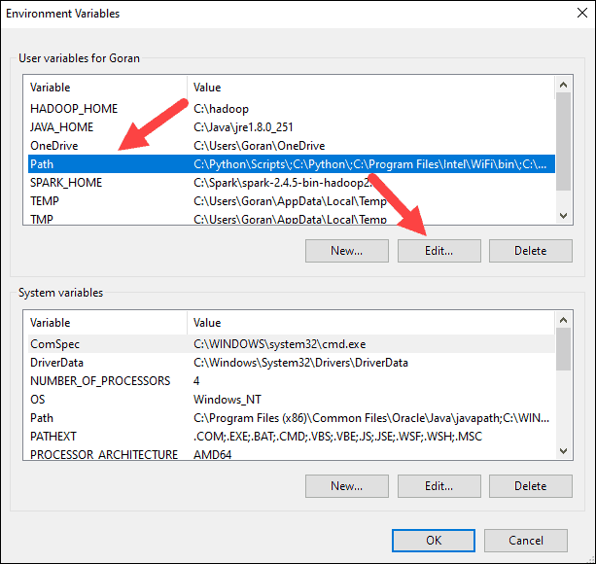
  - You should see a box with entries on the left. On the right, click New.
  - The system highlights a new line. Enter the path to the Spark folder C:\Spark\spark-2.4.5-bin-hadoop2.7\bin. We recommend using %SPARK_HOME%\bin to avoid possible issues with the path.
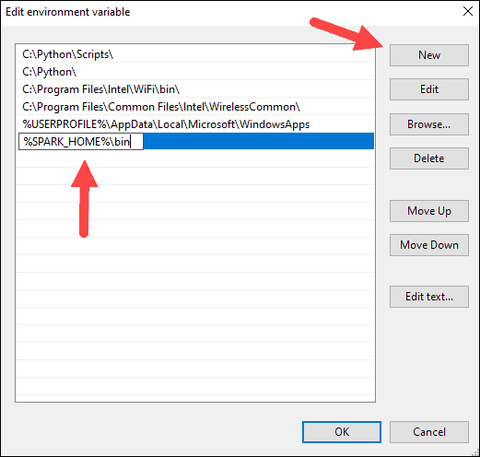
  - Repeat this process for Hadoop and Java.
    - For Hadoop, the variable name is HADOOP_HOME and for the value use the path of the folder you created earlier: C:\hadoop. Add C:\hadoop\bin to the Path variable field, but we recommend using %HADOOP_HOME%\bin.
    - For Java, the variable name is JAVA_HOME and for the value use the path to your Java JDK directory (in our case it is C:\Program Files\Java\jdk1.8.0_251).
  - Click OK to close all open windows.
- Download H2O Sparkling Water
  - We are using the version 3.30.0.1–1–2.4. It is available for download at http://h2o-release.s3.amazonaws.com/sparkling-water/spark-2.4/3.30.0.1-1-2.4/index.html
  - Extract and place the folder in C:\ and rename for convenience.
    - (in our case it is C:\SparklingWater).
- Create new Anaconda Environment
  - Start Anaconda as an administrator and create a new environment.
  - To create a new environment in Anaconda, first launch Anaconda Prompt with base (root) environment.
  - Then execute this command. This creates a new environment in Anaconda with name “h2o”.
conda create -n h2o python=3.6
  - To activate the new environment, enter this command. This activates the h2o environment we created with the first command.
conda activate h2o
  - Execute the following commands to install H2O in the new environment.
pip install h2o==3.30.0.1
  - Once this is successfully run, close all the tabs and launch Jupyter Notebook using jupyter notebook command from the prompt in the new environment.

- Launch H2O Sparkling Water
  - Open the command prompt and navigate to the SparklingWater folder we created in (I).
cd C:\SparklingWater\bin
  - Once in the folder, execute the following command:
pysparkling.cmd
  - This initiates the Spark Session where we can then execute Pyspark code. Leave this terminal running.
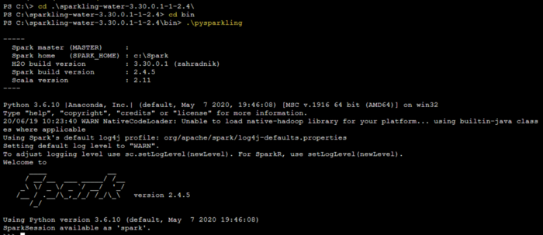
- Execute H2O instances in Jupyter Notebook
  - Open a new notebook in h2o environment.
  - Execute the following commands. This imports H2O and initializes a connection to an H2O instance.
import h2o
from pyspark.sql import Row, SparkSession

h2o.init()

  - This gets an existing SparkSession or, if there is no existing one, creates a new one based on the options set in this builder.
    - You can set a name for the application which will be shown in the Spark web UI.
spark = SparkSession.builder.appName(“SparklingWaterApp”).getOrCreate()
  - The next step is to create our H2O context by executing:
from pysparkling import *
hc = H2OContext.getOrCreate()
  - Screenshot
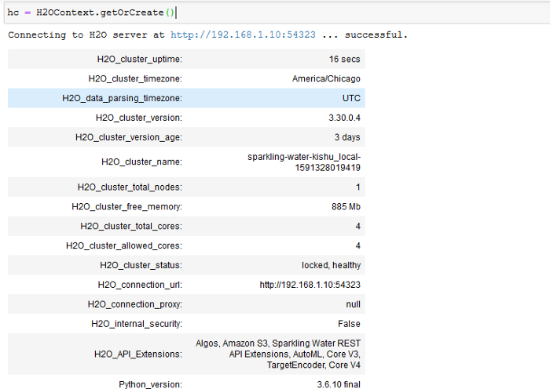
- Troubleshooting
  - Errors while importing Pyspark or Pysparkling
    - Open a new terminal and execute the below commands to install the respective packages.
pip install pyspark==2.4.5
pip install h2o-pysparkling-2.4==3.30.0.4–1

