Apache Spark Installation on Windows
- Requirements
  - A system running Windows 10
  - A user account with administrator privileges (required to install software, modify file permissions, and modify system PATH)
  - Command Prompt or Powershell
  - A tool to extract .tar files, such as 7-Zip
- Install Java 8
  - Open the command line by clicking Start > type cmd > click Command Prompt.
  - Type the following command in the command prompt:
java -version
  - If Java is installed, it will respond with the following output:
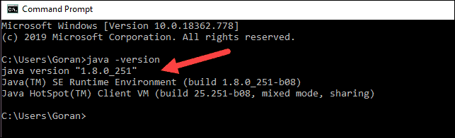
  - Your version may be different. The second digit is the Java version – in this case, Java 8.
    - Other Java version is not compatible with Spark as for the time being.
  - If you don’t have Java installed, open a browser window, and navigate to https://java.com/en/download/.
  - Difference between JDK and JRE
    - The Java Development Kit (JDK) is a software development environment used for developing Java applications and applets.
    - It includes the Java Runtime Environment (JRE), an interpreter/loader (Java), a compiler (javac), an archiver (jar), a documentation generator (Javadoc) and other tools needed in Java development.
    - Java Runtime Environment (JRE) provides the minimum requirements for executing a Java application
    - It consists of the Java Virtual Machine (JVM), core classes, and supporting files.
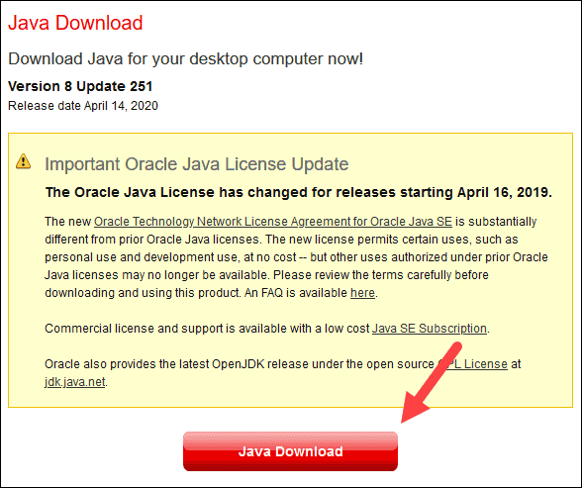
  - Click the Java Download button and save the file to a location of your choice.
  - Once the download finishes double-click the file to install Java.
- Install Python
  - To install the Python package manager, navigate to https://www.python.org/ in your web browser.
  - Mouse over the Download menu option and click Python 3.8.3. 3.8.3 is the latest version at the time of writing the article.
  - Once the download finishes, run the file.
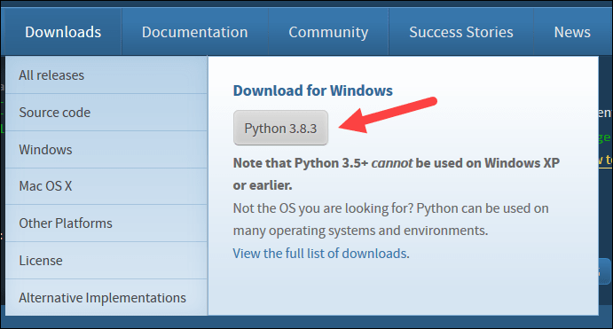
  - Near the bottom of the first setup dialog box, check off Add Python 3.8 to PATH. Leave the other box checked.
  - Next, click Customize installation.
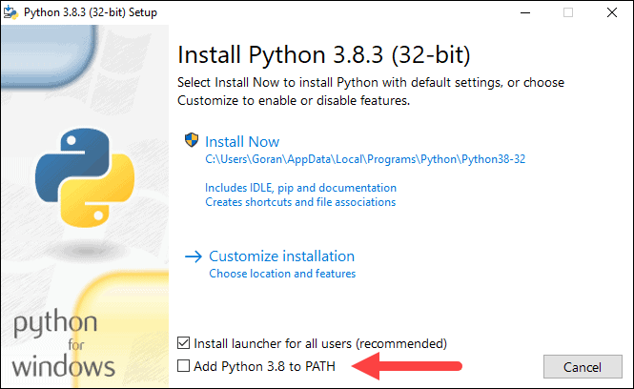
  - You can leave all boxes checked at this step, or you can uncheck the options you do not want.
  - Click Next.
  - Select the box Install for all users and leave other boxes as they are.
  - Under Customize install location, click Browse and navigate to the C drive. Add a new folder and name it as Python.
  - Select that folder and click OK.
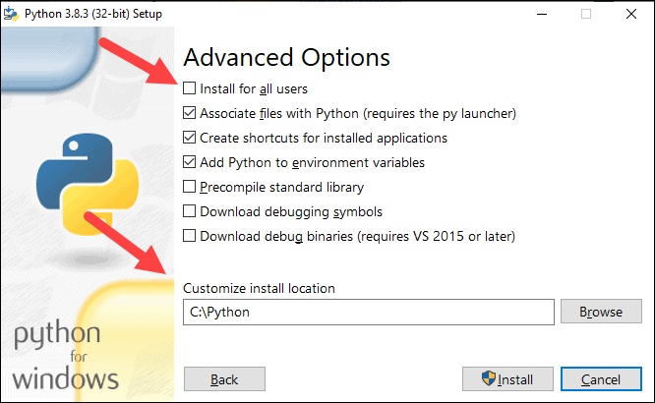
  - Click Install and let the installation complete.
  - When the installation completes, click the Disable path length limit option at the bottom and then click Close.
  - If you have a command prompt open, restart it. Verify the installation by checking the version of Python:
python –-version
The output should print Python 3.8.3.
- Download Apache Spark
  - Open a browser and navigate to https://spark.apache.org/downloads.html.
    - Under the Download Apache Spark heading, there are two drop-down menus. Use the current non-preview version.
    - In our case, in Choose a Spark release drop-down menu select 2.4.5 (Feb 05 2020). (or use the latest version of the time).
    - In the second drop-down Choose a package type, leave the selection Pre-built for Apache Hadoop 2.7.
  - Click the spark-2.4.5-bin-hadoop2.7.tgz link. (or the latest version of the time).
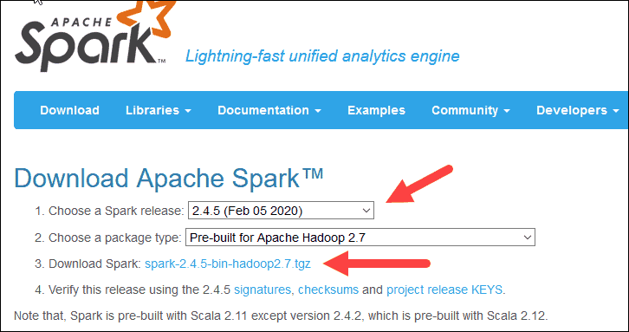
  - A page with a list of mirrors loads where you can see different servers to download from. Pick any from the list and save the file to your Downloads folder.
- Verify Spark Software file
  - Verify the integrity of your download by checking the checksum of the file. This ensures you are working with unaltered, uncorrupted software.
  - Navigate back to the Spark Download page and open the Checksum link, preferably in a new tab.
  - Next, open a command line and enter the following command:
certutil -hashfile c:\users\username\Downloads\spark-2.4.5-bin-hadoop2.7.tgz SHA512
  - Change the username to your username. The system displays a long alphanumeric code, along with the message Certutil: -hashfile completed successfully.
  - Compare the code to the one you opened in a new browser tab. If they match, your download file is uncorrupted.
- Install Apache Spark
  - Installing Apache Spark involves extracting the downloaded file to the desired location. Create a new folder named Spark in the root of your C:\ drive. From a command line, enter the following:
cd \
mkdir Spark
  - In Explorer, locate the Spark file you downloaded.
  - Right-click the file and extract it to C:\Spark using the tool you have on your system (e.g., 7-Zip).
  - Now, your C:\Spark folder has a new folder spark-2.4.5-bin-hadoop2.7 with the necessary files inside.
    - For example, C:\Spark\spark-2.4.5-bin-hadoop2.7.
- Add winutils.exe File
  - Download the winutils.exe file for the underlying Hadoop version for the Spark installation you downloaded.
  - Navigate to this URL https://github.com/cdarlint/winutils and inside the bin folder, locate winutils.exe, and click it.
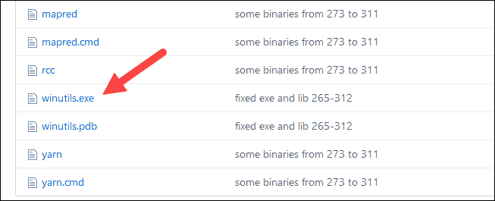
  - Find the Download button on the right side to download the file.
  - Now, create new folders Hadoop and bin on C:\ using Windows Explorer or the Command Prompt.
  - Copy the winutils.exe file from the Downloads folder to C:\hadoop\bin.
    - For example, C:\hadoop\bin\winutils.exe.
- Configure Environment Variables
  - This step adds the Spark and Hadoop locations to your system PATH. It allows you to run the spark-shell directly from a command prompt window.
  - Click Start and type environment.
  - Select the result labelled Edit the system environment variables.
  - A System Properties dialog box appears. In the lower-right corner, click Environment Variables and then click New in the next window.
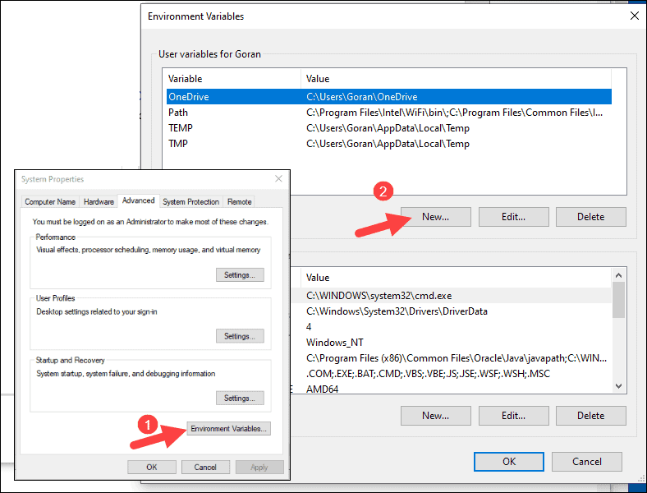
  - For Variable Name type SPARK_HOME.
  - For Variable Value type C:\Spark\spark-2.4.5-bin-hadoop2.7 and click OK. If you changed the folder path, use that one instead.
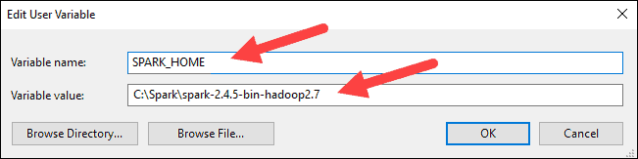
  - In the top box, click the Path entry, then click Edit. Be careful with editing the User Variable path. Avoid deleting any entries already on the list.

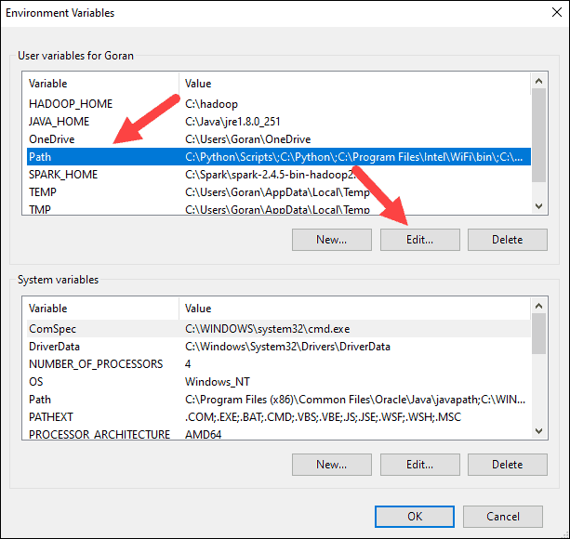
  - You should see a box with entries on the left. On the right, click New.
  - The system highlights a new line. Enter the path to the Spark folder C:\Spark\spark-2.4.5-bin-hadoop2.7\bin. We recommend using %SPARK_HOME%\bin to avoid possible issues with the path.
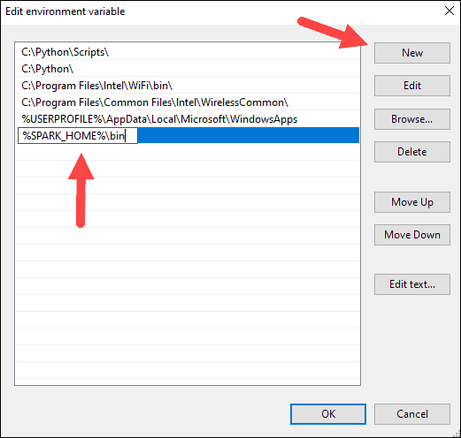
  - Repeat this process for Hadoop and Java.
    - For Hadoop, the variable name is HADOOP_HOME and for the value use the path of the folder you created earlier: C:\hadoop. Add C:\hadoop\bin to the Path variable field, but we recommend using %HADOOP_HOME%\bin.
    - For Java, the variable name is JAVA_HOME and for the value use the path to your Java JDK directory (in our case it is C:\Program Files\Java\jdk1.8.0_251).
  - Click OK to close all open windows.
- Launch Spark
  - Open a new command-prompt window using the right-click and Run as administrator then type this command:
C:\Spark\spark-2.4.5-bin-hadoop2.7\bin\spark-shell
If you set the environment path correctly, you can type spark-shell to launch Spark.
  - The system should display several lines indicating the status of the application. You may get a Java pop-up. Select Allow access to continue.
  - Finally, the Spark logo appears, and the prompt displays the Scala shell.
  - Open a web browser and navigate to http://localhost:4040/.
    - You can replace localhost with the name of your system.
  - You should see an Apache Spark shell Web UI. The example below shows the Executors page.
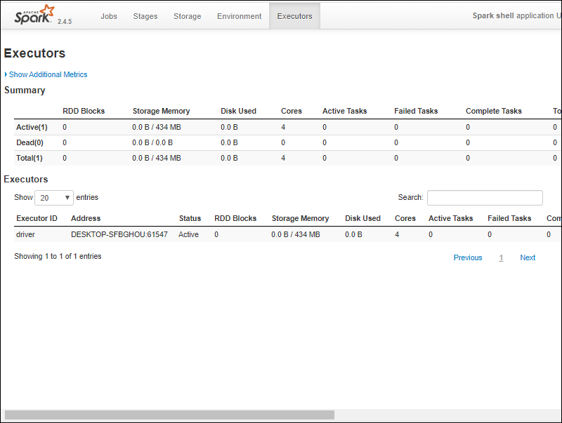
  - To exit Spark and close the Scala shell, press ctrl-d in the command-prompt window.
  - If you installed Python, you can run Spark using Python with this command:
pyspark
Exit using quit().
- Test Spark
  - In this example, we will launch the Spark shell and use Scala to read the contents of a file. You can use an existing file, such as the README file in the Spark directory, or you can create your own. We created pnaptest with some text.
  - Open a command-prompt window and navigate to the folder with the file you want to use and launch the Spark shell.
  - First, state a variable to use in the Spark context with the name of the file. Remember to add the file extension if there is any.
val x =sc.textFile("pnaptest")
  - The output shows an RDD is created. Then, we can view the file contents by using this command to call an action:
x.take(11).foreach(println)
  - Screenshot
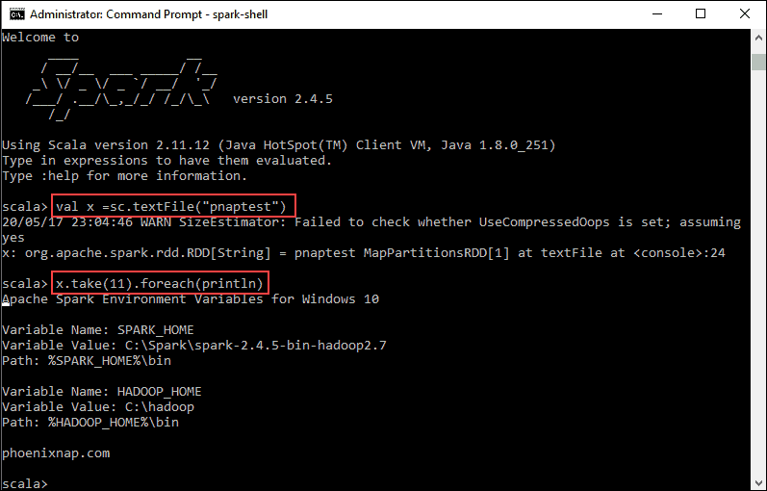
  - This command instructs Spark to print 11 lines from the file you specified. To perform an action on this file (value x), add another value y, and do a map transformation.
  - For example, you can print the characters in reverse with this command:
val y = x.map(_.reverse)
  - The system creates a child RDD in relation to the first one. Then, specify how many lines you want to print from the value y:
y.take(11).foreach(println)
  - Screenshot
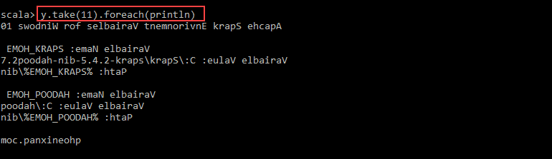
  - The output prints 11 lines of the pnaptest file in the reverse order.
  - When done, exit the shell using ctrl-d.

