

THE ENHANCED CONTRIBUTORS REGISTRATION SYSTEM

User Manual and Guide

THE ENHANCED CONTRIBUTORS REGISTRATION SYSTEM

User Manual and Guide

© 2019 Information Communication Technology Department, National Pension Commission (PenCom). All rights reserved.

No part of this publication may be reproduced, transmitted, transcribed, stored in a retrieval system, or translated into any language, in any form or by any means, electronic, mechanical, photocopying, recording, or otherwise, without prior written permission from PenCom.

All copyright, confidential information, patents, design rights and all other intellectual property rights of whatsoever nature contained herein are and shall remain the sole and exclusive property of PenCom. The information furnished herein is believed to be accurate and reliable.

However, no responsibility is assumed by PenCom for its use, or for any infringements of patents

or other rights of third parties resulting from its use.

The name and the logo are trademarks or registered trademarks of PenCom

All other trademarks are the property of the respective owners.

Table of Contents

Contents

**Document Control** ii

*Document Issue Control* ii

*Revision History* ii

Introduction 1

How to use the manual 1

Getting Started 7

To start the application 7

How do I log out or sign out of the application? 8

The Application Workspace 10

Application’s interface 10

Chapter

1

# Introduction

This manual is aimed at giving the user sufficient information on how to use the Enhanced Contributor Registration System. The manual was created to be used as guide on how to carry out key activities on the application.

## **How to use the manual**

The manual may be used as a reference, for users with concerns in specific (modules) topics; reference can be made to the table of contents or Index and directly to the topic page subsequently.

Key areas will be specified in bold to emphasize their importance. They will appear in an easy-to-follow bold text, for example “Export as CSV” will appear as “**Export as CSV**”.

When a key combination is described for example Press ‘**Alt+A’**, this means the user should hold down the keyboard’s Control ‘**Alt’** key found on either side of the keyboard, while pressing the keyboard’s ‘**A**’ key.

Websites/links will be represented in the format of the example below:

<http://pencom.gov.ng>

* **To click**: users should tap the left mouse button. Quickly touching and releasing your finger on the left mouse button.
* **To double-click**: users should tap twice the left mouse button. Two taps in rapid succession does the trick.
* **To right-click:** the user should tap the right mouse button. Quickly touching and releasing your finger on the right mouse button.

Chapter

2

# Getting Started

## To start the application

To launch the Enhanced Contributors Registration System, open the web browser



You will find the icon on your desktop or under the **start** button or shortcut on your desktop.

Enter the URL of the application <http://ecrs.pencom.gov.ng/ecrs> into the address bar of the web browser and press the **ENTER** key to redirect to the application. You will be redirected to the Login page of the application.

A Client side application is also for client side validation at the Operators side. PFAs shall download the software from the Application server and each PFA downloads a unique thin client application restricted to its PFA code. Some validation will take place at the PFA Client Side application (ECRS Data Preparation Tool). The Tool will compress data before submitting to PenCom.

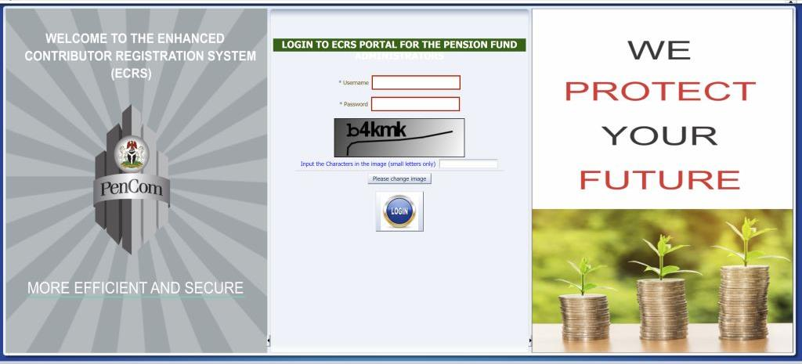

* Users should key in their username followed by the password and click on the **Enter** button. The assigned ECRS application login details should be used.
* After successful logon, the application will open as in the diagram below.

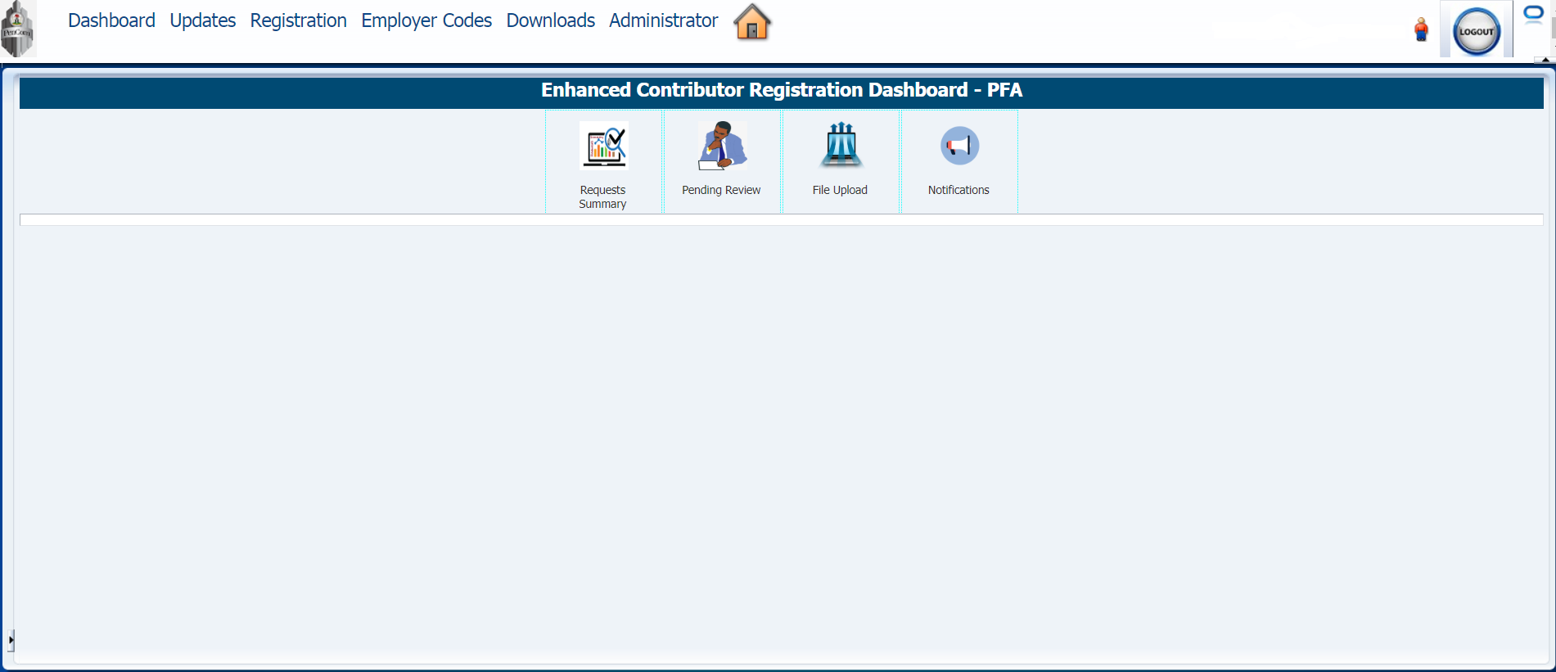

## **How do I log out or sign out of the application?**

Once you have logged-in successfully, on the far right side of the header is the logout button as shown below;

Dasshboard

* Click on the logout button and the application will automatically close your session and take you to the login screen again.
* At this point, you have successfully logged out of the application. You can close the browser window.

**Change of Password**

For password change/reset, the Operator can reset their existing password under the Administrator menu or upon its expiry send a password request via the support email stating reasons for the change/reset.

Chapter

3

# The Application Workspace

## **Application’s interface**

The ECRS is a modular application and is divided into modules. The modules are further classified into User Interface (UI) based modules and the Non-User Interface (UI) based modules.

[

The user interface based modules are the visual modules through which users interact or relate with the application while the non-user interface modules are the processes that run in the backend.

The ECRS will register and maintain pension contributors in formal and informal sectors with National Identification Number (NIN) as unique identifier.

The ECRS would also be able to accept recaptured existing contributors’ biodata and biometrics (Photo & Signature) to ensure uniqueness of each contributor. It will also have the capability of interfacing with other relevant Applications in the Commission such as Risk Management & Analysis System (RMAS).

[

A web service from NIMC shall be consumed for National Identification Number (NIN) verification and verified data shall be used for Business rule validations on the ECRS.

The section below describes the features of the application interface.

1. **DASHBOARD**

One of the major credits of the ECRS is the availability of a Dashboard for PFAs to view status of their requests and summary reports. The Dashboard is role based; logged in user sees only what he/she is authorised to see.

**Request Processing Summary**

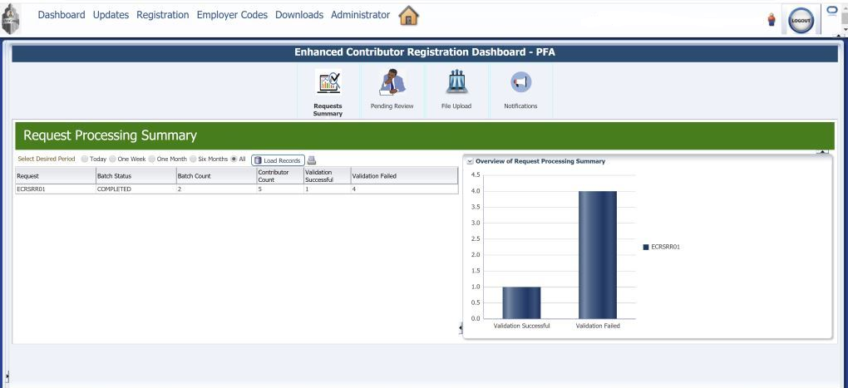

This feature presents a summary of the PFAs request indicating the request ID, batch status, batch count, total contributor count in request, success or failure rate and can be filtered into the desired period (daily, weekly or monthly). It also has a chart for a pictorial overview of the summary.

**Pending Review**

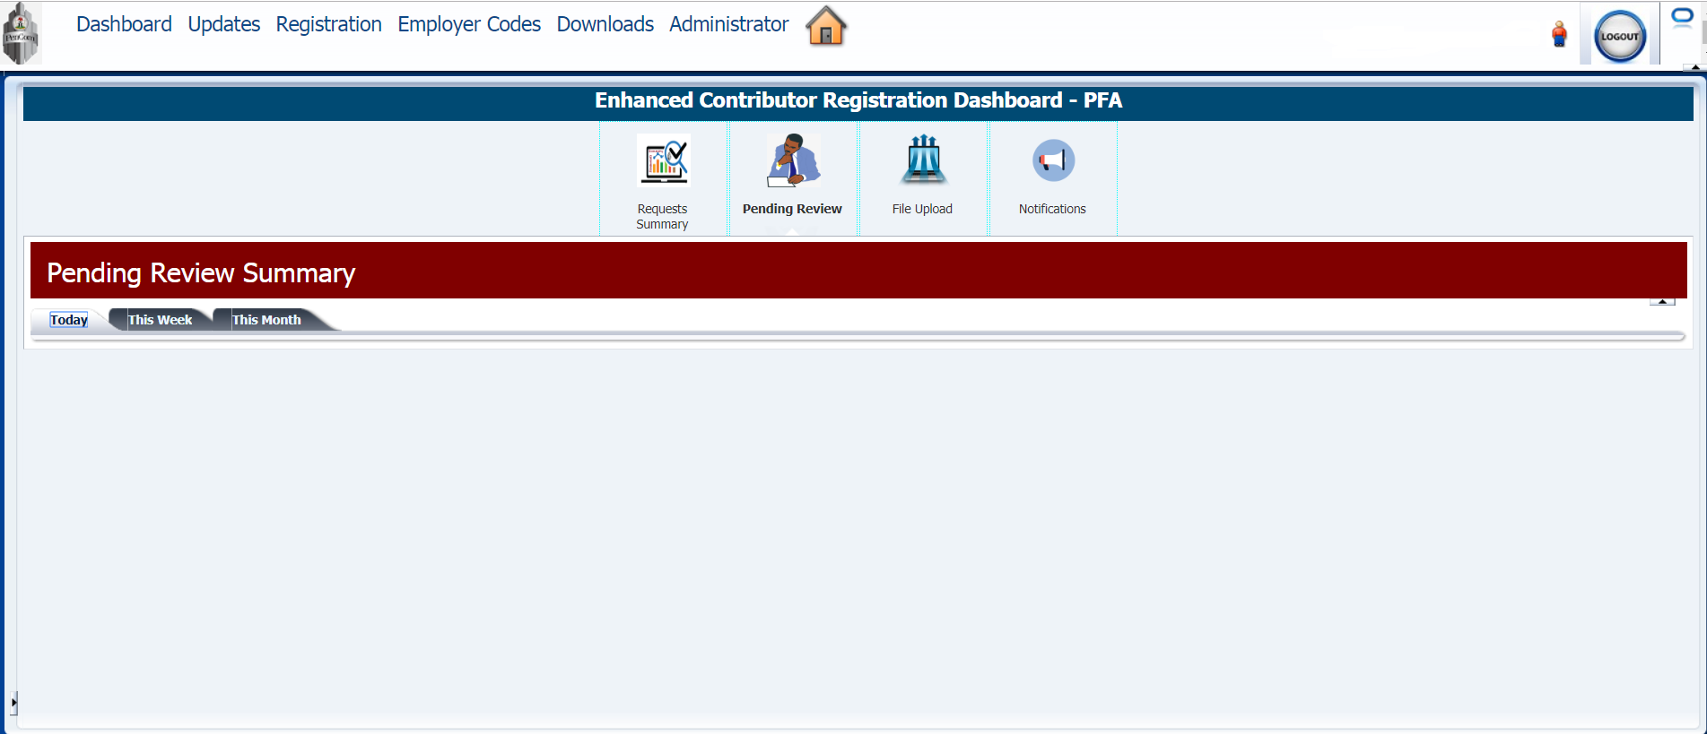

This feature presents a summary of the outstanding request that may require manual intervention by PenCom and can be filtered into the desired period (daily, weekly or monthly).

**File Upload**

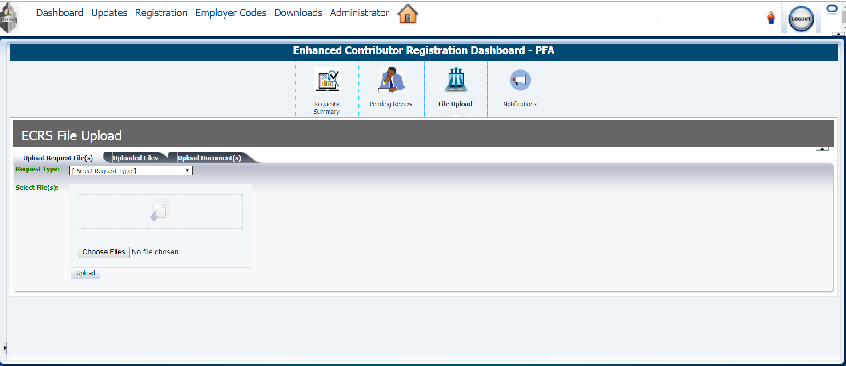

This is where web upload occurs by validating the XML for structure using the corresponding XML Schema Definition (XSD) depending on the request types; Completeness; correctness and some business rules. After the validation, a compressed jar file is produced which the PFA would upload to PenCom via the User Interface to obtain PIN.

The jar file has a naming file convention starting with PFA code followed by date and time stamp. The PFA can also view its status of submissions on the Dashboard.

**Notifications**

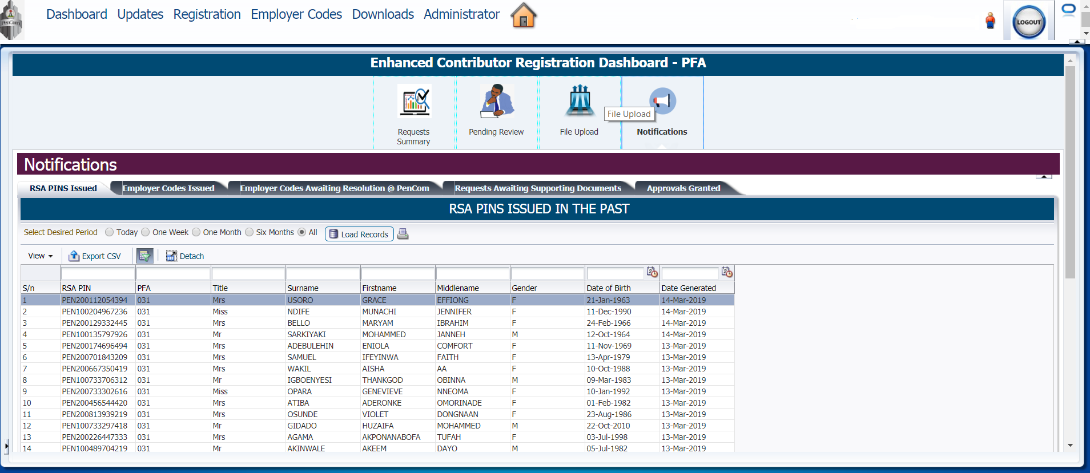

This feature displays without any form of query a holistic and real time representation of the PFAs request such as:

RSA PINs issued (specific to the logged PFA)

Employer codes issued

Employer codes request awaiting resolution at PenCom (specific to the logged PFA)

Requests awaiting supporting documents (specific to the logged PFA)

Approvals granted (specific to the logged PFA)

These representation can be filtered into desired periods (daily, weekly or monthly).

1. **UPDATES**

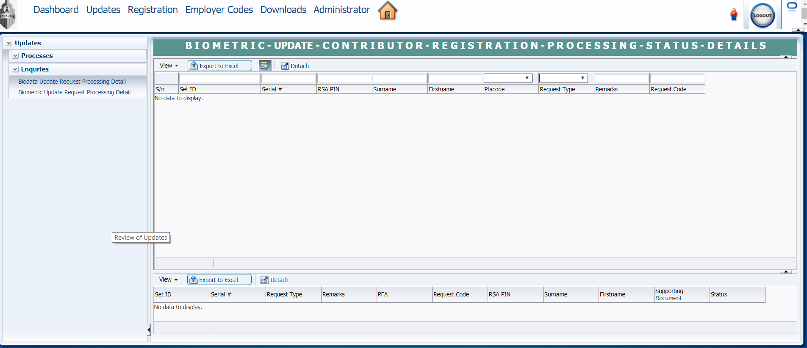

The Enquiries module has the functionalities of querying the ECRS for the following;

1. Updates of biodata request processing detail
2. Update of biometric request processing detail.
3. **REGISTRATION**

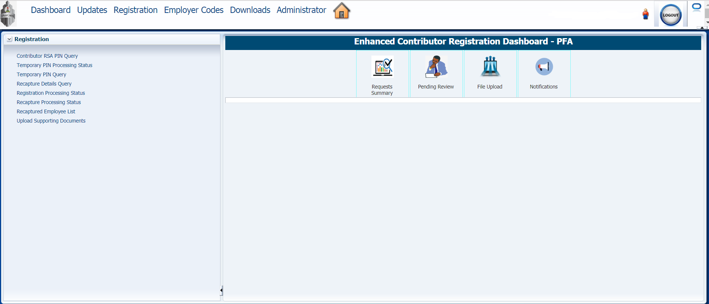

The registration module is further broken down into eight sub-modules as shown below;

**Contributor RSA PIN Query**This sub-module handles queries for RSA details. To query the Application for the details of an RSA, the user is to input data into the requested fields and click the search button. The search can be for single or bulk RSAs. The user can also expand the number of fields of data to be spooled out for the request.

##### **Temporary PIN Processing Status**This provides the status of the request for issuance of Temporary PINs for Employer Initiated registrations.

##### **Temporary PIN Query**

##### This queries the application for the Temporary PIN RSA details. To query the Application for the details of the Temporary RSA, the user is to input Temporary RSA PIN and hit the search button. The search can be for single or bulk RSAs. From the “Advanced” function, the user can also expand the number of fields of data to be spooled out for the query.

##### **Recapture Details Query**

##### This feature queries the Application for the Recaptured data of an RSA PIN. The data returned from the query can be saved.

##### **Registration Processing Status**

##### This feature displays a report showing the processing status of a registration request indicating the set ID, brief remark, PFA code, filename, processing status (failed, successful or pending), submission date, processing start and finish times.

##### **Recapture Processing Status**

##### This feature displays a report showing the processing status of a recapture request indicating the set ID, brief remark, PFA code, filename, processing status (failed, successful or pending), submission date, processing start and finish times.

##### **Recaptured Employee List**

##### This gives a view of the recaptured employees indicating their RSA PIN, Employer name Date of birth, Phone number, Employer and PFA. The view menu at the top right hand of this interface allows the user to; select the columns required, sort the columns and reorder the columns.

##### **Upload Supporting Documents**

##### Upload of supporting documents for the registration requests occurs here, the supporting documents to be uploaded must be in PDF format.

1. **EMPLOYER CODES**

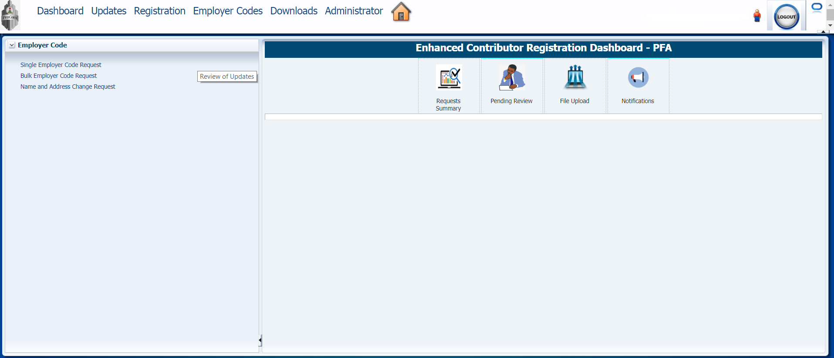

##### This module handles the request for Employer codes and the request can be single or bulk.

##### The single request entails the user filling out the required fields and uploading the supporting documents in PDF format.

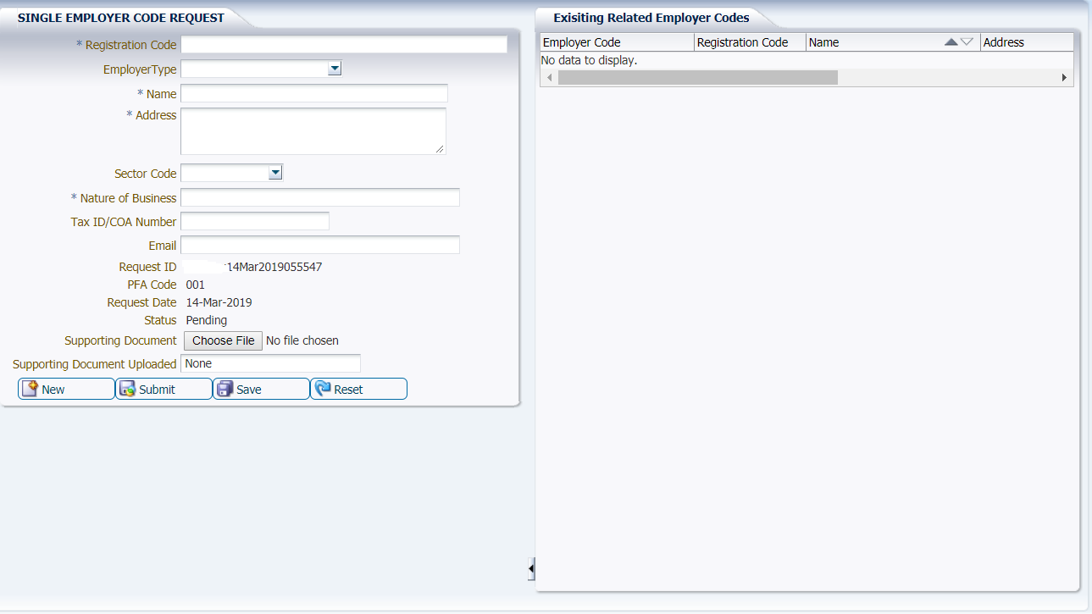

##### The bulk request entails uploading a CSV file containing multiple employer code requests alongside the supporting documents in PDF format.

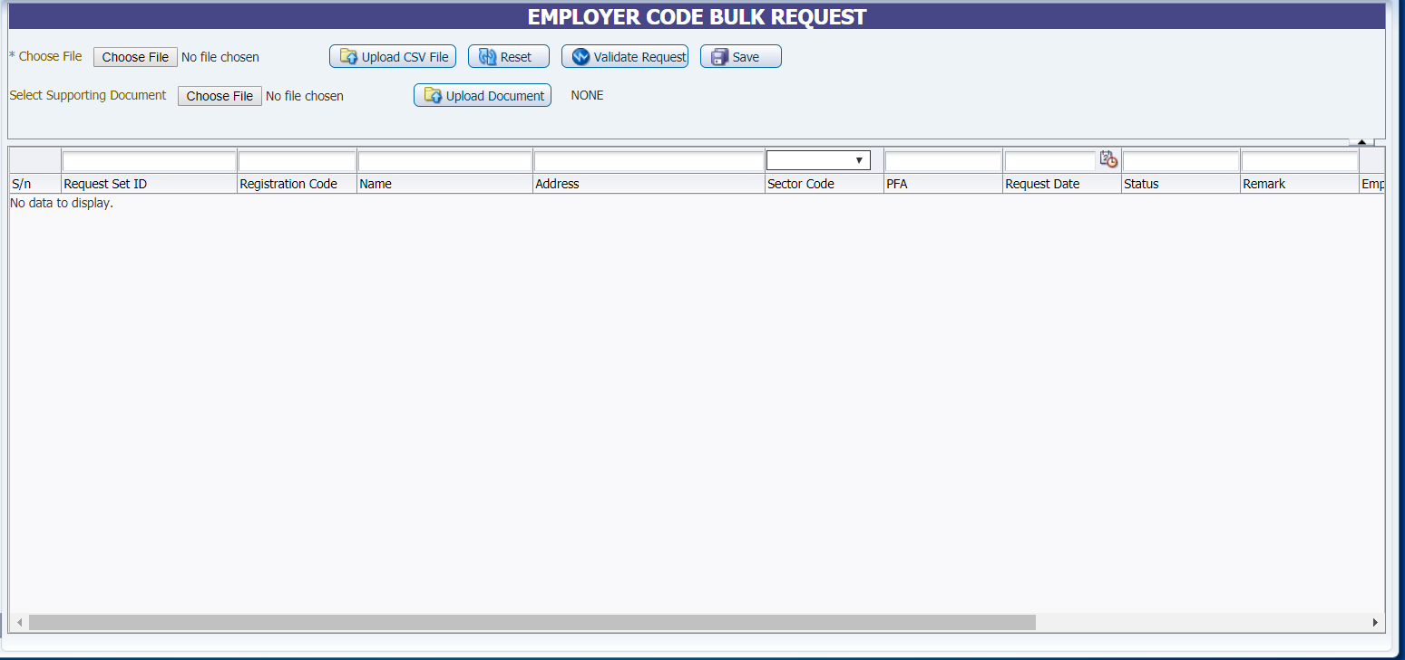

##### This module also handles updates such as name and address change for already generated employer codes.

1. **DOWNLOADS**

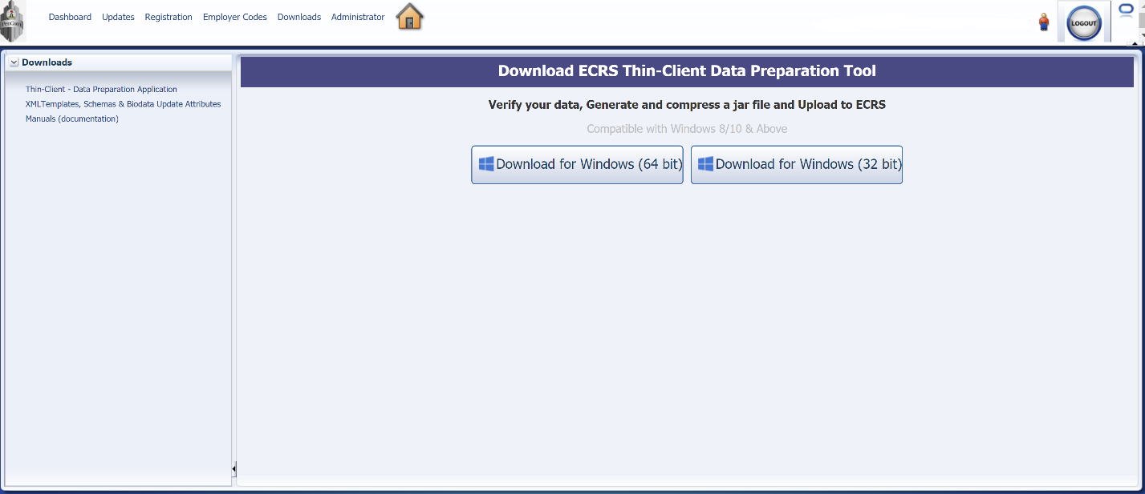

##### The downloads module houses the ECRS data preparation tool, XML Templates and Manuals. The data preparation tool can be downloaded for either Windows 32bit of 64bit. The data preparation tool is a Client side application would for client side validation at the Operators side. PFAs shall download the software from this module and each PFA downloads a unique client application restricted to its PFA code. Some validation will take place at the PFA Client Side application (ECRS Data Preparation Tool). The Tool will compress data before submitting to PenCom.

##### Full business rules validation shall take place at the Server in PenCom.

1. **ADMINISTRATION**

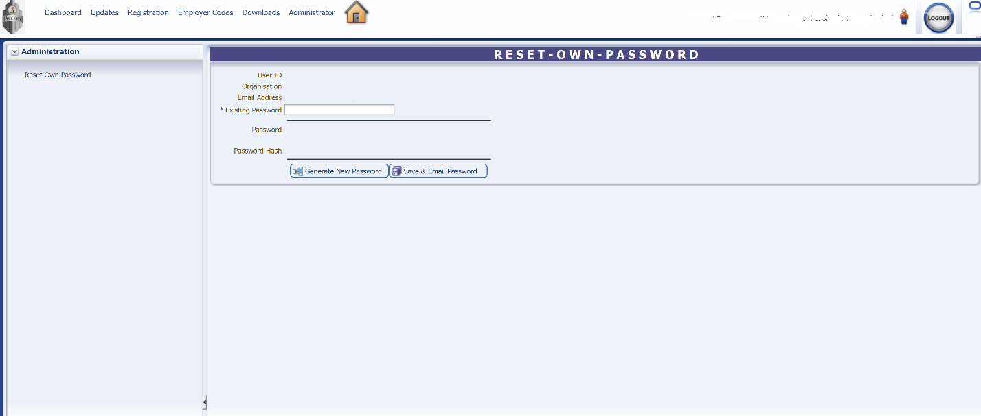

##### Password reset is carried out in this Administration module.