Software Requirements Specification
for
Online Belote Game
Version 1.0 approved
Prepared by
Borislav Hristov
Anelia Chervenska
23.08.2015
Table of Contents
Table of Contents ii
Revision History ii
1. Introduction 1
1.1 Purpose 1
1.2 Intended Audience and Reading Suggestions 1
1.3 Product Scope 1
2. Overall Description 2
2.1 System Environment 2
2.2 Product Functions 3
2.2.1 Use Case: Login 3
2.2.2 Use Case: Registration 3
2.2.3 Use Case: Home Page 4
2.2.4 Use Case: Profile Menu 4
2.2.5 Use Case: Games Lobby 5
2.2.6 Use Case: Create Game 5
2.2.7 Use Case: In Game 6
2.2.8 Use Case: Rating 6
2.2.9 Use Case: Store 7
3. External Interface Requirements 8
3.1 User Interfaces 8
3.1.1 Help Button 8
3.1.2 Date and Time 8
3.1.3 Wrong Input 8
3.1.4 Lose Game 9
3.1.5 Win Game 9

Introduction

Purpose
The purpose of this document is to present a detailed description of the Online Platform for the game “Belote”. It will explain the purpose and features of the system, the interfaces of the system, what the system will do, the constraints under which it must operate and how the system will react to external actions. This document is intended for both the stakeholders and the developers of the system.

Intended Audience and Reading Suggestions
The software requirement specification is intended for developers, project managers, marketing staff, users, testers and documentation writers.

Product Scope
Bridge-belote or belote in short is a popular card game. Belote is played by four people (2 teams consisting of 2 players) with a deck of 32 cards (from 7 till 10 and a jack, a queen, a king and an ace). According to the terminology, the word belote is used to describe a pair of king and queen of the same color. In the deck of 32 cards there are 4 colors with 8 cards each, and the cards are not shuffled while dealing, they are only split before each deal. The deal is done in counterclockwise direction. Four players participate in the game, divided in two teams, and play in a certain order.
The purpose of this project is to give to all the fans of this game, the opportunity to be able to play this game with people from all around the world, to communicate with other fans, make rating and reputation with their victories, upgrade their accounts buying different cards design and different backgrounds for playing tables.

Overall Description

System Environment 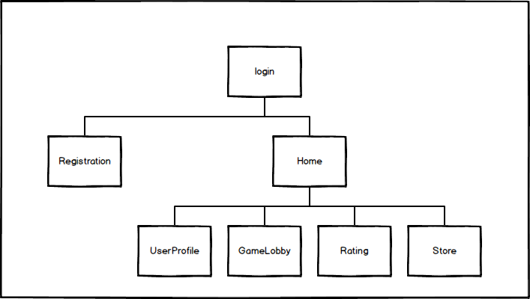
The users will have access to the site through the Internet. They will have to make a registration to be able to see information about the active games and other users. The site will have 7 active pages in its first release. The Login page and Registration page will be visible to everyone. Home page, UserProfile page, GameLobby page, Rating page and Store page will be visible only for logged users. In future releases will be added new pages to the Store.

Product Functions
This section outlines the use cases for each step the users will go through.

Use case: Login
Diagram:
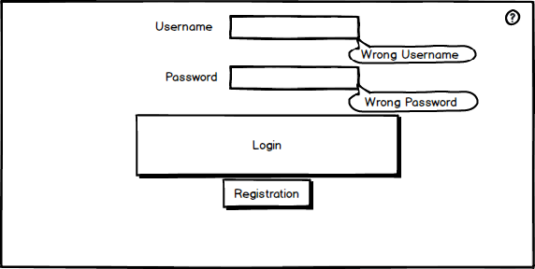
Brief Description
The login page gives users the option to log in or make a new registration. If the input is wrong, a tool tip shows up.
Initial Step-By-Step Description
- Input Username.
- Input Password.
- Click Login button.

Use case: Registration
Diagram:
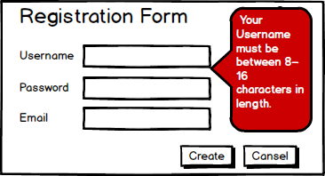
Brief Description
The registration page gives users the option to make a new account. If the input don’t answer the requirements a message is shown with the requirements.
Initial Step-By-Step Description
1. Input Username.
2. Input Password.
3. Input Email.
4. Click Create button.

Use case: Home Page
Diagram:
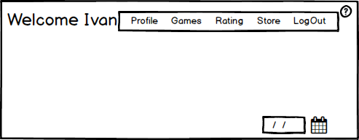
Brief Description
After successful login the user is sent to the Home page. From here he can navigate to all other pages in the site.
Initial Step-By-Step Description
1. Click Profile.
2. Click Games.
3. Click Rating.
4. Click Store.

Use case: Profile Menu
Diagram:
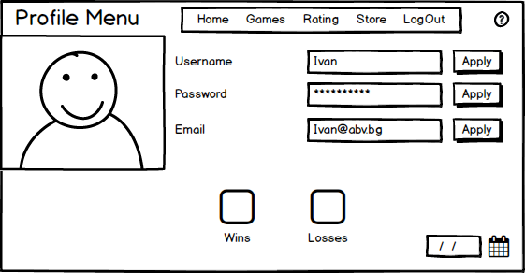
Brief Description
In the Profile page the user can see and change all the information for his account: Username, Password, Email Address, Avatar (from the next release), wins and losses.

Initial Step-By-Step Description

1. Insert new Username.
2. Click Apply.

Use case: Games Lobby
Diagram:
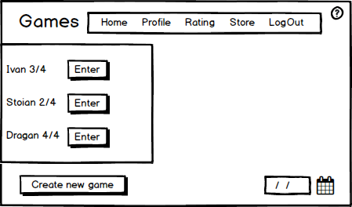
Brief Description
In the Games page the user can choose from different already created games or to make a new one. When click “Create a new game”, a new window appears.
Initial Step-By-Step Description
1. Choose game.
2. Click Enter.
3. Click Create New Game.

Use case: Creating a new game
Diagram:
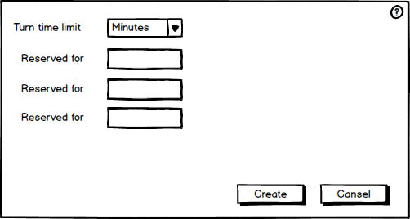
Brief Description
In the Creating new game window the user can choose the maximum time for each turn and to reserve slots for special users.
Initial Step-By-Step Description
1. Choose from the drop down menu.
2. Insert some Username.
3. Click Create.

Use case: In game
Diagram:
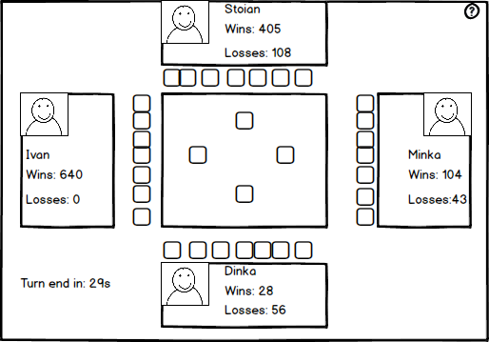
Brief Description
After entering a game a new window appears showing the four players, their stats, the game table and the cards for the respective player.
Initial Step-By-Step Description
1. Enter a game.
2. Choose a card.
3. Click twice on the card.

Use case: Rating
Diagram:
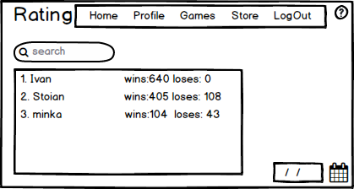
Brief Description
In the Rating page the user can see the stats for all registered players, or to search by username for a special one.
Initial Step-By-Step Description
1. Open Rating page.
2. Insert some Username.
3. Press Enter.

Use case: Store
Diagram:
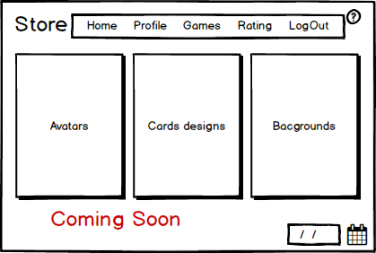
Brief Description
In the Store page users will be able to buy different upgrades for their games and profiles in the next releases.
Initial Step-By-Step Description
1. Enter the shop.
2. Choose some category.

External Interface Requirements

User Interfaces
3.1.1
On each page there will be a help button. After click on it, a message shows up with information about the current page.

Diagram:

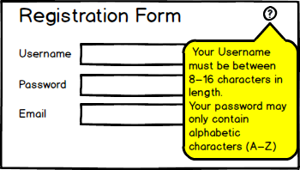

3.1.2
On each page after login into the system there will be information about the current date and time in the bottom right.

3.1.3
If the user try to enter a full game a message appears.
Diagram:
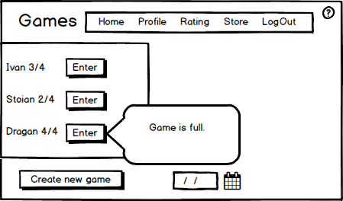

3.1.4
If the player lose or the turn time is over before you click any card twice the game ends and a message appears.
Diagram:


3.1.5
If the player wins a message appears.
Diagram:


