**NOISE POLLUTION MONITORING**

**Project Objectives:**

1. Noise Pollution Assessment: The primary objective of the Noise Pollution Monitoring project is to assess and monitor noise pollution levels in a specific area or region. This assessment will help in understanding the extent and severity of noise pollution and its potential impact on the environment and human health.

2. Data Collection: To collect comprehensive data on noise levels, sources of noise, and temporal patterns. This data will serve as the foundation for subsequent analysis and decision-making.

3. Real-time Monitoring: Implement a real-time noise monitoring system to continuously record noise levels, enabling immediate responses to noise incidents and effective management of noise pollution.

4. Noise Source Identification: Identify and categorize the sources of noise pollution in the monitored area. This information is crucial for designing targeted noise reduction strategies.

5. Compliance Monitoring: Ensure that noise pollution levels comply with local regulations and standards. When violations occur, prompt action can be taken to rectify the situation.

6. Public Awareness: Raise awareness among the community and stakeholders about the noise pollution issue, its impact, and the importance of sound management practices.

7. Submission of Results: Compile all project documentation, including reports, data, and recommendations, for submission to relevant authorities, community organizations, and other stakeholders.

**IoT Sensor Deployment:**

In order to successfully monitor noise pollution in a given area, the deployment of IoT (Internet of Things) sensors is crucial. These sensors enable real-time data collection, analysis, and reporting. Here's an overview of the key steps involved in deploying IoT sensors for noise pollution monitoring: Sensor Selection: Choose appropriate noise sensors with the ability to measure sound levels in decibels (dB). Consider factors like sensor accuracy, sensitivity, and durability. Ensure compatibility with IoT communication protocols (e.g., Wi-Fi, LoRa, Sigfox). Sensor Placement: Identify strategic locations for sensor deployment. Consider factors such as proximity to noise sources, accessibility, and coverage area. Mount sensors at a suitable height to avoid interference and vandalism. Power Supply: Ensure a reliable power source for the sensors. Options include battery-powered sensors, solar panels, or a wired power connection. Data Communication: Implement a communication infrastructure to transmit sensor data to a central server or cloud platform. Use IoT protocols and technologies for data transmission, such as MQTT, HTTP, or CoAP. Data Storage and Processing: Set up a cloud-based or on-premises data storage and processing system. Process and store data securely, ensuring it's readily accessible for analysis and reporting.

**Platform & App Development:**

The Noise Pollution Monitoring App is a cutting-edge application designed to address the growing concerns surrounding noise pollution in urban environments. This app serves as a valuable tool for both citizens and city officials, enabling them to track and manage noise levels effectively. The app utilizes the built-in microphone of a user's smartphone to constantly measure the ambient noise in real-time, providing instant feedback on noise levels in decibels (dB). Users can view noise data on a user-friendly interface, which includes maps with color-coded areas indicating noise hotspots. Additionally, the app offers features like historical noise data tracking, allowing users to identify trends and patterns over time. City authorities can access a centralized database of noise measurements, helping them pinpoint areas with persistent noise issues and take necessary steps to mitigate them. With the Noise Pollution Monitoring App, citizens can raise awareness about noise pollution, and municipalities can make informed decisions to create quieter and healthier urban environments.

Python played a pivotal role in the development of our Noise Monitoring App, offering versatility and efficiency at every stage. We harnessed Python to interface with noise sensors and IoT devices, enabling real-time data collection. Python's rich ecosystem of data analysis libraries facilitated data processing and the identification of noise patterns, while Matplotlib and Plotly empowered us to create interactive, visually appealing data visualizations. For server-side development, Python web frameworks like Django provided a robust foundation, and for cross-platform mobile support, we utilized Kivy. Python's seamless integration with cloud services like AWS and Google Cloud allowed for secure data storage and analysis. With a supportive developer community and open-source resources at our disposal, Python proved to be the ideal choice for building a comprehensive, user-friendly Noise Monitoring App.

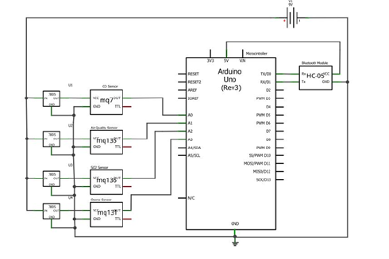**Schematic diagram:**

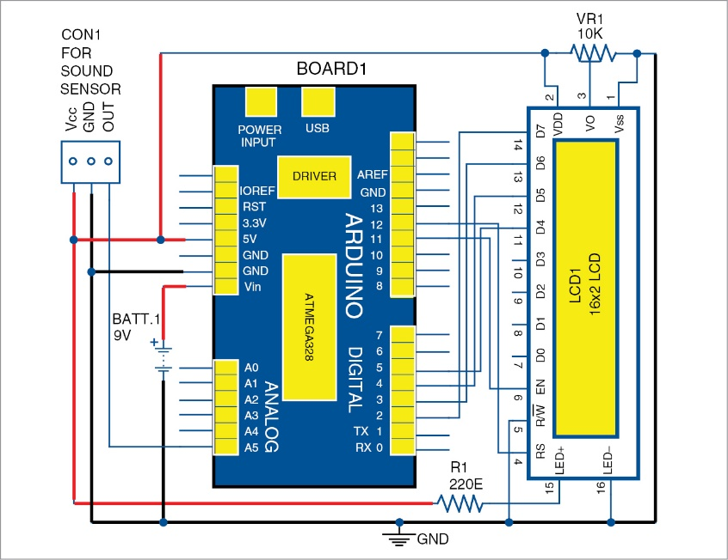

**Working:**

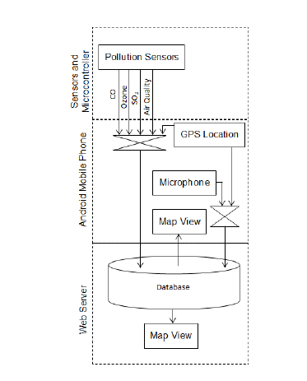

**IOT sensor:**

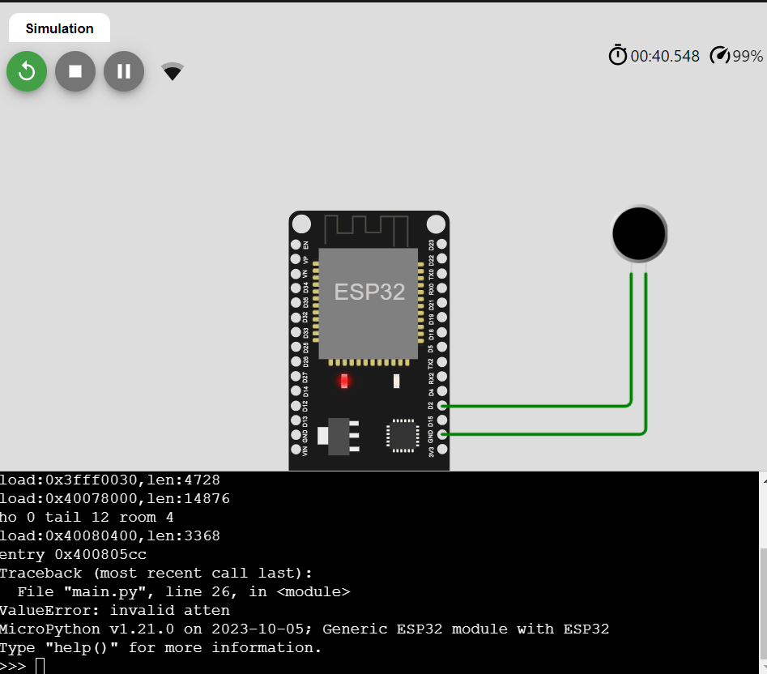

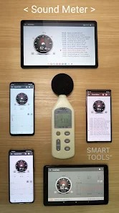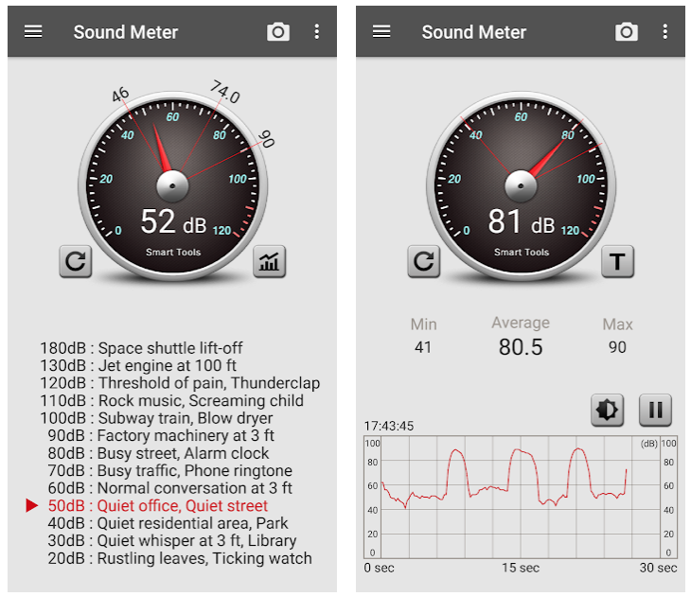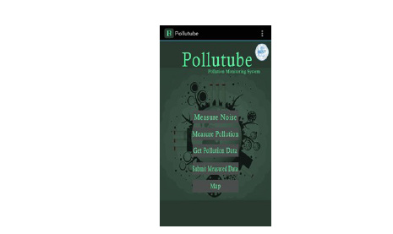**Mobile App interface:**