|  |
| --- |
| The use of gamification in respect to testing abilities for recruitment  By  Afzaal Shaikh  Student ID: 33464413  Supervisor: Professor Christophe Rhodes  Course: Computer Science BSc  Goldsmiths University of London, Department of Computing |
|  |

The candidate confirms that the following have been submitted*:*

|  |  |  |
| --- | --- | --- |
| **ITEMS** | **FORMAT** | **RECIPIENT(S) AND DATE** |
| DELIVERABLE 1 | REPORT  (ONLINE SUBMISSION IN PDF AND TWO HARD COPIES BOUND AND COVERED) | Monday 15th May 2017  Supervisor: Christophe Rhodes (online submission)  Tuesday 16th May 2017  Goldsmiths University  (two hard copies bound and covered) |
| DELIVERABLE 2 | UNITY PROGRAM WITH C# SCRIPTING IN ZIP FILE | Monday 15th May 2017  Supervisor: Christophe Rhodes |

Type of Project: Computer Software Program and Research

The candidate confirms that the work submitted is their own and the appropriate credit has been given where reference has been made to the work of others.

I understand that failure to attribute material which is obtained from another source may be considered as plagiarism.

Signature:

Name: Afzaal Shaikh

Abstract:

Gamification has been around for many years, using games in a non-gaming environment to perform certain actions such as testing. I believe games to be evolving rapidly in terms of technology and ability, in which many companies that have no relation at all with games, have implemented it in there day to day lives. This project will be conducted using a game program which can be utilised by a company to determine certain abilities in recruits. Such abilities which can be tested and observed would be the following below:

* Concentration/ Attention
* Strategic Thinking / Real Time Strategy
* Problem Solving
* Memory
* Reflexes
* Visual Acuity
* Real Time decision making

The project will be conducted through tests (game play and questionnaire) and research to determine my products feasibility for recruitment using gamification.

Acknowledgements:

I would like to thank the following people:

* My supervisor Professor Christophe Rhodes, who gave me feedback which deepened my insight into producing and finalizing this project. Also, it was with his help and directions that this project was put in motion.
* My friends and students who tested the game and filled in the questionnaire for feedback.
* Credit Suisse HR team for allowing me to come in to present my game, in which they tested and reviewed for me.
* My Father, Mother and Sisters who helped me with guidance with their years of experience and knowledge in project work and research.
* My friend for allowing me to use his laptop to conduct my testing after my one had broke

Contents

Chapter 1: Introduction 7

Introduction to Gamification 7

Examples of Gamification 8

Aim and Objective 9

Deliverables 9

Methodology 10

Project Schedule 12

Initial Project Schedule 12

Risk Assessment 13

Chapter 2: Background research 14

Coding 15

Storage 15

Chapter 3: Design 17

Review of Games: 19

System Requirements 22

Chapter 4: Implementation 24

Game Completion 24

Chapter 5: Testing 27

How the testing will occur 27

Testing the App 27

Functional Testing 27

End User Testing and results 28

Interview with HR Management 29

Chapter 6: Evaluation and Conclusion 31

Evaluation of Results 31

Table 1 Evaluation: 31

Table 2 Evaluation: 32

Graphical Design and Interpretation of Results: 37

Aims and Objectives Conclusion: 39

Conclusion for my Project Aims: 39

Actual Project Schedule 40

Future Development: 42

Personal Reflection: 43

Conclusion 44

Chapter 7: 45

References (NOTE ORIGINAL PLACE) 45

# Chapter 1: Introduction

### Introduction to Gamification

Gamification, is simply defined as game attributes which have been implemented for usage in a non-gaming environment. It is a process which has been around for many years, however the technology used now has evolved, making gamification stand out more in different sectors. It is the application of game elements and digital game design techniques to non-game problems, such as various business and social impact challenges [1]. It is a concept which is being utilized by companies all over, a main usage for gamification which has been around for over 20years, is its function of being a talent recruitment tool. Gamification has often been used interchangeable with the concepts of “serious games”. Here it is important to make a distinction. “Serious games” are games created for a non-entertainment purpose (for example learning and the development of skills) whereas “gamification” is the use of game elements and mechanics in non-game contexts [7]. It is meant to entice and motivate an individual to continue until completion; an example of this is removing screening methods and interviews, replacing them with game play instead to entertain the user, but also to make selection much simpler also. In 2014, M2 predicted that gamification would be a multi-billion-dollar industry by 2016 [6].

Take for instance, a company has selected 50 applicants out of 300 for summer internships, just by looking at CVs and qualifications. Although their CVs may be good, this does prove that they are the right person for the job. It is the use of gamification which can show the employers through results, which recruits has certain abilities which can be used in their environment. Basically, if the company is looking for real problem solver, they can create a game with a list of tasks where candidates are going to be solving tasks from real life [1] thus depicting a more practical view of the recruits. “Using criteria that are purely based on education and social background tends to lead to less diversity, but psychometric testing puts things on a more level playing pitch” – David Barrett, cut-e [3]

The People Analytics division at Google has found that team success is impacted by the “social sensitivity” of team members, i.e., the ability to perceive how others feel by using facial expressions and other non-verbal cues [10]. As stated above, qualifications and accomplishments cannot show the traits of the applicant, merely showing what they have done to get to this point. A problem with many companies receiving applicants is that many a time, CVs are similar and so harder to distinguish certain individuals from one another. This is where gamification comes into the picture, allowing employees, take for example a HR employee to analyse the potential recruit while they play the game, and when they have their results. I plan to use gamification in a simple way, implementing a simple game design which can be used by companies to test the abilities of candidates in;

* Concentration/ Attention
* Strategic Thinking / Real Time Strategy
* Problem Solving
* Memory
* Reflexes
* Visual Acuity
* Real Time decision making
* Others (please specify)

I plan to create a game which can show a user’s strength in these abilities, thus determining if they are the right candidate for the job, and how they can directly use these abilities in a company. Before I can start, there are certain points which I must consider

* Gamification works when it motivates the user
* Creativity is a fundamental tool in gamification
* Make sure it can keep a user entertained and engaged

The idea of creating a game to conduct these tests, is because the idea of gamification has grown to become a multi-billion-dollar industry. It is shown time and time again, the continuous expansion and development of games are becoming a vital part of our lives, and a perfect integration tool in sectors which have nothing to do with them. It is with this, that I decided and became motivated with developing a game which could be used in the recruitment side of gamification. Although I have played video games and brain games for many years, my actual skill in creating them is recent and simple. This however fuelled my determination for this project even further, as it is field n computing which interests me greatly. Having contacts within different well-known companies, take for example Credit Suisse; a prestigious and one of the world’s top investment banks, it has come to my attention that they are now moving towards implementing gamification in many areas of the company.

I quote from PHD student Maciej, doing a PHD in Psychology at City University *‘research has gone in to look at the relationship between long term game training and the improvement and development of the brain. Research has suggested that if certain criteria’s can be met they as a short term can be used to see individual’s abilities in a certain environment’* [25]. The development of serious games, should be able to serve a certain criterion of users and results. Game rewards must be matched to difﬁcult but attainable learning tasks. Some research even suggests that the best way to engage students with a game is to confuse them ﬁrst; the feeling of satisfaction and accomplishment from overcoming confusion leads to increased engagement [7].

### Examples of Gamification

As stated, gamification has been around for many years. It is a well-known practice implemented by companies to recruit individuals without them even knowing they were being recruited. There are many famous/ well-known examples of gamification such as the ones below:

The Daily Telegraph:

A well-known Newspaper, read by many. On 13th of January 1942, Alan Turing and British Intelligence offers devised a plan to find potential recruits. The plan was simple and discreet, they created a crossword puzzle which everyone could attempt. It was created in order to recruit new code breakers from the public. They, however failed to mention that it was for this reason, and many of the public who tried it and completed it where in fact contacted by the War Office, in which they were offered a great opportunity to work in Bletchley Park for its code breaking division. And some of the greatest agents were recruited through this crossword puzzle. [1]

The American Army:

The Daily Telegraph and British Intelligence Office where not the only ones to use gamification to recruit the public. In 1999, the American Army also used this technique to find people who had great potential to benefit in the army. They succeeded through the creation of a game called “American Army”. Gamers, during the game, are tasked with learning basics about the military process and learning how to work as a team. The U.S. Army turned this game into a powerful recruiting tool. [1][3]

Google:

Google, one of the largest companies in the world; a multi-billion-dollar company which is a recruiting magnet to some of the worlds most gifted people in technology. This tech giant for 12 years has been organizing a Google Code Jam software-writing competition in order to find new talent to work for the company. The way to appeal to the public, was to include a reward; the developers and engineers who enter would be drawn in to competing in a game, to win monetary prizes up to $50,000—but Google purpose was to attract potential hires with the right skills for the job and company. [6]

Umbel:

The big-data start-up Umbel has a gaming challenge called “Umbelmania,” in which amateur and professional coders fight a series of opponents in a first-person fighter-style game—but they are coding the movements. And just like any online game you would play, you can win points within the game. But, those points aren’t meaningless; they factor into how far you can advance into an interviewing process with the company. [6] [28]

## Aim and Objective

The aim of this project is to create a game application, which can be used to test different abilities of potential recruits in different companies. The application will allow users to analyse strengths in different abilities such as strategic thinking, problem solving, memory, quick thinking etc. The testing of the game should result from user feedback which will then be implemented through graphical solutions, showing what ability was tested the most through gameplay and how candidates did from one another.

* To explain Gamifications impact on society, history and dominating occurrence with many companies nowadays in terms of recruitment
* To create a game and explain what it is, how I have come to research this game and how I know using background research it can be good for recruitment?
* To explain what the game proposes in terms of development, and testing of different abilities
* To be able to gain feedback from my questionnaires
* To be able to categorise my results from the game and from the questionnaire graphically
* To interview a company’s HR team which has previously used gamification in their recruitment programs, and present them with my game solution and have feedback from them.
* To evaluate and conclude how my game relates to my project title

## 

## Deliverables

The deliverables for this project are stated below:

* A report of around 12,000 to 15,000 words, which contains
* Background research, designs and implementation and planning
* Results, evaluation and conclusion which provides justification for my application
* A game programme created using C# and Unity in which provides
* A rollerball function
* Cubes which have AI implemented in them, in which they follow the Player(rollerball)
* Cubes which have been placed in a way to hide the route
* Three levels with different routes, going up in difficulty where level 3 is the most complex
* An external file of the game built from Unity, to be played across Windows OS

## Methodology

The methodology of this project is a crucial step in terms of planning, creating and concluding this project. Due to my experience from my old college, I decided to use the ‘Iteration Development Model’ in creating the software and in writing my report. I decided to split my project up into 5 iterations, with each containing different milestones:

**ITERATION 1: PLANNING AND RESEARCH:**

The planning and research was what all projects must start with before they even start. It is here I finally gained an understanding as to what I will do for my project and how I will go about it. My main objective here was to create my ‘Project Preliminary Report’ and submit it on time to my university, allowing me to receive quicker feedback from my supervisor. I split this stage up in 4 parts which are as following:

* Research in different topic in computing and decide which one interests me
* Research chosen topic and decide on how to approach it
* See the dates for handing in the product and make an initial project timeline
* Complete project preliminary report and submit on time

**ITERATION 2: DESIGN:**

After planning and research, it was the time to go ahead and do the design. The design was split in 3 parts

* Game Design, this is the overall design and features that my game contained. I first conducted a brainstorm of ideas and showed it different friends to decide on one which would be best suited for the role. The role is the overall function of the game, in which it can relate to my title which is *‘*The Use Of Gamification In Respect To Testing Abilities For Recruitment’
* Game feasibility, here I made sure that I could do everything within the timeframe. For a game, it should take approximately 4 weeks to complete, so before I could move ahead with it I had to make sure I had all that was essential such as system requirements, equipment, prior knowledge of coding skills, foundation design (prototypes) etc.
* Final feedback for my design from my supervisor and other outside sources. If there were any problems with the design, it would be here to evaluate it. This is a crucial stage as it allows me to progress knowing that everything has been checked and that the risk of me having problems with creating the game will be minimised.

**ITERATION 3: IMPLEMENTATION:**

Creating my game for testing. Using the chosen platform (Unity) and programming language (C#), I begin to create my game. I have theorized that this should take approximately 4 weeks to complete as a suitable time span.

**ITERATION 4: TESTING AND RESULTS:**

This iteration was split into 4 stages

* Questionnaire testing was vital in determining if my game has any basis or foundation in proving that gamification can test abilities in one, for recruitment. The questionnaire was split into two different types of data collecting. Mostly qualitative where users use words and sentences to explain their feedback, there was also quantitative where users would give ratings out of 5 for the game and for each ability.
* System Testing which will be split into testing the app, functional testing of the app and end user testing. Testing the app; making sure the app could overall run and there are no errors. Functional testing; the test for making sure that the game is programmed correctly, and that it does what it is intended to do when run. End user testing; this final test goes hand in hand with all the tests, without the others passing this cannot be done. The ultimatum, where the game is tested by the users and the results are noted down.
* Meeting with Credit Suisse, an extra part of my testing but one which was needed as it makes my research and game more reliable and credible. Having a company like Credit Suisse test my game is amazing, to be able to go into their building and have someone from recruitment test my game and give positive feedback reassures me that my research and ideology behind my project can be proven.
* Plotting results on graphs/charts allows the progression to the final iteration of my project which is evaluation and conclusion of my overall project.

**ITERATION 5 EVALUATION AND CONCLUSION:**

Evaluation and conclusion, the final iteration, important in both parts, it is here where I talk about my overall project, my evaluation of the results and how this project can answer my title? The evaluation is split up into different graphs for a deeper analysation of my results. The main aspect of the conclusion is to prove that my work is credible and reliable, using the information found from results and research.

## Project Schedule

### Initial Project Schedule

The project plan is a timed outline of what I will be aiming to do every week until my deadline. It will be a log that should keep me up to date as to what I will do for this week and the following week. Also, every week Friday from 12:00pm until 12:30pm I will have a meeting with my supervisor discussing my project and where I stand presently.

|  |  |
| --- | --- |
| **DATE:** | **TASK:** |
| 20/1 | Meet with supervisor and discuss proposal |
| 27/1 | Take I feedback and look at improvements, also draw up design of the gaming app |
| 3/2 | Start looking at articles for research and draw about a section plan of report |
| 10/2 | Write up preliminary report for submission and ask for feedback from supervisor |
| 17/2 | Submit preliminary report and start creating app game |
| 24/2 | Write up my report and start a first draft for it show my supervisor and attain feedback for it |
| 3/3 | Make changes in report but start testing candidates |
| 10/3 | Attain results from video and data in table and write up an evaluation. |
| 14/3 | Look and research and evaluate |
| 31/3 | Submit first draft report to Supervisor |
| 7/4 | Read thesis and check over it, and have it ghost read by other individuals for feedback. |
| 14/4 | By 31st march first draft of my report should be uploaded |
| 21/4 | Look at the feedback given and make changes |
| 28/4 | Using video research write up evaluation |
| 5/5 | Write up the presentation and train |
| 15/5 | Submit final dissertation |

Table 1.1: The initial project plan which was done in my Preliminary report

RED- Easter holiday during those weeks

## Risk Assessment

Below is a risk assessment of what could cause delays/ problems with the completion of the project. Risk is assessment is critical in making sure that you outline all negative impacts this project could receive, so that you can work to avoid them. My father has said to me on many occasions, I quote *‘if you have a plan or idea, make sure you sit down and make note of all the possible ways it could go wrong, that way you know what your worst-case scenario will be’* (Shaikh)[30].

|  |  |  |
| --- | --- | --- |
| **Risk** | **How to avoid** | **Risk Level** |
| The game cannot run on certain computers due to it being on unity | Making sure that all the correct specifications is present before running the software or using a device | low |
| Screen size of devices are different, which would result in the game screen not showing all the information | Testing the game on different screen sizes to make sure it is adaptable | medium |
| User end testers do not give permission to allow their names to be recorded for results | Keep them anonymous or if they still refuse for any reason, find another participant willing to give permission | low |
| The game cannot run on a certain device due to the games software or the devices software being outdated | Use the newest up to date software for creating the game, and make sure it can accommodate older versions | medium |
| HR manager cannot make the testing/ interview | The HR manager is being interviewed for the game specifically, due to their experience and usage of gamification in their company. Therefore, find times that will accommodate the HR Manager | low |

# Chapter 2: Background research

Here I will outline my decisions regarding, how I will go about in developing my game and in what way I will use my game for my problem statement. This will include such decision in what programming language, platform, operating system

**Platform For The Game:**

Mobile Application:

Computer Application:

Conclusion:

**Operating System:**

Windows:

MAC:

Conclusion:

**Platform In Creating The Game:**

Unity:

Unreal:

**Programming Language:**

JAVA:

C#:

Conclusion:

AI Implementation:

### Coding

The coding I decided to use for my game was C# using the platform Unity. In order to determine which language was the most advantageous to use I first created a pros and cons table for C# and JAVA, which were the programming languages which I have used in the past for software programming.

|  |  |
| --- | --- |
| C# | JAVA |
| Used it before in gaming and AI | Used before in gaming and software development |
| The platform I am using is UNITY which I have used in scripting with this language | Game creation is better on unity |
| Easier to understand, write and compile | It can run on any platform |
| Runs on windows platform | Have not recently used JAVA |
| Recently used |

Looking at the pros and cons, I concluded that C# was the logical choice, therefore coding my game in this language.

### Storage

Keep your code in one place — Whether you work on multiple computers or just want to get some old projects off your computer, GitHub is the perfect place to store your projects online [20]. Git repository was used to manage my coding throughout the project. A git repository is advantageous as it provides a backup version if anything goes wrong with my present version and keeps all my projects code in one place, which I can then access in other places.

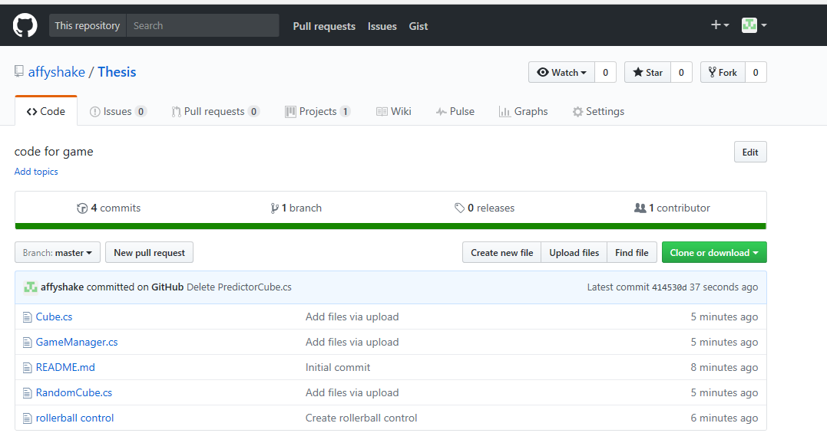

# Chapter 3: Design

The Design and Implementation is a simple

**3.7.5. Usability Requirements**

1. **The user interface must be easy to understand and use.**
   1. The Control system employed must be accessible, logical and uncomplicated, and must not hinder the way in which the system is used.
   2. Menus should be clear and easy to navigate.

**Justification:** A systems user interface, as discussed in the LiteratureSurvey and the Requirements Analysis, is an area that if not given due consideration can seriously affect the usability of the product. It is better for the user interface to be less complicated and easy to use, than sophisticated and difficult to use.

Sommerville (1) states that you should apply Shneiderman’s user interface design principles to the design of a systems user interface. These include User Familiarity and User Diversity. These principles will be discussed further in the design chapter of this document (see section 4.6.1.).

**Source:** Gathered from Literature Survey and Evaluation of ExistingSystems.

1. **The interface should be highly learnable, so that users with no knowledge of the game of snooker can learn how to use the system. Justification:** From the Stakeholder Analysis, the system has two maincategories of users; those who know are familiar with the game of snooker and those who are not. The system must allow both sets of users to become skilled at using the game. This could be done by utilising graphical prompts or an informative help section.

**Source:** Gathered from Stakeholder Analysis and Evaluation ofExisting Systems.

1. **The interface must be memorable to frequent users of the system. Justification:** The interface, in particular the control system, should beeasy to remember so that frequent users can use the system without the need to browse through help facilities or user manuals.

Preece et al (12) state ten usability principles developed by Jakob Nielsen, with this requirement covered under principle 8 ‘flexibility and efficiency of use’.

**Source:** Gathered from Literature Survey.

1. **The system should be accessible by one or more users.**

**Justification:** Snooker, as a standard, is played by two players. Thesystem being developed could however be played by a single user, playing against themselves, or by numerous user, with one or more on a

team. We must ensure that the system allows accessibility to users when the system is used in these scenarios.

**Source:** Gathered from Rule Centred Analysis and StakeholderAnalysis.

1. **Output from the system, whether visual or otherwise, must be clear and unambiguous.**

**Justification:** Output, such as visual prompts and the scores, must beclear in the message or function they are conveying to the user. If this message is not clear, consideration should be made as to whether the output adds anything to the usability of the system.

**Source:** Gathered from the Literature Survey.

1. **The system should operate at an efficient frame rate so that it can be used by computers of an appropriate specification.**
   1. The code should be kept efficient so that the frame rate does not run at a noticeably slower speed on medium to high-end

specification computers.

**Justification:** The game should run on computers with specification asdetailed in non-functional requirement 1. The frame rate chosen should allow for this specification computer to use the system without compromising the usability of the game.

**Source:** Gathered from Literature Survey.

**3.7.6. User Requirements**

1. **The system must support all types of user, irrespective of the level of knowledge they possess relating to the game of snooker. Justification:** As discussed in the stakeholder analysis there are twomain branches of stakeholders; those with and those without knowledge of the game of snooker. It is important to provide support to those users that are unfamiliar with the rules of snooker, so that a large number of stakeholders are not at a disadvantage to other stakeholders. **Source:** Gathered from Stakeholder Analysis.
2. **The system should exhibit a sensible level of difficulty, allowing the facility for users to improve their skills as they use the system more frequently.**

**Justification:** All users want their competency level to grow the morefrequently they use a system. This is especially so in relation to games, as the user will not want to keep playing if they cannot get better through practice. The system should therefore provide facilities for improvement. An example of this is to provide an aiming system that the user can adapt to and handle more effectively the more often they use it. If users cannot improve, they will probably choose to no longer play the game.

**Source:** Gathered from Literature Survey, MDA Framework andEvaluation of Existing Systems.

1. **The system must ensure users can judge their progress in the game, in order to satisfy the competitive aspect of the game of snooker. Justification:** Competition is a key part of snooker, with the winnerscoring the most points in a frame. Users must be able gauge their progress in the game in order to know if they are currently winning or losing, else this competitive element is lost.

**Source:** Gathered from MDA Framework.

### Review of Games:

To see what type of game I want to create, I decided to research certain games which are known to test abilities which I wish to implement within my game. Researching games that are similar in functions and gameplay is fundamental to my design, as it gives me an understanding of what the finish product should portray. It allows me to see and study a variety of different ways these games were developed. I decided the best way to research what type of games are primarily used for this type of testing, is the ones where I can play them to see first-hand how they are in testing certain abilities. I used a website which I am familiar with to research these games, as they are known to post games to test the abilities I wish to include in my game. Below are the review of 5 games which I played:

**Game 1: Light Force Double Maze:**

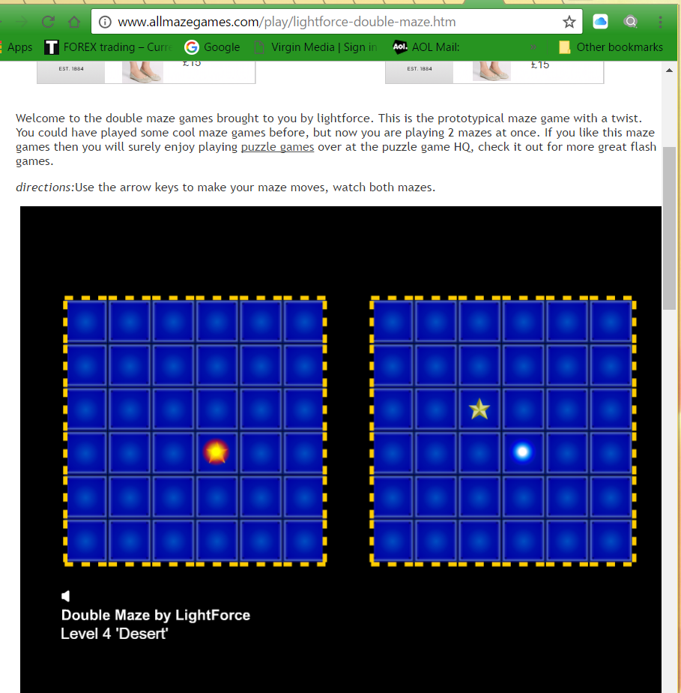

Figure 2.1 [21] the above game is called ‘light force double maze’

Having played this game, I realised that it was mainly a problem solver in which the 2 blue dots had to be aligned with the two stars. However, the stars are in different places, and so are the balls, therefore resulting in a huge amount of time spent on finding different solutions to this puzzle.

|  |  |
| --- | --- |
| PROS | CONS |
| A good test in terms of problem solving | The game does get boring after you have played it |
| Design is simple | It doesn’t test me enough in terms of abilities, I was left unchallenged as I progressed through further levels |
| Playing the game, I felt that my concentration increased as I was just sat there playing the game |  |
| It can be used in gamification, for companies that require a lot of problem solving |  |

**Game 2: Sleight of Hands:**

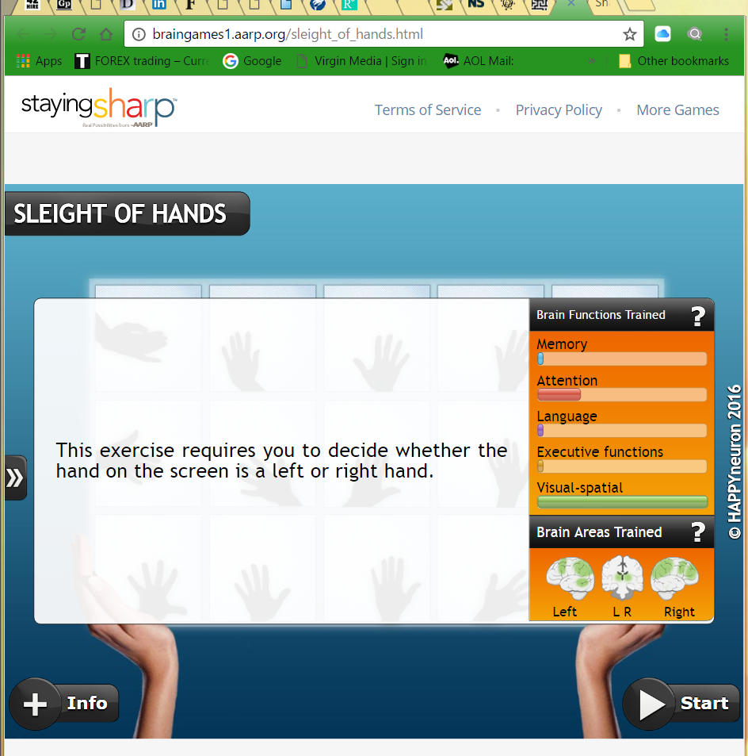

Figure 2.2 [22] a game called ‘Sleight of hands’

Sleight of hands is a game which although does not utilize abilities which I am looking for in my game as much as I’d want it to, although it showed me a new way for testing also. Visual-spatial is a function which can be used in future proposals or even as a new addition of my current game. It is basically the ability to see hidden shapes within a background of other objects. As you can see there is a brain function box to the side, which shows what is being trained while playing the game, this narrows my search for different games to this site, as I know can play games which have previously be put as a test for certain abilities.

|  |  |
| --- | --- |
| PROS | CONS |
| Challenging as you progressed each level | Apart from visual-spatial it doesn’t test you on anything else |
| A diagram showing what you are being tested on | Even though it challenges you , as you progress further, the game renders interest as it becomes repetitive with hand movements as there are only two solutions while playing the game. The two solutions are either your right hand or your left hand. |
| Good design, the colour and diagrams are very effective in keeping the user entertained |

**Game 3: Shapes and Colours:**

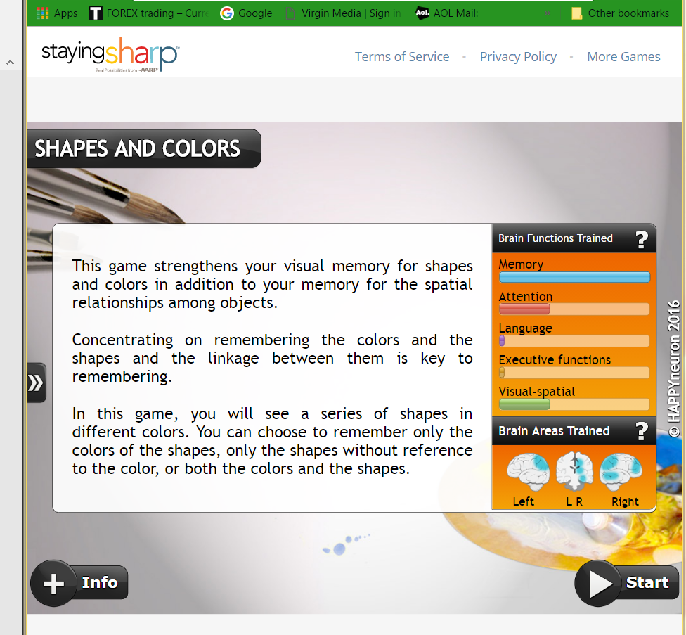

Figure 2.3 [23] Shape and Colours

A game that strains memory as its most important function in testing. Playing this game, I could see many ways I could implement this into my chosen game. for instance, showing the solution to a controlled group of users. I would test the after a certain amount of time, as doing it straight away would be insufficient due to the image being fresh in their minds.

|  |  |
| --- | --- |
| PROS | CONS |
| A good memory game | Doesn’t have any other strengths in testing other abilities |
| Good layout and design |
| Gameplay keeps me entertained |
| Having played this with my friend, it became competitive very quickly |

Concept:

The Game is a rollerball maze game split into three levels of difficulty. There is a hidden route in the game which allows the user to proceed into the next level. As the player controls the ball, there will be a cube behind which will follow it making sure the player only has a short amount of time to figure out the route. If the player where to collide with any of the cubes, the game would go back to the beginning. The user’s game play will be timed to categorise them with their time to complete each level. Below is an image of what the game should look like, it will be coded in C# and programmed in unity.

Unity:

Unity is the platform chosen to create this game.

C#:

AI:

The game concept is simple, it is a maze concept, in which a rollerball must get through the other side dodging obstacles and researching higher levels. It is quite different in which the blocks will be camouflaged in with the background, and the users will view the solution of the game first for a certain amount of time and then they must try to remember the solution and finish the game.

First of all using my literature review I will conduct research as to what type of games are used for memory and devise my own from that research. Having now looked at what games are like for memory, and games which are used for gamification I have created this simple maze one which incorporates the user’s ability to process images at a certain time, and use their short memory to access these memories for solutions. The game will have 3 levels ranging from easy to hard. The test will be conducted with 36 candidates which I have chosen. My candidates will have a large range in age and an equal amount of male to female ratio, this is to gather better more effective results. I will use the timed results to see if I can overall categorise candidates in to different table regarding their short term memory ability. I f there are candidate that cannot finish the easy levels or hard levels then they will be put into different categories aswell and be made note of.

Evaluation:

My evaluation will be the test results of my game. Below is the result table to expect once I have conducted my research, in which I test the time using a stopwatch it takes for a user to complete the levels and then categorise them in groups with their times. I will also be videoing candidates, candidates who I have signed up for to take my tests will have already been notified as to the videoing and so will have agreed upon it already.

## System Requirements

As I am using Unity 5.6 for this game, I must make sure that I and users meet the minimum system requirements for development and Game play. The system requirement below is from Unity actual site:

For development use

* OS: Windows 7 SP1+, 8, 10; Mac OS X 10.8+.
* GPU: Graphics card with DX9 (shader model 3.0) or DX11 with feature level 9.3 capabilities.
* iOS: Mac computer running minimum OS X 10.9.4 version and Xcode 7.0 or higher.
* Android: Android SDK and Java Development Kit (JDK).
* UWP: Visual Studio 2015 or later and Windows 10 SDK;
* IL2CPP scripting backend also requires C++ compiler feature to be installed with Visual Studio.

For game play:

* OS: Windows XP SP2+, Mac OS X 10.8+, Ubuntu 12.04+, SteamOS+.
* Graphics card: DX9 (shader model 3.0) or DX11 with feature level 9.3 capabilities.
* CPU: SSE2 instruction set support.
* iOS player requires iOS 7.0 or higher (dropping 6.0).
* Android: OS 4.1 or later; ARMv7 (Cortex) CPU with NEON support or Atom CPU; OpenGL ES 2.0 or later.
* WebGL: Any recent desktop version of Firefox, Chrome, Edge or Safari.
* Windows Phone: 8.1 or later.

(https://unity3d.com/unity/system-requirements)

# Chapter 4: Implementation

## Game Completion

Below is screenshots of the completed game and code in which I will annotate it.

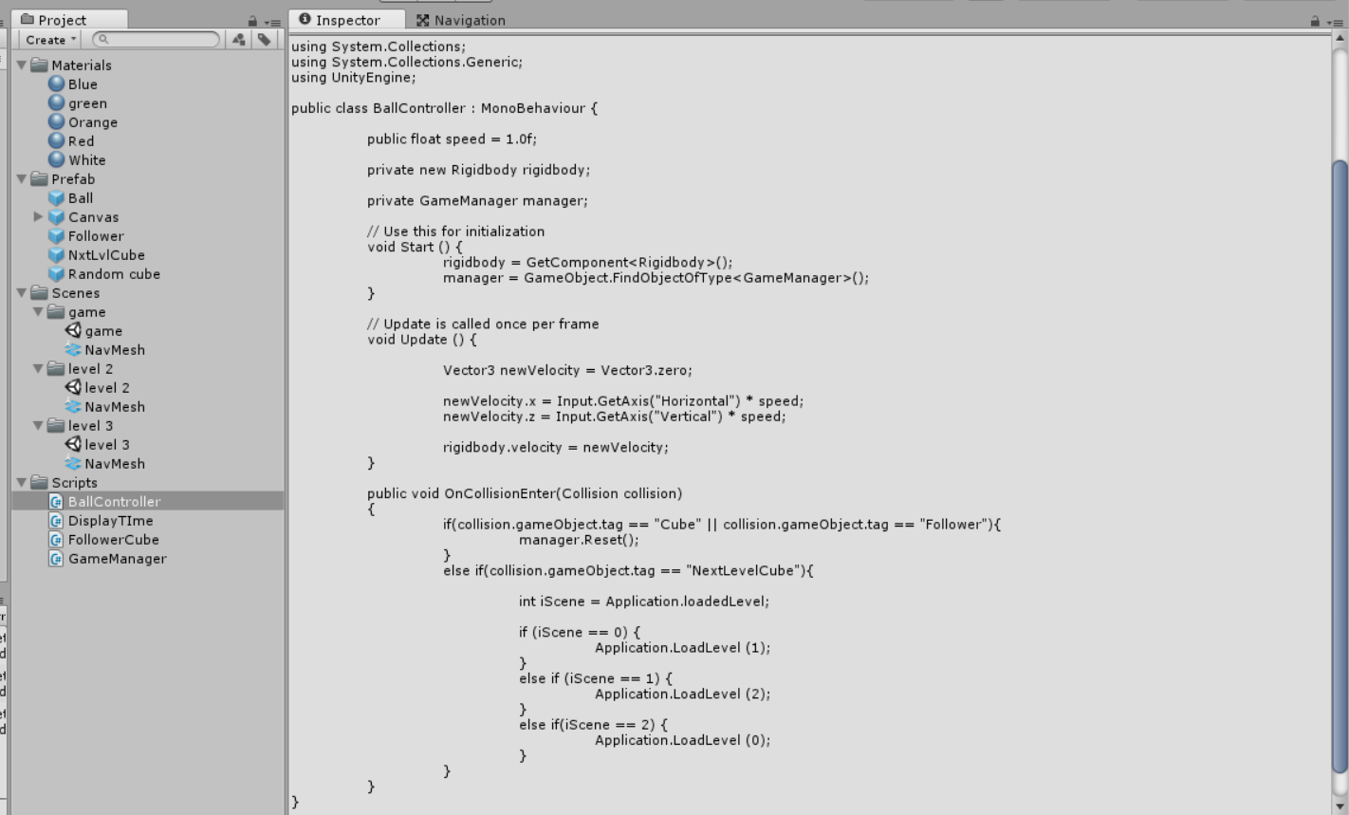

Before explaining the cube AI scripts, it is important to explain the ball’s code, written as the BallController script. It starts by getting a reference of the ball’s rigid body and a reference to the active game manager. On every update step, the ball’s speed is set to the value of the directional input axes multiplied by the speed. The speed can be set in the editor. Finally, the ball constantly checks for collisions with other cubes. If the ball collides with an object tagged as “Cube” or “Follower”, it calls the game manager’s Reset method. However, if the ball where to collide with the object tagged as “NextLevelCube” the game would load the next scene/ level.

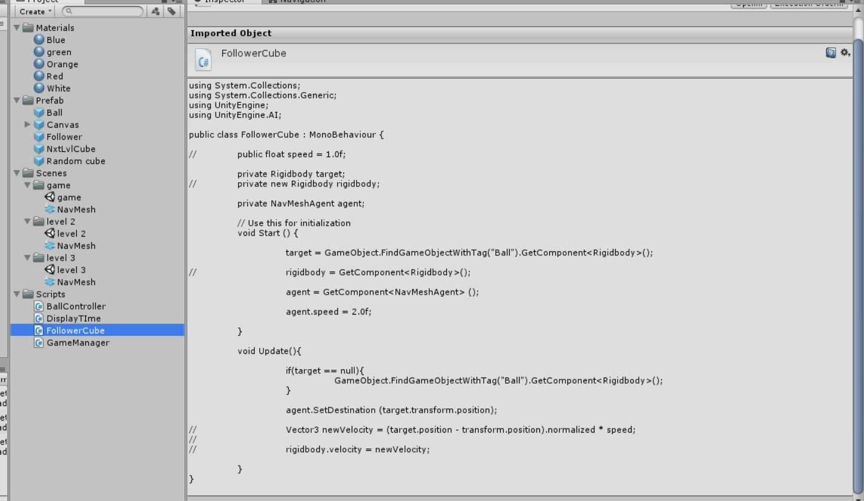

This is the code for the cube that follows the player’s position. On the Start method, it sets the target as the object on scene tagged as “Ball”. In Update, it refreshes the target’s reference if it is lost, then it sets the velocity as the position vector of the target minus the cube’s position vector normalized, multiplied by the speed. This ensures that the speed vector will point exactly towards the ball’s position when setting the origin in the cube. Being the ‘Nav Mesh Agent’, the AI implemented allows the cube to move around certain objects blocking its path. This can only be done, if the objects have been implemented with a navmesh. Navmesh is a commonly-used technique in Game AI to define a walkable area in an environment. It's also used to calculate a path between two points, make an NPC walk from its position to a goal, let an enemy reach a player or move the player to a desired destination [26].

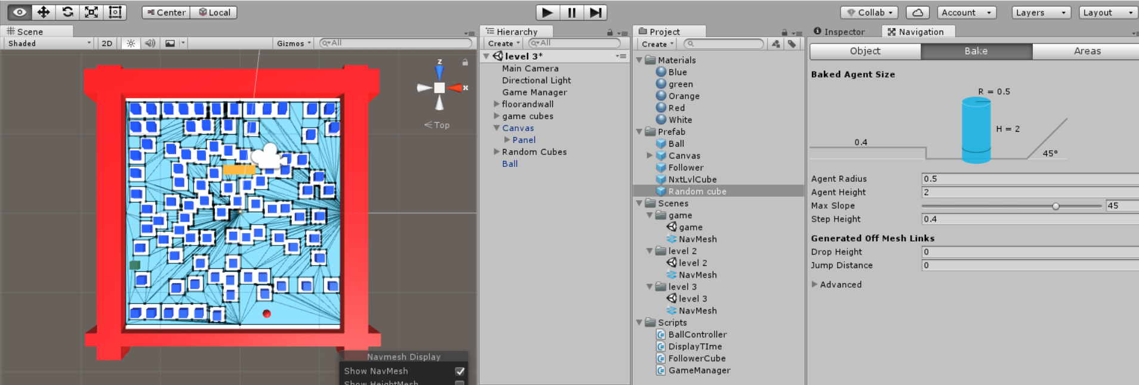

# Chapter 5: Testing

### How the testing will occur

The testing will occur through users who play the game while I observe and note their results. Primarily the group will consist of university student aged 20-23 who will be split into two equal groups consisting of one group that sees the solution of each level for 10 seconds, 10seconds before starting the game and another that does not see the solution and starts the game. In order, to make the test fair each participant will have 5 attempts at each level with no time limit, should the participant fail to finish the level before the five attempts, they will simply skip that level and continue to the next level where they are tested. After the game, I will collect all my results and give questionnaires for feedback to the users. The results from the game for each level and from the questionnaire will be graphically categorised.

### Testing the App

Throughout the creation of the app, I would conduct tests to make sure that it progresses smoothly. Such tests where debugging of the game and code to make sure there were no errors. To make sure I could test this properly and efficiently, I devised a test plan which would allow me to keep up to date with testing. I conducted each test every week for 4weeks until completion. Whenever there was a red box I would revise the error and fix the problem.

|  |  |  |  |  |
| --- | --- | --- | --- | --- |
| Debug program resulting in error free | 1st | 2nd | 3rd | 4th |
| Check if different scenes are running | 1st | 2nd | 3rd | 4th |
| Check scripts and run them to make sure no errors | 1st | 2nd | 3rd | 4th |
| Game is running | 1st | 2nd | 3rd | 4th |
| Objects are doing what they are supposed to do | 1st | 2nd | 3rd | 4th |

Figure 5.1: A table consisting of the systematic testing of the app

### Functional Testing

The functional testing is the testing which shows whether my application does what it is supposed to do in terms of specific functions. The tests where repeatedly tested every week for 4weeks until completion, as shown below. If it passed the box would be highlighted green, if it failed the box would be highlighted red and I would revise that problem, and attempt to fix it.

|  |  |  |  |  |
| --- | --- | --- | --- | --- |
| TASK | 1ST | 2ND | 3RD | 4TH |
| Does the ball move when arrow keys are pressed |  |  |  |  |
| Does the follower cube follow the balls movements |  |  |  |  |
| If the follower cube collides with the ball does it reload scene |  |  |  |  |
| If the ball collides with the placed cubes will the scene reload |  |  |  |  |
| Does the clock start at 00:00 every time scene reloads |  |  |  |  |
| When the ball gets to the end block, does the game load on to the next scene/ level |  |  |  |  |

Figure 5.2: Table depicting the functional testing results of the game for 4 weeks

### End User Testing and results

As stated the user testing will be split into 2 equal groups, consisting of one group seeing the solution and the other not seeing the solution as this is to test to see if memory has an impact in this game as well. The aim is to show that there is a way to distinguish results and users with this game once all the data has been collected and compiled together in charts. As they play the game, they will be timed and their times of completion for every level will be noted down.

Here will be the results from

* The actual candidates that played the game
* The feedback from the users’ questionnaires
* Graphical interpretation of the results of all the users’ with relation to time, of the ones who saw the solution (controlled group) and ones who did not
* Graphical interpretation of the feedback for abilities tested in the form of a table and pie chart

The questions I will ask the end users are the following:

1. Name:

2. Age:

3. Occupation:

4. If you were to state abilities this game challenged you with please circle them or state any others and give a rating out of 5 where 1=no use 2= not challenged 3= slightly challenged 4= challenging 5=much challenged?

* Concentration/ Attention
* Strategic Thinking / Real Time Strategy
* Problem Solving
* Memory
* Reflexes
* Visual Acuity
* Real Time decision making
* Others (please specify)

5. Please give a brief evaluation of you playing the game and what you were experiencing playing it?

6. In your own words, if this game where to be used as testing for hiring purpose, what sort of job sector would it be most useful in?

7. if you were to rate this game out of 5 (1=bad 2=okay 3=playable 4=very good 5=great) how would you rate it and why?

8. In your own words what should this type game have to make it good or what improvements should be made to the present game?

**Overall feedback from each question:**

4. If you were to state abilities this game challenged you with please circle them or state any others and give a rating out of 5 where 1=no use 2= not challenged 3= slightly challenged 4= challenging 5=much challenged?

|  |  |  |  |  |  |
| --- | --- | --- | --- | --- | --- |
| **Ability:** | **Total number of User Ratings given to each ability (out of 5):** | | | | |
| **1** | **2** | **3** | **4** | **5** |
| Concentration/ Attention | 0 | 3 | 8 | 11 | 19 |
| Strategic Thinking/ Real Time Strategy | 0 | 4 | 17 | 12 | 8 |
| Problem Solving | 7 | 6 | 11 | 10 | 6 |
| Memory | 4 | 4 | 10 | 7 | 16 |
| Reflexes | 6 | 9 | 10 | 6 | 10 |
| Visual Acuity | 1 | 6 | 9 | 14 | 11 |
| Real Time Decision Making | 0 | 6 | 11 | 10 | 13 |

5. Please give a brief evaluation of you playing the game and what you were experiencing playing it?

Overall with this question, most users explained stress, frustration, excitement, fun, challenge and pressure when playing the game. Some individuals commented on how the AI was used and how this would cause problems to them when playing the game as the AI implemented follower cube got closer it would put more pressure on them causing them to make wrong decisions. From the feedback from this question, it shows the game having an overall positive impact with the users when they were playing it.

6. In your own words, if this game where to be used as testing for hiring purpose, what sort of job sector would it be most useful in?

This question produced a variety of results, some that were similar and repetitive in different questionnaires. Those that were repetitive were pilot training, consultancy, IT, retail, taxi service, something which would require abilities such as memory, concentration, quick decisions. For some they wrote what they experience while playing the game in terms of abilities, and would say job sectors which would require this ability. I received one feedback saying that it should not be used at all which was interesting and so I asked the user if they could elaborate on that, the reason behind this answer was because they thought if they person cannot play games how is that fair if it is a job which has nothing to do with games. I found this response extremely fundamental as it contradicts the exact purpose of gamification and this project. Having explained to her about gamification and how it is changing the way companies are recruiting, the user went away understanding a whole new topic and decided to research this topic themselves.

7. if you were to rate this game out of 5 (1=bad 2=okay 3=playable 4=very good 5=great) how would you rate it and why?

A positive result with 34 out of 40 questionnaires rating it a 4 or 5. That’s 85% of the people that played my game thought the game was good. Most reasons of why they rated it a 4 or 5 was due to to it being challenging and difficult, although there was some negative feedback, that the sensitivity of the controls could be better and the design could be improved. Overall this result in feedback was very good.

8. In your own words what should this type game have to make it good or what improvements should be made to the present game?

The final question, overall the majority talked about the design, more levels, better controls and more AI implemented cubes to make the levels more difficult in the future. Many talked about multi-player abilities where friends could verse each other on their phones. I took this idea into consideration in future development as it could be useful with improving its gamification abilities by adding a sense of competition between recruits.

### Interview with HR Employee

I had organised an interview with a HR Employee from Credit Suisse, to meet me and test my application. It was also for me to give her a presentation on what the game can do for her company in terms of recruitment and how it differs from other games. While visiting her was delayed, when I did visit her I had other Credit Suisse employees test the game also in front of her, explaining their results and the idea and function behind this game, also explaining how it relates to gamification in relation to recruitment.

Below is the questionnaire given to her. The questionnaire differed from the student end user questionnaire, the following questions and her answer are:

1. Name: -

2. Age:  -

3. Occupation: Team Manager-Market Risk IT-Graduate Recruiter

4. If you were to state abilities this game challenged you with please circle them or state any others and give a rating out of 5 where 1=no use 2= not challenged 3= slightly challenged 4= challenging 5=much challenged?

* Concentration/ Attention 4
* Strategic Thinking / Real Time Strategy 3
* Problem Solving 4
* Memory 4
* Reflexes 2
* Visual Acuity 4
* Real Time decision making 4
* Others (please specify)

Patience 4

5. Please give a brief evaluation of you playing the game and what you were experiencing playing it?

‘Although a simple concept, the game is very addictive, I would enjoy playing it in a relaxed setting where it is easier to concentrate’

6. In your own words, if this game were to be used as testing for hiring purpose, what sort of job sector would it be most useful in?

‘Any role that requires attention to detail, real time decision making. Could cover a wide variety of sectors’

7. If you were to rate this game out of 5 (1=bad 2=okay 3=playable 4=very good 5=great) how would you rate it and why?

‘4-although I struggled to complete the levels I really enjoyed the game. found it easier once I knew the paths’

8. In your own words what should this type of game have to make it good or what improvements should be made to the present game?

‘The shadows of the blocks could be more prominent, I sometimes struggled to see the shadows’

9. Have you used similar games in the past for hiring purposes, if yes please describe at least one of the games?

No

10. Would you use this game for any future hiring purposes, if yes, please specify what it is in games such as this, which allow you to determine potential recruits based on their playing ability?

‘Yes, analytical mindsets, problem solving skills, strategy solutions’

11. If you were to purchase this game for hiring and testing purposes, how much would you pay for it?

N/A

12. How long would a game like this be used for until you use another

‘12months’

13. Having had experience in recruitment, what is your overall view of gamification in the hiring process?

‘ I feel it will have an important role in the future of hiring’

15. How were you testing potential recruits before gamification and which in your own opinion is more effective?

‘Problem solving exercises, problem solving exercises are similar but don’t perhaps show the full extent of solving without communicating which gamification does’

Looking at her answers, a main answer would be question 10, in which she answered that yes, she would use this in recruiting. Speaking to her she said that a game like this however would be used at the very end of recruiting when they need to reduce the amount of potentials to an even smaller number, e.g. 25 final recruits to10 employees. Although they would use the game, it would need some improvements’ which they would do in their own development team and that it would be used with multiple tests also, mainly due to the fact that all the recruits could have similar results, which would make the test indecisive therefore they would need other evidence also. Looking at the feedback, I believe there could have been more feedback added however time was a problem with them and so I left with what I had which even though small still gave me answers that I was looking for. What I myself could do next time, is visit different job sectors and companies and test it there to gain a wider variety of answers and compare which sectors would accept this game as a form of gamification in their company fortrecruitment.

# Chapter 6: Evaluation and Conclusion

## Evaluation of Results

The results were overall conclusive regarding the project objectives and research. In order to test if certain abilities could be shown whilst playing the game, a control group was created. The test users where chosen at random in different universities, to provide a range of different people, therefore removing bias results. There were three test groups in this report:

1) Test group 1 – consisted of test users playing the game having had no hints at the solution.

2) Test group 2 – This is the control group which consisted of test users having seen the game solution and then playing the game.

3) Test group 3 – consisted of the test users from Investment Bank – Credit Suisse, London.

In this section, the feedback from all the test users, in the form of tables and figures, is presented. Table 1 below displays the timed results per level of each user, where the boxes highlighted in green, are from the controlled group and the results in red are the test users from Investment Bank Credit Suisse; where I had conducted a presentation and interview with part of the Recruitment and Business Analysis team about my game and dissertation. Table 2 displays the test user feedback of abilities demonstrated in the game.

### Table 1 Evaluation:

As stated in the section above, the test was conducted with three different test groups, where test group 1 went straight into gameplay, whilst test group 2 would see the solution for 10 seconds, wait 10 seconds and then proceed with gameplay. The latter being the controlled group, showed a greater improvement in results with many users completing the level at a quicker time than the former group as expected. From the table, it can be seen that 50% of test group 1 failed to complete the final level below 150 seconds, in contrast to the controlled group where only 1 user failed to meet that limit. This shows that the memory of the users played an integral part in completing the levels. The pattern generally demonstrated an increase of time taken to complete the level every time the test user moved up a level.

Key for Table 1: Test group 1 (no shading colour), Test group 2 – control group (grey shaded colour), **Test group 3** – Credit Suisse employees (bold font)

|  |  |  |  |
| --- | --- | --- | --- |
| **Test User:** | **Test Users Time(s) For Each Level Completion** | | |
| Level 1 | Level 2 | Level 3 |
| 1 | 21 | 82 | 150> |
| 2 | 15 | 31 | 48 |
| 3 | 40 | 102 | 150> |
| 4 | 48 | 92 | 106 |
| 5 | 41 | 88 | 128 |
| 6 | 20 | 38 | 103 |
| 7 | 42 | 128 | 148 |
| 8 | 68 | 93 | 131 |
| 9 | 71 | 118 | 150> |
| 10 | 52 | 23 | 72 |
| 11 | 83 | 141 | 150> |
| 12 | 28 | 65 | 51 |
| 13 | 62 | 45 | 150> |
| 14 | 85 | 121 | 150> |
| 15 | 28 | 45 | 81 |
| 16 | 22 | 33 | 60 |
| 17 | 45 | 81 | 150> |
| 18 | 24 | 30 | 85 |
| 19 | 68 | 121 | 150> |
| 20 | 26 | 20 | 74 |
| 21 | 52 | 69 | 136 |
| 22 | 33 | 87 | 122 |
| 23 | 21 | 42 | 102 |
| 24 | 85 | 41 | 78 |
| 25 | 45 | 60 | 98 |
| 26 | 15 | 23 | 48 |
| 27 | 33 | 59 | 101 |
| 28 | 28 | 27 | 52 |
| 29 | 48 | 102 | 150> |
| 30 | 38 | 65 | 91 |
| 31 | 37 | 43 | 78 |
| 32 | 23 | 62 | 82 |
| 33 | 41 | 69 | 121 |
| 34 | 18 | 39 | 57 |
| 35 | 55 | 78 | 150> |
| 36 | 11 | 25 | 52 |
| **37** | **37** | **45** | **78** |
| **38** | **29** | **32** | **51** |
| **39** | **26** | **38** | **46** |
| **40** | **31** | **43** | **47** |

Table 6.1: The table above shows the overall test results of the users. The general pattern was an increase of time taken to complete every time the test user moved up a level.

### Table 2 Evaluation:

|  |  |  |
| --- | --- | --- |
| Ability | Number of candidates/41 candidates rating this ability as effective | Percentage Result (%) |
| **Concentration/ Attention** | 32 | 88.89 |
| Strategic Thinking/ Real Time Strategy | 26 | 72.22 |
| Problem Solving | 22 | 61.11 |
| **Memory** | 30 | 83.33 |
| Reflexes | 18 | 50.00 |
| **Visual Acuity** | 29 | 80.56 |
| **Real Time Decision Making** | 30 | 83.33 |
| Others | 0 | 0 |

Table 6.2: The above table shows the number of users that circled abilities that had been tested of theirs during gameplay. The abilities with the highest percentage result from user feedback are highlighted in bold.

Table 6.2 demonstrates the percentage and number of candidates who experienced specific abilities whilst playing the game. The main abilities, which stood out the most to the test users, were concentration, memory, visual acuity and real time decision-making (as highlighted in bold). Out of all of the abilities to be tested during gameplay, these four highlighted are fundamentally integral to recruiters in job criteria as commented by Noor Rashid, Credit Suisse [**29**]. The games objective was to test the chosen abilities through both realistic and attainable means; through analysing the data in table 6.2, it can be seen that the game has achieved both ideals.

### Table 3 Evaluation:

|  |  |  |  |  |  |
| --- | --- | --- | --- | --- | --- |
| Ability: | Total number of User Ratings given to each ability (from 1 – 5, 1 being ‘nouse’ and 5 being ‘much challenged’): | | | | |
| Concentration/ Attention | 0 | 3 | 8 | 11 | 19 |
| Strategic Thinking/ Real Time Strategy | 0 | 4 | 17 | 12 | 8 |
| Problem Solving | 7 | 6 | 11 | 10 | 6 |
| Memory | 4 | 4 | 10 | 7 | 16 |
| Reflexes | 6 | 9 | 10 | 6 | 10 |
| Visual Acuity | 1 | 6 | 9 | 14 | 11 |
| Real Time Decision Making | 0 | 6 | 11 | 10 | 13 |

Table 6.3: Shows the total results from the rating of abilities from test users

Table 6.3 is the quantitative approach to data collecting for the game. In the questionnaire, ratings were necessary in order to rate from 1 to 5 to demonstrate the challenging strength of each ability whilst the test users played the game. The ratings definitions were as stated below:

* 1=no use
* 2= not challenged
* 3= slightly challenged
* 4= challenging
* 5=much challenged

The use of quantitative data was for the plotting and analysing of results on charts and tables. From the table 6.3 above, the majority of test users either found the game abilities ‘much challenged’ or ‘challenging’; therefore, labelling the game a success in its purpose. Table 6.3 abilities and corresponding results have been represented as percentages in pie charts in the figures below.

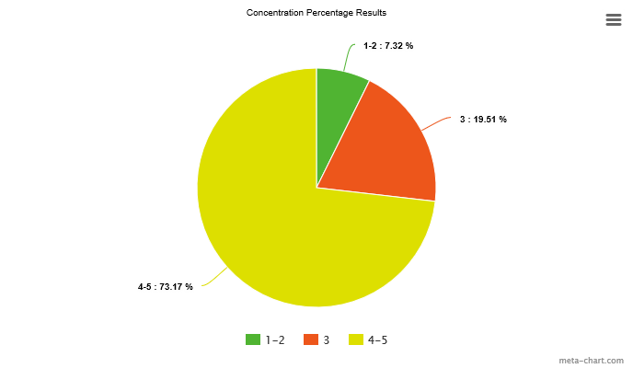

Figure 6.4.1 pie chart demonstrates the percentage of users that rated concentration. The chart strongly illustrates that majority of the users (73.17%) rated concentration a 4 (challenging) or 5 (much challenged) with only 7.32% saying there was no challenge at all or they did not even use concentration. This allows me to deduce that concentration is a main trait for ability with this game.

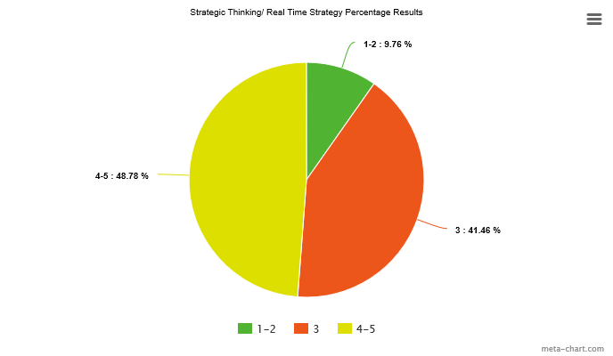

Figure 6.4.2 pie chart demonstrates the total percentage rating for strategic thinking/ real time strategy. The ability was again strongly challenged with only 9.76% rating it 1(no use) or 2(not challenged), however the game was limited at three levels in this initial prototype and hence was not as challenging as can be, as 41% selected 3 which means they were only slightly challenged.

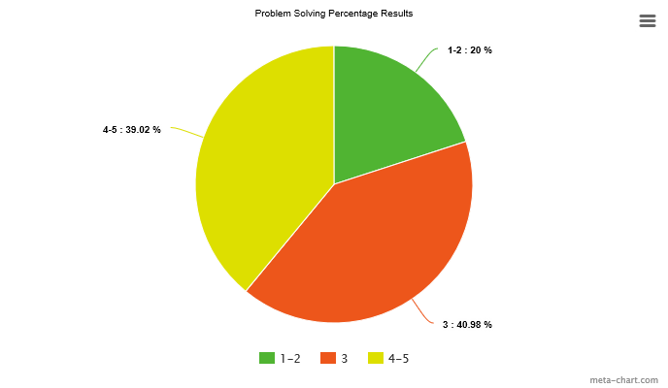

Figure 6.4.3 pie chart demonstrates the total percentage rating for problem solving shows again similar results to figure 6.4.2. However, 20% of the total voted 1-2, which shows that even though the majority were challenged in some way, the game could be developed to accommodate this problem solving ability in a different way.

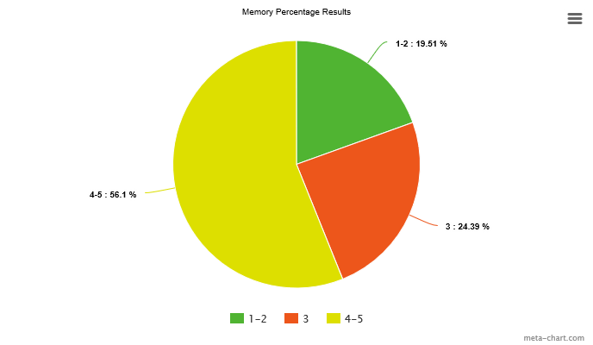

Figure 6.4.5 pie chart demonstrates the total percentage rating for memory. Straight away from the graph it shows that 56.1% of the test users voted 4-5 in their questionnaires. This is an amazing result as only 50% of the test users were a controlled group for testing memory, showing that this ability was a major success within the game.

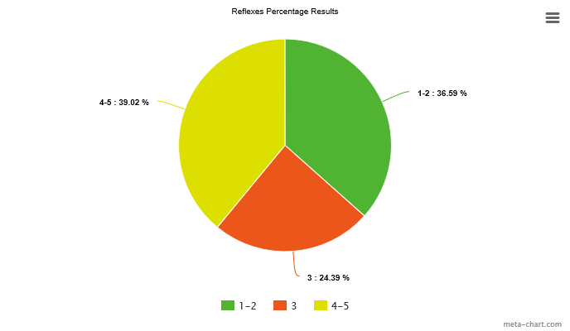

Figure 6.4.6 pie chart demonstrates the total percentage rating for reflexes. From the chart, it can be seen that 36.59% of users rated it 1-2, showing it never had as much of an impact whilst playing the game. Even though 39.02% of applicants rated it as 4-5 and 24.39% a 3, reflexes was a skill shown to be a weak ability within the game, having the largest amount of 1-2 votes out of all the abilities. This would have to be further researched to see if this is a skill vital in the corporate world and hence if so, would be incorporated into future designs.

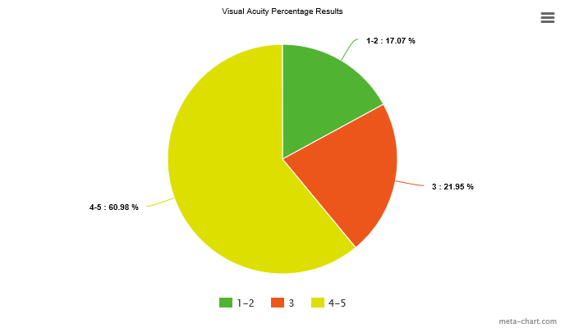

Figure 6.4.7 this pie chart demonstrates the total percentage rating for visual acuity. A main ability which was tested, visual acuity ability was to test the sharpness of the users. The results depicted above indicated that 60.98% of users rated it 4-5, whilst 21.95% of users rated it 3; this together sums up to 82.93% of users finding it challenging. This concludes that visual acuity was important in this game to succeed and an ability which can be tested using this game.

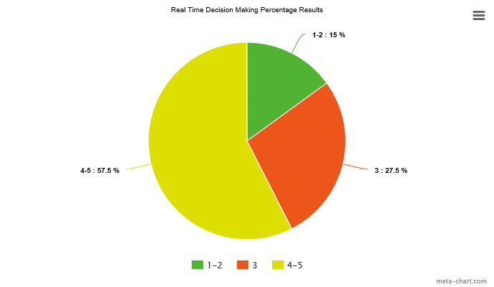

Figure 6.4.8 this pie chart demonstrates the total percentage rating for real time decision making, again a main ability to test and see if it challenged them and 85% of users were challenged, with 57.5% rating it 4-5 and 27.5% rating it 3. This depict its success within the game showing that this game does in fact test your ability to implement real time decision making while playing the game.

### Graphical Design and Interpretation of Results:

Figure 6.5.1: Results depicting the time taken(s) to complete Level 1 for each test user (all even numbered users from 2-36 were part of the controlled group this is the same for Figure 6.5.2 and Figure 6.5.3 below).

Figure 6.5.2: Results depicting the time taken(s) to complete Level 2 for each test user.

Figure 6.5.3: Results depicting the time taken(s) to complete Level 3 for each test user. (Note: all results that are labelled 150 seconds are 150 and greater (150>), this is due to having a time limit of 150s on each level, and so if a player takes 150s or more to complete/ not complete a level in the game he/she will be automatically noted down as 150>).

The graphs above are all the results, from each level. From analysing each graph and prior research, the results for all three graphs (fig 6.5.1, figure 6.5.2, figure 6.5.3) in relation to test users can show three different test user result analysis:

**Analysis Case 1: Consistent achievement of a test user having good results:**

First, the graphs overall when compared simultaneously show us a pattern of results with test users. When a test user has performed well, they also excel in performance in the other levels. Take for instance user 2, in level 1 they achieved 15s, in level 2 they achieved 31s and in level 3 they achieved 48s. This proves that they are a strong candidate and is strong when using their abilities such as memory, as user 2 was part of the controlled group where they were showed the solution beforehand. All of the even numbered users (minus the Credit Suisse employees test numbers 37-40) were part of the controlled group to test memory ability, and again apart from some users the majority excelled in finishing each level faster than their counterpart). The most significant analysis is the results of the Credit Suisse Employees who played the game and have assumed strength in each of the tested skills as members of the corporate world. These employees were users 37-40, and they were not shown the solution beforehand and yet throughout each level they were above average for finishing the levels quickly. These results can also display that if Credit Suisse employees are good at playing the game, then the game can be used in recruiting to determine stronger individuals, since Credit Suisse employees should have assumed talent in these skill sets and their scores can be a benchmark against the constitution of a potential recruit.

**Analysis Case 2: Consistent depiction of a test user struggling in all three levels:**

The odd numbered users and Credit Suisse employees were all not shown the solution in advance, instead they went straight into gameplay. Most them obtained slower results than the controlled group with some struggling constantly, for example:

* User 11 having scored 83s in the first level, 141s in the second level and greater than 150s (cut off point) in the third level, shows that the user was a weak candidate, showing weakness in being able to use certain abilities whilst playing the game. Unfortunately for a candidate such as this, they would most probably not be chosen in recruitment if based solely on gaming results. If they were in a pool of competition that shared similar academic results/ CVs, and they played this game, they would most certainly be one of the evicted as their results showed constant struggling.
* User 4, being part of the controlled group still demonstrated struggling factors even when shown the solution. In level 1 scoring 48s, this was the easiest level, however in level 2 and 3, this user struggled scoring times 92s and 106s respectively. Being part of the controlled group, this user was shown the solutions for each level and yet still struggled with completion, showing them to be a weak candidate, particularly for the memory skill.

**Analysis Case 3: A test user initially struggling to complete and then providing good results:**

Going back to the research of the project, it was written that ‘Some research even suggests that the best way to engage students with a game is to confuse them ﬁrst; the feeling of satisfaction and accomplishment from overcoming confusion leads to increased engagement [7]’ (page 8 line 24-26). A prime example of this is in my results with user 24. At first user 24 struggled with the game, scoring 85s in the first level, nonetheless, this user while confused and struggling at first improved drastically in the 2nd and 3rd levels scoring 41s and 78s. This shows the users adaption to the gameplay, and perseverance in completing the levels. In my opinion, this type of result with a user, is perfect in showing how this game can be used to improve oneself and challenge oneself, which is certainly a skill important to recruiters wanting to test the ability to adapt to new and difficult situations whilst under time pressure, as this is a skill vital to the corporate world.

Overall the conclusions of the results indicate a wide variety of different strengths with users, but these strengths correlate and can hence separate certain stronger individuals from the rest for potential employment; thus indicating this game to fulfil its purpose as a useful tool in the recruitment process.

## Aims and Objectives Conclusion:

|  |  |
| --- | --- |
| To explain Gamifications impact on society, history and dominating occurrence with many companies nowadays in terms of recruitment | Objective has been met |
| To create a game and explain what it is, how I have come to research this game and how I know using background research it can be good for recruitment? | Objective has been met |
| To explain what the game proposes in terms of development, and testing of different abilities | Objective has been met |
| To be able to gain feedback from my questionnaires | Objective has been met |
| To be able to categorise my results from the game and from the questionnaire graphically | Objective has been met |
| To interview a company’s HR employee which has previously used gamification in their recruitment programs, and present them with my game solution and have feedback from them. | Objective has been met |
| To evaluate and conclude how my game relates to my project title | Objective has been met |

Table 6.4: Tale containing my objectives with reference to if they have been met

### Conclusion for my Project Aims:

Although my initial timing to complete all my objectives was not followed, and I had to make different arrangement to accompany certain tasks. The overall completion of my test results and evaluation finalized this completion, it was this final task at hand which allowed me to say that the main objectives which are below were met and complete:

* To create a game and explain what it is, how I have come to research this game and how I know using background research it can be good for recruitment?
* To explain what the game proposes in terms of development, and testing of different abilities
* To interview a company’s HR team which has previously used gamification in their recruitment programs, and present them with my game solution and have feedback from them.
* To evaluate and conclude how my game relates to my project title

I laid out each objective to be a foundation to the other/others. Without one being complete, the others would not have been 100% fully met.

## Actual Project Schedule

As I proceeded through the project, I came across certain problems which would not allow me to stick to my initial plan. Below is my Initial plan formatted to meet my actual project plan:

|  |  |
| --- | --- |
| **DATE:** | **TASK:** |
| 20/1 | Meet with supervisor and discuss proposal |
| 27/1 | Take I feedback and look at improvements, also draw up design of the gaming app |
| 3/2 | Start looking at articles for research and draw about a section plan of report |
| 10/2 | Write up preliminary report for submission and ask for feedback from supervisor |
| 17/2 | Submit preliminary report and start creating app game |
| 24/2 | Write up my report and start a first draft for it show my supervisor and attain feedback for it.  **What was done instead:**  Once the preliminary report was done I decided to focus on the layout of the game and the layout of the dissertation, not starting the report |
| 3/3 | Make changes in report but start testing candidates  **What was done instead:**  It was here once I received feedback from my preliminary report, that I showed my supervisor how I wish to layout my dissertation and how my game will look. |
| 10/3 | Attain results from video and data in table and write up an evaluation.  **What was done instead:**  This was to do with my game, however my game was still in the process of being created as there were still some flaws to my design. A major flaw was that of the routes to take for each level and how to go about hiding them with the cubes. I also received feedback with my questionnaire that was needed for my evaluation, and so I was delayed more in completing my initial objectives. I also discussed with my supervisor the necessity of video data, and we decided that questionnaire feedback would suffice instead. |
| 14/3 | Look and research and evaluate  **What was done instead:**  Here I started my report which should have been started on 24/2 with a brief introduction and adding correction made from my preliminary report into it. While I would do this, I also looked at changing the routes of my game as once I put them in it was too obvious and easy to play. |
| 31/3 | Submit first draft report to Supervisor  **What was done instead:**  Nothing was complete as I went away for a while and have jobs, so my time was spent in other activities. My first draft was therefore not complete; however, my game was complete and so I decided to plan when the testing would occur. |
| 7/4 | Read thesis and check over it, and have it ghost read by other individuals for feedback.  **What was done instead:**  As I had created rough explanations of my introduction, deliverables, methodology, background research, design, implementation I started to write it up properly. Unfortunately, gaming was delayed as my game had a few errors with ti and the route needed changing as I received feedback from it, and they said the route in level 2 was much harder than level 3 which was a problem. |
| 14/4 | By 31st march first draft of my report should be uploaded  **What was done instead:**  This was Easter Holidays, my draft report had been completed and my game had been designed properly now, so I decided to start my testing. |
| 21/4 | Look at the feedback given and make changes  **What was done instead:**  This week I went to certain universities and tested my game. my game testing was then delayed again, as my laptop had broken and was no longer able to be portably used. This caused an unfortunate hindrance and so I had to find another laptop to use my game on so I can go around testing candidates. |
| 28/4 | Using video research write up evaluation  **What was done instead:**  As stated before, I decided that video research was no longer needed , and this week I went to see my supervisor one final time to receive feedback on my dissertation draft. The game testing had also started again. |
| 5/5 | Write up the presentation and train  **What was done instead:**  A problem occurred while testing which delayed my results, evaluation and conclusion, it was exam time for many university students so when visiting student many were adamant in not moving away from their studies to help, yet after visiting many universities I finally received a positive number of results to carry on with my evaluation and conclusion. It was this week where I finally was able to meet with Credit Suisse to receive feedback and finalize my dissertation. |
| 15/5 | Submit final dissertation |

Table 6.5: Table containg actual Project Plan

All boxes in green means that I had completed the task on time, all boxes in red means that it was not completed on time and an alternative was done that week which is written in aswell.

RED- Easter holiday during those weeks

### Conclusion of Planning:

My initial plan at first was good in terms of giving me an approximate to the tasks that I will be doing on certain weeks, however I did not take in any outside factors which did prevent me from following this plan. The above plan shows what I did instead of following the plan I laid out at first. This although was time consuming and more stressful, I was still able to complete everything on time and submit this dissertation on time. Overall I think the planning needed some improvements in terms of making it more realistic, though, I did still use it as a foundation to show me how long I have left until deadline date.

## Future Development:

In terms of the project research, making the game app more difficult and using more test users, would be beneficial for future analysis; this would be as a support to see if a pattern with the results (figures 6.5.1,2,3) still exist in longer durations of playing. Modifying the games design and functions to include many more features such as those below, or even to create a new game to focus on a certain sector/ company would be good future development to aid with gamification to be used in different corporate sectors (for example make more technical coding based games for the technology industry).

Modifications to the existing game could be:

• Results player board: this would entice more competition between recruits.

• Better aesthetic layout and design, which would be more appealing.

• More levels that increase in difficulty, which would allow for a longer duration of analysis of the recruits’ skills.

More improvements based on the current feedback from my test users’ questionnaires were that multi-player functionality could be implemented in the game where users oppose each other simultaneously on the same grid. A reward system could be created and implemented whilst the rollerball be given shooting capabilities, so users can potentially send the opposing user to the beginning again whilst they move on to the next level. This could improve the games strategic ability and could be used in sectors such as security and sports to demonstrate certain individuals’ potential in being strategic and being steps ahead of their opponent as well as still opposing the AI cube. Addition of more AI cubes, and using different shapes for walls would also increase the players’ visual acuity and are extra feature to be considered.

The study of gamification in the corporate world is still new territory, and could be proven even more beneficial to different corporate sectors, using the results and learning curve that this project has proven. Another future idea would be to allow for four individuals to play a game that has been created based on a specific role in a company and to test specific skills that are utilised in this role. All four candidates would be interviewed and assessed on the day job in order to judge a correlation between results and performance on the day job.

Future development feedback of this game was an eye opener to the further potential of the game. The future main interest of this game would be to put it on the IOS app store one day. On interviewing Noor Rashid, a Credit Suisse Business Analyst who had previously studied Computer Science, she said ‘the game has potential, it can be used to create complex levels and you can make it into a fully developed game with menus and everything. Why not make it multiplayer and add score systems or a prize, I see so much potential in this game’ (N. Rashid, 2017).

There are many opportunities in the future to improve and develop this project, in terms of making it more advanced with greater detail, predominantly in testing and evaluation. Although there are still improvements, at present, this project is still conclusive of the statement ‘The Use of Gamification in Respect to Testing Abilities for Recruitment’.

## Personal Reflection:

This project is a success that produced viable results and future research that can be considered. It was a topic that was interesting and hence research and producing the game were both enjoyable. The project was extremely challenging, nevertheless any obstacles such as were overcome, for instance my actual testing took even longer to do due to the fact many university students were preparing for their exams also, to overcome this I decided that I need to expand my timing for game testing and visit multiple universities to make sure I get the numbers needed for my results. Another challenge was my laptop battery had been broken and so using my laptop for testing was now void, to overcome this I needed to find a laptop with windows which I did through a friend, now being able to continue testing users. The accomplishment of completing this project and conducting the necessary research is very satisfying, and demonstrates the ability that I can achieve anything I put my mind to. A game was created by myself independently which proved adequate research was conducted as well as adequate testing by a large audience, including a respected company such as Credit Suisse; this has provided a sense of accomplishment as this project has been successfully completed.

A lot of research was necessary for this project, including the testing, which portrayed the measures needed to make sure I produced credible data and information. The project has also given me a stepping-stone into delving deeper into how games can be applied to non-gaming environments for not just recruitment, but everyday interaction with certain sectors. Getting users to give feedback for the game was highly useful as a path to research other game ideas as a business.

The largest lessons learnt were in planning a project and milestones, adequately managing time and fundamentally, how to research and focus on a topic of viable use in the future.

Personally, I have reaped many rewards and benefits from conducting this project. The overall project has provided me a greater confidence in terms of the ability to code games, research topics and overall produce a viable product. An insight into research has been gained and has been an enjoyable experience, one in which I would love to continue on a larger scale such as pursuing PhD opportunities.

## Conclusion

Overall the project was a success, and supports the idea that gamification can influence recruitment through the observance of certain abilities. Even though the game is not as formal as one may need for a specific environment, it does show the contrast between gameplay and decision making in terms of observing users. It is fundamental for companies to research outside of the box, when recruiting potential employees. With this game, I strongly believe that it can prove that gamification can test abilities in relation to recruitment. Regular use of the current game by an individual would result in problems, as they get use to the pattern in the three levels, however this is where the beauty of the game comes in to play; it does not matter how many people have played the game, its solutions and routes are not set in stone. Meaning that the complexity of the game is without a limit, you can create any route needed and the game can be catered to your own difficulty of levels.

The overall design of the game is plain and could be further improved; nonetheless the game was created for testing one’s ability, which it succeeded in. Of course, a larger study group will need to be tested, and other aspects must be involved and taken in to consideration with recruitment such as particular skills to assess. This demonstrates that in order to make the game public, further tests would need to be conducted to make sure that no matter the number of applicants tested, abilities can be shown through gameplay. Finally, I thoroughly enjoyed this project as it allowed me to gain an even deeper insight to the world of gaming, and how it is being used in non-gaming environments.

Personally, I believe that my product and results are successful in proving and solving my statement ‘The Use of Gamification in Respect to Testing Abilities for Recruitment’.

# Chapter 7:

## References (NOTE ORIGINAL PLACE)

1. Tegze, J. (2016) *‘Gamification in Recruitment’* Available from: <https://42hire.com/gamification-in-recruitment-ac95cce8ed32#.dks9dkf4y> [Accessed February 2017]
2. (2015) *‘Can the recruitment of gamification work’* Available from: <http://www.thechemistrygroup.com/blog/can-the-gamification-of-recruitment-work/> [Accessed February 2017]
3. Everett, C. (2016) *‘Gamification in recruitment: psychometric selection for more diverse talent’* Available from: <http://www.personneltoday.com/hr/gamification-recruitment-psychometric-selection-diverse-talent/> [Accessed February 2017]
4. Chow, S. (2014) *‘A Novel Approach to Employee Recruitment: Gamification’* Available from: ‘<http://theses.ucalgary.ca/bitstream/11023/1916/4/ucalgary_2014_chow_sam.pdf> [Accessed February 2017]
5. Rodrigo, M.: Dynamics of student cognitive-affective transitions during a mathematics game. Simul. Gaming 42, 85–99 (2010). doi: 10.1177/1046878110361513
6. White, C. (2015) *‘5 Companies That Are Successfully Using Gamification for Recruiting’* Available from: <https://business.linkedin.com/talent-solutions/blog/recruiting-strategy/2015/5-companies-that-are-successfully-using-gamification-for-recruiting> [Accessed February 2017]
7. Smith, F. (2014) *‘A Brief History of Gamification [#Infographic]’* Available from: <http://www.edtechmagazine.com/higher/article/2014/07/brief-history-gamification-infographic> [Accessed February 2017]
8. Raczkowski, F. (2013) *‘Rethinking Gamification’* Available from: <http://projects.digital-cultures.net/gamification/files/2013/05/Felix-Raczkowski-_-rethinking-gamification.pdf> [Accessed February 2017]
9. <https://writepass.com/journal/2013/04/sample-dissertation-methodology/> [Accessed February 2017]
10. <http://time.com/3743739/company-logo-quiz/> [Accessed February 2017]
11. <https://www.psychologytoday.com/tests/iq/memory-test> [Accessed February 2017]
12. Derry, K. Tansley, C. Hafermalz, E. (2014) *‘Hiring in the Age of Social Media’* Available from: <http://irep.ntu.ac.uk/id/eprint/3248/1/218817_668.pdf> [Accessed February 2017]
13. The Pymetrics Science Team (2016*) ‘Gamification of the Hiring Process’* Available from: <https://hcexchange.conference-board.org/attachment/pymetrics---WSRSept16web-8.pdf> [Accessed February 2017]
14. Landers, N R. Callan, C R. (2015*) ‘Casual Social Games as Serious Games: The Psychology of Gamification in Undergraduate Education and Employee Training’* Available from: <https://www.researchgate.net/publication/278691286_Casual_Social_Games_as_Serious_Games_The_Psychology_of_Gamification_in_Undergraduate_Education_and_Employee_Training> [Accessed February 2017]
15. Owen, A. Highfield, R. (2010) *‘Putting your intelligence to the ultimate test’* Available from: <https://www.newscientist.com/article/mg20827841-300-putting-your-intelligence-to-the-ultimate-test/> [Accessed February 2017]
16. Vestberg, T. Reinebo, G. Maurex, L. Ingvar, M. Petrovic, P. (2017*) ‘Core executive functions are associated with success in young elite soccer players’* Available from: <http://journals.plos.org/plosone/article?id=10.1371/journal.pone.0170845#sec001> [Accessed February 2017]
17. <http://happybrain.org/concentration.php> [Accessed February 2017]
18. <http://happybrain.org/memory.php> [Accessed February 2017]
19. Rusbult, C. (1989-2011) *‘Effective Learning Skills (memory, concentration, reading & listening, exams, time use)’* Available from: <http://www.asa3.org/ASA/education/learn/203.htm> [Accessed February 2017]
20. <https://guides.github.com/introduction/getting-your-project-on-github/> [Accessed February 2017]
21. <https://unity3d.com/unity/system-requirements> [Accessed February 2017]
22. Light force Double Maze <http://www.allmazegames.com/play/lightforce-double-maze.htm> [Accessed February 2017]
23. Sleight of Hands Game <http://braingames1.aarp.org/sleight_of_hands.html> [Accessed February 2017]
24. Shapes and Colours game <http://braingames1.aarp.org/shapes_and_colors.html> [Accessed February 2017]
25. Maciej PHD student, City University of London. (2017) *‘serious gaming and psychology’* quote [accessed April 2017]
26. <https://www.binpress.com/tutorial/unity3d-ai-navmesh-navigation/119> [accessed April 2017]
27. Noguci, Y. (2015) *‘Recruiting Better Talent With Brain Games And Big Data’* Available from: <http://www.npr.org/sections/alltechconsidered/2015/02/25/388698620/recruiting-better-talent-with-brain-games-and-big-data> [accessed April 2017]
28. Maycotte, H.O. (2015) *‘How Companies Can Improve Recruitment And Engagement With Gamification’* Available from: <https://www.forbes.com/sites/homaycotte/2015/07/07/how-companies-can-improve-recruitment-and-engagement-with-gamification/#1b758dcc66ed> [Accessed April 2017]
29. Rashid.N (2017) ‘*Credit Suisse Business Analyst employee quote on improvements’* [May 2017]
30. Shaikh.A (2017) *Quote about making risk assessment* [accessed May 2017]