INCIDENT REPORT
FIRST REPORT OF INCIDENT
Instructions to International Locations GSS: Please complete this form for any incident involving 1) injury to guest, 2) loss of property of a guest, or 3) injury to a MVW associate. Please send the completed report as soon as possible to the appropriate Chubb office and copy Vic Marmo (Vic.marmo@mvwc.com), Cade Williams (cade.williams@mvwc.com), Clarence Izzard (clarence.izzard@mvwc.com), Sheila O’Connor (sheila.Oconnor2@mvwc.com) and Stan Young (Stanley.young@chubb.com).
In the event of a serious injury or incident, please immediately call Vic Marmo (407-206-6467), Clarence Izzard (404-449-2384) and the local Chubb office.

Resort Name:
Marriott Club Son Antem
Resort Address:
Ctra MA19, km20. 07620 Llucmajor. Baleares

All Reports Must Include:
☒ Photos
☒ Guest Folio
☒ Guest / Associate Statements

Type of Incident: | Head injury | Report Number:
Day, Date, Time of Incident: | Sunday, March 23rd 2025, 16:45 | General Location of Incident: | Garden, Villa 444
Day, Date, Time Reported: | Sunday, March 23rd 2025, 16:55 | Specific Location of Incident: | In the garden, behind the right side of the barbecue

Guest Name: Smith | Arrival Date: March 17th, 2025
Address: 58 Blackmore Road | Departure Date: March 24th, 2025
City, State, ZIP: Kelvedon Hatch, Brentwood, CM 150 BJ | Room Number: Villa 444
Phone Number: +447976500971 | Date of Birth: August 24th, 1957
Email: gailsmith2124@me.com | Grandchild’s Name: Oliver Smith

Injury/Illness | First Aid: ☒ | Medical Treatment: ☐ | Hospital: ☐
Injury/Illness | Description of Injury: | Head injury
Injury/Illness | Body Part: | Head (cranium)
Injury/Illness | Police/Fire:

Loss, Theft,  Property Damage | Item(s) Description:
Loss, Theft,  Property Damage | Estimated Value:

Auto Accident: | Vehicle: | VIN: | YEAR: | MAKE:
Auto Accident: | MODEL: | Damage:
Auto Accident: | Other Vehicle: | VIN: | YEAR: | MAKE
Auto Accident: | MODEL: | Damage:

Disturbance: |  |  | Eviction: ☐ |  | Trespassing: ☐ |  | Arrest: ☐ |  | Other: ☐
Additional Details |  |  | Click or tap here to enter text.
Witness: | Name: |  |  | Address: |  |  |  | Phone #:
Witness: | Name: |  |  | Address: |  |  |  | Phone #:
Witness: | Name: |  |  | Address: |  |  |  | Phone #:

I’ve received a call from the FO that Mrs. Smith requested a doctor because her grandson Oliver (4 years) hit the top of his head. He was playing in the garden near the barbecue and when he stood up, he hit his head on the right edge from the barbecue. I’ve passed by to check up on the situation and I met the doctor too on site, he examined Oliver and luckily the cut was superficial, and he did not need stitches or a visit to the hospital, further examination was not necessary but supervision during the next couple of hours from Oliver’s behavior were important.

I’ve added photos from the barbecue where the accident happened. I’ve asked if I can make photos from the wound for insurance purposes, but Mrs. Smith declined.

Photos: (Copy & Paste)

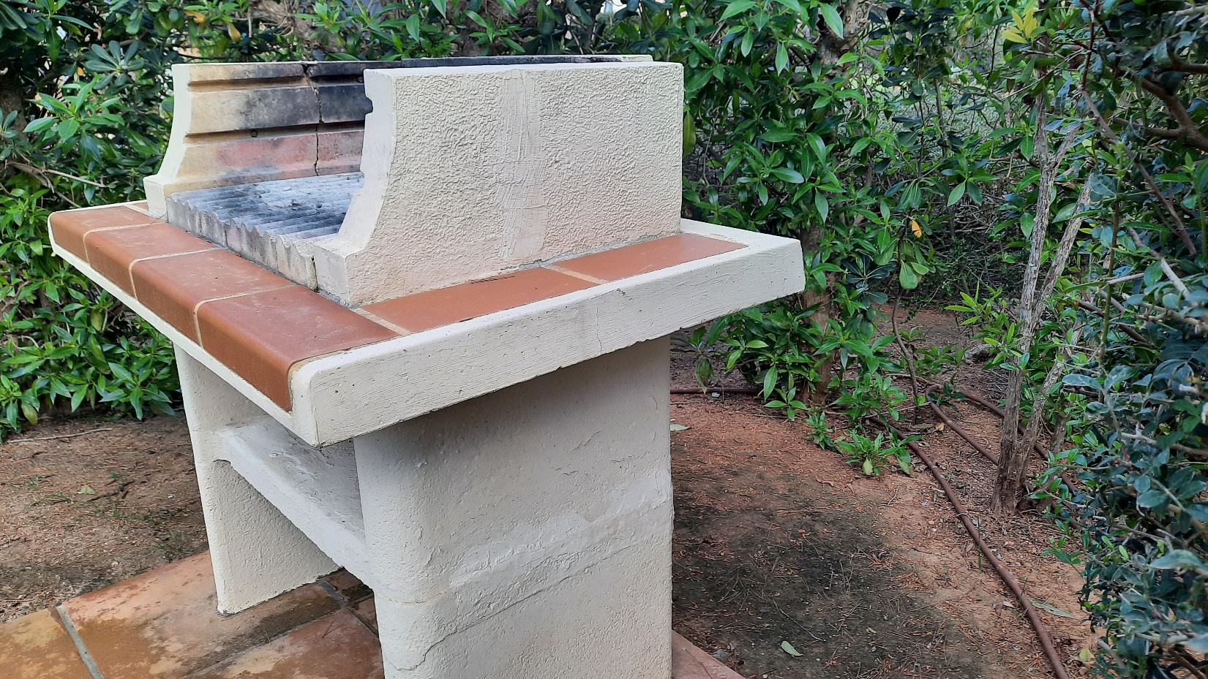

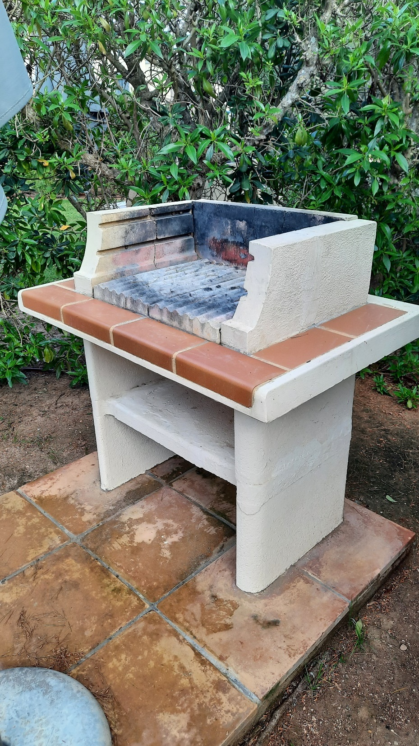

Preparer Name: | Jeffrey Woudenberg | Title: | Guest Relations & Activities Manager (MoD on shift)
Signature: |  | Phone # | 971705200

