Split is the largest city on the Croatian coast of the Adriatic Sea; after Zagreb it is the second largest city in Croatia. It is situated between the gulf of Kaštela, which can be seen from the northern side of Marjan, and the mountain ranges of Kozjak and Mosor. Because of the protection of the high mountains, we have very mild, typical Mediterranean climate here in Split.

This area has been attractive to man for habitation ever since early prehistory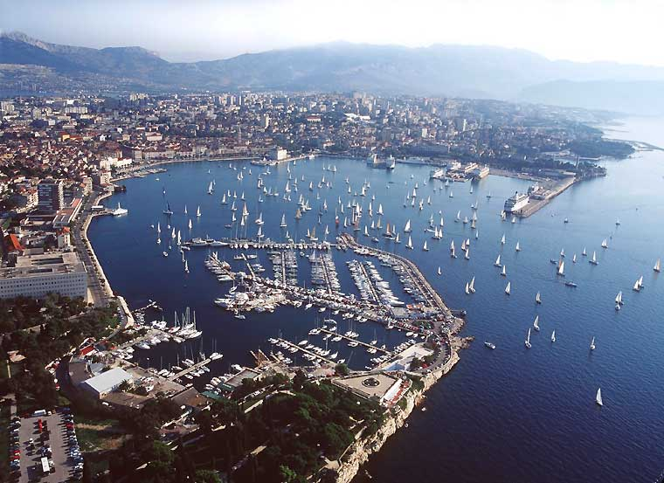. The Greeks founded their first colonies in the area in the 4th century BC: Tragurion (Trogir), Salonae (Solin), Epetion (Stobreč). In the period of Roman domination Salonae developed into a large city. Not far from Salonae, there was a small Greek settlement called Aspalathos which got the name after a plant which in early spring blooms with tiny, intensive yellow flowers-*brnistra.* In the Roman period it was named Spalatum. The palace of the Roman emperor Diocletian was built at the bottom of the southern cove of the peninsula of Split, in the period between 293 and 305 AD.

Diocletian’s palace is the world’s best preserved palace from the Roman period. In 1979 the historic core of Split together with the Palace became a part of the UNESCO’s list of world heritage; it is considered in the whole world as the key building for the understanding that type of architecture. 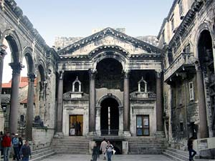After being under Byzantine rule, Venetian Republic, Napoleon, Austro-Hungarian Monarchy, as well as a part of Yugoslavia, Split in now one of the most beautiful cities in Croatia, and in Europe as well; the people in Split tend to call it “*the most beautiful city in the world*”. And maybe that is not far from truth, especially considering the fact that all those rulers left beautiful monumental traces in the city, which are preserved to this very day. This is the best invitation for all of you! Come and see many different architectural monuments all existing in harmony; come and walk along the most beautiful embankment you have ever seen; come and enjoy our beautiful sea! We are waiting for you!

