CHAPTER FOUR

SYSTEM ANALYSIS AND DESIGN
  - Introduction
This chapter presents the system analysis and design of the Integrated Compliance Tracking and Risk Management System for Facility Safety. It describes the system requirements, design methodologies, and overall system structure. The chapter also explains how different system components interact to support compliance tracking, risk assessment, and inspection management. It provides a foundation for understanding how the system will be developed and implemented to meet user needs.
  - Requirement Analysis
Requirement analysis is the process of identifying, documenting, and validating the needs and expectations of users and stakeholders for a system (Somerville, 2011). It ensures that the developed system fulfills its intended purpose and operates effectively within its environment. In this study, requirement analysis is categorized into two main types: system requirements and user requirements. System requirements define the technical and operational resources needed for the system to function, while user requirements describe how users interact with the system and the services it must provide.
- System Requirement
System requirements refer to the specifications that define the technical infrastructure and resources necessary for the operation of a software system (IEEE, 1998). They describe what is needed for the system to function effectively within its environment and ensure reliable performance. In this study, system requirements are categorized into three main types: hardware requirements, software requirements, and data requirements, each of which plays a critical role in supporting the development and operation of the system.
- Data Requirement
Data requirements describe the specific data elements that the system needs to collect, process, store, and retrieve to support its operations. In this study, data was collected through literature review, interviews with facility personnel, and observation of existing compliance and safety management practices. These sources provided both theoretical and practical insights into the types of data required for effective facility compliance tracking and risk management.
The types of data used in the system include
  - User Data: Includes information such as name, role (administrator, inspector, technician), contact details, and login credentials. This data is used for user authentication, authorization, and tracking system activities.
  - Asset Data: Includes details of facility assets such as fire protection systems, lifts, electrical installations, boilers, and pressure vessels. This data is used to monitor asset status and ensure compliance with safety regulations.
  - Inspection Data: Includes inspection schedules, dates, inspection results, and status (completed, pending, overdue). This data is used to track inspections and ensure they are conducted within the required timeframes.
  - Compliance Data: Includes certification records, expiry dates, and compliance status of assets. This data is used to monitor regulatory compliance and generate alerts for expiring or overdue certifications.
  - Risk Data: Includes identified hazards, risk levels, and mitigation measures linked to specific assets. This data is used for risk assessment and management.
  - Incident Data: Includes records of incidents and near misses, including their causes, impact, and affected assets. This data is used to analyze safety issues and prevent future occurrences.
  - Task (CAPA) Data: Includes corrective and preventive actions, assigned personnel, deadlines, and task status. This data is used to track the resolution of identified issues and ensure accountability.

- Software Requirement
Software requirements refer to the specific programs, frameworks, and tools needed to develop, run, and maintain a software system effectively (Sommerville, 2011). They define the technological environment within which the system operates and ensure that all components function correctly and efficiently.
The software used in this project includes:
- React: A JavaScript library used to develop the web-based user interface. It enables the creation of interactive and responsive components for users such as administrators, inspectors, and technicians.
- JavaScript/TypeScript: Programming languages used to implement application logic, handle user interactions, and manage system functionality on both the frontend and backend.
- Node.js and Express: Used for backend development and creating APIs that handle communication between the user interface and the database. They support efficient data processing and system operations.
- PostgreSQL: A relational database management system used to store and manage system data such as assets, inspections, risks, and compliance records in a structured format.
- Visual Studio Code: A code editor used for writing, editing, and debugging system code during development. It provides useful extensions and tools that improve productivity.
- Postman: A tool used for testing APIs to ensure proper communication between the frontend and backend components of the system.
- Git and GitHub: Used for version control and managing the development process. They help track code changes, support collaboration, and maintain backups of the project.

- Hardware Requirement
Hardware requirements refer to the physical devices and equipment needed to support the development, deployment, and operation of a software system (Shelly & Rosenblatt, 2012). These requirements ensure that the system can run efficiently and that users are able to access and interact with it effectively.
The hardware used in this project includes:
- Laptop/PC: Used for system development, coding, and testing. It provides the computing power required to run development tools, servers, and databases.
- Server/Cloud Infrastructure: Used to host the application and database, enabling the system to be accessed remotely by users. It ensures data availability and system scalability.
- Mobile Devices (Smartphones/Tablets): Used by inspectors and technicians to access the system in real-time, especially during inspections and reporting activities in the field.
- Internet Connection: Required for communication between the client (user interface) and the server, as well as for accessing cloud-based services and databases.
- These hardware components collectively support the effective development, deployment,

- User Requirement
User requirements describe the needs and expectations of users regarding what the system should do in order to achieve its intended purpose. They focus on the services and interactions required by end users and stakeholders. According to Sommerville (2011), user requirements are typically divided into two categories: functional requirements and nonfunctional requirements, which define what the system does and how well it performs those functions.
- Functional Requirement

Functional requirements describe the specific services and behaviors that the system must provide to users. According to Pressman (2014), they define the operations that the system should perform to meet user needs and solve the identified problem.
The Facility Compliance and Safety Management System shall:
- Allow users (administrators, inspectors, and technicians) to register, log in, and manage their accounts securely.
- Enable administrators to register and manage facility assets such as fire systems, lifts, electrical installations, boilers, and pressure vessels.
- Allow the system to schedule inspections and track inspection status (completed, pending, or overdue).
- Enable inspectors to record inspection results and report non-compliance issues.
- Generate alerts and notifications for upcoming inspections, overdue tasks, and expiring certifications.
- Provide a risk assessment module for identifying hazards, assessing risks, and managing risk registers linked to assets.
- Nonfunctional Requirement
Nonfunctional requirements describe the quality attributes of the system, including performance, usability, security, and reliability. According to Sommerville (2011), they define how well the system performs its functions rather than what it does.
The system must:
- Ensure data security and privacy through secure authentication and role-based access control.
- Provide high performance with fast response time during data processing and retrieval.
- Be user-friendly with a simple, clear, and responsive interface.
- Ensure system reliability and availability for continuous monitoring of compliance activities.
- Be scalable to support additional users, assets, and features as the system grows.

4.3 System Design
4.3.1 System Architecture
System Architecture refers to the overall structure and organization of a system, including its components, interactions, and operational processes. According to Bass (2013), system architecture defines how system elements interact to achieve the intended functionality and performance requirements. This section presents the architectural design of the proposed Facility Compliance and Safety Management System to provide a clear understanding of how the system operates and supports facility safety and regulatory compliance management. The purpose of this architecture is to ensure effective monitoring of assets, inspection management, risk assessment, incident reporting, CAPA tracking, and certification management within facilities.
The system architecture consists of the following key components:
i. Inspectors conduct inspections on facility assets such as lifts, fire protection systems, electrical installations, boilers, and pressure vessels, then record inspection findings and compliance status in the system.
ii. Safety Officers manage risk registers, assess identified hazards, report incidents or near-miss events, and create Corrective and Preventive Action (CAPA) tasks to address safety issues.
iii. Technicians receive assigned CAPA tasks, perform corrective or preventive maintenance activities, and update task progress and completion status within the system.
iv. Estate Managers / Compliance Officers manage assets, certifications, licences, inspection schedules, and assign CAPA tasks while monitoring overall compliance performance of facility assets.
v. Administrators manage users, system settings, and overall system operations, including monitoring reports and maintaining secure access control.
vi. The core system automates inspection scheduling, compliance tracking, risk monitoring, CAPA workflows, certification expiry alerts, and report generation to support continuous facility safety and regulatory compliance management.

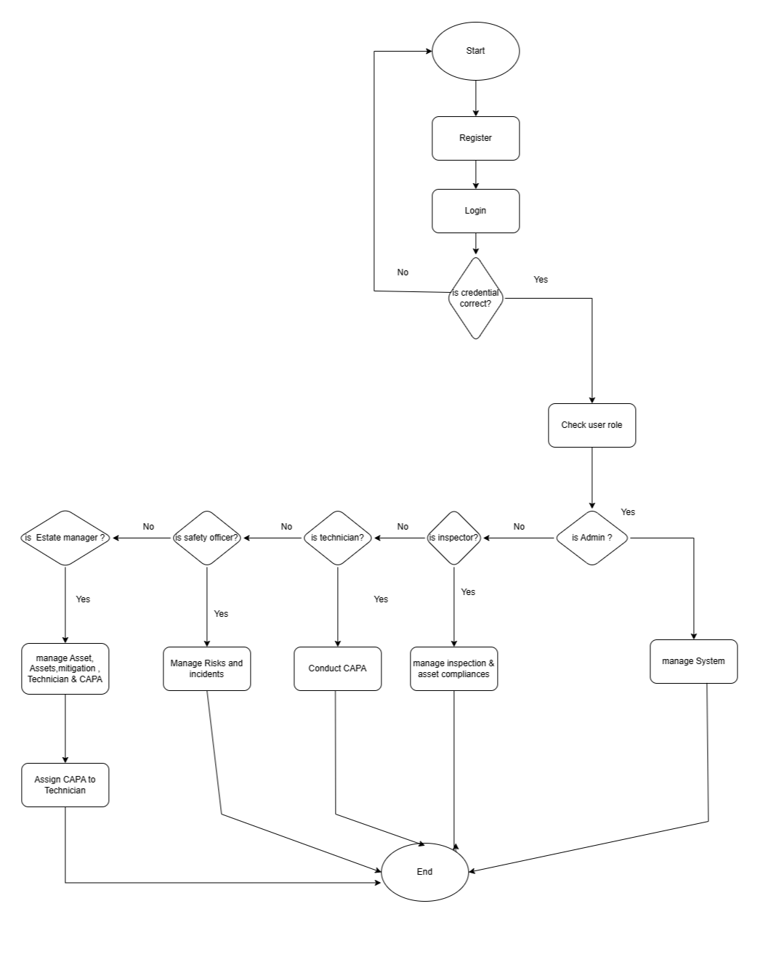

Figure 4.1: systems architecture
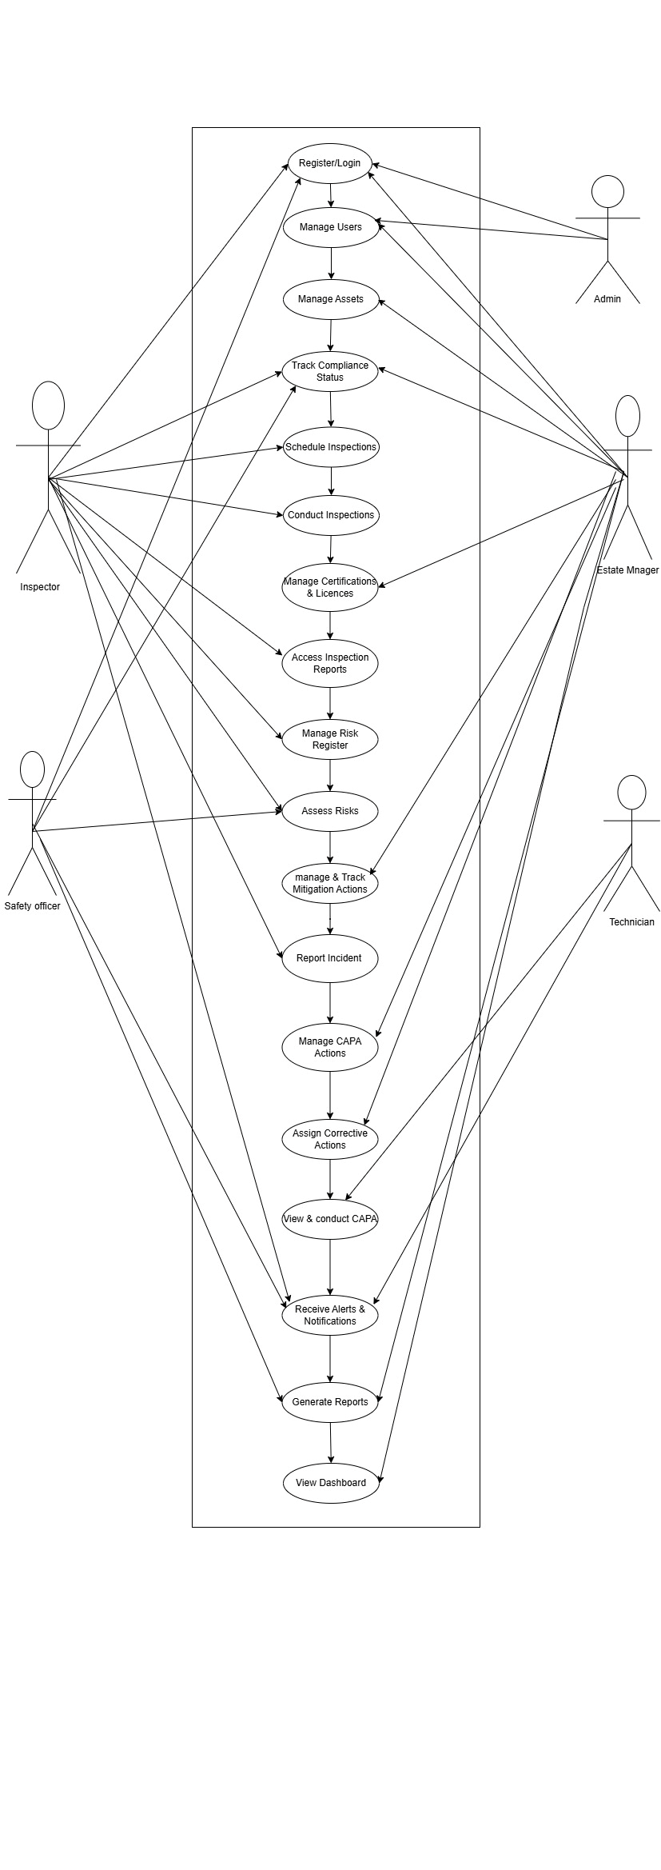
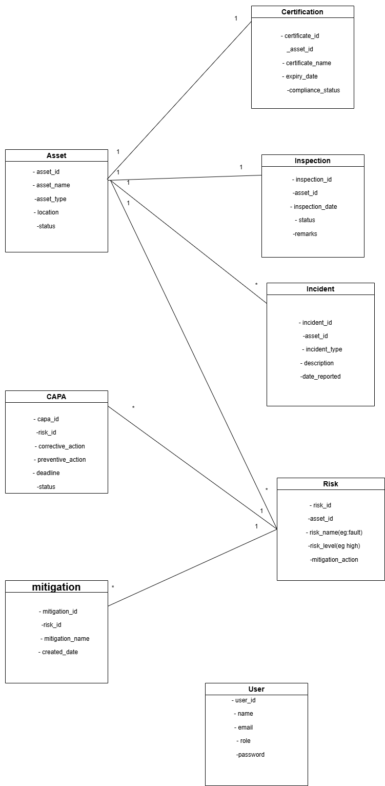
Figure 4.2:ERD diagram

