Octave
GNU Octave, version 3.0.1
Copyright (C) 2008 John W. Eaton and others.
This is free software; see the source code for copying conditions.
There is ABSOLUTELY NO WARRANTY; not even for MERCHANTIBILITY or
FITNESS FOR A PARTICULAR PURPOSE. For details, type `warranty'.

Octave was configured for "i486-pc-linux-gnu".

Additional information about Octave is available at http://www.octave.org.

Please contribute if you find this software useful.
For more information, visit http://www.octave.org/help-wanted.html

Report bugs to <bug@octave.org> (but first, please read
http://www.octave.org/bugs.html to learn how to write a helpful report).

For information about changes from previous versions, type `news'.

c5 =

0.0321031 -0.1975300 -0.0292464 1.0457547 0.0027743 -0.0070102

a =

0 0 0 0 0 0
5 0 0 0 0 0
0 4 0 0 0 0
0 0 3 0 0 0
0 0 0 2 0 0
0 0 0 0 1 0

c5T =

0.0321031
-0.1975300
-0.0292464
1.0457547
0.0027743
-0.0070102

dc5 =

0.00000
0.16052
-0.79012
-0.08774
2.09151
0.00277

dc5T =

0.00000 0.16052 -0.79012 -0.08774 2.09151 0.00277

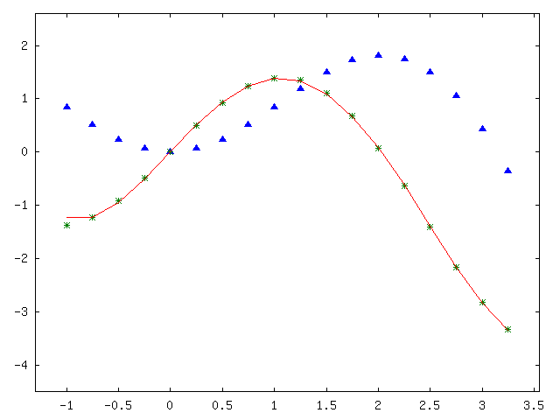

Octave Code
% f(x)=x*sin(x);
% df(x)=sin(x)+x*cos(x);

x=-1:0.25:3.25;
f=x.*sin(x);
df=sin(x)+x.*cos(x);

c5=polyfit(x,f,5);

a1=[0,5,0,0,0,0]'; % (x^5)'=5x^4
a2=[0,0,4,0,0,0]'; % (x^4)'=4x^3
a3=[0,0,0,3,0,0]'; % (x^3)'=3x^2
a4=[0,0,0,0,2,0]'; % (x^2)'=2x
a5=[0,0,0,0,0,1]'; % (x)'=1
a6=[0,0,0,0,0,0]'; % (c)'=0

a=[a1,a2,a3,a4,a5,a6];

dc5=a*c5';
dc5p=polyval(dc5,x);
plot(x,f,'^;f(x);',x,df,'@;df(x)/dt;',x,dc5p,'-;Pdf(x)/dt;');
axis([-1.3,3.55,-4.5,2.6]);

print -dpng workshop2.png

c5
a
c5T=c5'
dc5
dc5T=dc5'

Matlab
c5 =
0.0321 -0.1975 -0.0292 1.0458 0.0028 -0.0070
a =
0 0 0 0 0 0
5 0 0 0 0 0
0 4 0 0 0 0
0 0 3 0 0 0
0 0 0 2 0 0
0 0 0 0 1 0
c5T =
0.0321
-0.1975
-0.0292
1.0458
0.0028
-0.0070
dc5 =
0
0.1605
-0.7901
-0.0877
2.0915
0.0028
dc5T =
0 0.1605 -0.7901 -0.0877 2.0915 0.0028
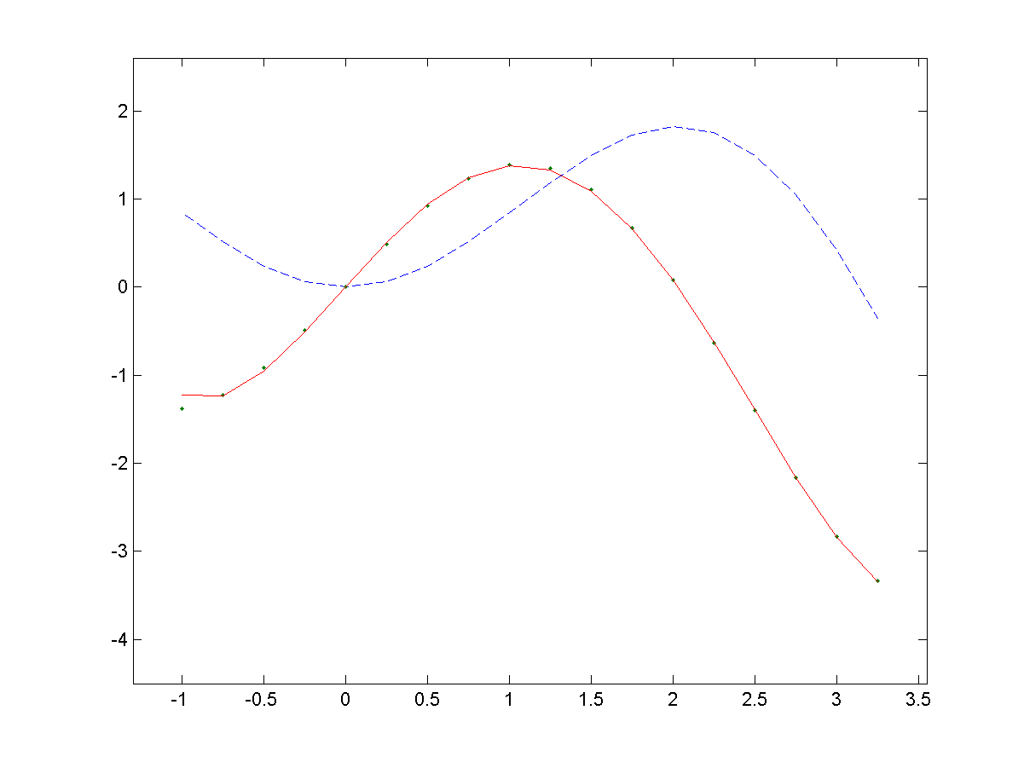

Matlab Code
% f(x)=x*sin(x);
% df(x)=sin(x)+x*cos(x);

x=-1:0.25:3.25;
f=x.*sin(x);
df=sin(x)+x.*cos(x);

c5=polyfit(x,f,5);

a1=[0,5,0,0,0,0]'; % (x^5)'=5x^4
a2=[0,0,4,0,0,0]'; % (x^4)'=4x^3
a3=[0,0,0,3,0,0]'; % (x^3)'=3x^2
a4=[0,0,0,0,2,0]'; % (x^2)'=2x
a5=[0,0,0,0,0,1]'; % (x)'=1
a6=[0,0,0,0,0,0]'; % (c)'=0

a=[a1,a2,a3,a4,a5,a6];

dc5=a*c5';
dc5p=polyval(dc5,x);
plot(x,f,'—',x,df,'.',x,dc5p,'-');
axis([-1.3,3.55,-4.5,2.6]);

print -dpng workshop2.png

c5
a
c5T=c5'
dc5
dc5T=dc5'

