Workshop 4

Afief Halumi
302323001

% Main.m
[x,p,x2,f]=afiefpoly(1);
subplot(3,2,1);
plot(x,p,x2,f);
axis([-3*pi,3*pi,-3.5,3.5]);

[x,p,x2,f]=afiefpoly(3);
subplot(3,2,2);
plot(x,p,x2,f);
axis([-3*pi,3*pi,-3.5,3.5]);

[x,p,x2,f]=afiefpoly(5);
subplot(3,2,3);
plot(x,p,x2,f);
axis([-3*pi,3*pi,-3.5,3.5]);

[x,p,x2,f]=afiefpoly(15);
subplot(3,2,4);
plot(x,p,x2,f);
axis([-3*pi,3*pi,-3.5,3.5]);

[x,p,x2,f]=afiefpoly(15);
subplot(3,2,5);
plot(x,p,x2,f);
axis([-3*pi,3*pi,-3.5,3.5]);

[x,p,x2,f]=afiefpoly(15);
subplot(3,2,6);
plot(x,p,x2,f);
axis([-3*pi,3*pi,-3.5,3.5]);

print -dpng n1.png

% afiefpoly.m
function [x,p,x2,f] = afiefpoly(n)

co = zeros(n+1,2);
x = -3*pi:0.1:3*pi;
p=zeros(length(x),1);

for k=1:n
co(k,1)=(((-1)^k-1)/(k^2*pi));
co(k,2)=((-1)^(k+1))/k;
end

for k=1:length(x)
p(k)=pi/4;
for j=1:n
p(k)=p(k)+co(j,1)*cos(j*x(k))+co(j,2)*sin(j*x(k));
end
end

x2=[-3*pi,-3*pi,-2*pi,-pi,-pi,0,pi,pi,2*pi,3*pi];
f=[pi,0,0,pi,0,0,pi,0,0,pi];

Output
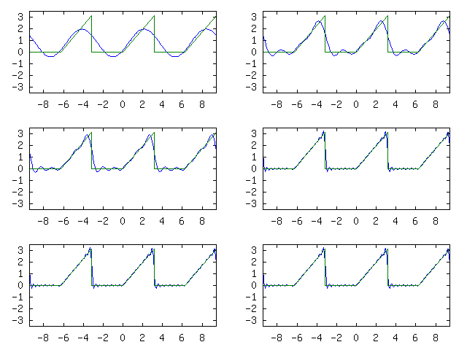

Coefficient Calculation

Notes
These results were obtained by using GNU Octave. Following are the legal notes concerning GNU Octave:

GNU Octave, version 3.0.1
Copyright (C) 2008 John W. Eaton and others.
This is free software; see the source code for copying conditions.
There is ABSOLUTELY NO WARRANTY; not even for MERCHANTIBILITY or
FITNESS FOR A PARTICULAR PURPOSE. For details, type `warranty'.

Octave was configured for "i486-pc-linux-gnu".

Additional information about Octave is available at http://www.octave.org.

Please contribute if you find this software useful.
For more information, visit http://www.octave.org/help-wanted.html

Report bugs to <bug@octave.org> (but first, please read
http://www.octave.org/bugs.html to learn how to write a helpful report).

For information about changes from previous versions, type `news'.

