Lab Report
Lab 01
AI and Decision Support systems

Muhammad Afif Ul Hasnain
210648

Task 1
Code:
# # # # # # # # # # # # # # # # # # # # # # # # # # # # # # # # # # # # # # # # # # # # # #
# Coded by: #
# Muhammad Afif Ul Hasnain #
# # # # # # # # # # # # # # # # # # # # # # # # # # # # # # # # # # # # # # # # # # # # # #
# Import OS to clear python shell
import os
# Import time for sleep(). otherwise, shell clears instantly
import time
# Addition Function
def add(a, b):
return a+b
# subtraction Function
def sub(a, b):
return a-b
# Multiplication Function
def mul(a, b):
return a*b
# division Function
def div(a, b):
return a/b
# display menu Function
def menu():
while True:
# wait 3 seconds
time.sleep(3)
# Clear shell
os.system('clear')
# Print the menu out
print("Please choose one of the following options to proceed")
print("1. Add")
print("2. Subtract")
print("3. Multiply")
print("4. Divide")
print("9. Exit")
# get user input
inp = int(input(">"))
# If user chooses to exit
if(inp == 9):
break
# Else if user chooses to add 2 numbers
elif (inp == 1):
print("Enter the first number")
a = int(input(">"))
print("Enter the second number")
b= int(input(">"))
sum = add(a, b)
print(str(a) +' + ' + str(b) + ' = ' + str(sum))
# Else if user chooses to subtract one number from another
elif (inp == 2):
print("Enter the first number")
a = int(input(">"))
print("Enter the second number")
b = int(input(">"))
diff = sub(a, b)
print(str(a) + ' - ' + str(b) + ' = ' + str(diff))
# Else if user chooses to multiply 2 numbers
elif (inp == 3):
print("Enter the first number")
a = int(input(">"))
print("Enter the second number")
b = int(input(">"))
prod = mul(a, b)
print(str(a) + ' * ' + str(b) + ' = ' + str(prod))
# Else if user shooses to divide one number over the other
elif (inp == 4):
print("Enter the first number")
a = int(input(">"))
print("Enter the second number")
b = int(input(">"))
quot = div(a, b)
print(str(a) + ' / ' + str(b) + ' = ' + str(quot))
# If user input is not any expected value:
else:
print("Invalid selection!")
continue
# Funcrtion call for menu display.
menu()

Output:
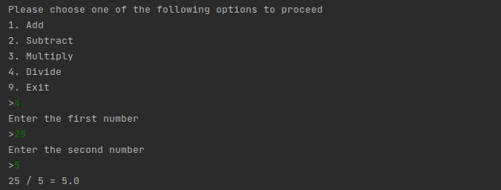

Task 2
Code:
# # # # # # # # # # # # # # # # # # # # # # # # # # # # # # # # # # # # # # # # # # # # # #
# Coded by: #
# Muhammad Afif Ul Hasnain #
# # # # # # # # # # # # # # # # # # # # # # # # # # # # # # # # # # # # # # # # # # # # # #
# define function
def fact(n):
# if n is greater than 0, take fact of n-1
if n > 0:
return n*fact(n-1)
# if n <= 0, return 1
else:
return 1
# ask the user to input a number
print("Enter the number you want the factorial to be calculated for")
# got the input
cin = int(input(">"))
# calculate factorial
factorail = fact(cin)
# display
print(str(cin)+"! = "+str(factorail))

Output:
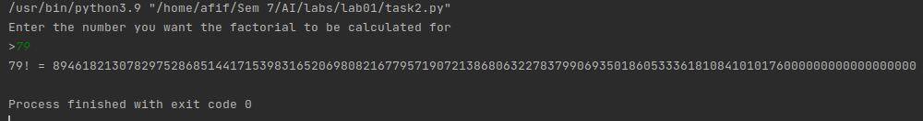

Task 3
Code:
# # # # # # # # # # # # # # # # # # # # # # # # # # # # # # # # # # # # # # # # # # # # # #
# Coded by: #
# Muhammad Afif Ul Hasnain #
# # # # # # # # # # # # # # # # # # # # # # # # # # # # # # # # # # # # # # # # # # # # # #
# Get initial string as input
print("Enter a string")
strin = input(">")
# split the string
strin = strin.split(" ")
# declare empty string
piglatin = ""
# loop through splitted string parts
for substr in strin:
# if full stop or comma or exclaimation mark or question mark, skip
if substr[-1] == '.' or substr[-1] == ',' or substr[-1] == '!' or substr[-1] == '?':
temp = substr[0]
# use second to last character and not the last character
temp1 = substr[-2]
piglatin = piglatin + temp1 + substr[1:-2] + temp + " "
else:
temp = substr[0]
temp1 = substr[-1]
piglatin = piglatin + temp1 + substr[1:-1] + temp + " "
# print oputput
print(piglatin)

Output:
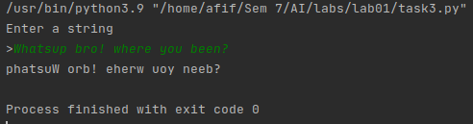

Home Task
Code:
# # # # # # # # # # # # # # # # # # # # # # # # # # # # # # # # # # # # # # # # # # # # # #
# Coded by: #
# Muhammad Afif Ul Hasnain #
# # # # # # # # # # # # # # # # # # # # # # # # # # # # # # # # # # # # # # # # # # # # # #
# get sequence size
print("Enter the number of Numbers to calculate ")
n = int(input(">"))
# get seed values to grow the sequence from
print("Enter seed values")
a = int(input(">"))
b = int(input(">"))
series = [a, b]
# loop to generate new numbers
for i in range(1,n):
new_num = series[i] + series[i-1]
series.append(new_num)
# display the results
print("The fibonacci series generated is:")
print(series)

Output:
