# LAB # 6:

## GREEDY BEST FIRST SEARCH FOR GRAPHs

**Objectives:**

* To implement Greedy Best First Search (GBFS or GFS) algorithm for graphs using python

**Hardware/Software Required:**

Hardware: Desktop/ Notebook Computer

Software Tool: Python 2.7/ 3.6.2

**Introduction:**

In this Lab we will see one of the informed search strategies i.e., Best First Search Algorithm. In this algorithm node selected for expansion depends on **evaluation function *f(n).*** This evaluation constructed on cost estimate, hence the vertex with lowest cost is expanded first. Best first Search also uses a **Heuristic Function** ***h(n).***

***h(n) = estimated cost of the cheapest path from the state at node n to a goal state***

Greedy Best First Search (GBFS) is based on greedy algorithm in which node that is closest to the goal node is expanded first. GBFS uses heuristic function for node evaluation. Since at any level, BFS expands a node with the lowest cost so we need to implement a priority queue to hold the nodes with their costs as priority.

The pseudocode for the BFS is given below:

BFS(Graph g, sNode, goal, priority = 0, path = [])

Initialize a Priority Queue ‘PQ’ and insert sNode in it.

while PQ is not empty

u = PQ.get()

if u.value is the goal

return path

else

foreach neighbor v of u

foreach key in v

if key not in path

Insert v in PQ

Append u.value in path

return path

**Lab Tasks:**

1. Study ‘queue’ and use it to develop priority queues in python and check if it’s working properly.

2. Implement Best First Search using edge cost as an evaluation function algorithm in python for following graph 1

3. Implement Best First Search using cost estimate function and Greedy Best First Search using heuristic values given in figure 1 in python for graph 2.

4. Write down your opinion based on the outputs of task3.

**Graph 1: Start Node:** A, **Goal:** G

**Graph2: Start Node:** Arad, **Goal:** Bucharest

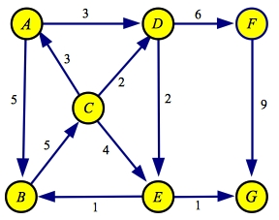

Graph 1

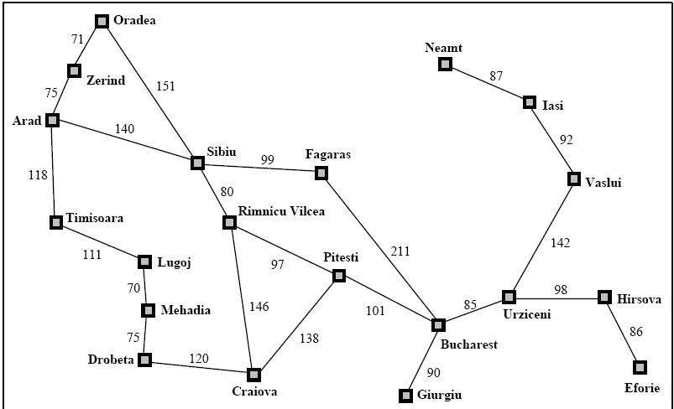

Graph 2

Figure 1:Values of h(n)—straight-line distances for Graph 2.

5.Write a script to decompose the given image into an undirected graph where the pixel represents the vertices and adjacent vertices are connected to each other via 4-connectivity and the cost on edges between adjacent nodes is their intensity differences. Use GBFS algorithm to traversal decomposed image starting from pixel 150 to pixel 165.

|  |  |  |
| --- | --- | --- |
| 150 | 2 | 5 |
| 80 | 145 | 45 |
| 74 | 102 | 165 |

**Conclusion:**

Write the conclusion about this lab

**NOTE:** A lab journal is expected to be submitted for this lab.