# LAB # 7:

## A* SEARCH FOR GRAPHs

**Objectives:**

* To implement optimal A* algorithm for graphs using python

**Hardware/Software Required:**

Hardware: Desktop/ Notebook Computer

Software Tool: Python 2.7/ 3.6.2

**Introduction:**

A* is the best form of greedy first search that gives path with optimal cost for reaching goal from the start node. A* search not only checks the heuristic value at each node, but it also adds the path cost for reaching that node as well along with the heuristics through which the global optimal path is achieved. The shortest path is obtained through Dijkstra’s algorithm where the path cost at each node is calculated as:

$$f\left(n\right)=g\left(n\right)+h(n)$$

Where f(n) is the path cost at nth node, h(n) is the heuristic value of nth node to goal, g(n) is the cost for reaching nth node from start. The C for the A* search is given below:

AStar(graph, heuristic, startNode, goal):

Initialize PriorityQueue

Add ‘startNode’ in PriorityQueue with minimal priority

Initialize a dictionary ‘cameFrom’ with the first key as startNode

Initialize another dictionary ‘costSoFar’ with first key as startNode along with its cost

while q is not empty:

currentNode = PriorityQueue.get()

foreach neighbor in graph[currentNode]:

for key in neighbor.keys():

newCost = costSoFar[currentNode] + costToReachNeighbor

if key not in costSoFar or newCost < costSoFar[key]:

costSoFar[key] = [newCost]

priority = newCost + heuristics[key]

q.put((key,priority))

cameFrom[key] = [currentNode]

return reconstructPath(cameFrom, startNode, goal)

reconstructPath(cameFrom, start, goal):

current = goal

initialize ‘path’ list

while current is not start:

append ‘current’ in path

update ‘current’ to cameFrom[current]

append ‘start’ in ‘path’

reverse the ‘path’ list

return path

**Lab Tasks:**

1. Implement Priority Queue.

2. Implement A* algorithm in python for following graph:

**Graph1: Start Node:** Arad, **Goal:** Bucharest

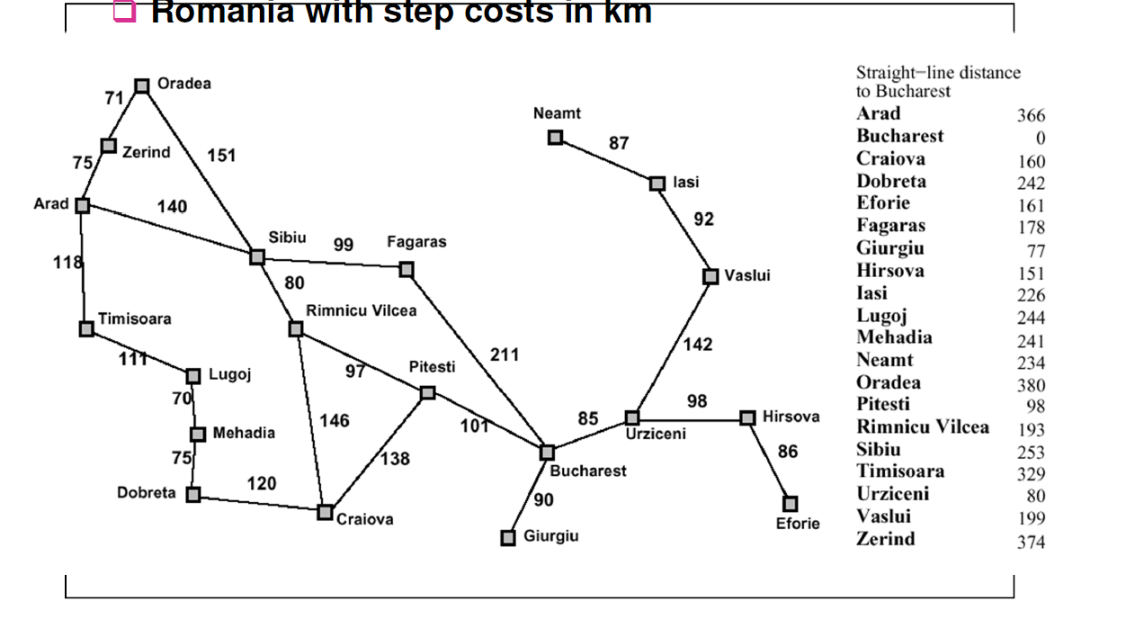

**Graph 1**

3.Write a script to decompose the given image into an undirected graph where the pixel represents the vertices and adjacent vertices are connected to each other via 4-connectivity and the cost on edges between adjacent nodes is their absolute intensity differences. The heuristic values should be calculated by taking the Manhattan distance for each pixel coordinates. The Manhattan distance between two points ($x_{0},y_{0}$) and ($x_{1},y_{1}$) can be calculated as:

$$D=\left|y_{1}-y_{0}\right|+|x_{1}-x_{0}|$$

Use A* algorithm to traverse decomposed image starting from pixel 150 to pixel 165.

|  |  |  |
| --- | --- | --- |
| 150 | 2 | 5 |
| 80 | 145 | 45 |
| 74 | 102 | 165 |

**Conclusion:**

Write the conclusion about this lab

**NOTE:** A lab journal is expected to be submitted for this lab.