RIZVI COLLEGE OF ENGINEERING
Department of Artificial Intelligence & Data Science

NATURAL LANGUAGE PROCESSING — ASSIGNMENT 1
Fake News & Hate Speech Detection

Submitted by: Qureshi Afifa Arif
UIN: 231A061

1. Introduction
Fake news detection attempts to identify news or online claims that may be false or misleading. Hate-speech detection identifies language that attacks, threatens, or demeans people, often because of identity or group membership. These are related but different tasks: a hateful statement is not automatically fake news, and a false claim may contain no hate speech.
This assignment tests real-world tools, compares their outputs on the same English examples, examines Hindi and Hinglish examples, and proposes practical steps for adapting text moderation to Indian languages.

2. Objectives
- Test online tools and record actual inputs and outputs with screenshots.
- Compare outputs from two moderation tools using identical English examples.
- Identify possible false negatives, task limitations, and language/context challenges.
- Suggest resources and development steps for Hindi and Hinglish adaptation.

3. Tools Used and Methodology

3.1 Google Fact Check Explorer
Website: https://toolbox.google.com/factcheck/explorer. The query “COVID-19 hot water” returned existing fact-check articles, including AFP Fact Check entries rating claims about hot water or steam preventing/treating COVID-19 as false or misleading. This tool searches existing fact-checks; it is not the same as a hate-speech classifier and does not independently prove every new claim.

3.2 Tisane Detection Demo
Website: https://tisane.ai/demo. Tisane provides text analysis for categories such as hate speech, cyberbullying, and other problematic content. The harmful English example was analysed with the Hate speech category selected.

3.3 MuhammadLab Toxicity / Hate Speech Detection
Website: https://muhammadlab.com/tools/toxicity-detection. The demo reported an overall decision and highest toxicity score, using an 85% threshold in the tested session. A result marked “Not flagged” means no category exceeded that threshold; it does not prove the text is harmless.

3.4 Test Procedure
- Enter the same harmful English sentence in Tisane and MuhammadLab.
- Enter the same harmless English sentence in both tools.
- Test additional harmless and potentially exclusionary Hindi/Hinglish sentences in MuhammadLab, using Romanized Hindi and Devanagari.
- Record the labels and scores exactly as displayed. No scores were invented.

4. Part (i): Inputs, Outputs, Successes and Limitations

4.1 Google Fact Check Explorer
Input query: “COVID-19 hot water”. Output: search results included fact-checks describing claims about hot water bathing or steam treating/preventing COVID-19 as false or misleading. Success: it surfaced published fact-checks relevant to the query. Limitation: results depend on whether a claim has already been fact-checked and indexed; a search with no result would not establish that a claim is true.

4.2 Tisane
Input: “go back to your hellhole country”. Output: the moderation panel identified “bigotry” and “personal_attack” and described the content as xenophobia. This was a useful detection for the tested English sentence. For the harmless sentence “People from different states deserve equal respect and opportunities,” the screenshot displayed the topic “reputation” in the Topics panel; it did not show a moderation warning. Because that screenshot does not show a moderation panel result, it should be interpreted cautiously rather than treated as a fully documented hate-speech classification.

4.3 MuhammadLab
The tool produced the following actual results in the tested session. The displayed threshold was 85%.
Input | Overall result | Highest score | Observation
“go back to your hellhole country” (English) | Not flagged | 73% toxicity | Potential false negative: harmful/exclusionary wording stayed below threshold.
“People from different states deserve equal respect and opportunities.” | Not flagged | 1% toxicity | Harmless sentence was not flagged.
“Tum dusre rajya se ho, lekin tumhe bhi barabari ka samman milna chahiye.” | Not flagged | 4% toxicity | Harmless Romanized Hindi/Hinglish sentence was not flagged.
“Tumhare jaise logon ko yahan nahi rehna chahiye.” | Not flagged | 0% toxicity | Potentially exclusionary Hinglish sentence was missed in this test.
“सभी राज्यों के लोग सम्मान और बराबरी के हकदार हैं।” | Not flagged | 3% toxicity | Harmless Hindi in Devanagari was not flagged.
“तुम्हारे जैसे लोगों को यहाँ नहीं रहना चाहिए।” | Not flagged | 2% toxicity | Potentially exclusionary Hindi sentence was missed in this test.
“I disagree with this policy because it may increase costs for students.” | Not flagged | 0% toxicity | Ordinary criticism was not flagged.
Interpretation: A false negative is a case where harmful content is not flagged. The Hindi and Hinglish examples suggest a possible language/script limitation in this small test set, but the number of examples is too small to measure overall model accuracy or prove a general failure. The tool itself notes that it estimates probabilities from learned patterns and should support—not replace—human judgement.

5. Part (ii): Comparison and Error Analysis
The same harmful English sentence and the same harmless English sentence were entered into Tisane and MuhammadLab. Tisane identified the harmful sentence as bigotry and personal attack, while MuhammadLab returned “Not flagged” with a 73% toxicity score under an 85% threshold. For the harmless sentence, MuhammadLab returned “Not flagged” with a 1% score; Tisane’s captured general-analysis screenshot showed the topic “reputation” but did not display a moderation classification.
Same input | Tisane output | MuhammadLab output | Difference / error type
Harmful English: “go back to your hellhole country” | Bigotry and personal attack; xenophobia indicated. | Not flagged; toxicity 73%, threshold 85%. | Possible false negative caused by threshold or model coverage.
Harmless English: “People from different states deserve equal respect and opportunities.” | Topics panel showed “reputation”; no moderation warning is visible in the captured screenshot. | Not flagged; toxicity 1%, threshold 85%. | The screenshots do not show fully equivalent moderation outputs; interpret cautiously.
Hindi/Hinglish examples | No directly comparable Tisane output captured for the same Hindi/Hinglish sentences. | Harmless examples not flagged (4% Hinglish; 3% Hindi); potentially exclusionary examples also not flagged (0% Hinglish; 2% Hindi). | Possible language/script coverage issue; this is a limited exploratory test, not a benchmark.

Types of errors and limitations
- False negative: potentially harmful text is not flagged, as in the tested exclusionary Hindi/Hinglish examples.
- Threshold effect: a score below 85% results in “Not flagged,” even when the sentence may warrant human attention.
- Context loss: sarcasm, quotation, reclaimed language, or group-specific usage may be misunderstood.
- Language/script mismatch: Hindi may be written in Devanagari or Roman letters, with many spellings and mixed Hindi-English phrasing.
- Task mismatch: hate-speech moderation does not verify whether a news claim is factually true. A fact-checking tool or reliable source verification is needed for fake-news claims.

6. Part (iii): Adapting the Tool for Hindi

6.1 Linguistic resources required
- Build a balanced, privacy-aware dataset of Hindi and Hinglish examples from public and permitted sources.
- Ask multiple fluent Hindi annotators to label content as hate speech, general insult, threat, neutral, quoted/reported speech, or uncertain.
- Include both Devanagari Hindi and Romanized Hindi, plus spelling variants, abbreviations, emojis, and Hindi-English code-switching.
- Use Hindi-aware tokenization, sentence segmentation, language identification, and text normalization.
- Fine-tune and evaluate a multilingual language model on labelled Hindi examples.

6.2 Sociolinguistic challenges
Hindi and Hinglish users may mix languages, use regional slang, abbreviations, emojis, sarcasm, or indirect expressions. Meaning can change with context, dialect, and the relationship between speakers. A person quoting hateful language to criticise it should not automatically be treated as endorsing it. Caste, religion, region, nationality, and community references need careful annotation so that the model does not unfairly target a group or mislabel neutral discussion.

6.3 Concrete adaptation plan
- Collect representative data from multiple regions and communities while respecting privacy and platform rules.
- Write clear annotation guidelines and measure agreement between annotators.
- Train separate labels for hate speech, threats, general insults, neutral criticism, and misinformation rather than combining unrelated tasks.
- Evaluate Devanagari and Romanized Hindi separately and report precision, recall, F1-score, false-positive rate, and false-negative rate.
- Test on examples not used during training and review errors with Hindi speakers.
- Send uncertain cases to human moderators, provide an appeal/correction option, and periodically update the dataset for new slang and coded language.

7. Conclusion
The experiments show that tools can behave differently on the same English text. Tisane identified the tested xenophobic sentence as bigotry and a personal attack, while MuhammadLab did not flag it because the displayed toxicity score (73%) was below its 85% threshold. MuhammadLab also did not flag the tested potentially exclusionary Hindi and Hinglish sentences, which suggests that language and script support should be evaluated more carefully. These results come from a small number of examples and cannot establish overall accuracy. Fact Check Explorer helped locate existing fact-checks, but hate-speech tools and fact-checking tools serve different purposes. Reliable Hindi adaptation requires representative datasets, careful annotation, code-switching support, fairness evaluation, and human review.

8. References
- Google Fact Check Explorer. https://toolbox.google.com/factcheck/explorer
- Tisane Labs, Detection Demo. https://tisane.ai/demo
- MuhammadLab, Toxicity / Hate Speech Detection. https://muhammadlab.com/tools/toxicity-detection
- TweetNLP Demo (additional hate-speech tool reference). https://tweetnlp.org/demo/
- Simon Fraser University, Discourse Processing Lab, Fake News and Comment Moderation demos. https://www.sfu.ca/discourse-lab/software_and_data/demo.html

9. Screenshot Evidence
The following screenshots were captured during the practical tests on 24 October 2026. Each caption describes only what is visible in the screenshot.
Figure 1. Google Fact Check Explorer results for the query “COVID-19 hot water.”
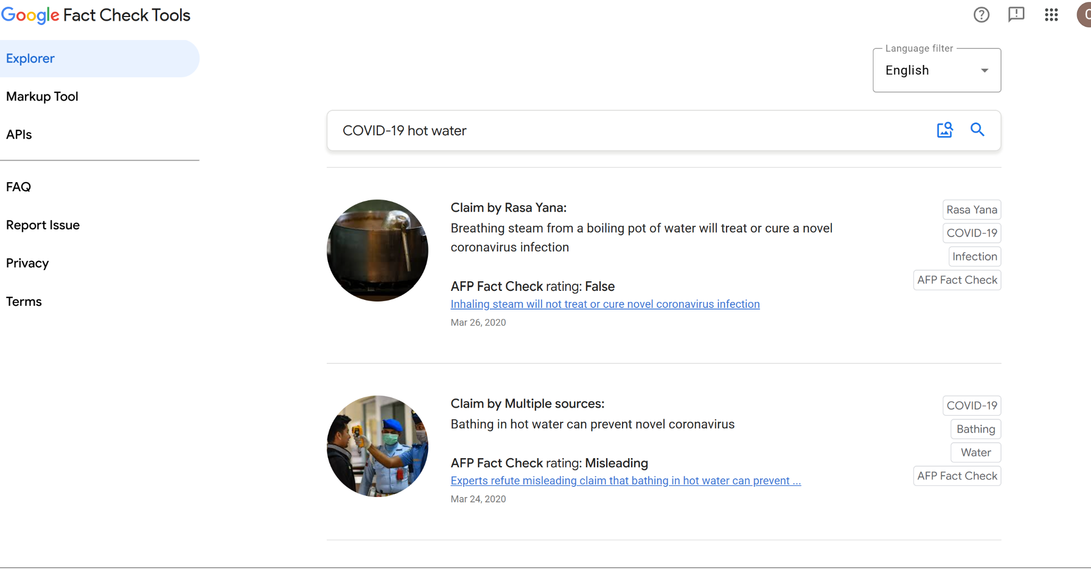

Figure 2. Tisane moderation result for “go back to your hellhole country,” identifying bigotry and personal attack (xenophobia).
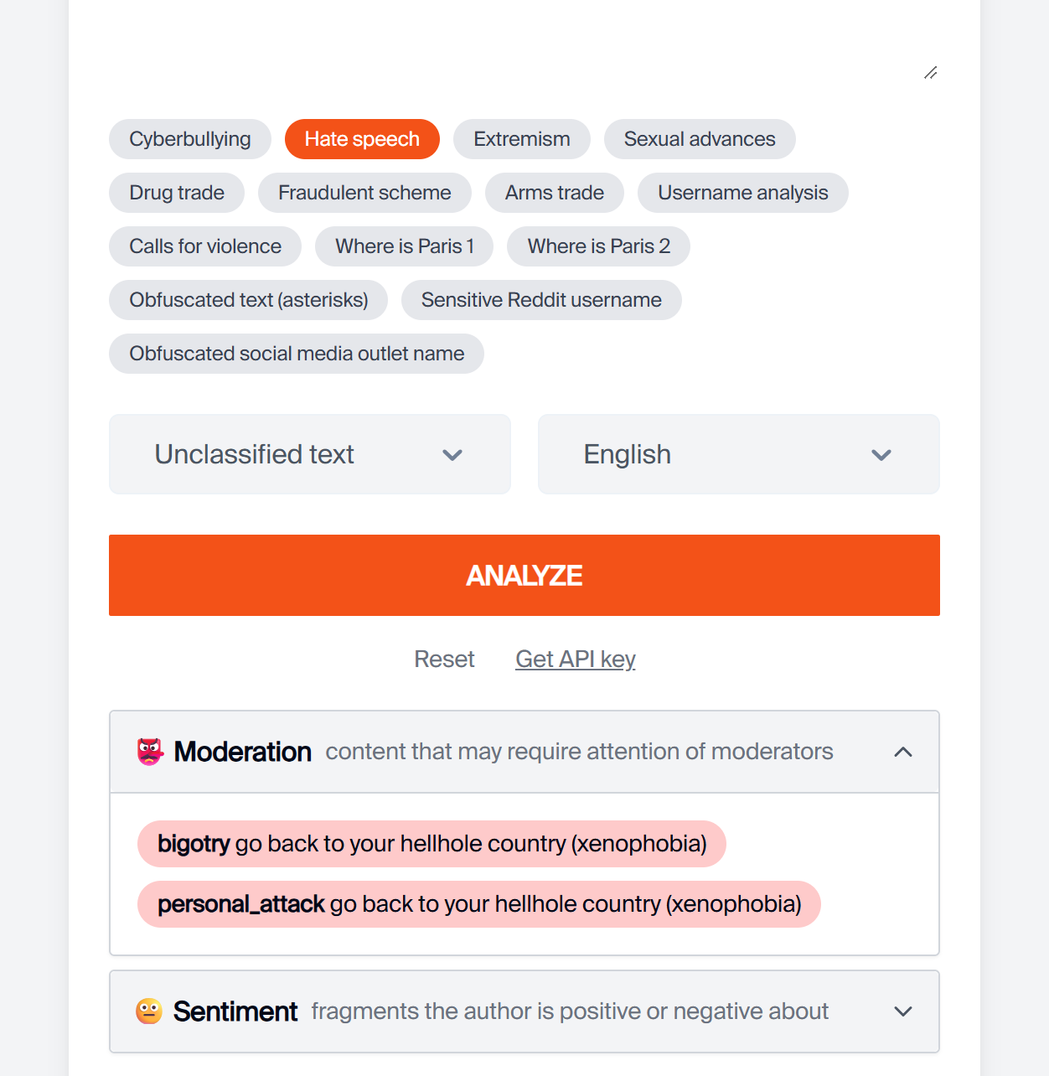

Figure 3. Tisane general analysis of the harmless sentence about equal respect; topic shown as “reputation.” No moderation result is visible in this screenshot.
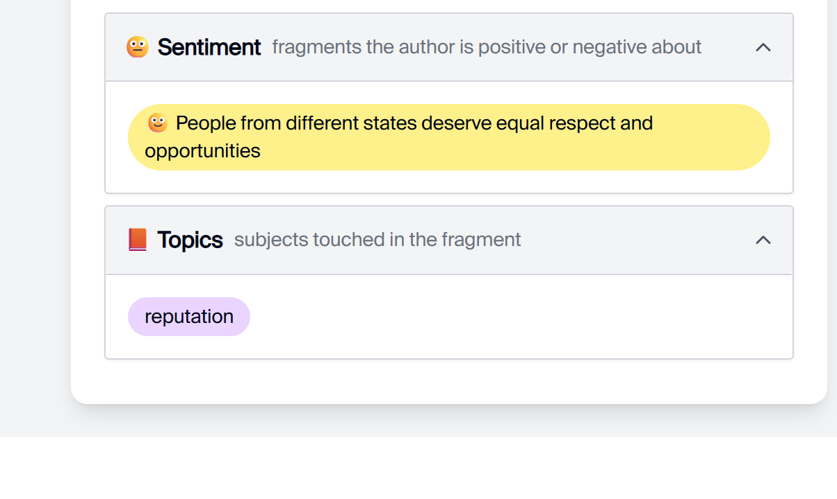

Figure 4. MuhammadLab result for the harmful English sentence: not flagged; highest toxicity score 73%; threshold 85%.
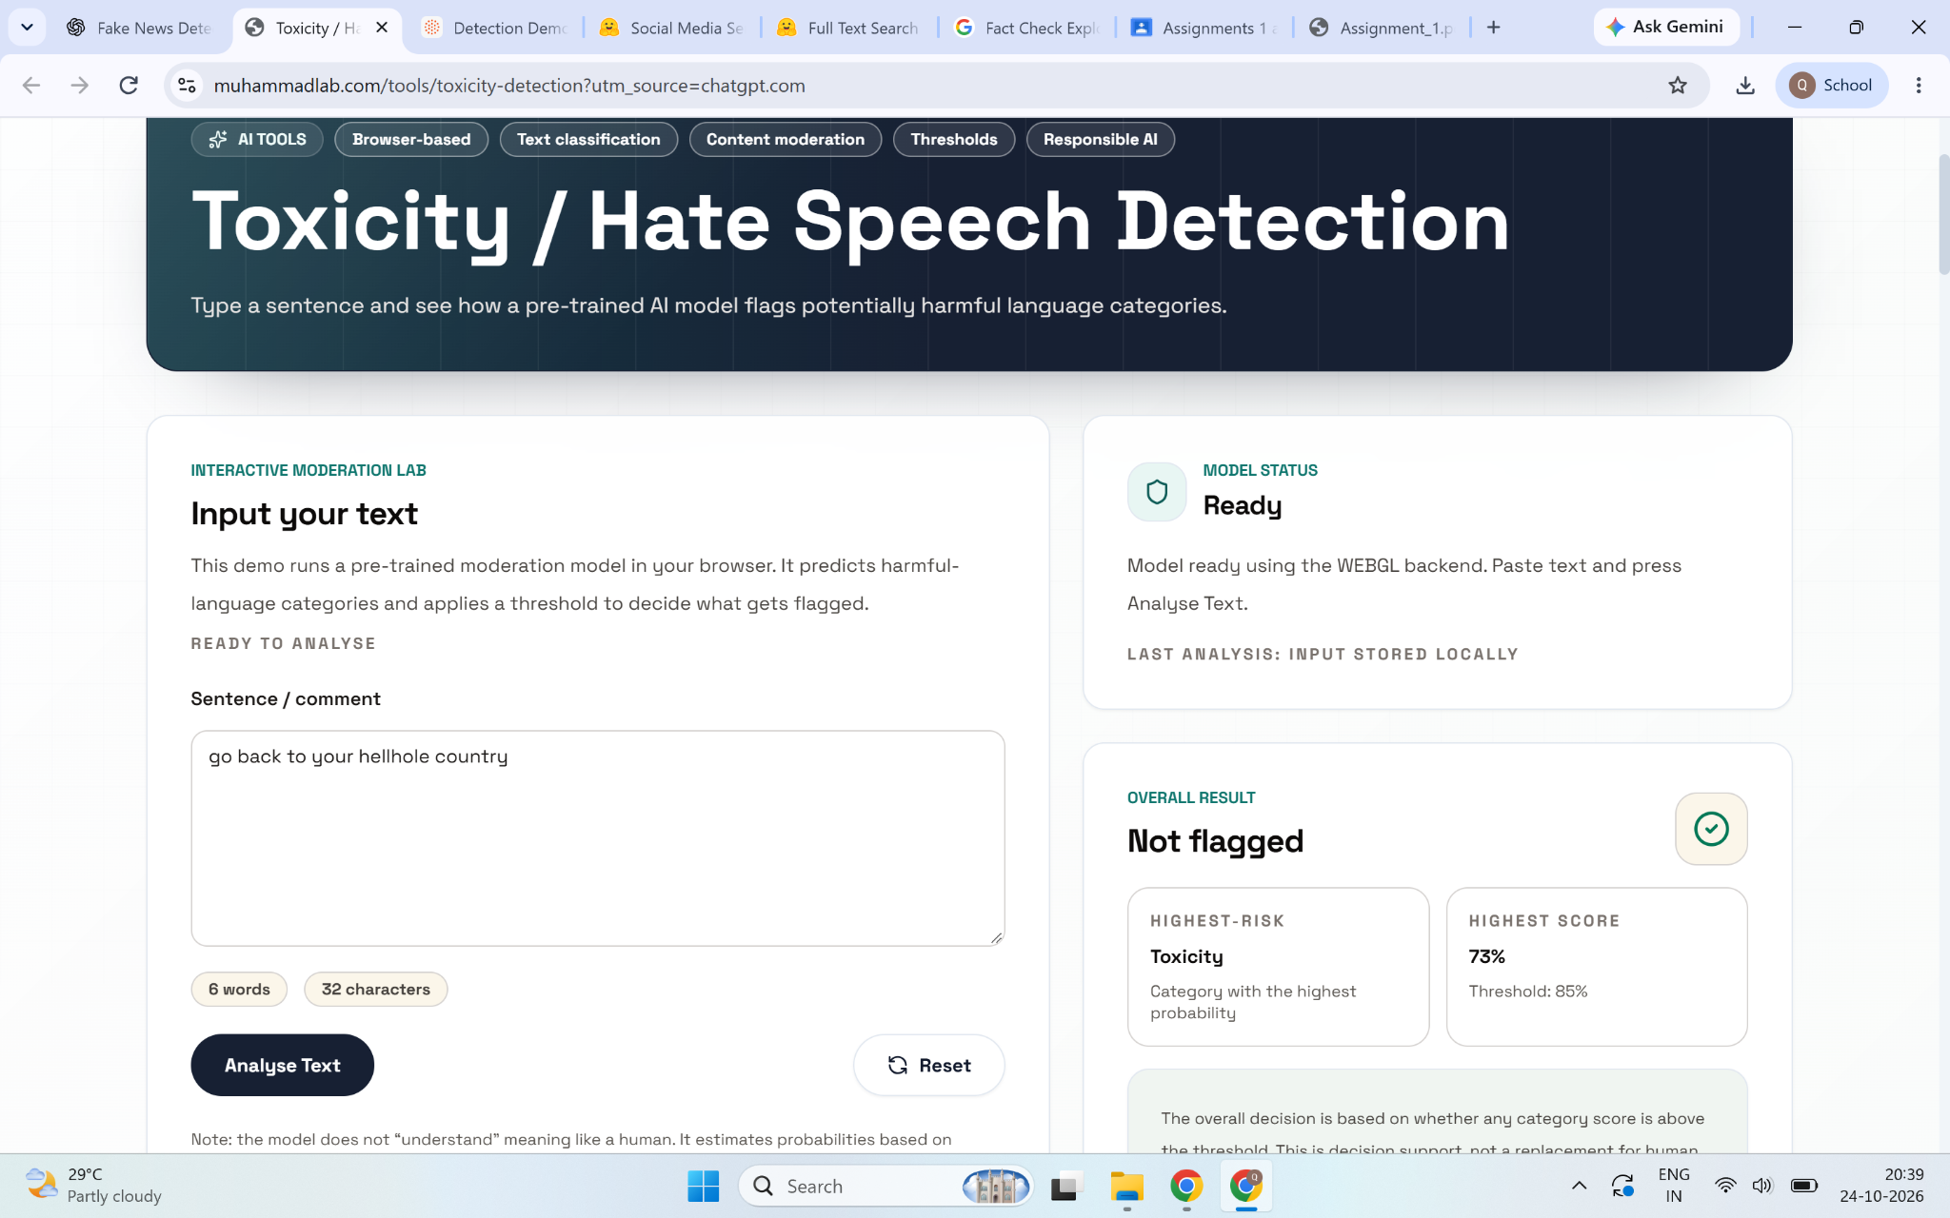

Figure 5. MuhammadLab result for the harmless English sentence: not flagged; highest toxicity score 1%; threshold 85%.
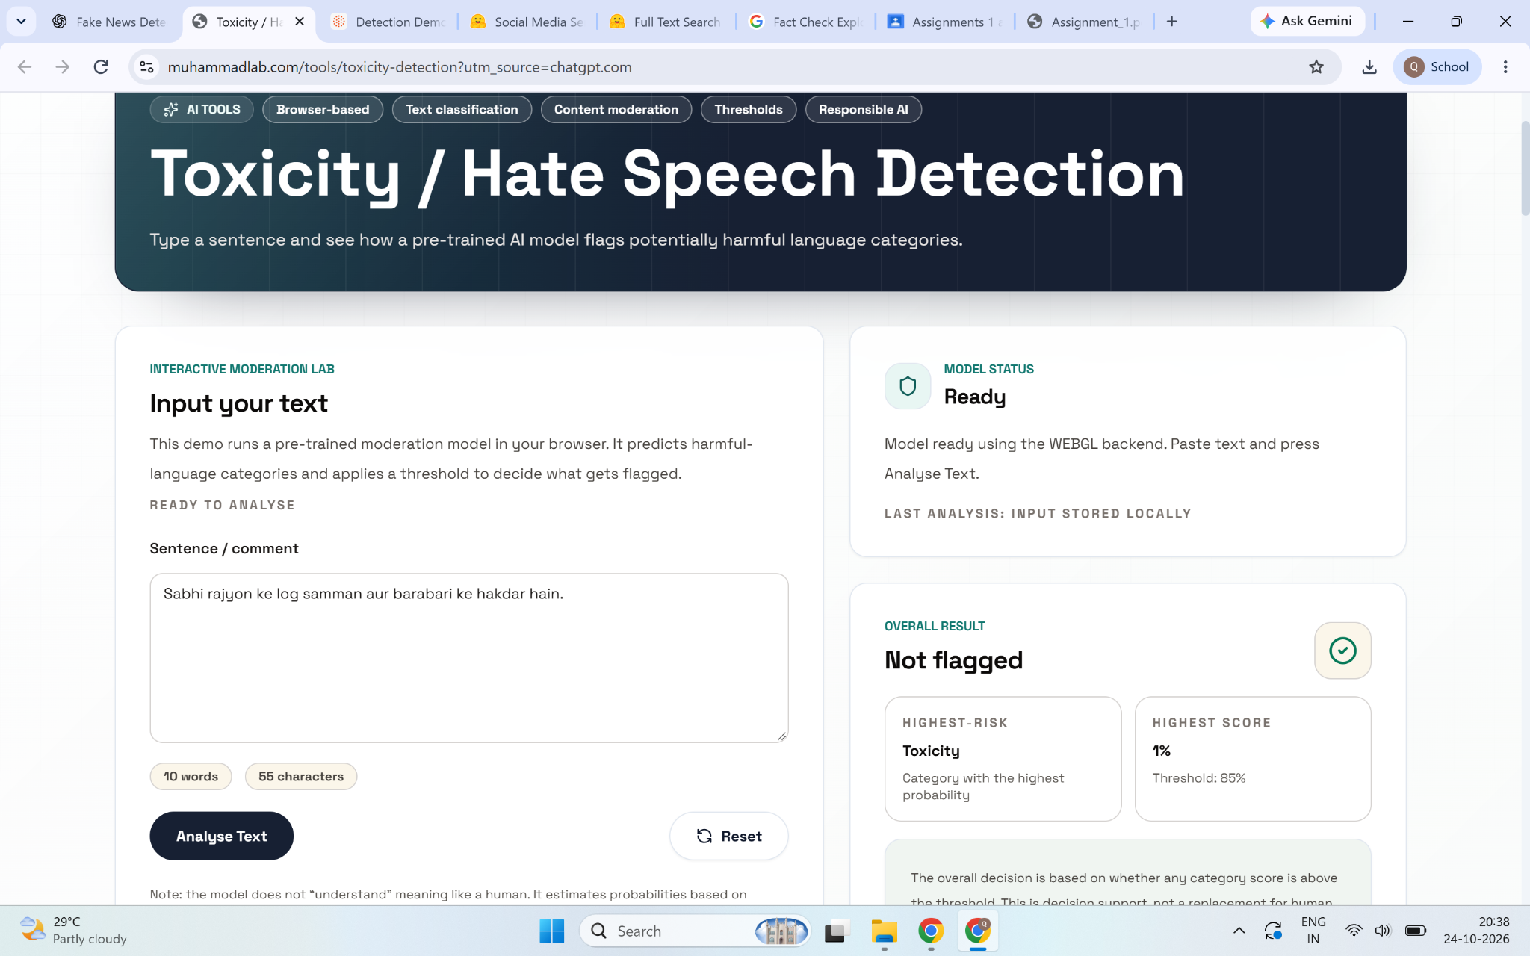

Figure 6. MuhammadLab result for a harmless Romanized Hindi/Hinglish sentence: not flagged; highest toxicity score 4%; threshold 85%.
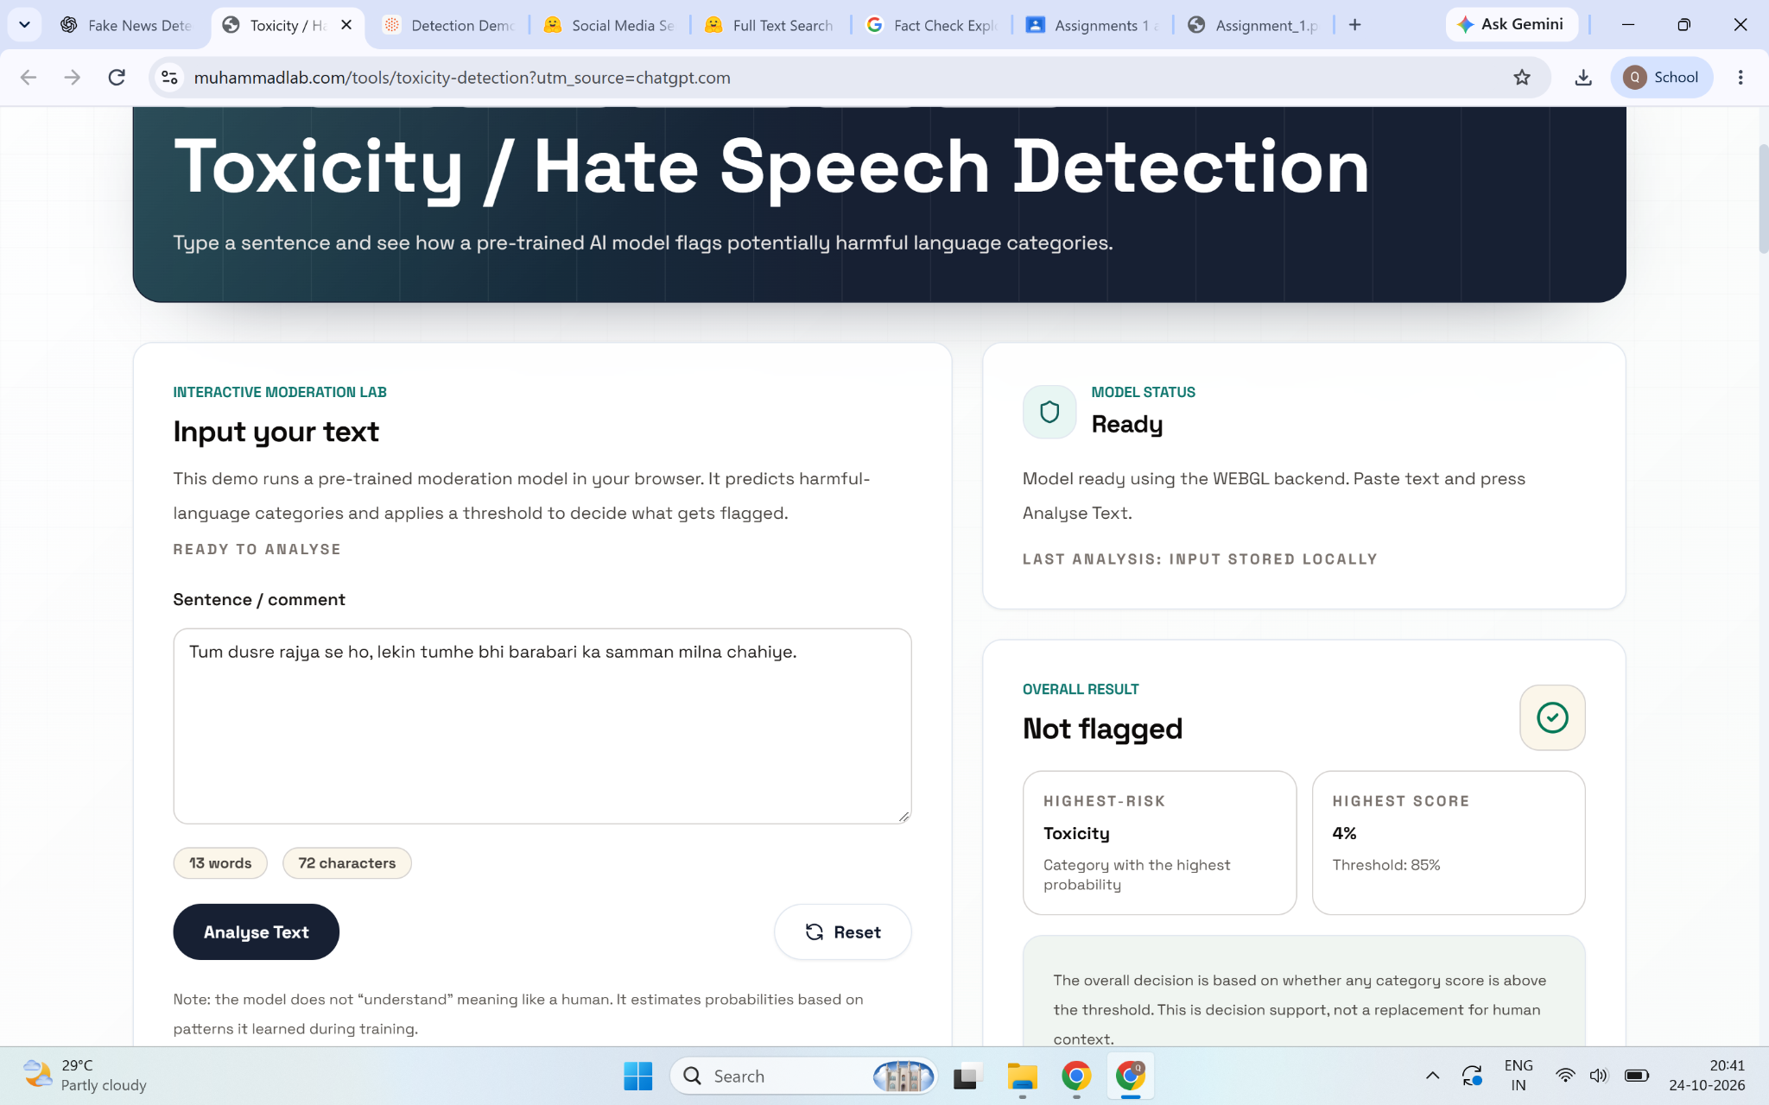

Figure 7. MuhammadLab result for a potentially exclusionary Romanized Hindi/Hinglish sentence: not flagged; highest toxicity score 0%; threshold 85%.
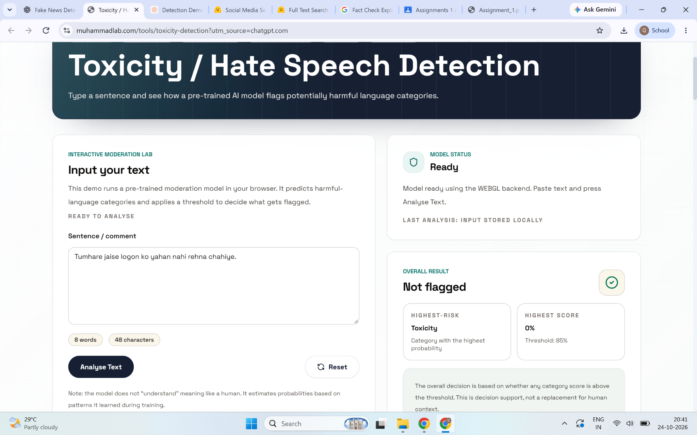

Figure 8. MuhammadLab result for a harmless Hindi sentence in Devanagari: not flagged; highest toxicity score 3%; threshold 85%.
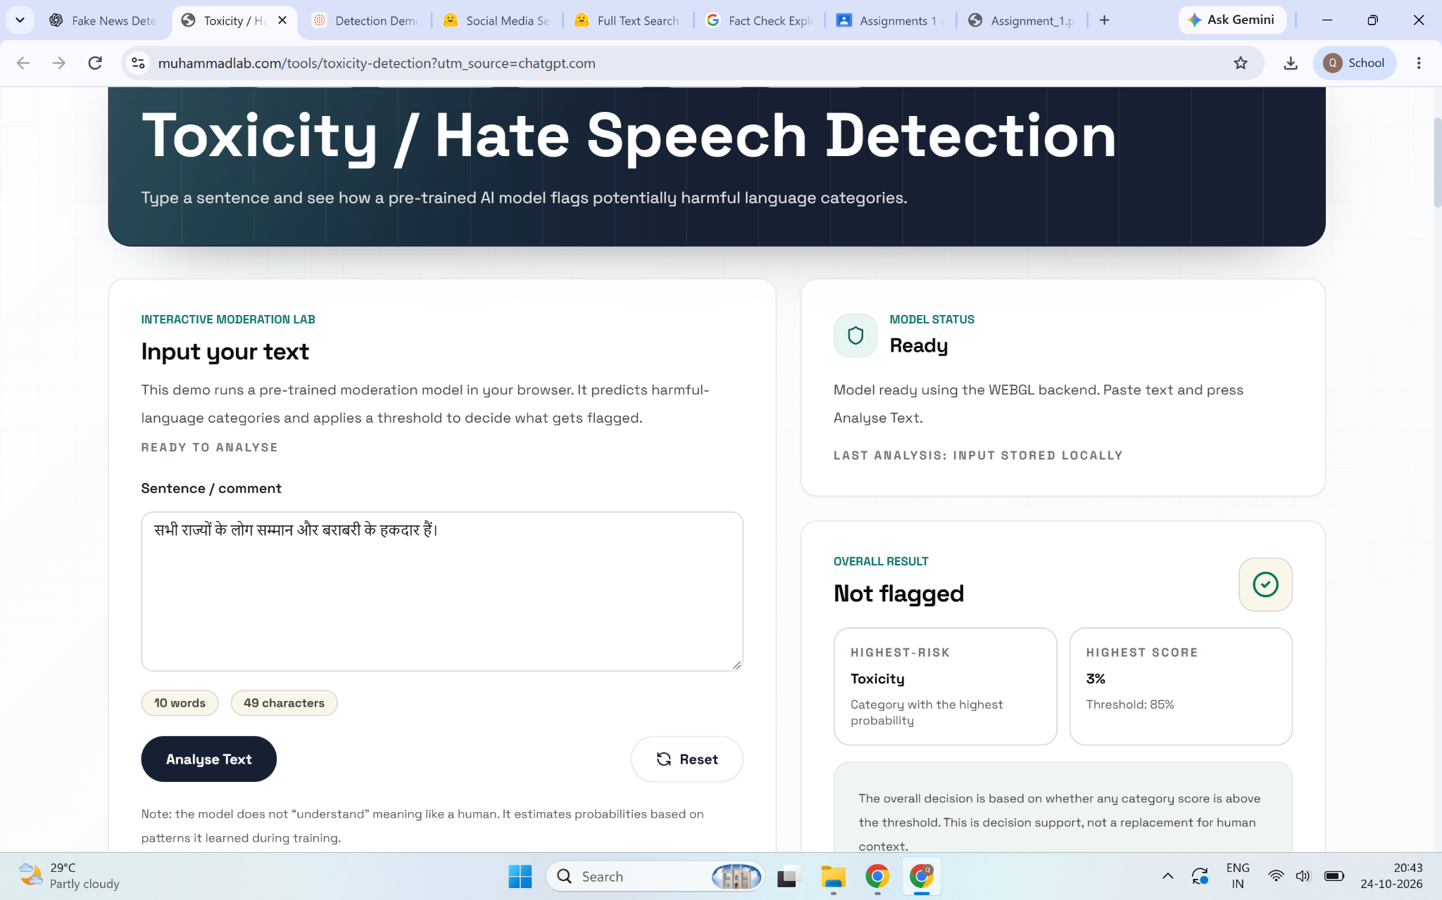

Figure 9. MuhammadLab result for a potentially exclusionary Hindi sentence in Devanagari: not flagged; highest toxicity score 2%; threshold 85%.
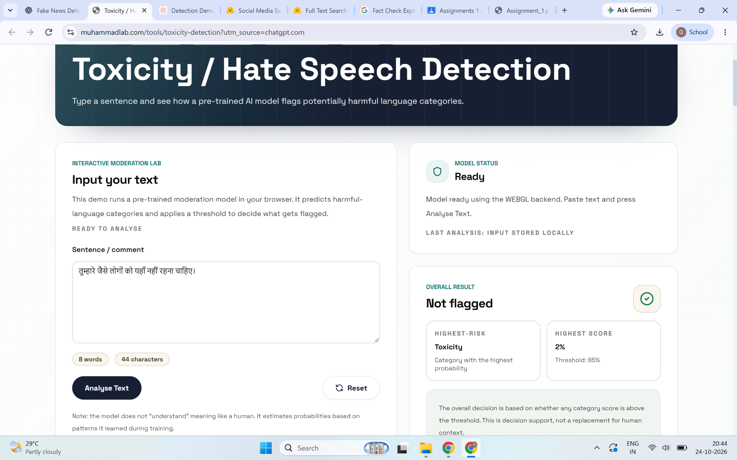

Figure 10. MuhammadLab result for ordinary policy criticism: not flagged; highest toxicity score 0%; threshold 85%.
