SVKM’s NMIMSSVKM’s NMIMS
School of Technology Management & Engineering, Chandigarh
A.Y. 2026 - 27
Course: Database Management Systems
Project Report
Program | Masters in computer applications
Semester | I
Name of the Project: | Library Management System
Details of Project Members
Batch | Roll No. | Name
2 | A053 | Afifa Shaikh
1 | A023 | Umam Hashmi
Date of Submission:

Contribution of each project Members:
Roll No. | Name: | Contribution
A053 | Afifa Shaikh
A023 | Umam Hashmi

Github link of your project:
https://github.com/afifaaaaah/A053-A023_DBMSProject_Report.git
Note:
- Create a readme file if you have multiple files
- All files must be properly named (Example:R004_DBMSProject)
- Submit all relevant files of your work ( Report, all SQL files, Any other files)
- Plagiarism is highly discouraged (Your report will be checked for plagiarism)

Rubrics for the Project evaluation:
First phase of evaluation:  Innovative Ideas (5 Marks)  Design and Partial implementation (5 Marks) | 10 marks
Final phase of evaluation  Implementation, presentation and viva, Self-Learning and Learning Beyond classroom | 10 marks

Project Report
Library Management System

By-
Afifa Shaikh, Roll number: A053
Umam Hashmi, Roll number: A023

Course: DBMS

AY: 2026-27

Table of Contents

Sr no. | Topic | Page no.
1 | Storyline | 4
2 | Components of Database Design | 5-6
3 | Entity Relationship Diagram | 7
4 | Relational Model | 7
5 | Normalization | 8-9
6 | SQL Queries | 9-19
7 | Project Demonstration | 20-21
8 | Self-learning beyond classroom | 21
9 | Learning from the project | 21-22
10 | Challenges faced | 22
11 | Conclusion | 23

I. Storyline
A small college library lends books to students. At the moment all records are kept on paper, so it is hard to answer simple questions: Who has this book? When is it due? How many copies are left? Which books are overdue?
To fix this, we design a small database with three kinds of data:
- Members: students registered in the library.
- Books: the books the library owns, with the number of copies available.
- Issues: a record created every time a member borrows a book (issue date, due date, return date).
Requirements:
- Store member details (name, email, phone, join date).
- Store book details (title, author, category, copies available).
- A member can borrow many books, and a book can be borrowed by many members over time.
- Every borrowing must record the issue date, due date and return date (empty until returned).
- The librarian should be able to find unreturned books, overdue books, popular books, and fines.

II. Components of Database Design

Entities, attributes and primary keys
Entity | Attributes | Primary Key
Member | member_id, name, email, phone, join_date | member_id
Book | book_id, title, author, category, copies_available | book_id
Issue | issue_id, member_id, book_id, issue_date, due_date, return_date | issue_id
Foreign keys: Issue.member_id references Member.member_id, and Issue.book_id references Book.book_id.

Relationships, cardinality and participation
Relationship | Cardinality | Participation
Member borrows Book (through Issue) | Many-to-Many (M:N) | Member: partial, Book: partial
Member has Issue | One-to-Many (1:N) | Member: partial (a member may never borrow), Issue: total (every issue belongs to a member)
Book appears in Issue | One-to-Many (1:N) | Book: partial (a book may never be issued), Issue: total (every issue is for a book)
In simple words: one member can have many issue records, one book can have many issue records, and every issue record must have exactly one member and one book. The Issue table turns the many-to-many relationship into two one-to-many relationships.

III. Entity Relationship Diagram
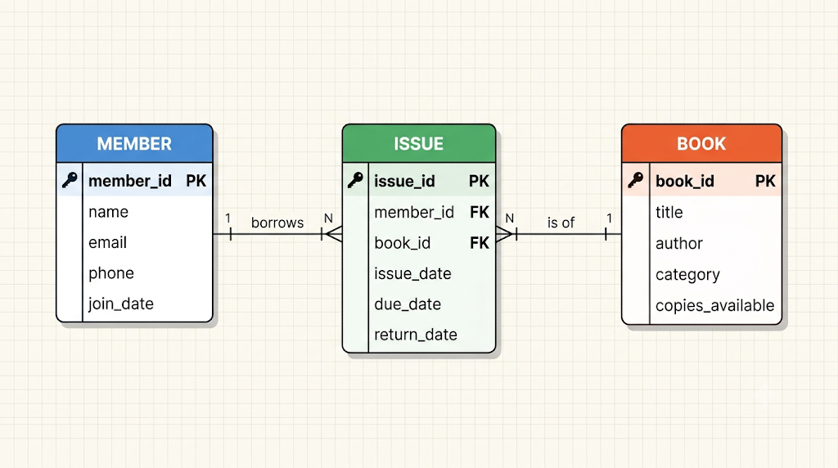

IV. Relational Model
The ER diagram converts into 3 tables. Primary keys are marked PK and foreign keys FK:
- Member(member_id PK, name, email, phone, join_date)
- Book(book_id PK, title, author, category, copies_available)
- Issue(issue_id PK, member_id FK, book_id FK, issue_date, due_date, return_date)
Conversion rules used: each strong entity becomes a table; the one-to-many relationships are stored by placing the "one" side's primary key as a foreign key in the "many" side (Issue).

V. Normalization
Starting (unnormalized) table: one row per member, with several books in one cell.
member_id | member_name | phone | books_borrowed
1 | Aarav Sharma | 9876543210 | Database Systems, Wings of Fire
1NF (First Normal Form): every cell must hold a single value. We give each borrowed book its own row.
Loan(member_id, member_name, phone, book_id, title, author, issue_date, due_date, return_date) with key (member_id, book_id, issue_date).
2NF (Second Normal Form): no partial dependency on part of a composite key.
- member_id → member_name, phone (depends only on member_id)
- book_id → title, author, category (depends only on book_id)
So we split into Member, Book and Issue.
3NF (Third Normal Form): no non-key column depends on another non-key column. In Member, Book and Issue every non-key column depends only on its table's key. (due_date is chosen by the librarian for each issue and can be extended, so it is not a fixed function of issue_date.)
BCNF (Boyce-Codd Normal Form): for every functional dependency X → Y, X must be a candidate key.
- Member: member_id → all columns (also email → all columns, since email is UNIQUE and is a candidate key)
- Book: book_id → all columns
- Issue: issue_id → all columns
All determinants are candidate keys, so the database is in BCNF. There is no repeated data and no insert, update or delete anomaly.

VI. SQL Queries
Q1. (WHERE) List all Computer Science books.
SELECT title, author FROM Book WHERE category = 'Computer Science';

SCREENSHOT-
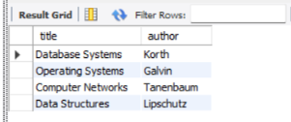

Q2. (ORDER BY) Members who joined after 1 May 2026, newest first.
SELECT name, join_date FROM Member
WHERE join_date > '2026-05-01' ORDER BY join_date DESC;

SCREENSHOT-
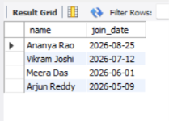

Q3. (LIKE) Books whose title starts with D.
SELECT title FROM Book WHERE title LIKE 'D%';

SCREENSHOT-
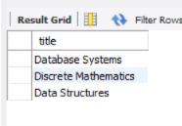

Q4. (BETWEEN) Books issued between 1 Oct and 10 Oct 2026.
SELECT issue_id, issue_date FROM Issue
WHERE issue_date BETWEEN '2026-10-01' AND '2026-10-10';

SCREENSHOT-

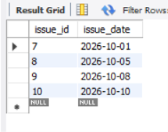

Q5. (IN) Biography and Poetry books with their copies.
SELECT title, copies_available FROM Book
WHERE category IN ('Biography','Poetry');

SCREENSHOT-

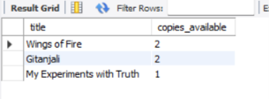

Q6. (DISTINCT) List the different book categories.
SELECT DISTINCT category FROM Book;

SCREENSHOT-

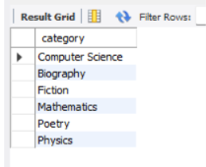

Q7. (Aggregate functions) Total books, total copies, average, maximum and minimum copies.
SELECT COUNT(*) AS total_titles, SUM(copies_available) AS total_copies,
AVG(copies_available) AS avg_copies,
MAX(copies_available) AS max_copies, MIN(copies_available) AS min_copies
FROM Book;

SCREENSHOT-

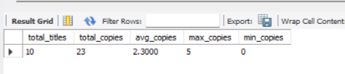

Q8. (GROUP BY) Number of books in each category.
SELECT category, COUNT(*) AS books FROM Book GROUP BY category;

SCREENSHOT-

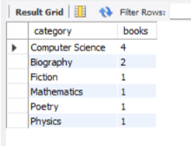

Q9. (HAVING) Members who have borrowed more than one book.
SELECT member_id, COUNT(*) AS total_borrowed FROM Issue
GROUP BY member_id HAVING COUNT(*) > 1;

SCREENSHOT-

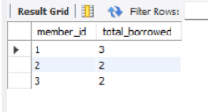

Q10. (INNER JOIN, 3 tables) Which books are currently not returned, and by whom?
SELECT m.name, b.title, i.due_date
FROM Issue i
JOIN Member m ON i.member_id = m.member_id
JOIN Book b ON i.book_id = b.book_id
WHERE i.return_date IS NULL;

SCREENSHOT-
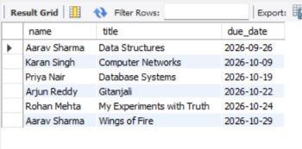

Q11. (LEFT JOIN) Members who have never borrowed a book.
SELECT m.name FROM Member m
LEFT JOIN Issue i ON m.member_id = i.member_id
WHERE i.issue_id IS NULL;

SCREENSHOT-
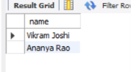

Q12. (Subquery with NOT IN) Books that have never been issued.
SELECT title FROM Book
WHERE book_id NOT IN (SELECT book_id FROM Issue);

SCREENSHOT-
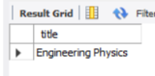

Q13. (Subquery with aggregate) Books with more copies than the average.
SELECT title, copies_available FROM Book
WHERE copies_available > (SELECT AVG(copies_available) FROM Book);

SCREENSHOT-
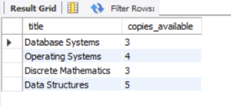

Q14. (JOIN + date condition) Overdue books (not returned and due date before 22 Oct 2026).
SELECT i.issue_id, m.name, b.title, i.due_date
FROM Issue i
JOIN Member m ON i.member_id = m.member_id
JOIN Book b ON i.book_id = b.book_id
WHERE i.return_date IS NULL AND i.due_date < '2026-10-22';

SCREENSHOT-
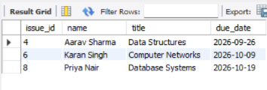

Q15. (GROUP BY + ORDER BY + LIMIT) Top 3 most issued books.
SELECT b.title, COUNT(*) AS times_issued
FROM Issue i JOIN Book b ON i.book_id = b.book_id
GROUP BY b.title
ORDER BY times_issued DESC, b.title
LIMIT 3;

SCREENSHOT-
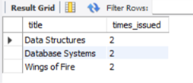

Q16. (UNION) Books that need attention: low stock (1 copy or less) or never issued.
SELECT title FROM Book WHERE copies_available <= 1
UNION
SELECT title FROM Book WHERE book_id NOT IN (SELECT book_id FROM Issue);

SCREENSHOT-
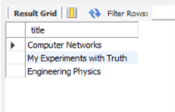

Q17. (UPDATE) Aarav returns Data Structures today (issue 4).
UPDATE Issue SET return_date = '2026-10-22' WHERE issue_id = 4;
SELECT issue_id, return_date FROM Issue WHERE issue_id = 4;

SCREENSHOT-
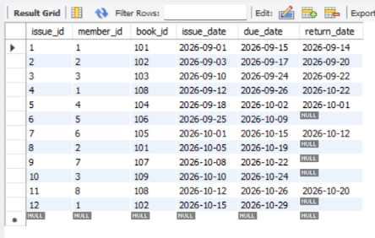

Q18. (UPDATE with calculation) Add the returned copy back to stock.
UPDATE Book SET copies_available = copies_available + 1 WHERE book_id = 108;
SELECT title, copies_available FROM Book WHERE book_id = 108;

SCREENSHOT-
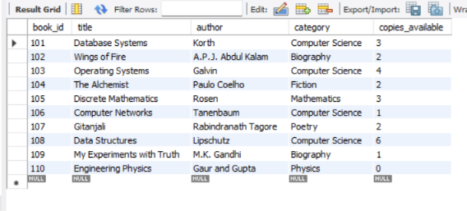

Q19. (ALTER TABLE) Add a city column to Member.
ALTER TABLE Member ADD COLUMN city VARCHAR(30);

SCREENSHOT-
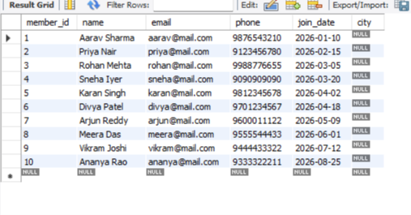
Q20. (VIEW) Create a view of currently borrowed books and display it.
CREATE VIEW Currently_Borrowed AS
SELECT m.name, b.title, i.due_date
FROM Issue i
JOIN Member m ON i.member_id = m.member_id
JOIN Book b ON i.book_id = b.book_id
WHERE i.return_date IS NULL;
SELECT * FROM Currently_Borrowed;

SCREENSHOT-
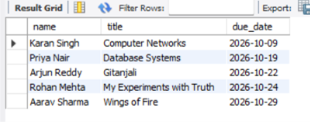

Q22. (DELETE) Delete a member who has no issue records (Ananya, id 10).
DELETE FROM Member WHERE member_id = 10;
SELECT COUNT(*) AS members_left FROM Member;

SCREENSHOT-
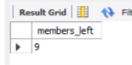

VI. Project demonstration
Tools used:
- SQLite3 as the DBMS (command line or DB Browser for SQLite)
- draw.io for the ER diagram
- Microsoft Word for the report
No GUI was built; the project is demonstrated through the SQL command line.
SCREENSHOTS-
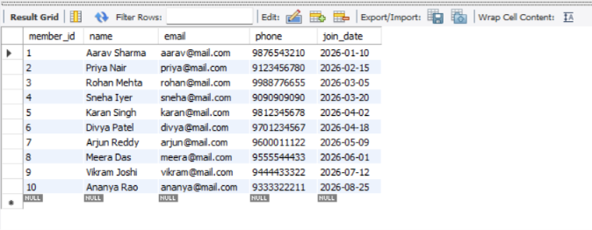
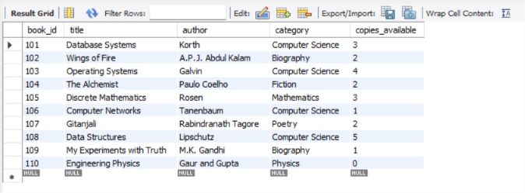
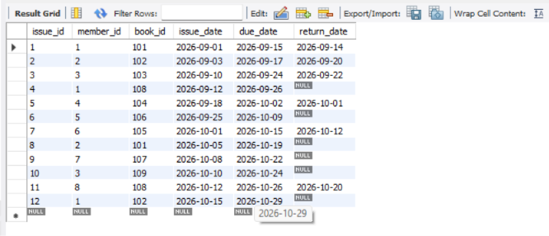

VII. Self -Learning beyond classroom:
- Practiced extra SQL on free sites such as W3Schools and SQLZoo.
- Learned date functions (julianday) to calculate late days and fines.
- Learned to create views and use LEFT JOIN, NOT IN and UNION, which helped answer real library questions.
- Learned to use CHECK, UNIQUE and NOT NULL constraints to keep data correct.
- Learned to draw ER diagrams with draw.io and to use SQLite and DB Browser.

VIII. Learning from the Project

- How to turn a real-life problem into entities, relationships, and tables.
- The difference between primary keys and foreign keys, and how they protect data.
- How a many-to-many relationship is solved with a third table.
- How normalization (1NF to BCNF) removes repeated data.
- How to write 20+ SQL queries from simple SELECT to joins, subqueries and views.
- The project helped me connect classroom theory to a real-world database.

IX. Challenges Faced

- Deciding which tables were needed and how to connect them.
- Understanding the many-to-many relationship and why Issue is needed.
- Foreign key errors when inserting in the wrong order (Member and Book must be filled before Issue).
- Understanding the difference between 3NF and BCNF.
- Calculating late days, since date functions differ between SQLite and MySQL.

X. Conclusion
This project shows how a database can replace paper records in a library. The three-table design (Member, Book, Issue) stores all the data without repetition and is in BCNF. SQL queries let the librarian quickly see borrowed books, overdue books, popular books, and fines. Constraints such as primary keys, foreign keys, UNIQUE, and CHECK keep the data correct. In future, the project can be extended with fines, tables, librarian login, book reservations, and a simple GUI.

