MOCKITO

EXERCISE 1: STABBING AND STUBBING

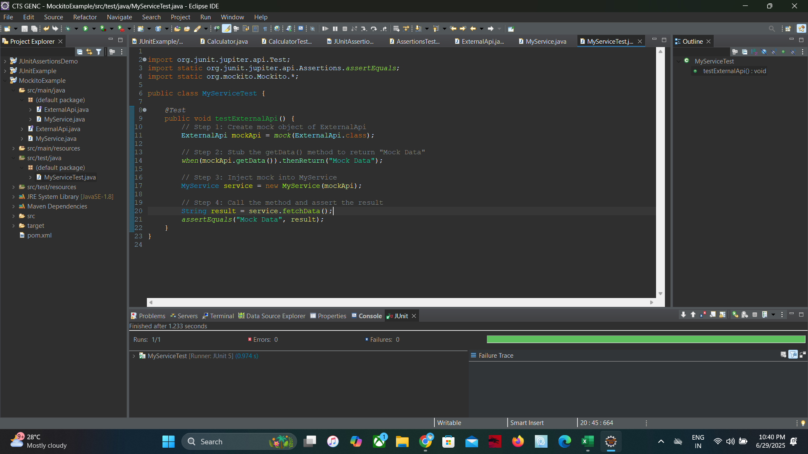

EXERCISE 2: Verifying Interactions

ADD VERIFY IN THE TEST CLASS

