**Computer Graphic ClassAssignment3**

**Afif 2019048586**

**Implementation**

a)

- It manipulates the same way as ClassAssignment1.

b)

-i. Open bvh file with drag and drop. Rendering a file that you have each time you drag a file.

- ii. Draw with tpose when rendering. It is not automatically animated and is drawn as a line segment and connected to the end site.

-iii. Press space bar to animate it.

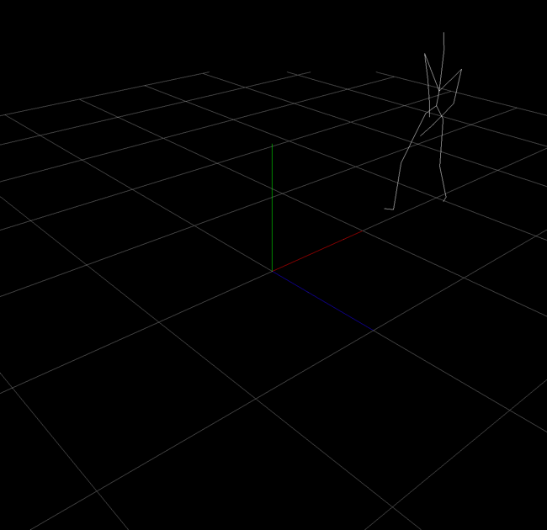

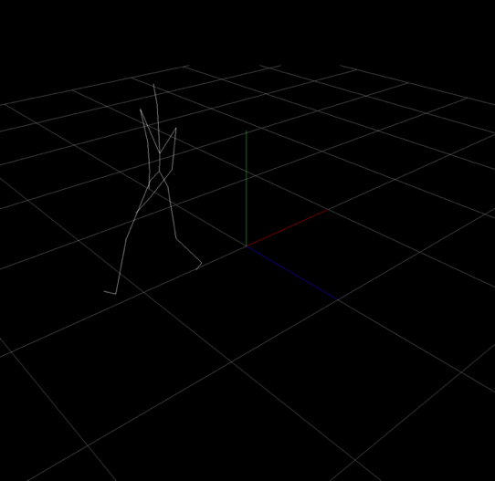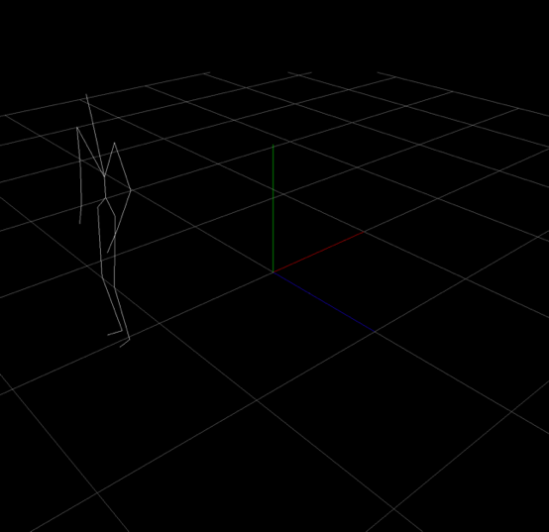

-iv. Bvh file informations such as file name, number of frames, fps, number of joints, list of all joint name will be printed.

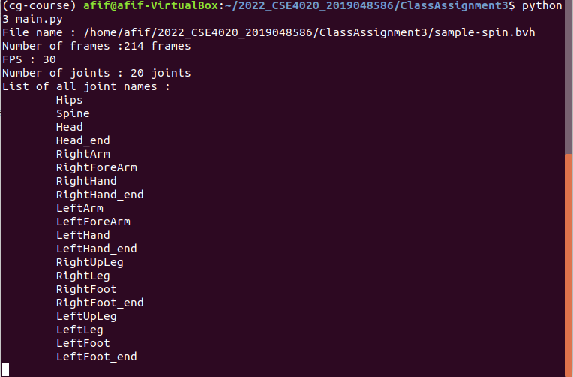

**2)Video Link**

<https://vimeo.com/717915519>