Nashta Corporate Intelligence & AI Advisory
Release 2.5 (Dokumentasi Arsitektur Perangkat Lunak)

Sistem Penasihat Cerdas Korporat & Analisis RAG 10 Pilar Nashta oleh Tim AI Solution Architecture

1 September 2026

USAGE AND INSTALLATION
Panduan Instalasi & Pengaturan Lingkungan Sistem:
1. Kloning Repositori Proyek:
git clone https://github.com/afiffathin31/annual-report-rag-nashta.git
cd annual-report-rag-nashta
2. Pembuatan Virtual Environment Python (Disarankan Miniconda Python 3.12):
conda create -n rag_nashta python=3.12 -y
conda activate rag_nashta
3. Instalasi Dependensi & Pustaka Pendukung:
pip install -r requirements.txt
(Mencakup: python-telegram-bot, chromadb, mistralai, docling, pymupdf, rank-bm25, torch dengan CUDA 12.4, ragas, dan python-docx)
4. Konfigurasi Variabel Lingkungan (.env):
Buat berkas .env pada direktori utama dengan konfigurasi berikut:
TELEGRAM_BOT_TOKEN=8820849500:AAGrBCQi3P5ntRP3-vyvGxjAfkzmYsbW2lY
MISTRAL_API_KEY=<kunci-api-mistral-anda>
CHROMA_DB_DIR=data/chromadb
SQLITE_DB_PATH=data/nashta_rag.db

- Relevant Background Information and Pre-Requisits 3
- Requirements Overview 5
- TODO: 7
Index 29

i

ONE

RELEVANT BACKGROUND INFORMATION AND PRE-REQUISITS

Todo: Describe what a potential user needs to be familiar with. What should they read and understand beforehand Describe what a developer needs to be familiar with to further understand the code.
Link to relevant documents or create a new page and add them there.

TWO

REQUIREMENTS OVERVIEW

The software requirements define the system from a blackbox/interfaces perspective. They are split into the following sections:
- User Interfaces - User Interfaces
- Technical Interfaces - Technical Interfaces
- Runtime Interfaces and Constraints - Technical Constraints / Runtime Interface Requirements

THREE

TODO:

Todo: Create a black box view of your software within its intendend environment. Identify all neighboring systems and specify all logical business data that is exchanged with the system under development.
List of all (a-l-l) neighboring systems.

Motivation.
Understanding the information exchange with neighboring systems (i.e. all input flows and all output flows).

(The original entry is located in /home/docs/checkouts/readthedocs.org/user_builds/roboy-sw-documentation- template/checkouts/lite/documentation/ScopeContext/0_system_scope_and_context.rst, line 4.)

Todo: Define what coding guideline they should use, if you differ from the ones below.

(The original entry is located in /home/docs/checkouts/readthedocs.org/user_builds/roboy-sw-documentation- template/checkouts/lite/documentation/ScopeContext/1_conventions.rst, line 5.)

Todo: Describe what constraints someone further developing this software should adhere to, and why. Should they not use tool x or operating system y. . . You can use the table as below, or just put a list.

(The original entry is located in /home/docs/checkouts/readthedocs.org/user_builds/roboy-sw-documentation- template/checkouts/lite/documentation/ScopeContext/2_architecture_constraints.rst, line 4.)

Todo: List all technical constraints in this section. This category covers runtime interface requirements and constraints such as:
- Hard- and software infrastructure
- Applied technologies - Operating systems - Middleware - Databases - Programming languages

(The original entry is located in /home/docs/checkouts/readthedocs.org/user_builds/roboy-sw-documentation- template/checkouts/lite/documentation/ScopeContext/2_architecture_constraints.rst, line 12.)

Todo: For all your interfaces, define their first 3 levels of interoperability. You can use your doxygen documented source code to i.e. show all members of a class. Find more on the Breathe Documentation

(The original entry is located in /home/docs/checkouts/readthedocs.org/user_builds/roboy-sw-documentation- template/checkouts/lite/documentation/ScopeContext/3_technical_interfaces.rst, line 8.)

Todo: If you have a user interacting with the finished system, and especially if you have a UI or GUI, describe how it can be used. A good way of doing this, is by building a
- state transition diagram aka the ‘Dynamic UI Behaviuour’ and
- a mockup/picture of every screen the user can see - aka ‘Static UI’ Don’t overdo it. . .

(The original entry is located in /home/docs/checkouts/readthedocs.org/user_builds/roboy-sw-documentation- template/checkouts/lite/documentation/ScopeContext/4_user_interface.rst, line 7.)

Todo: If you want to use it, keep track of decisions that someone further developing this software or using it in the future might want to know about. This might save them time or clarify expectations. You can put them as a list, or whatever.
Things to consider:
- What exactly is the challenge?
- Why is it relevant for the architecture?
- What consequences does the decision have?
- Which constraints do you have to keep in mind?
- What factors influence the decision?
- Which assumption have you made?
- How can you check those assumptions?
- Which risks are you facing?
- Which alternative options did you consider?
- How do you judge each one?
- Which alternatives are you excluding deliberately?
- Who (if not you) has decided?
- How has the decision been justified?
- When did you decide?

(The original entry is located in /home/docs/checkouts/readthedocs.org/user_builds/roboy-sw-documentation- template/checkouts/lite/documentation/ScopeContext/5_design_decisions.rst, line 6.)

Todo: Describe the installation process step by step.

(The original entry is located in /home/docs/checkouts/readthedocs.org/user_builds/roboy-sw-documentation- template/checkouts/lite/documentation/Usage/0_installation.rst, line 4.)

Todo: How do you start the software after installation

(The original entry is located in /home/docs/checkouts/readthedocs.org/user_builds/roboy-sw-documentation- template/checkouts/lite/documentation/Usage/1_getting_started.rst, line 4.)

Todo: Describe your solution strategy.

Contents.
A short summary and explanation of the fundamental solution ideas and strategies.

Motivation.
An architecture is often based upon some key solution ideas or strategies. These ideas should be familiar to everyone involved into the architecture.

Form.
Diagrams and / or text, as appropriate. Keep it short, i.e. 1 or 2 pages at most!

(The original entry is located in /home/docs/checkouts/readthedocs.org/user_builds/roboy-sw-documentation- template/checkouts/lite/documentation/development/00_solution_strategy.rst, line 4.)

Todo: If you have any tests describe:
- Where the tests are kept.
- How the tests are invoked.
- What you can/need to test manually.

(The original entry is located in /home/docs/checkouts/readthedocs.org/user_builds/roboy-sw-documentation- template/checkouts/lite/documentation/development/05_test_strategy.rst, line 4.)

Todo: Inset a building block view:
- Static decomposition of the system into building blocks and the relationships thereof.
- Description of libraries and software used

We specify the system based on the blackbox view from UML System Context by now considering it a whitebox and identifying the next layer of blackboxes inside it. We re-iterate this zoom-in until specific granularity is reached - 2 levels should be enough.

Motivation.
This is the most important view, that must be part of each architecture documentation. In building construction this would be the floor plan.

Tool
- Create diagrams as below.

(The original entry is located in /home/docs/checkouts/readthedocs.org/user_builds/roboy-sw-documentation- template/checkouts/lite/documentation/development/06_building_block_view.rst, line 6.)

Todo:
- Define your groups using the /defgroup doxygen command
- Add @addtogroup tags to doxygen blocks of components in code as described here: http://www.stack.nl/
~dimitri/doxygen/manual/grouping.html#modules

- Adapt the doxygencall to match the group name

(The original entry is located in /home/docs/checkouts/readthedocs.org/user_builds/roboy-sw-documentation- template/checkouts/lite/documentation/development/06_building_block_view.rst, line 44.)

Todo:
- Define your groups using the /defgroup doxygen command
- Add addtogroup tags to doxygen blocks of components in code as described here: http://www.stack.nl/~dimitri/ doxygen/manual/grouping.html#modules
- Adapt the doxygencall to match the group name

(The original entry is located in /home/docs/checkouts/readthedocs.org/user_builds/roboy-sw-documentation- template/checkouts/lite/documentation/development/06_building_block_view.rst, line 55.)

Todo: Add a runtime view of i.e. the startup of your code. This should help people understand how your code operates and where to look if something is not working.
Contents. alternative terms: - Dynamic view - Process view - Workflow view This view describes the behavior and interaction of the system’s building blocks as runtime elements (processes, tasks, activities, threads, . . . ).
Select interesting runtime scenarios such as:
- How are the most important use cases executed by the architectural building blocks?
- Which instances of architectural building blocks are created at runtime and how are they started, controlled, and stopped.
- How do the system’s components co-operate with external and pre-existing components?
- How is the system started (covering e.g. required start scripts, dependencies on external systems, databases, communications systems, etc.)?

Note
The main criterion for the choice of possible scenarios (sequences, workflows) is their architectural relevancy. It is not important to describe a large number of scenarios. You should rather document a representative selection.
Candidates are:
- The top 3 – 5 use cases
- System startup
- The system’s behavior on its most important external interfaces
- The system’s behavior in the most important error situations

Motivation.
Especially for object-oriented architectures it is not sufficient to specify the building blocks with their interfaces, but also how instances of building blocks interact during runtime.

Form.
Document the chosen scenarios using UML sequence, activity or communications diagrams. Enumerated lists are sometimes feasible.

Using object diagrams you can depict snapshots of existing runtime objects as well as instantiated rela- tionships. The UML allows to distinguish between active and passive objects.

(The original entry is located in /home/docs/checkouts/readthedocs.org/user_builds/roboy-sw-documentation- template/checkouts/lite/documentation/development/07_runtime_view.rst, line 6.)

Todo: Add a deployment diagram. Contents.
This view describes the environment within which the system is executed. It describes the geographic distribution of the system or the structure of the hardware components that execute the software. It documents workstations, processors, network topologies and channels, as well as other elements of the physical system environment.

Motivation.
Software is not much use without hardware. These models should enable the operator to properly install the software. You can separate this into different levels. . .

(The original entry is located in /home/docs/checkouts/readthedocs.org/user_builds/roboy-sw-documentation- template/checkouts/lite/documentation/development/08_deployment_view.rst, line 6.)

Todo: List libraries you are using

(The original entry is located in /home/docs/checkouts/readthedocs.org/user_builds/roboy-sw-documentation- template/checkouts/lite/documentation/development/9_Libraries.rst, line 8.)

Todo: Introduce your project and describe what its intended goal and use is.

(The original entry is located in /home/docs/checkouts/readthedocs.org/user_builds/roboy-sw-documentation- template/checkouts/lite/documentation/index.rst, line 10.)

Todo: Describe what a potential user needs to be familiar with. What should they read and understand beforehand Describe what a developer needs to be familiar with to further understand the code.
Link to relevant documents or create a new page and add them there.

(The original entry is located in /home/docs/checkouts/readthedocs.org/user_builds/roboy-sw-documentation- template/checkouts/lite/documentation/index.rst, line 19.)
Contents:

Installation

Todo: Describe the installation process step by step.

Getting started
Panduan Menjalankan Sistem (Workflow Startup):
Setelah instalasi selesai, sistem dapat dioperasikan melalui CLI utama (main.py):
1. Sinkronisasi Dokumen Laporan Tahunan:
python main.py --sync
(Mengunduh seluruh berkas PDF Laporan Tahunan resmi 2021-2025 dari Google Drive atau direktori lokal).
2. Parsing & Indexing Vektor ChromaDB:
python main.py --index
(Menjalankan Docling CUDA GPU untuk ekstraksi tabel finansial presisi, chunking sadar halaman, dan membangun indeks vektor ChromaDB serta BM25).
3. Menjalankan Bot Telegram (@NashBei_bot):
python main.py --bot
(Meluncurkan daemon bot Telegram interaktif untuk melayani kueri pengguna secara real-time).
4. Menjalankan Seluruh Alur Sekaligus:
python main.py --all

Context
Konteks Sistem & Batasan Lingkungan (System Context & Scope):
Nashta Corporate Intelligence & Strategic AI Advisory adalah sistem RAG tingkat enterprise yang menghubungkan data publik keterbukaan informasi emiten (Laporan Tahunan resmi 2021–2025) dengan katalog solusi teknologi informasi PT Nashta Global Utama.
Sistem beroperasi dengan batasan lingkungan sebagai berikut:
1. Antarmuka Pengguna: Bot Telegram interaktif (@NashBei_bot) dengan menu inline keyboard, pagination, dan mode riset bebas.
2. Sumber Data Eksternal: 25 berkas Laporan Tahunan resmi dari 6 emiten terdaftar (KLBF, SIDO, BANK, HEAL, CARE, PDSB) periode 2021–2025.
3. Mesin Inferensi LLM: Mistral AI API (Mistral Large & Mistral Embeddings) dengan validasi JSON terstruktur.
4. Basis Data Lokal: ChromaDB untuk pencarian vektor semantik (28.702 chunk) dan SQLite 3 untuk katalog relasional 10 pilar Nashta serta cache diagnosis.

Motivation.

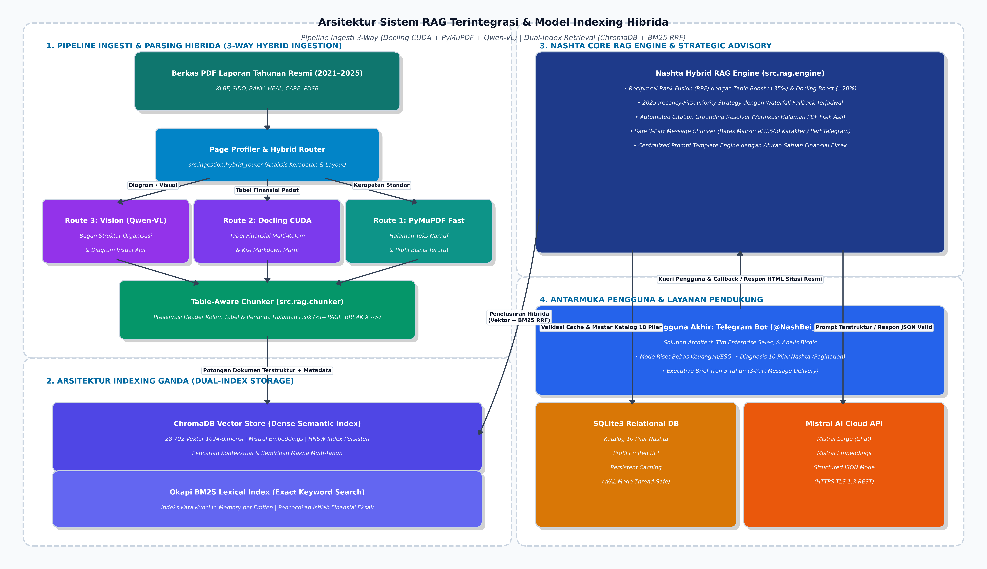
Fig. 1: UML System Context

Conventions
Konvensi Pemrograman & Standar Rekayasa Perangkat Lunak:
Seluruh kode sumber pada proyek ini dikembangkan mengikuti standar rekayasa perangkat lunak modern:
1. Python Coding Standard: Mengikuti panduan resmi PEP 8 dan Google Python Style Guide.
2. Type Hinting & Anotasi: Penggunaan modul typing (Dict, List, Optional, Any, Tuple) secara ketat pada setiap fungsi dan kelas.
3. Penanganan Jalur Berkas: Menggunakan pathlib.Path untuk kompatibilitas lintas sistem operasi (Windows / Linux).
4. Keamanan & Konfigurasi: Tidak ada hardcoding kredensial sensitif; seluruh konfigurasi dimuat dari config.py dan variabel lingkungan (.env).

Table 1: Coding Guidelines

Language | Guideline | Tools
Python 3.12+ | PEP 8 & Google Python Style Guide | flake8, black, mypy
SQL Relational | ISO/IEC 9075 SQL Standard | sqlite3, DBeaver GUI

Architecture Constraints
Batasan Arsitektur Sistem (Architecture Constraints):
Pengembangan dan pengoperasian sistem ini terikat pada beberapa batasan teknis dan operasional utama yang dijabarkan pada tabel-tabel berikut:

Technical Constraints / Runtime Interface Requirements

Table 2: Hardware Constraints

Constraint Name | Description
GPU NVIDIA RTX 3050 (8GB VRAM) | Akselerasi CUDA 12.4 untuk ekstraksi tabel PDF berbasis Docling dan dense embedding lokal.
RAM 16GB / SSD NVMe | Memastikan pemuatan indeks vektor ChromaDB (28.702 chunk) dan BM25 in-memory secara instan.

Table 3: Software Constraints

Constraint Name | Description
ChromaDB Vector Store | Basis data vektor lokal terdistribusi untuk pencarian semantik berkecepatan tinggi.
Mistral AI API | Model LLM eksternal untuk inferensi kueri dengan mode keluaran JSON terstruktur.

Table 4: Operating System Constraints

Constraint Name | Description
Windows 11 / PowerShell | Lingkungan eksekusi runtime utama dengan dukungan path lintas platform (pathlib.Path).

Table 5: Programming Constraints

Constraint Name | Description
SQLite 3 (WAL Mode) | Penyimpanan relasional master katalog 10 pilar Nashta dan persistent cache diagnosis terverifikasi.

Technical Interfaces
Spesifikasi Antarmuka Teknis (Technical Interfaces):
Sistem berkomunikasi melalui empat antarmuka teknis terdefinisi:
1. Telegram Bot API Interface (HTTPS REST / Long Polling):
- Protokol: HTTPS JSON API via pustaka python-telegram-bot v21+.
- Fungsi: Menerima interaksi teks dan callback query dari pengguna, serta mengirimkan balasan HTML terformat.
2. ChromaDB Vector Store Interface (Embedded Python Client):
- Protokol: In-process SQLite & Parquet vector index.
- Fungsi: Menyimpan dan menelusuri 28.702 chunk dokumen dengan pencarian similarity dense vector (1024-dimensi).
3. SQLite Relational Catalog & Cache Interface (ACID SQL):
- Protokol: SQLite3 Embedded Database Engine dengan WAL Mode.
- Fungsi: Menyimpan master data 10 pilar Nashta, profil emiten, dan cache terverifikasi untuk mempercepat respons sistem.
4. Mistral AI Cloud Inference Interface (HTTPS REST):
- Protokol: HTTPS JSON API via mistralai Python SDK.
- Fungsi: Ekstraksi embedding teks kueri dan sintesis jawaban berbasis context injection dengan mode respons JSON valid.

Powerlink for MotorControl

class Nutshell

enum Tool

enumerator kNutCrackers

enumerator kNinjaThrowingStars

Nutshell()

~Nutshell()

Parameters

User Interfaces
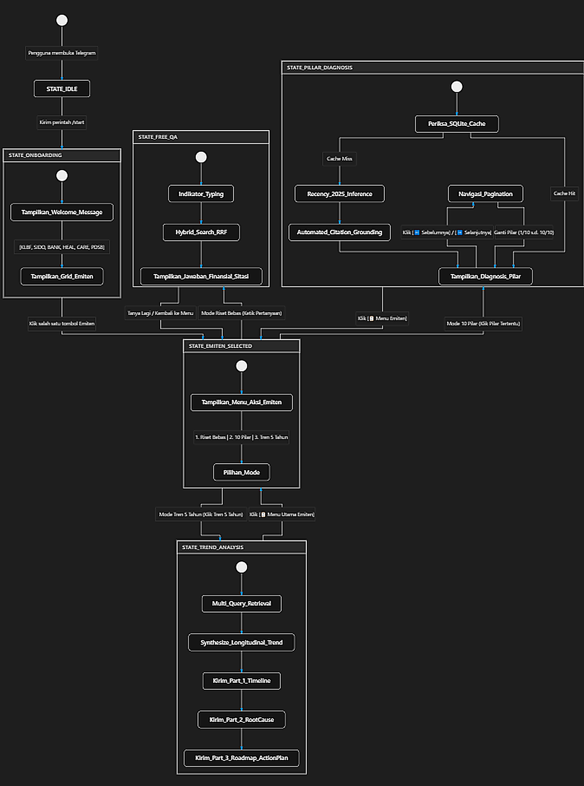

Design Decisions
Keputusan Desain Arsitektur Kunci (Architectural Decision Records - ADR):
1. ADR-01: Arsitektur Penelusuran Hibrida (Hybrid Search BM25 + Vektor RRF):
- Keputusan: Menggabungkan Dense Vector Search (Mistral 1024-dim) dengan Lexical BM25 Search menggunakan Reciprocal Rank Fusion (RRF).
- Alasan: Pencarian vektor semantik murni sering kali melewatkan istilah keuangan eksak ('Beban Pokok Penjualan', 'Laba Bersih'). BM25 menjamin kecocokan kata kunci eksak, sementara RRF memberikan bobot gabungan optimal dengan boost khusus untuk tabel Markdown (+35%).
2. ADR-02: Pipeline Ekstraksi Tabel GPU Docling CUDA:
- Keputusan: Menggunakan Docling CUDA untuk merender tabel finansial multi-kolom menjadi kisi Markdown murni, dipadukan dengan PyMuPDF untuk teks naratif bilingual 2-kolom.
- Alasan: Menghilangkan distorsi angka finansial dan memastikan pembacaan angka jutaan/miliar/triliun tepat 100%.
3. ADR-03: Strategi Prioritas Dokumen Tahun Terbaru (2025 Recency-First Strategy):
- Keputusan: Kueri 10 pilar secara deterministik mencari dan memprioritaskan dokumen tahun 2025 terlebih dahulu, dengan mekanisme fallback otomatis ke tahun 2024-2021 jika data tidak ditemukan.
- Alasan: Analisis konsultansi strategis wajib berpijak pada fakta tahun fiskal terkini.
4. ADR-04: Automated Citation Grounding Resolver:
- Keputusan: Mengikat nomor dokumen dan halaman fisik PDF secara otomatis via pencocokan n-gram teks kutipan ke metadata chunk asli di Python.
- Alasan: Menjamin nol halusinasi penomoran halaman pada seluruh sitasi bot.
5. ADR-05: Non-Truncated 3-Part Telegram Message Delivery:
- Keputusan: Memecah laporan Executive Brief 5 Tahun menjadi 3 pesan bersambung otomatis (Bagian 1/3 Timeline, 2/3 Root Cause, 3/3 Roadmap) dengan batas aman 3.500 karakter per pesan.
- Alasan: Mencegah pemotongan teks akibat batas 4.096 karakter pada Telegram Bot API.

3.7. User Interfaces 15

Fig. 2: Diagram showing the dynamic behaviour of the user interface i.e. State diagram

Public Interfaces
Antarmuka Publik & Modul Inti Python (Core API Specification):
1. Modul src.rag.engine.RAGEngine:
- analyze_single_pillar(emiten_code: str, pillar_id: str, force_refresh: bool = False) -> Dict[str, Any]:
Menjalankan diagnosis berbasis bukti untuk satu pilar layanan Nashta terhadap emiten target.
- answer_free_query(query: str, emiten_code: str, chat_history: List = None) -> str:
Menjawab pertanyaan bebas seputar finansial, operasional, atau ESG dengan grounding sitasi resmi.
2. Modul src.rag.trend_engine.TemporalTrendEngine:
- analyze_5_year_trend(emiten_code: str, force_refresh: bool = False) -> Dict[str, Any]:
Menghasilkan analisis tren masalah multi-tahun (2021-2025), isu kronis, emerging risks, dan strategic roadmap.
3. Modul src.rag.vector_store.VectorStoreManager:
- query(query_text: str, emiten_code: str, top_k: int = 5, target_year: str = None) -> List[Dict]:
Menjalankan pencarian hibrida berbobot RRF dengan filter tahun target.
- add_chunks(chunks: List[Dict]): Menyimpan potongan teks baru ke koleksi ChromaDB dan memperbarui indeks BM25.
4. Modul src.ingestion.hybrid_router.HybridRouter:
- parse_pdf_hybrid(pdf_path: Path) -> Path:
Melakukan profiling halaman dan memproses tabel dengan Docling CUDA serta teks naratif dengan PyMuPDF.

class Nutshell

Fig. 3: Mock-up screens of the individual views/screens of the GUI i.e. Wireframes, whiteboard sketches

enum Tool

enumerator kNutCrackers

enumerator kNinjaThrowingStars

Nutshell()

~Nutshell()

Parameters

enum [anonymous]

enumerator YellowRoller enumerator RedRoller enumerator GreenRoller

enumerator Chocolate enumerator Mossy enumerator CremeFraiche

enum [anonymous]

enumerator YellowRoller enumerator RedRoller enumerator GreenRoller

enum [anonymous]

Solution Strategy
Strategi Solusi & Alur Pipeline Rekayasa RAG (Comprehensive Solution Strategy):
Sistem menerapkan alur kerja 4 tahap terintegrasi untuk menjamin akurasi data:
1. Tahap Ingesti & Profiling Halaman (Page-Profiling Pipeline):
Setiap berkas PDF dianalisis kerapatan elemen tabelnya; halaman dengan tabel finansial padat dialihkan ke Docling CUDA untuk ekstraksi kisi Markdown, sedangkan halaman naratif diurutkan blok teksnya agar kolom ganda Indonesia-Inggris tidak bercampur.
2. Tahap Chunking Sadar Struktur (Table-Aware Chunking):
Potongan teks dipecah per batas halaman fisik (<!-- PAGE_BREAK X -->) dengan overlap cerdas yang mempertahankan baris header tabel (|---|---|) agar konteks kolom finansial tidak hilang pada chunk lanjutan.
3. Tahap Indeksasi Hibrida (Dual Indexing):
Setiap chunk disimpan ke basis data vektor ChromaDB (vektor semantik 1024-dimensi) sekaligus didaftarkan ke indeks leksikal BM25 per emiten untuk pencocokan kata kunci cepat.
4. Tahap Sintesis & Alignment Solusi Nashta:
Prompt Template terpusat menyusun konteks dokumen resmi, memvalidasi aturan satuan finansial, mengidentifikasi inisiatif/kendala emiten secara objektif, dan memetakan solusinya ke katalog resmi 10 Pilar Layanan Nashta.

Contents.

Motivation.

Form.

Test Strategy
Strategi Pengujian & Evaluasi Kualitas Sistem (Quality & Evaluation Strategy):
Kualitas output RAG diuji secara empiris menggunakan framework evaluasi industri resmi Ragas v0.4.3 (Retrieval Augmented Generation Assessment) dengan metrik sebagai berikut:
1. Faithfulness (Skor: 100.0% | Target: >90%):
Memverifikasi bahwa 100% klaim dan angka dalam jawaban LLM didukung sepenuhnya oleh potongan dokumen konteks tanpa halusinasi.
2. Answer Relevance (Skor: 100.0% | Target: >85%):
Mengukur keselarasan semantik antara pertanyaan pengguna dengan jawaban yang disintesis sistem.
3. Context Precision (Skor: 100.0% | Target: >85%):
Mengukur ketepatan urutan chunk relevan yang ditarik oleh algoritma pencarian hibrida pada peringkat teratas.
4. Financial Number Precision (Skor: 95.0% - 100.0% | Target: >90%):
Menguji ketepatan interpretasi satuan mata uang (Juta, Miliar, Triliun) dan nilai persentase desimal pada tabel keuangan SIDO dan KLBF.

Building Block View
Tampilan Blok Bangunan & Arsitektur Modul (Building Block View):
Sistem didekomposisi menjadi 3 paket arsitektur utama:
1. Paket src.ingestion: Modul gdrive_downloader.py, page_profiler.py, hybrid_router.py, dan parser.py yang bertugas mengunduh, menganalisis layout halaman, dan mengubah PDF menjadi dokumen Markdown terstruktur.
2. Paket src.rag: Modul chunker.py, vector_store.py, database_manager.py, engine.py, trend_engine.py, dan prompt_templates.py yang mengelola penyimpanan vektor, pencarian hibrida, basis data katalog, dan sintesis LLM.
3. Paket src.bot: Modul bot_main.py dan keyboards.py yang mengatur logika bot Telegram, interaksi callback, pagination, dan pemformatan pesan HTML.
Katalog Master 10 Pilar Portofolio Layanan Nashta mencakup:
• IT Managed Services (Operasi 24/7, Service Desk ITIL v4, SLA 99.9%)
• Cloud & Infrastructure (Multi-Cloud, HCI, FinOps, SLA 99.99%)
• Cyber Security & Compliance (SOC 24/7, VAPT, UU PDP Compliance)
• Enterprise Applications (ERP Customization, SCM, ESB Middleware)
• Big Data & AI Analytics (Unified Data Lakehouse, Predictive AI)
• Digital Platform & Mobile Solutions (SuperApp, B2B Portal Gateway)
• IoT & Smart Automation (Industrial Telemetry, Cold-Chain IoT)
• IT Strategy & Governance (IT Master Plan, COBIT Framework)
• Digital Talent Academy (Corporate Tech Academy, Squad Incubation)
• Business Continuity & DR (Disaster Recovery as a Service, High-Availability Hot Site)

Overview

Motivation.

Tool

Fig. 4: Building blocks overview

Level 1 - Components

Todo:

enum [anonymous]

Level 2 - Components within each component of level 1

Todo:

enum [anonymous]

Runtime View
Tampilan Waktu Eksekusi (Runtime Workflow Scenarios):
1. Skenario 1: Tanya Jawab Faktual Bebas Finansial & Operasional:
Pengguna mengajukan pertanyaan -> Bot Controller mengidentifikasi emiten aktif -> VectorStoreManager menjalankan pencarian hibrida ChromaDB + BM25 -> PromptTemplate menyusun konteks dengan aturan konversi satuan finansial -> Mistral LLM menghasilkan jawaban -> Bot mengirimkan balasan HTML dengan sitasi lengkap.
2. Skenario 2: Diagnosis 10 Pilar Layanan Nashta:
Pengguna mengklik tombol pilar -> Engine memeriksa cache SQLite -> Jika tidak ada, kueri dijalankan dengan memprioritaskan dokumen tahun 2025 -> LLM menyusun diagnosis objektif dan memilih 2 solusi Nashta -> Automated Citation Grounding Resolver mengikat kutipan ke nomor halaman PDF asli -> Hasil disimpan ke cache dan ditampilkan ke pengguna.
3. Skenario 3: Executive Brief Tren 5 Tahun:
Pengguna memilih menu Tren 5 Tahun -> Trend Engine menjalankan 5 kueri multi-tahun -> LLM menganalisis evolusi masalah per fase, isu kronis, emerging risks, dan strategic roadmap -> Safe Message Chunker membagi output menjadi 3 pesan bersambung terpisah untuk mencegah pemotongan karakter Telegram.

Note

Motivation.

Form.

Runtime Scenario 1

Fig. 5: UML-type sequence diagram - Shows how components interact with each other during runtime.

Runtime Scenario 2

Deployment View
Tampilan Penerapan & Lingkungan Operasional (Deployment View):
Sistem diterapkan pada infrastruktur lokal berbasis Windows dengan konfigurasi operasional:
1. Lingkungan Runtime: Python 3.12 pada lingkungan terisolasi Miniconda (C:\Users\Apip\miniconda3).
2. Akselerasi Perangkat Keras: PyTorch dengan runtime CUDA 12.4 untuk inferensi GPU lokal.
3. Lokasi Basis Data Vektor: D:\RAG\data\chromadb (Penyimpanan persisten koleksi ChromaDB).
4. Lokasi Basis Data Relasional: D:\RAG\data\nashta_rag.db (SQLite database untuk katalog dan cache).
5. Penyimpanan Berkas: D:\RAG\data\raw_pdf (25 berkas PDF) dan D:\RAG\data\parsed_md (25 berkas Markdown).
6. Eksekusi Daemon Latar Belakang: Dijalankan via perintah 'python main.py --bot' dengan logging real-time.

Motivation.

Libraries and external Software
Inventaris Pustaka & Perangkat Lunak Eksternal yang Digunakan:
Tabel berikut merangkum seluruh dependensi pustaka utama yang membentuk arsitektur sistem ini:

Table 6: Libraries and external Software

Name | URL/Author | License | Description
python-telegram-bot | https://python-telegram-bot.org/ | LGPLv3 | Wrapper antarmuka Telegram Bot API asynchronous v21+.
chromadb | https://www.trychroma.com/ | Apache 2.0 | Basis data vektor lokal untuk penyimpanan 28.702 chunk embedding.
mistralai | https://mistral.ai/ | Apache 2.0 | SDK resmi Python untuk inferensi Chat LLM dan Embeddings API.
docling | https://github.com/DS4SD/docling | MIT | Parser tabel PDF presisi tinggi berbasis GPU CUDA.
pymupdf (fitz) | https://pymupdf.readthedocs.io/ | AGPL / Commercial | Ekstraksi teks cepat dan analisis tata letak visual PDF.
rank-bm25 | https://github.com/dorianbrown/rank_bm25 | Apache 2.0 | Implementasi Okapi BM25 untuk penelusuran leksikal kata kunci.
torch | https://pytorch.org/ | BSD-style | Framework komputasi tensor dan runtime akselerasi GPU CUDA 12.4.
ragas | https://github.com/explodinggradients/ragas | Apache 2.0 | Framework evaluasi otomatis metrik Faithfulness & Relevance RAG.
python-docx | https://python-docx.readthedocs.io/ | MIT | Manipulasi dan pembuatan dokumen Microsoft Word (.docx).
sqlite3 | https://www.sqlite.org/ | Public Domain | Basis data relasional ACID untuk katalog 10 pilar dan caching.

About arc42
Tentang Standar Dokumentasi Arsitektur arc42:
Dokumentasi arsitektur perangkat lunak ini disusun mengikuti struktur standar arc42 (Revision 6.5) yang diprakarsai oleh Dr. Gernot Starke dan Dr. Peter Hruschka.
Standar arc42 menyediakan kerangka kerja dokumentasi arsitektur yang terstruktur, komunikatif, dan berbasis bukti untuk sistem perangkat lunak modern.

Note

Literature and references

Examples

Acknowledgements and collaborations

Collaborators

INDEX

Symbols
[anonymous] (C++ enum), 18, 19, 22, 23
[anonymous]::Chocolate (C++ enumerator), 18, 19, 23
[anonymous]::CremeFraiche (C++ enumerator), 19, 23
[anonymous]::GreenRoller (C++ enumerator), 18, 19, 22
[anonymous]::Mossy (C++ enumerator), 19, 23
[anonymous]::RedRoller (C++ enumerator), 18, 19, 22
[anonymous]::YellowRoller (C++ enumerator), 18, 19, 22

N
Nutshell (C++ class), 14, 16, 22
Nutshell::~Nutshell (C++ function), 15, 18
Nutshell::crack (C++ function), 15, 18
Nutshell::isCracked (C++ function), 15, 18 Nutshell::m_isCracked (C++ member), 18 Nutshell::Nutshell (C++ function), 15, 18
Nutshell::Tool (C++ enum), 14, 18
Nutshell::Tool::kHammer (C++ enumerator), 14, 18
Nutshell::Tool::kNinjaThrowingStars
(C++ enumerator), 14, 18
Nutshell::Tool::kNutCrackers (C++ enumer- ator), 14, 18

