

**IAS2243**

**WEB APPLICATION AND**

**MANAGEMENT**

GROUP MEMBER:

AFIFFUDDIN BIN NOLI

(4182012231)

NASRULLAH BIN ZAINI BAKRI

(4182005921)

MUHAMMAD UZAYR BIN NORAZLAN

(4182005241)

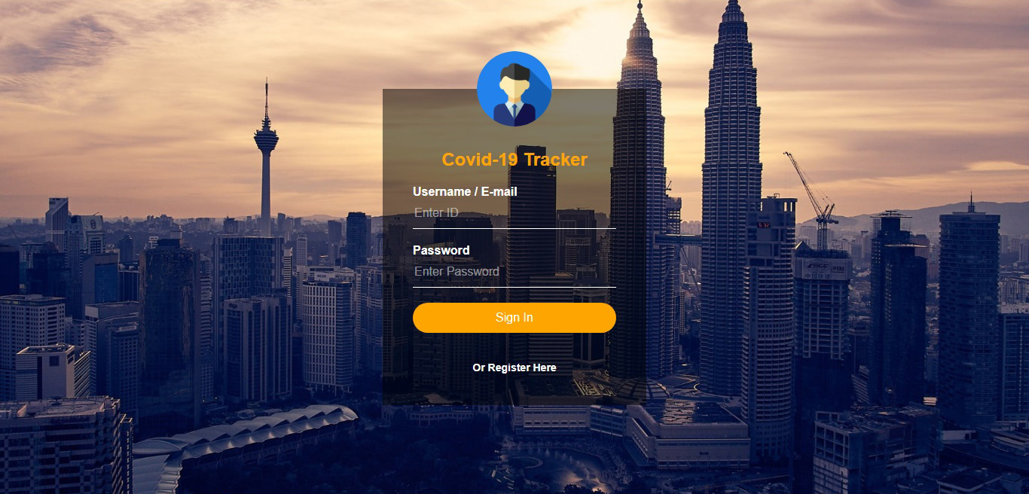

This is the first interface for the website is a log in interface which required user to sign in in order to access the website.

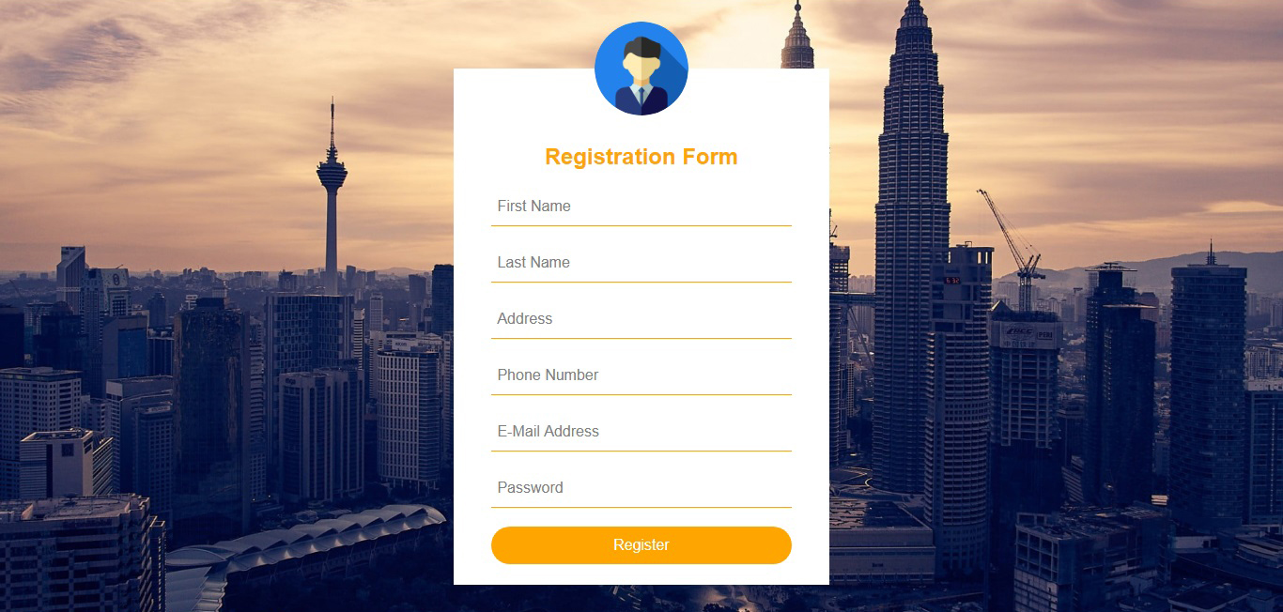

For new user, they can self-register at the website online registration form. Once user submitted their form, the system will validate their account hence allowing them to sign in and access the website.

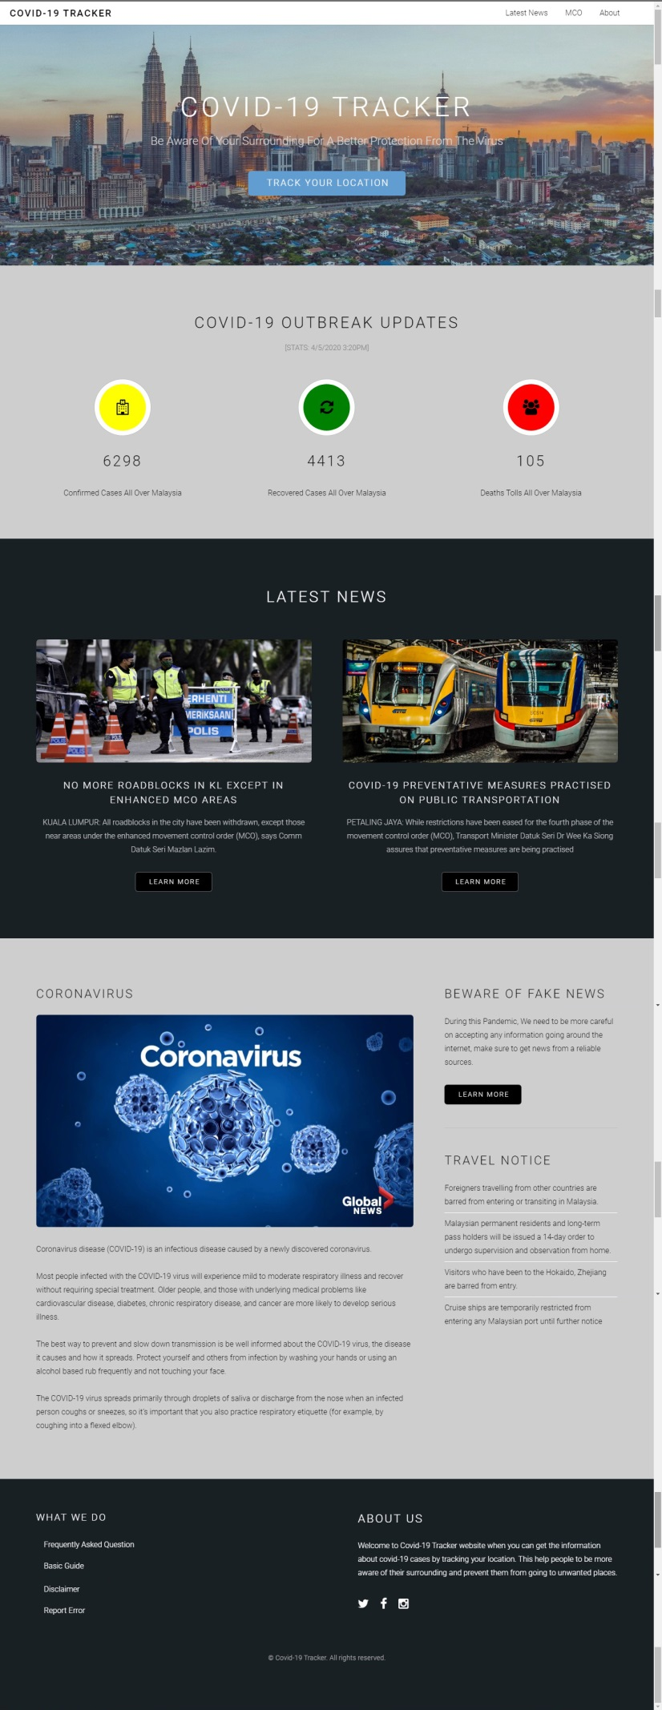

User will be directed to the main page of the website once they successfully log in. At the home page, users can go through the whole webpage. The menu bar consists of Latest News, MCO and info about the website.

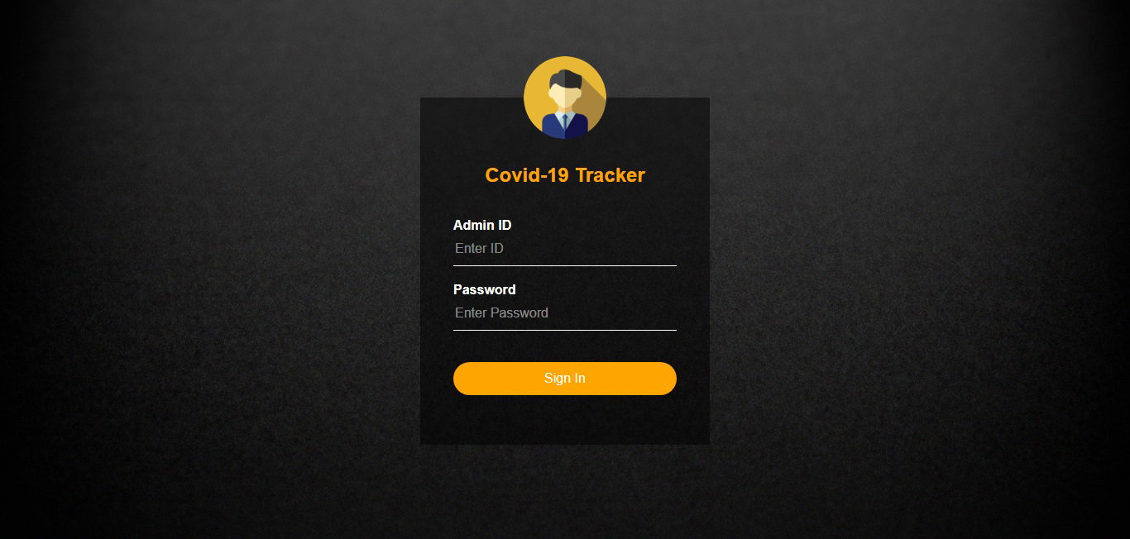

This is the log in interface for admin.

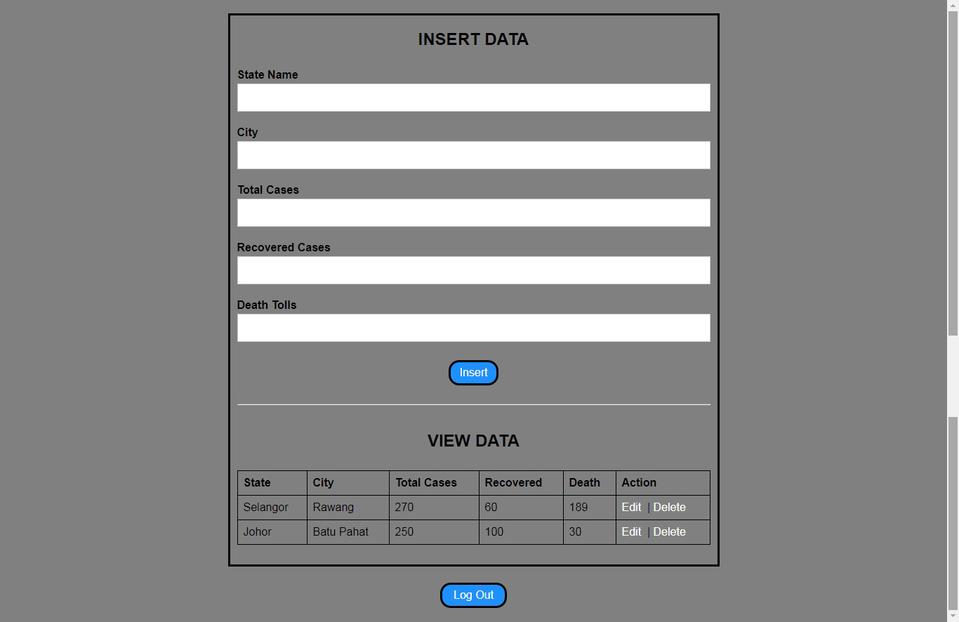

Once log in, admin can update, create, and delete data from the database.

