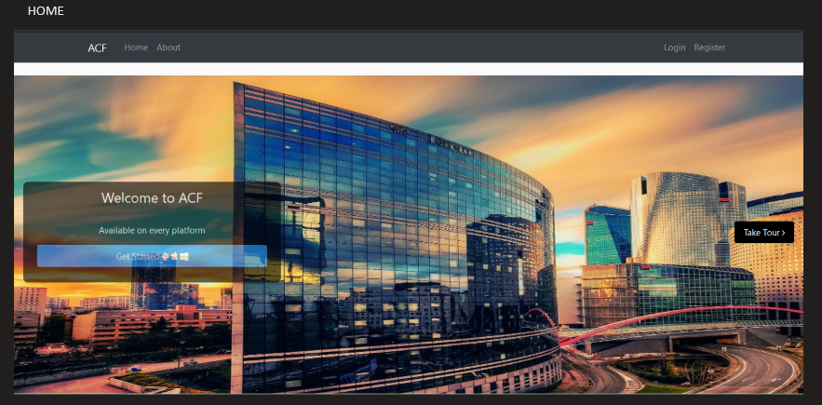

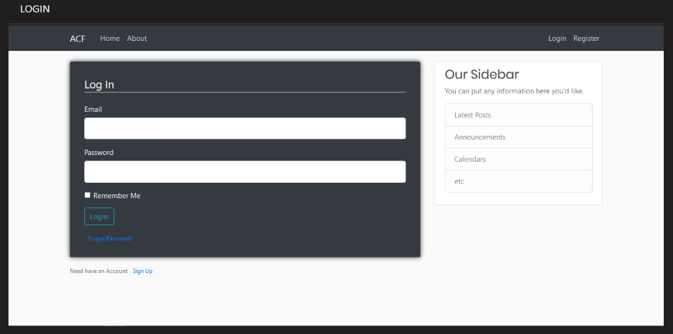

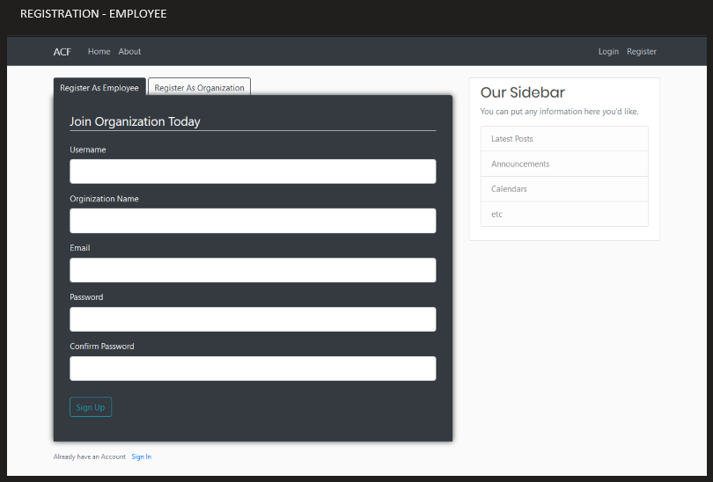

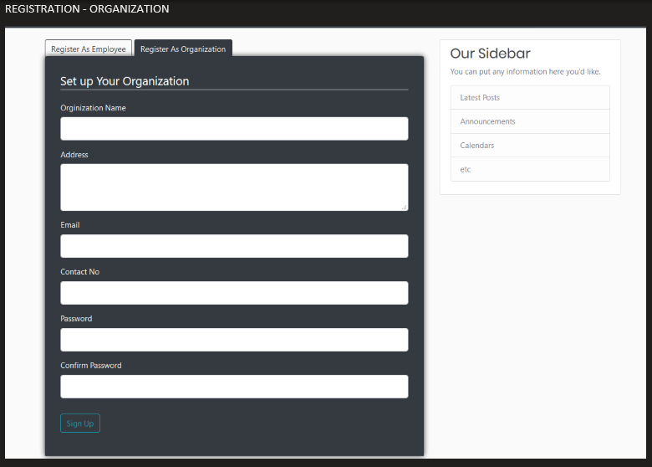

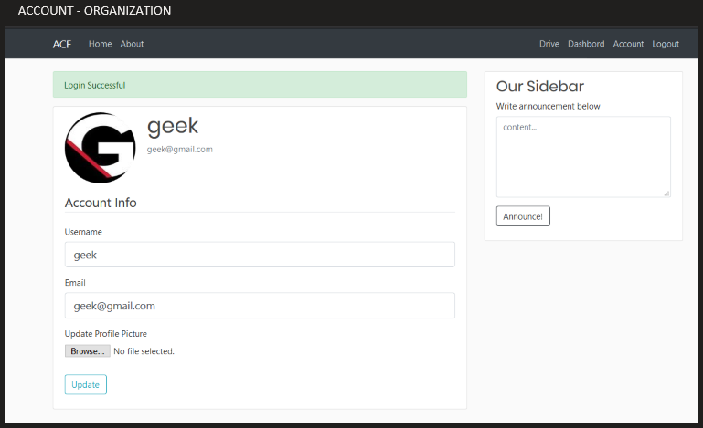

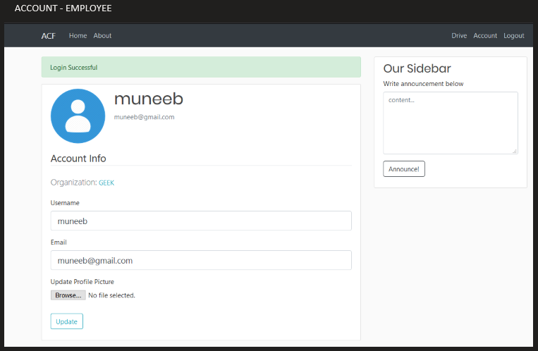

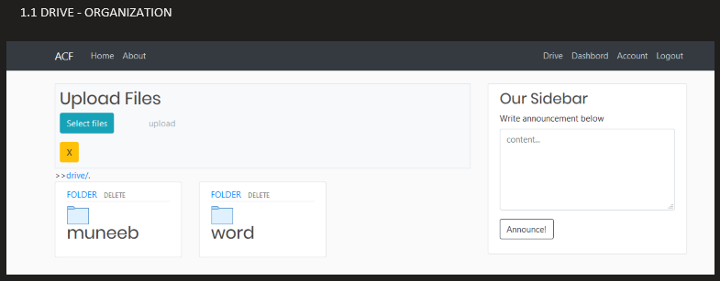

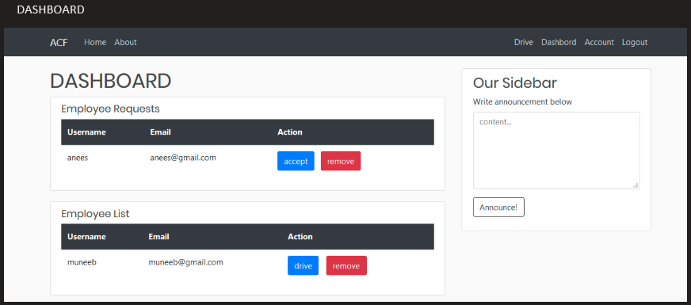

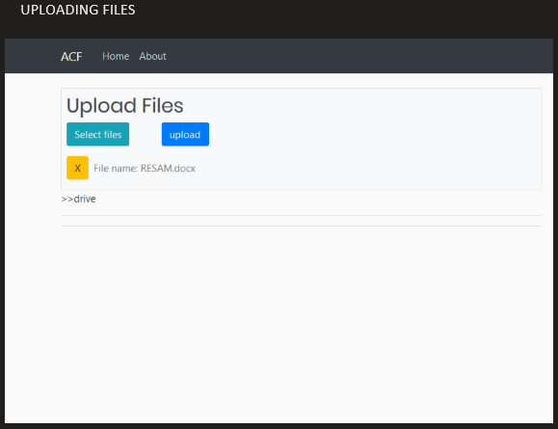

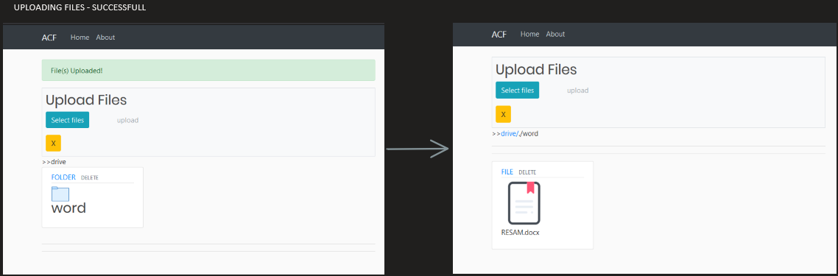

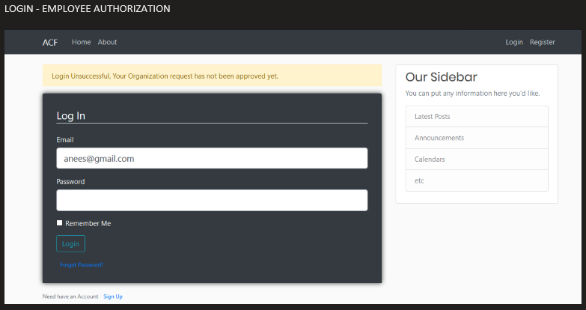

LOG FILE CONTENTS:

1. Optimizing Categorization Algorithm for new functionality.
2. Redefining Database Models
3. Designing User Interface for the New features
4. Adding new registration forms for employee and organization
5. Adding new Dashboard for organization
6. Creating routes for New features
7. Creating models and form classes for new features
8. Optimizing Routes according to new optimized algorithm
9. Add Directory/File handling Functionalities like downloading, removing and uploading and cancel upload
10. Add multi upload files feature
11. Creating New Home Page for the Project.
12. Adding User Authorization and validation
13. Testing application
14. Optimizing Server Setting
15. Creating docker files
16. Uploading on cloud container