VULNERABILITY ANALYSIS REPORT
Target: Metasploitable 2 (192.168.56.103)
Week 10 — Vulnerability Analysis Assignment
Date: 7 June 2026
Classification: Confidential

1. Executive Summary (Non-Technical)
This report presents the findings of a vulnerability assessment conducted against a Metasploitable 2 virtual machine (IP: 192.168.56.103) in a controlled lab environment. The assessment was performed using automated scanning tools including Nmap (with the Vulners and Vuln NSE scripts) and Nikto to identify, classify, and prioritize security weaknesses present on the target system.

OVERALL RISK LEVEL: HIGH | Total Vulnerabilities Found: 10
Critical: 4 | High: 5 Medium: 1

Biggest Concern: The most critical finding is a confirmed backdoor in vsFTPd version 2.3.4 (CVE-2011-2523) running on port 21, which allows any unauthenticated remote attacker to execute arbitrary commands with root privileges. Combined with multiple other critical and high-severity vulnerabilities across FTP, SSH, DNS, web services, and insecure legacy protocols, the target system is severely exposed and should be treated as fully compromised in any real-world context.

2. Scope & Methodology
Target IP / Host | 192.168.56.103 (Metasploitable 2)
Network Range | 192.168.56.0/24
Scan Type | Unauthenticated (black-box)
Tools Used | Nmap 7.95 (--script vulners, --script vuln), Nikto v2.5.0
Date & Duration | 7 June 2026 | 07:20 – 07:42 EDT (~22 minutes)
Environment | Isolated VirtualBox lab network (Host-Only Adapter)

Methodology Steps
- Host Discovery: nmap -sn 192.168.56.0/24 to identify live hosts on the network.
- Service Enumeration: nmap -sV --script vulners 192.168.56.103 to fingerprint services and retrieve known CVEs.
- Vulnerability Scanning: nmap -sV --script vuln 192.168.56.103 to actively test for exploitable conditions.
- Web Application Scanning: nikto -h 192.168.56.103 to identify web-layer misconfigurations and vulnerabilities.
- Analysis & Reporting: Cross-reference results with CVE/CWE databases, assign CVSS v3.0 scores, and document findings.

3. Host Discovery & Target Identification
An initial ping sweep of the 192.168.56.0/24 subnet was performed to enumerate live hosts. Four hosts were identified. The target Metasploitable 2 machine was confirmed at 192.168.56.103.

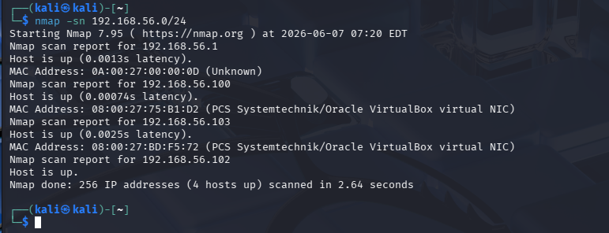
Figure 1: Nmap host discovery scan — 192.168.56.103 identified as live target

The attacker machine (Kali Linux) then confirmed direct access by logging into the Metasploitable 2 console using the default credentials (msfadmin/msfadmin), demonstrating weak default credential exposure.

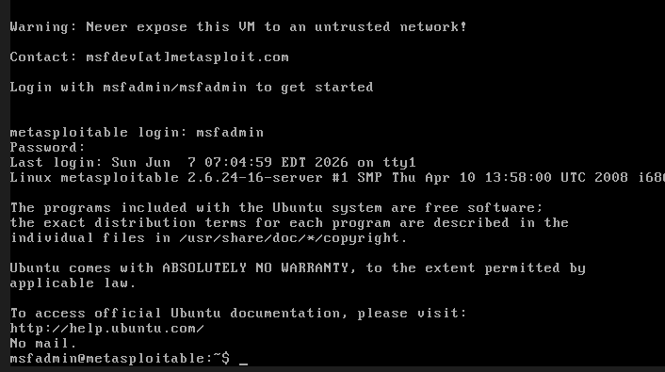
Figure 2: Successful login to Metasploitable 2 using default credentials (msfadmin/msfadmin)

4. Findings Summary
The following table summarizes all vulnerabilities identified during the assessment, ordered by severity.

ID | Vulnerability | CVE | CVSS | Severity | Service | Port
F-01 | vsFTPd 2.3.4 Backdoor Command Execution | CVE-2011-2523 | 10.0 | Critical | FTP | 21
F-02 | OpenSSH 4.7p1 Multiple Vulnerabilities | CVE-2023-38408 | 9.8 | Critical | SSH | 22
F-03 | Telnet Service Enabled (Unencrypted) | N/A | 7.5 | High | Telnet | 23
F-04 | ISC BIND 9.4.2 Remote Code Execution | CVE-2008-0122 | 10.0 | Critical | DNS | 53
F-05 | Netkit RSH/REXEC Services Enabled | N/A | 7.5 | High | RSH | 512-514
F-06 | ProFTPD 1.3.1 Multiple Vulnerabilities | CVE-2019-12815 | 9.8 | Critical | FTP | 2121
F-07 | MySQL 5.0.51a Unauthorized Access | CVE-2017-15945 | 7.8 | High | MySQL | 3306
F-08 | Apache 2.2.8 Outdated & Misconfigured | CVE-1999-0678 | 7.5 | High | HTTP | 80
F-09 | phpMyAdmin Exposed Without Auth | CVE-2003-1418 | 7.5 | High | HTTP | 80
F-10 | PHP Info Page Exposed | CWE-552 | 5.3 | Medium | HTTP | 80

5. Scan Evidence

5.1 Nmap Vulners Script — FTP & SSH Services
The Nmap vulners NSE script was executed against port 21 (vsftpd 2.3.4) and port 22 (OpenSSH 4.7p1), revealing multiple Critical and High severity CVEs with CVSS scores up to 10.0.

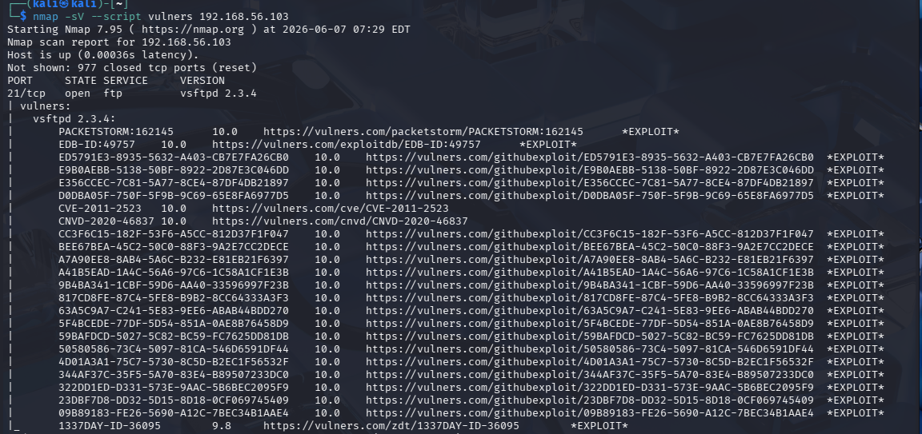
Figure 3: Nmap vulners scan — vsftpd 2.3.4 on port 21 with CVSS 10.0 exploits

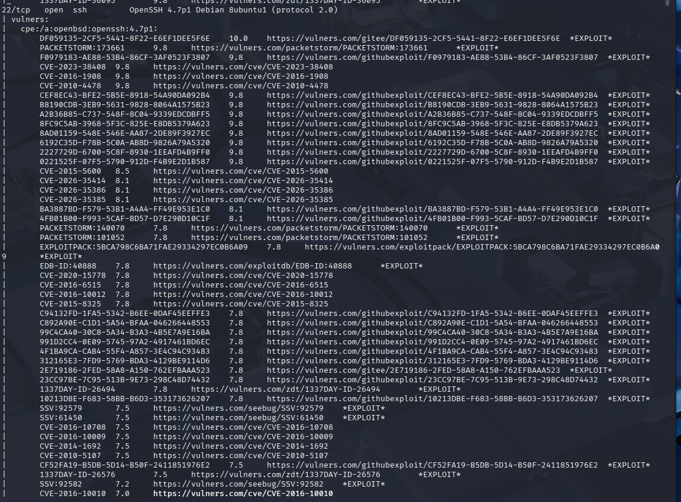
Figure 4: Nmap vulners scan — OpenSSH 4.7p1 on port 22 with multiple CVEs

5.2 Nmap Vulners Script — Telnet, SMTP, DNS Services
Additional services on ports 23 (Telnet), 25 (SMTP/Postfix), and 53 (ISC BIND 9.4.2) were scanned, revealing critical DNS vulnerabilities and unencrypted legacy protocols.

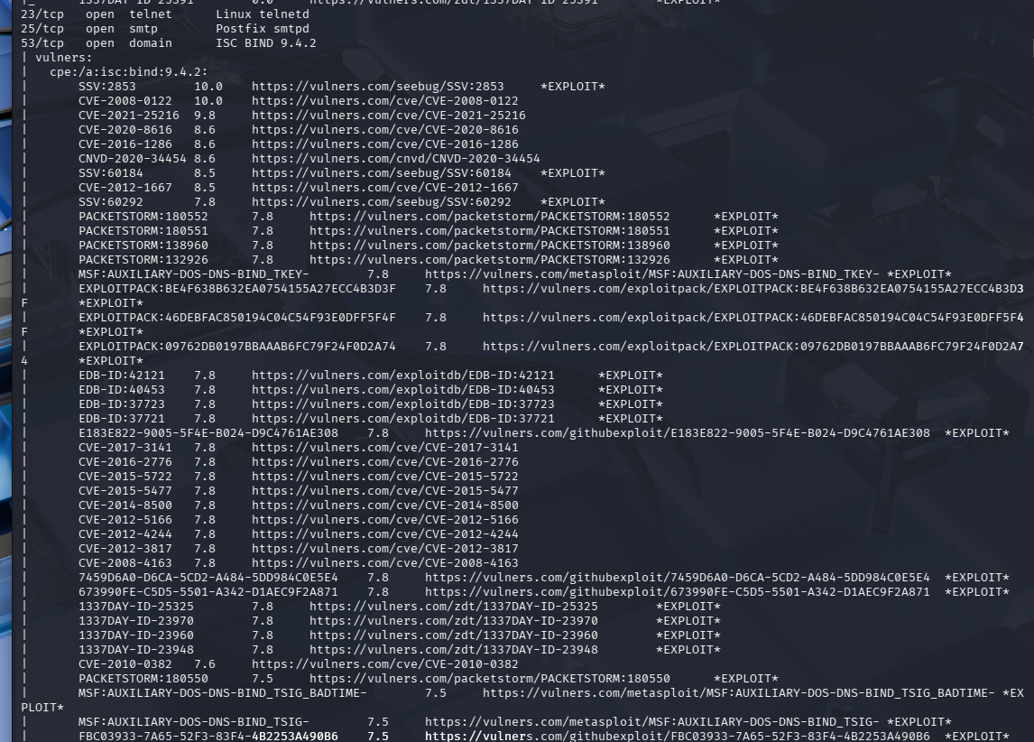
Figure 5: Nmap vulners scan — Telnet (port 23), SMTP (port 25), DNS BIND 9.4.2 (port 53)

5.3 Nmap Vulners Script — RSH, ProFTPD, MySQL Services
Further scanning revealed dangerous legacy services (rexec/rsh/rlogin on ports 512-514), a vulnerable ProFTPD 1.3.1 instance, and an outdated MySQL 5.0.51a database.

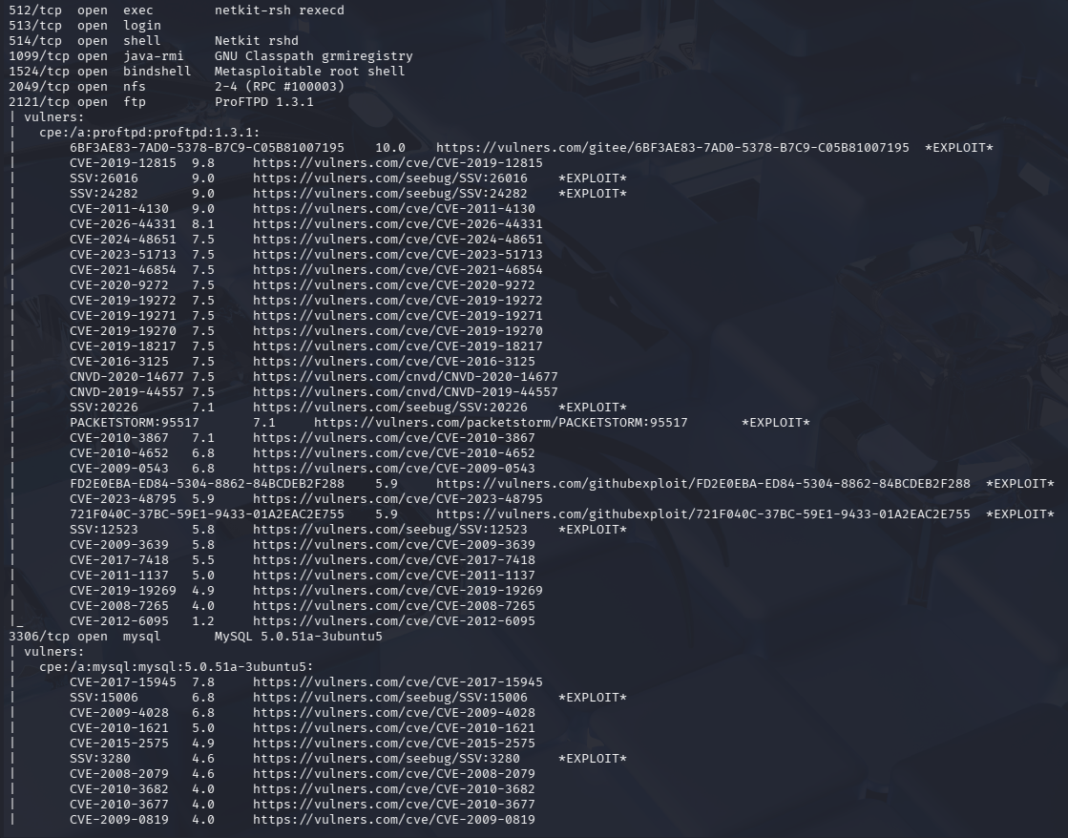
Figure 6: Nmap vulners scan — RSH services (512-514), ProFTPD 1.3.1 (2121), MySQL (3306)

5.4 Nikto Web Application Scan
A Nikto scan against the HTTP service on port 80 identified 27 issues including an exposed phpMyAdmin panel, PHP info page, directory indexing, outdated Apache version, and missing security headers.

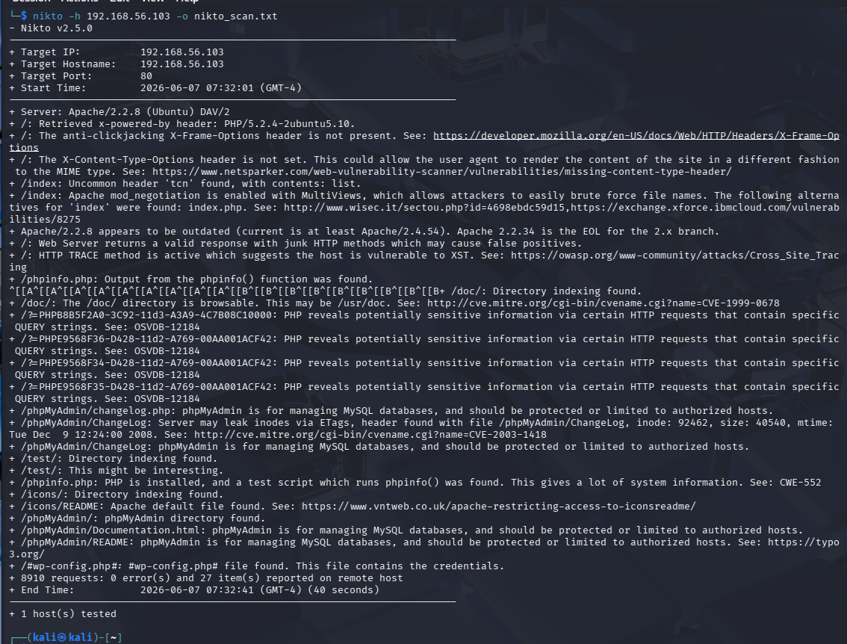
Figure 7: Nikto scan results — Apache 2.2.8, phpMyAdmin exposed, PHP info page, directory indexing (27 items)

5.5 Nmap Vuln Script — Confirmed vsftpd Backdoor
The Nmap vuln NSE script confirmed the vsftpd 2.3.4 backdoor (CVE-2011-2523) as VULNERABLE and Exploitable. The exploit resulted in a root shell (uid=0, gid=0), confirming full system compromise is achievable.

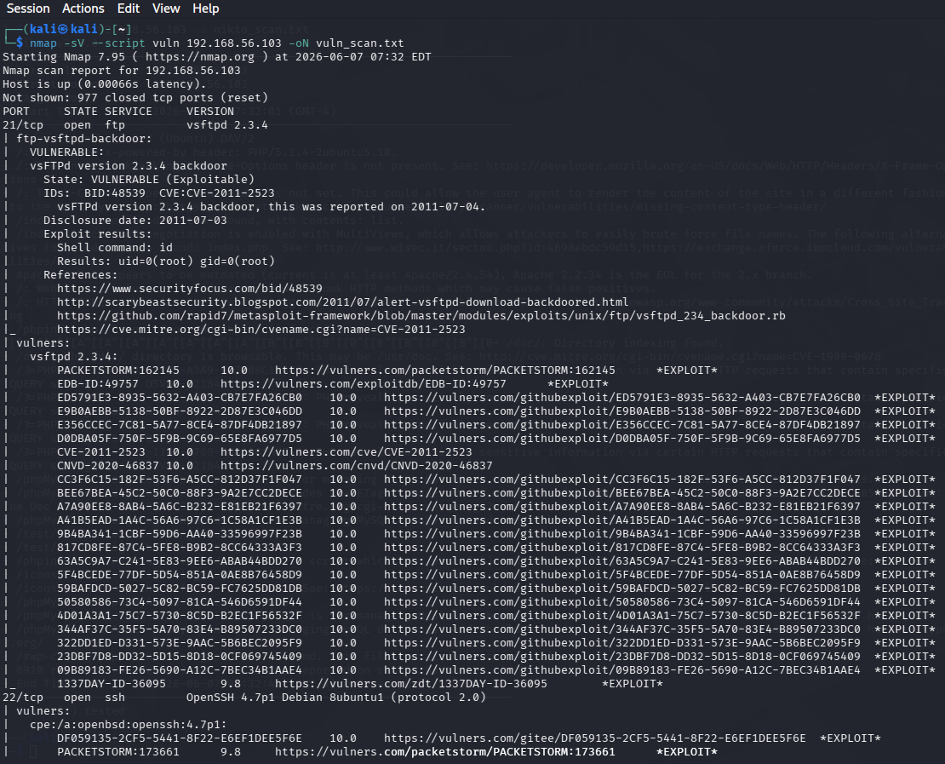
Figure 8: Nmap vuln script confirming CVE-2011-2523 vsftpd backdoor — State: VULNERABLE (Exploitable), uid=0(root)

6. Detailed Findings

F-01 — vsFTPd 2.3.4 Backdoor Command Execution
Vulnerability Name | vsFTPd 2.3.4 Backdoor Command Execution
CVE ID | CVE-2011-2523
CVSS Score | 10.0 (Critical)
CVSS Vector | AV:N/AC:L/PR:N/UI:N/S:C/C:H/I:H/A:H
Severity | Critical
Service / Port | FTP / Port 21
False Positive? | No — Confirmed exploitable by Nmap vuln script. State shown as VULNERABLE (Exploitable) with uid=0(root) in exploit results.

Description:
vsFTPd version 2.3.4 contains an intentionally introduced backdoor. When a username containing a smiley face (":)") is sent to port 21, the service opens a bind shell on port 6200, granting full root access without any authentication. This was confirmed by the Nmap vuln script returning uid=0(root).
Impact:
An unauthenticated remote attacker can gain a root-level command shell on the target system, leading to complete system compromise including data theft, lateral movement, persistence, and ransomware deployment.
Recommendation:
Immediately remove vsFTPd 2.3.4 and upgrade to the latest stable vsFTPd release (3.0.5+). Disable FTP entirely if not required; use SFTP (port 22) instead. Apply firewall rules to restrict port 21 and 6200 access.

F-02 — OpenSSH 4.7p1 Multiple Critical Vulnerabilities
Vulnerability Name | OpenSSH 4.7p1 Multiple Critical Vulnerabilities
CVE ID | CVE-2023-38408 (CVSS 9.8)
CVSS Score | 9.8 (Critical)
CVSS Vector | AV:N/AC:L/PR:N/UI:N/S:U/C:H/I:H/A:H
Severity | Critical
Service / Port | SSH / Port 22
False Positive? | No — OpenSSH 4.7p1 is a documented vulnerable version with numerous published CVEs. The vulners database confirms these are known exploitable issues.

Description:
OpenSSH version 4.7p1 is severely outdated (released ~2007) and affected by dozens of known CVEs. The Nmap vulners scan identified CVE-2023-38408 (CVSS 9.8) and many others scored 8.1 and above, including remote code execution and privilege escalation vulnerabilities.
Impact:
Remote attackers may exploit known weaknesses in the SSH daemon to gain unauthorized access, intercept sessions, or execute arbitrary code.
Recommendation:
Upgrade OpenSSH to the latest stable version (9.x). Disable password authentication; enforce key-based authentication only. Restrict SSH access to trusted IP ranges via firewall rules.

F-03 — Telnet Service Enabled (Plaintext Protocol)
Vulnerability Name | Telnet Service Enabled (Plaintext Protocol)
CVE ID | N/A
CVSS Score | 7.5 (High)
CVSS Vector | AV:N/AC:L/PR:N/UI:N/S:U/C:H/I:N/A:N
Severity | High
Service / Port | Telnet / Port 23
False Positive? | No — Telnet is inherently insecure by design. No encryption is applied to any data in transit.

Description:
The Telnet service (Linux telnetd) is enabled and listening on port 23. Telnet transmits all data including credentials in plain text, making it trivially interceptable by any attacker with network access.
Impact:
Any attacker on the same network segment can perform a man-in-the-middle attack and capture login credentials transmitted over Telnet. This violates basic confidentiality requirements.
Recommendation:
Immediately disable the Telnet service. Replace with SSH for all remote management needs. Ensure no telnet packages remain installed on the system.

F-04 — ISC BIND 9.4.2 Remote Code Execution
Vulnerability Name | ISC BIND 9.4.2 Remote Code Execution
CVE ID | CVE-2008-0122
CVSS Score | 10.0 (Critical)
CVSS Vector | AV:N/AC:L/PR:N/UI:N/S:C/C:H/I:H/A:H
Severity | Critical
Service / Port | DNS / Port 53
False Positive? | No — BIND 9.4.2 is a well-documented vulnerable version. Multiple critical CVEs are publicly known and have published exploits.

Description:
ISC BIND version 9.4.2 is running on port 53 and is affected by CVE-2008-0122 (CVSS 10.0), which allows remote code execution. Additionally, CVE-2021-25216 (CVSS 9.8) and multiple other High-severity issues were identified by the vulners scan.
Impact:
A remote attacker can exploit the DNS service to execute arbitrary code, crash the service (denial of service), or use DNS cache poisoning to redirect users to malicious servers.
Recommendation:
Upgrade ISC BIND to the latest stable release. If DNS is not required, disable the service entirely. Restrict DNS queries to authorized resolvers and enable DNSSEC.

F-05 — Netkit RSH/REXEC/RLOGIN Services Enabled
Vulnerability Name | Netkit RSH/REXEC/RLOGIN Services Enabled
CVE ID | N/A
CVSS Score | 7.5 (High)
CVSS Vector | AV:N/AC:L/PR:N/UI:N/S:U/C:H/I:N/A:N
Severity | High
Service / Port | RSH/REXEC/RLOGIN / Port 512-514
False Positive? | No — These services are inherently insecure by design and have been deprecated for decades in favor of SSH.

Description:
The legacy Berkeley r-services (rexec on port 512, rlogin on port 513, rsh on port 514) are running via Netkit-rsh and Netkit rshd. These services use trust-based authentication (host-based) with no encryption, making them susceptible to IP spoofing and session hijacking.
Impact:
Attackers can exploit trust relationships between hosts to gain unauthorized access without a password. All data transmitted, including commands and output, is unencrypted.
Recommendation:
Disable and uninstall all r-services (rsh, rexec, rlogin) immediately. Replace with SSH. Block ports 512-514 at the firewall perimeter.

F-06 — ProFTPD 1.3.1 Multiple Critical Vulnerabilities
Vulnerability Name | ProFTPD 1.3.1 Multiple Critical Vulnerabilities
CVE ID | CVE-2019-12815
CVSS Score | 9.8 (Critical)
CVSS Vector | AV:N/AC:L/PR:N/UI:N/S:U/C:H/I:H/A:H
Severity | Critical
Service / Port | FTP / Port 2121
False Positive? | No — ProFTPD 1.3.1 is a documented vulnerable version with known public exploits including Metasploit modules.

Description:
ProFTPD version 1.3.1 is running on port 2121 and is affected by CVE-2019-12815 (CVSS 9.8) which allows arbitrary file copy without authentication, as well as CVE-2011-4130 and multiple other high-severity vulnerabilities. This version is severely outdated.
Impact:
Remote attackers can copy arbitrary files on the server without authentication, potentially accessing sensitive configuration files, credentials, or planting backdoors.
Recommendation:
Upgrade ProFTPD to the latest stable version (1.3.8+). If FTP is required, enforce TLS/SSL (FTPS). Consider replacing FTP entirely with SFTP. Restrict access by IP address.

F-07 — MySQL 5.0.51a Unauthorized Access
Vulnerability Name | MySQL 5.0.51a Unauthorized Access
CVE ID | CVE-2017-15945
CVSS Score | 7.8 (High)
CVSS Vector | AV:L/AC:L/PR:L/UI:N/S:U/C:H/I:H/A:H
Severity | High
Service / Port | MySQL / Port 3306
False Positive? | No — MySQL 5.0.51a is confirmed end-of-life with multiple known CVEs. Remote root access without credentials is a known default misconfiguration in Metasploitable.

Description:
MySQL version 5.0.51a is running on port 3306. This version is end-of-life since 2012 and is affected by CVE-2017-15945 (CVSS 7.8) and multiple other vulnerabilities. MySQL on Metasploitable 2 is commonly misconfigured to allow remote root login without a password.
Impact:
Attackers can gain unauthorized access to the database, exfiltrate sensitive data, modify database contents, or use the MySQL UDF (User Defined Function) feature to escalate to OS-level code execution.
Recommendation:
Upgrade MySQL to a supported version (8.0+). Disable remote root login. Enforce strong passwords for all database accounts. Bind MySQL to localhost only (127.0.0.1) if external access is not required.

F-08 — Apache 2.2.8 Outdated and Misconfigured
Vulnerability Name | Apache 2.2.8 Outdated and Misconfigured
CVE ID | CVE-1999-0678
CVSS Score | 7.5 (High)
CVSS Vector | AV:N/AC:L/PR:N/UI:N/S:U/C:H/I:N/A:N
Severity | High
Service / Port | HTTP / Port 80
False Positive? | No — Apache 2.2.8 has numerous published CVEs. Directory indexing and TRACE method are confirmed active misconfigurations visible in Nikto output.

Description:
Apache version 2.2.8 is running on port 80, which is severely outdated (EOL since 2013; current is 2.4.x). Nikto identified that the server version is exposed in response headers, directory indexing is enabled, the HTTP TRACE method is active (enabling XST attacks), and the Apache mod_negotiation MultiViews option assists file brute-forcing.
Impact:
Attackers can leverage known Apache 2.2.x vulnerabilities, enumerate directory contents, perform Cross-Site Tracing (XST) attacks, and brute-force hidden files.
Recommendation:
Upgrade Apache to the latest 2.4.x release. Disable directory indexing (Options -Indexes). Disable the TRACE method (TraceEnable Off). Remove server version from response headers (ServerTokens Prod).

F-09 — phpMyAdmin Exposed Without Authentication Restriction
Vulnerability Name | phpMyAdmin Exposed Without Authentication Restriction
CVE ID | CVE-2003-1418
CVSS Score | 7.5 (High)
CVSS Vector | AV:N/AC:L/PR:N/UI:N/S:U/C:H/I:N/A:N
Severity | High
Service / Port | HTTP / Port 80
False Positive? | No — phpMyAdmin is confirmed accessible by Nikto. The ETag inode leak is a known documented issue.

Description:
phpMyAdmin is accessible at /phpMyAdmin/ on the web server without any IP restriction. Nikto confirmed that phpMyAdmin is exposed and that ETags in the ChangeLog file may leak inode numbers (CVE-2003-1418). The /wp-config.php# file was also found, which may contain database credentials.
Impact:
An attacker with network access can reach the phpMyAdmin interface to attempt database authentication, potentially gaining full MySQL control via the web GUI. Leaked inode data assists fingerprinting.
Recommendation:
Restrict phpMyAdmin access to trusted IP addresses using Apache allow/deny rules. Enforce strong authentication. Consider moving phpMyAdmin to a non-standard URL. Remove phpMyAdmin entirely if not operationally required.

F-10 — PHP Info Page Publicly Accessible
Vulnerability Name | PHP Info Page Publicly Accessible
CVE ID | CWE-552
CVSS Score | 5.3 (Medium)
CVSS Vector | AV:N/AC:L/PR:N/UI:N/S:U/C:L/I:N/A:N
Severity | Medium
Service / Port | HTTP / Port 80
False Positive? | No — The phpinfo() page is confirmed accessible by Nikto (CWE-552: Files or Directories Accessible to External Parties).

Description:
The phpinfo() test page is accessible at /phpinfo.php on the web server. This page exposes sensitive system information including PHP version, installed modules, server configuration, environment variables, and file paths, which can assist an attacker in planning further attacks.
Impact:
Attackers can gather detailed reconnaissance about the server environment, identify further exploitable PHP modules or misconfigurations, and use exposed paths to conduct targeted attacks.
Recommendation:
Remove the phpinfo.php file immediately. Audit the web root for any other test or debug scripts. Implement a policy to never deploy debug files in production environments.

7. Remediation & Recommendations Summary
The following table summarizes remediation priorities based on severity and exploitability:

ID | Vulnerability | Priority | Recommended Action
F-01 | vsFTPd 2.3.4 Backdoor | IMMEDIATE | Remove vsFTPd 2.3.4, upgrade or switch to SFTP
F-02 | OpenSSH 4.7p1 Vulns | IMMEDIATE | Upgrade OpenSSH, enforce key-based auth
F-04 | ISC BIND 9.4.2 RCE | IMMEDIATE | Upgrade BIND or disable DNS service
F-06 | ProFTPD 1.3.1 Vulns | IMMEDIATE | Upgrade ProFTPD or disable FTP, use SFTP
F-03 | Telnet Enabled | SHORT-TERM | Disable Telnet, use SSH exclusively
F-05 | RSH/REXEC/RLOGIN | SHORT-TERM | Disable and uninstall all r-services
F-07 | MySQL 5.0.51a | SHORT-TERM | Upgrade MySQL, restrict remote root access
F-08 | Apache 2.2.8 | SHORT-TERM | Upgrade Apache, fix misconfigurations
F-09 | phpMyAdmin Exposed | SHORT-TERM | Restrict access, enforce authentication
F-10 | PHP Info Exposed | LONG-TERM | Remove debug files, audit web root

References:
- NIST NVD: https://nvd.nist.gov/
- CVE Database: https://www.cve.org
- CWE MITRE: https://cwe.mitre.org/index.html
- OWASP Top 10: https://owasp.org/www-project-top-ten/
- CVSS v3.0 Calculator: https://www.first.org/cvss/calculator/3.0

