IKB21403 — Vulnerability Assessment
WEEK 4 LAB REPORT
Footprinting & Reconnaissance — Metadata Extraction
Chapter 3 | Passive Footprinting using OSINT Tools

1. Environment Setup
Before performing metadata extraction, the Kali Linux environment was updated and the required tools were installed.

1.1 System Update
Command executed:
sudo apt update

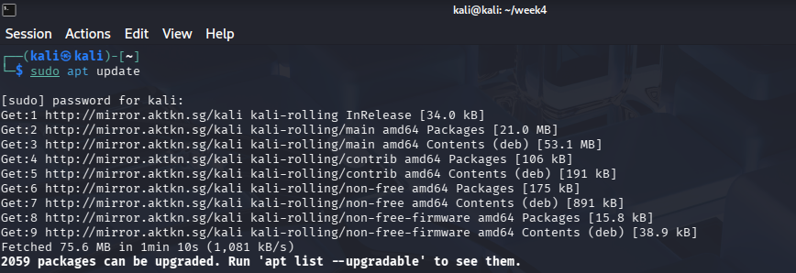

Result: The system successfully fetched updated package lists from the Kali rolling repository. A total of 2,059 packages were available for upgrade, confirming the system is connected and repositories are reachable.

1.2 Tool Installation — exiftool & binwalk
Command executed:
sudo apt install exiftool binwalk -y

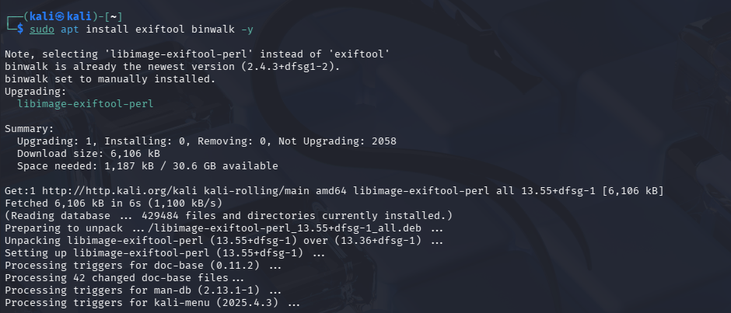

Result: exiftool (libimage-exiftool-perl v13.55) was successfully upgraded. binwalk was already at the latest version (2.4.3+dfsg1-2). Both tools are now ready to use for metadata and steganography analysis.

2. Lab Files Overview
The week4 working directory contains the following files to be analyzed:

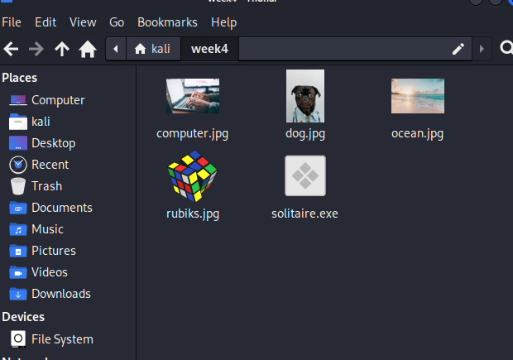

File | Type | Tool Used
ocean.jpg | JPEG Image | exiftool
computer.jpg | JPEG Image | strings, hexeditor
dog.jpg | JPEG Image | binwalk
rubiks.jpg | JPEG Image | file (check file type)
solitaire.exe | Executable (.exe) | file (check file type)

3. Task 1 — Metadata Extraction using exiftool (ocean.jpg)
Exiftool reads embedded metadata from image files, revealing information such as camera model, GPS coordinates, creation date, software used, and hidden comments placed by creators or attackers.

3.1 Command & Output
exiftool ocean.jpg

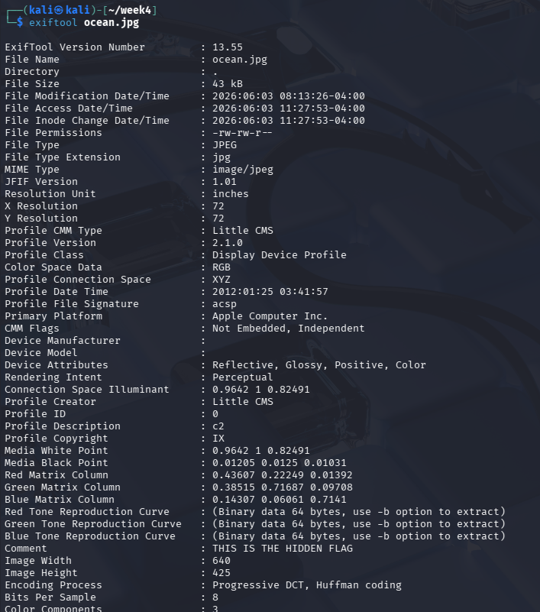

3.2 Key Findings
Metadata Field | Value
File Name | ocean.jpg
File Size | 43 kB
File Type | JPEG
MIME Type | image/jpeg
Image Width | 640 px
Image Height | 425 px
X / Y Resolution | 72 dpi
Color Space | RGB
Primary Platform | Apple Computer Inc.
Profile Creator | Little CMS
Comment (Hidden Flag) | THIS IS THE HIDDEN FLAG

Finding: The Comment field in ocean.jpg contains a hidden message: "THIS IS THE HIDDEN FLAG". This demonstrates how sensitive or secret information can be embedded inside ordinary-looking image files using metadata fields, making exiftool a critical tool for information leakage detection.

4. Task 2 — String Extraction using strings (computer.jpg)
The strings command extracts all printable ASCII character sequences from a binary file. This is useful for discovering hidden text, credentials, URLs, or flags embedded within image or executable files.

4.1 Command & Output
strings computer.jpg

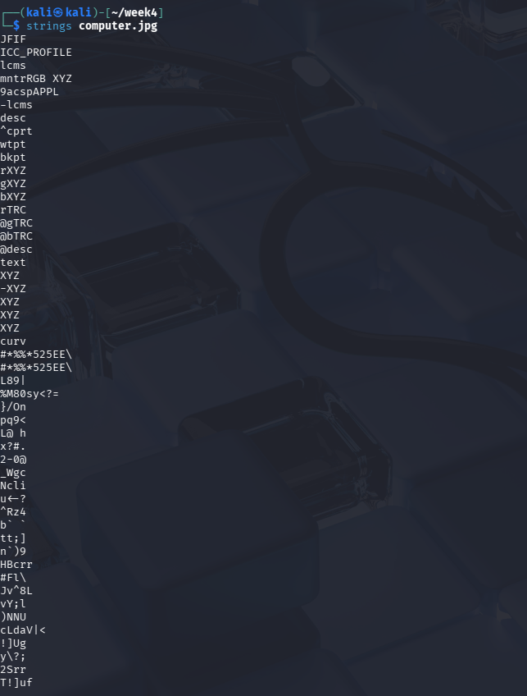

4.2 Filtered Search
To search for specific keywords, strings can be piped to grep:
strings computer.jpg | grep -i "flag"
strings computer.jpg | grep -i "hidden"
strings computer.jpg | grep -i "password"

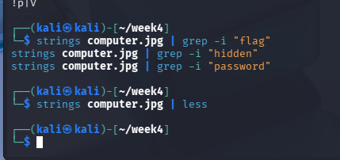

Finding: The strings output shows raw printable text embedded in the binary data of computer.jpg. No explicit "flag" or "hidden" keyword was returned from the grep filters in this case, but the tool successfully extracted embedded text strings such as JFIF, ICC_PROFILE, and other binary metadata markers. This confirms the file contains embedded profile data typical of JPEG images.

5. Task 3 — Steganography Detection using binwalk (dog.jpg)
Binwalk is a tool for searching binary files for embedded files and executable code. It is commonly used in CTF challenges and real-world forensics to detect and extract hidden data appended to image files.

5.1 Scan — binwalk dog.jpg
binwalk dog.jpg

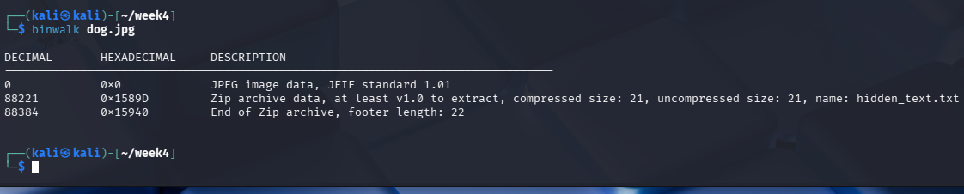

Finding: Binwalk detected two signatures inside dog.jpg:
- At offset 0x0 — JPEG image data (JFIF standard 1.01), confirming the file starts as a valid JPEG.
- At offset 0x1589D — A ZIP archive (hidden_text.txt, compressed size: 21 bytes), confirming a hidden file is appended inside the image.

5.2 Extraction — binwalk -e dog.jpg
binwalk -e dog.jpg
cd _dog.jpg.extracted/
ls
cat hidden_text.txt

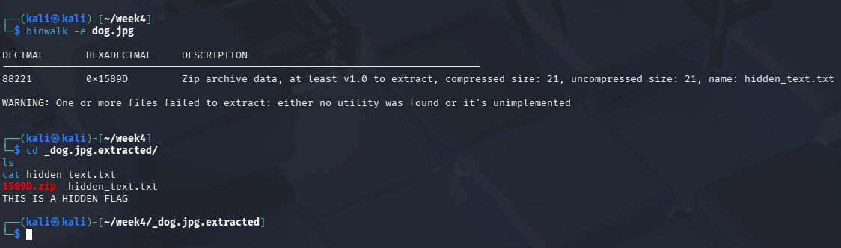

Finding: After extraction, the _dog.jpg.extracted/ directory contains 1589D.zip and hidden_text.txt. Reading hidden_text.txt reveals the message: "THIS IS A HIDDEN FLAG". This confirms that steganographic data was successfully hidden inside a normal-looking JPEG image by appending a ZIP archive after the image data.

6. Task 4 — True File Type Detection using file command
The file command identifies the true type of a file by inspecting its magic bytes (file signature), regardless of the file extension. This is important in security analysis because attackers often disguise malicious files by changing their extensions.

6.1 solitaire.exe
file solitaire.exe

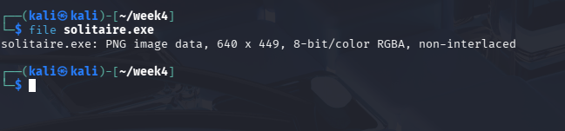

Finding: Despite having a .exe extension (suggesting a Windows executable), the file command reveals that solitaire.exe is actually a PNG image (640 x 449, 8-bit/color RGBA, non-interlaced). This is a classic example of file masquerading — a threat actor could disguise an image (or malware) as an executable to deceive users or evade basic security filters.

6.2 rubiks.jpg
file rubiks.jpg

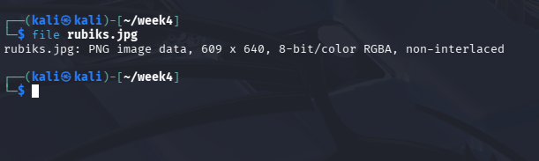

Finding: rubiks.jpg is identified as a PNG image (609 x 640, 8-bit/color RGBA, non-interlaced) despite having the .jpg extension. This confirms the file extension is misleading — the actual file format is PNG. This technique could be used to hide the true nature of a file and bypass file-type-based filtering.

7. Summary of Findings
File | Tool | Hidden Data Found | Key Finding
ocean.jpg | exiftool | YES | Comment field: "THIS IS THE HIDDEN FLAG"
computer.jpg | strings | Partial | Embedded binary strings; no plain-text flag via grep
dog.jpg | binwalk | YES | Extracted hidden_text.txt: "THIS IS A HIDDEN FLAG"
solitaire.exe | file | YES | File is PNG, not EXE — disguised file type
rubiks.jpg | file | YES | File is PNG, not JPEG — disguised file extension

7.1 Security Implications
This lab demonstrates three key information security risks:
- Metadata Leakage (exiftool): Files can silently carry hidden data in metadata fields. Organizations should strip metadata from files before sharing them publicly.
- Steganography (binwalk): Attackers can hide entire files inside images by appending archives. Firewalls and antivirus tools that only check file extensions would miss this.
- File Masquerading (file command): Files with false extensions can bypass naive type-checking. True file identification using magic bytes is always necessary.

Conclusion: Passive footprinting through metadata analysis is a powerful and completely passive technique that reveals significant information leakage without triggering any alerts on the target system.

