TryHackMe
Credential Brute-Force Attack Lab Report
April 29, 2026

1. Overview
This report documents the completion of the TryHackMe Hydra room. The objective of this lab is to learn how to use Hydra — a fast and flexible online password cracking tool — to perform brute-force attacks against web login forms and SSH services. The lab demonstrates how weak or common passwords can be discovered through automated credential attacks.

2. Tools & Environment
Component | Details
Platform | TryHackMe
Room | Hydra
Attacker Machine | Kali Linux
Tool Used | Hydra v9.6
Target IP | 10.48.150.185
Wordlist | /usr/share/wordlists/rockyou.txt
Connection Method | OpenVPN (TryHackMe VPN)

3. Environment Setup

3.1 Connecting to TryHackMe VPN
Before accessing any target machines, it is necessary to connect to the TryHackMe VPN so that the private target IP is reachable from the attacker machine.
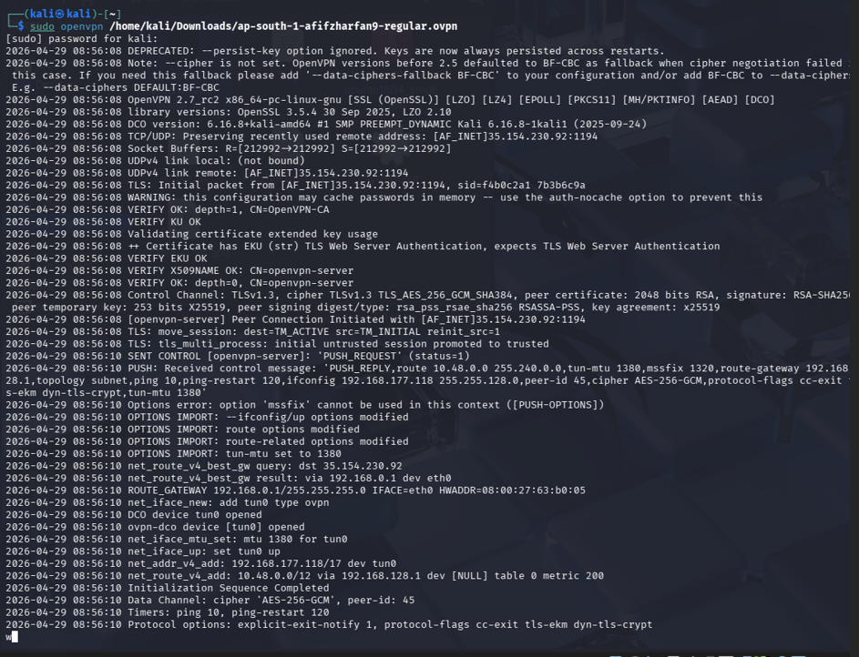

- Download the OpenVPN configuration file from: https://tryhackme.com/access
- Open a terminal in Kali Linux and run the following command:
sudo openvpn yourfile.ovpn
- Wait until the terminal displays: Initialization Sequence Completed
- Once connected, open the Firefox browser in Kali and navigate to the target IP.

3.2 Accessing the Target Web Application
After a successful VPN connection, navigate to the target machine's login page in the Kali browser:
http://10.48.150.185/login
The page displays a login form titled "Hydra Challenge" with Username and Password fields. This is the target for the brute-force attack.

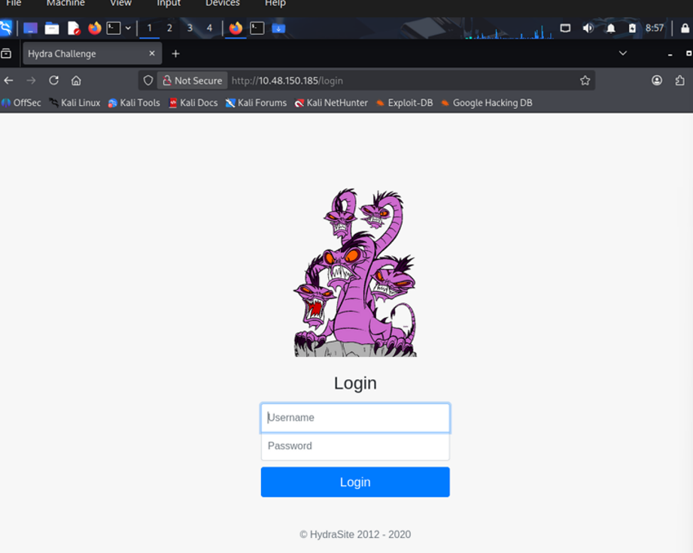

4. Task 1 — Brute-Force Web Login (HTTP POST Form)

4.2 Understanding the Attack
Hydra automates the process of submitting username and password combinations to a login form and checks whether the server's response indicates a successful login. The key parameters needed are:
- The URL path of the login form (/login)
- The HTML field names for username and password
- The failure message displayed when credentials are wrong

4.3 Hydra Command
The following command was used to perform the brute-force attack:
hydra -l molly -P /usr/share/wordlists/rockyou.txt 10.48.150.185 http-post-form "/login:username=^USER^&password=^PASS^:F=incorrect" -V
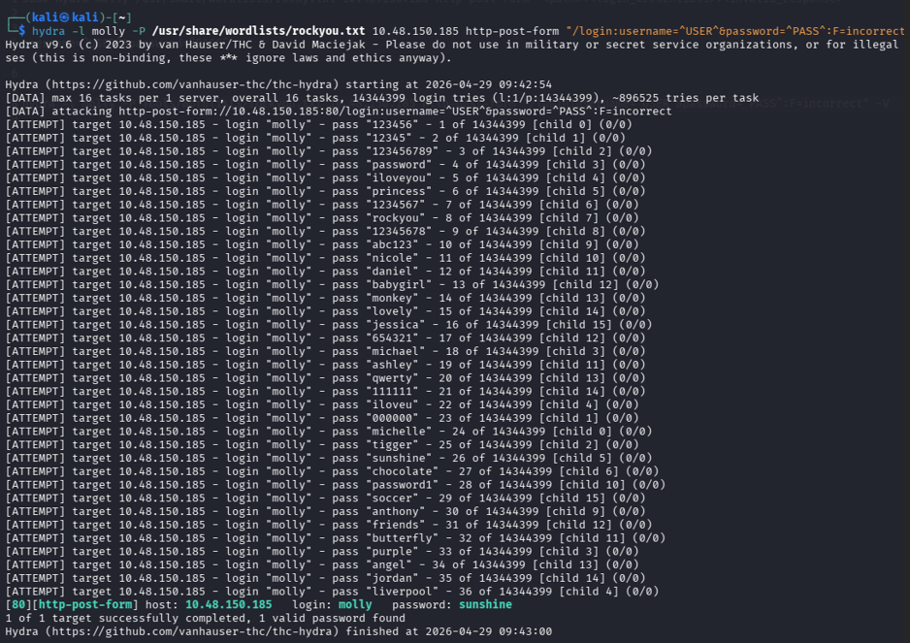
Flag / Option | Description
-l molly | Specifies a single username to test: molly
-P rockyou.txt | Specifies the password wordlist file path
10.48.150.185 | IP address of the target machine
http-post-form | Attack module for HTTP POST login forms
/login | The URL path of the login form
username=^USER^ | HTML field name for the username input
password=^PASS^ | HTML field name for the password input
F=incorrect | Failure string — response text when login fails
-V | Verbose mode — shows each attempt in the terminal

4.4 Result
Hydra successfully identified the correct credentials after testing passwords from the wordlist:

Field | Value
Username | molly
Password | sunshine

These credentials were then used to log into the web application, which returned the first flag.
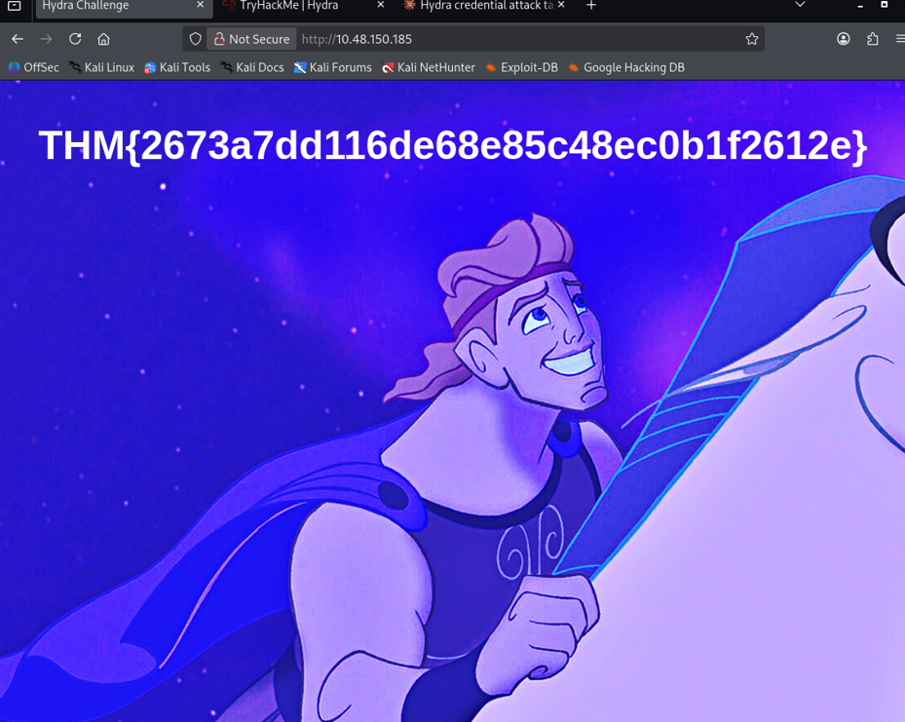

5. Task 2 — Brute-Force SSH Login

5.2 Hydra Command for SSH
The following command was used to attack the SSH service:

hydra -l molly -P /usr/share/wordlists/rockyou.txt 10.48.150.185 ssh -V
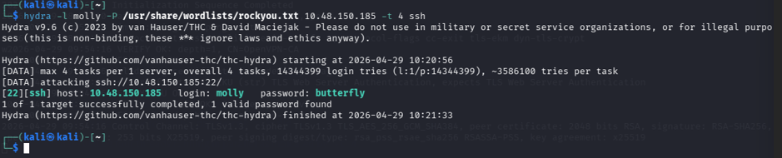
Flag / Option | Description
-l molly | Target username
-P rockyou.txt | Password wordlist
10.48.150.185 | Target machine IP address
ssh | Protocol/service being attacked (SSH port 22)
-V | Verbose mode to show each attempt

5.3 Logging in via SSH
After Hydra discovered the SSH password, the following command was used to log into the target machine:
ssh molly@10.48.150.185
Enter the password found by Hydra when prompted. Once logged in, retrieve the flag:
cat flag2.txt
x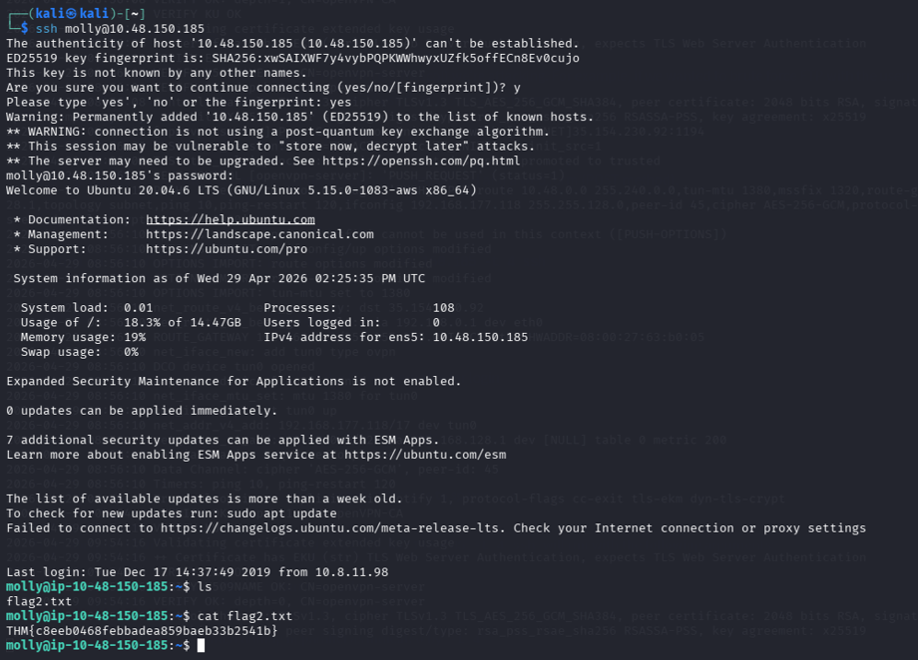

5.4 Result
Hydra successfully cracked the SSH credentials, allowing remote access to the target machine. The second flag was retrieved from the home directory.
