**LAPORAN PRAKTIKUM INTERNET OF THINGS**

# **JOBSHEET-1**

# **LED**



**Dosen Pengampu :**

**Irsyad Arif**

**Oleh:**

**Noorr Afiad TI3D/19 (1941720232)**

**PROGRAM STUDI TEKNIK INFORMATIKA**

**JURUSAN TEKNOLOGI INFORMASI**

**POLITEKNIK NEGERI MALANG**

**JULI 2022**

**Praktikum**

### **Project 1: Running LED RGB**

kode program berikut pada Visual Studio Code

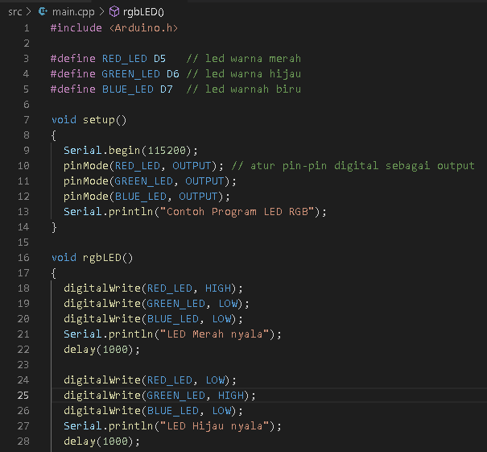

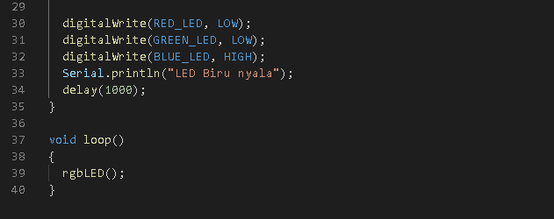

Link Video hasil project 1: <https://drive.google.com/file/d/1rQ6VuENfKEuwIxUCn4Nv7ajsuOLkjl2v/view?usp=sharing>

### **Project 2: SOS LED**

kode program berikut pada Visual Studio Code

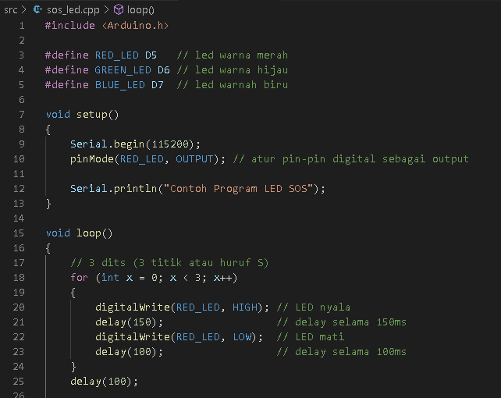

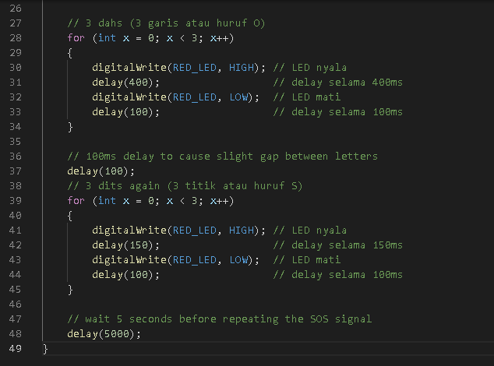

Link Video Hasil project 2 : <https://drive.google.com/file/d/1h01CBfzogXVVWpDynFgM5GT0D7l8oDJV/view?usp=sharing>

**TUGAS:**

Link video hasil : <https://drive.google.com/file/d/1w04bPTxhKA_Jb0NA4cIGWWO50DVVcDO0/view?usp=sharing>