**Supplementary information**

**Less is more: facilitation of diversity as a key ecosystem function that declines with increasing local plant species richness**

Christopher J Lortie 1,2* et al.

1. Department of Biology, York University,

4700 Keele St.,

Toronto, ON Canada.

M3J 1P3

* Correspondence: lortie@yorku.ca

2. The National Center for Ecological Analysis and Synthesis (NCEAS),

UCSB, Santa Barbara, CA, USA. 93101.

**Supplementary Figure 1.** Preferred Reporting Items for Systematic Reviews and Meta-Analyses statement for the synthesis of shrub facilitation and the the term positive. Web of Science was queried August 2020. See main text for full search details.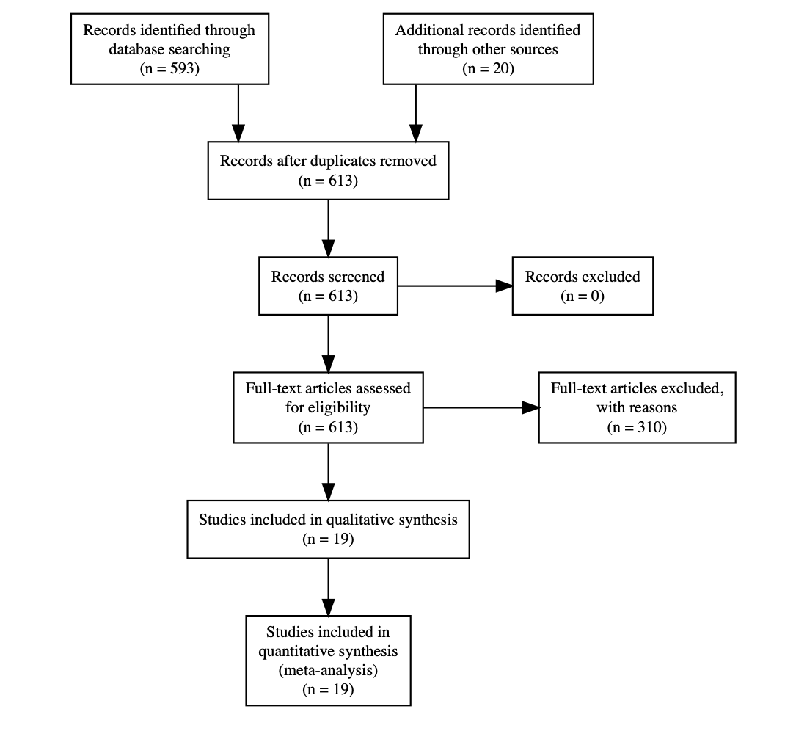

**Supplement Table 1. List of studies included in meta-analysis on the facilitation of diversity in shrub ecosystems.**

| Table 1 | | | | | |
| --- | --- | --- | --- | --- | --- |
| ID | year | authors | title | journal | DOI |
| **6** | 2019 | Bai, Yuxuan; Zhang, Yuqing; Michalet, Richard; She, Weiwei; Jia, Xin; Qin, Shugao | Responses of different herb life-history groups to a dominant shrub species along a dune stabilization gradient | BASIC AND APPLIED ECOLOGY | 10.1016/j.baae.2019.06.001 |
| **11** | 2019 | Mashizi, Azam Khosravi; Sharafatmandrad, Mohsen | Assessing the effects of shrubs on ecosystem functions in arid sand dune ecosystems | ARID LAND RESEARCH AND MANAGEMENT | 10.1080/15324982.2019.1634655 |
| **32** | 2019 | Ruwanza, Sheunesu | Nurse plants have the potential to accelerate vegetation recovery in Lapalala Wilderness old fields, South Africa | AFRICAN JOURNAL OF ECOLOGY | 10.1111/aje.12536 |
| **64** | 2018 | Zhang, Gefei; Zhao, Wenzhi; Zhou, Hai; Yang, Qiyue; Wang, Xiaofen | Extreme drought stress shifts net facilitation to neutral interactions between shrubs and sub-canopy plants in an arid desert | OIKOS | 10.1111/oik.04630 |
| **83** | 2017 | Wang, Xiangtai; Michalet, Richard; Chen, Shuyan; Zhao, Liang; An, Lizhe; Du, Guozhen; Zhang, Xiaochen; Jiang, Xingpei; Xiao, Sa | Contrasting understorey species responses to the canopy and root effects of a dominant shrub drive community composition | JOURNAL OF VEGETATION SCIENCE | 10.1111/jvs.12565 |
| **115** | 2016 | Holthuijzen, Maike F.; Veblen, Kari E. | GRAZING EFFECTS ON PRECIPITATION-DRIVEN ASSOCIATIONS BETWEEN SAGEBRUSH AND PERENNIAL GRASSES | WESTERN NORTH AMERICAN NATURALIST | 10.3398/064.076.0308 |
| **273** | 2013 | Cuevas, Jaime G.; Silva, Sergio I.; Leon-Lobos, Pedro; Ginocchio, Rosanna | Nurse effect and herbivory exclusion facilitate plant colonization in abandoned mine tailings storage facilities in north-central Chile | REVISTA CHILENA DE HISTORIA NATURAL | 10.4067/S0716-078X2013000100006 |
| **294** | 2012 | Abdallah, F.; Chaieb, M. | The influence of trees on nutrients, water, light availability and understorey vegetation in an arid environment | APPLIED VEGETATION SCIENCE | 10.1111/j.1654-109X.2012.01201.x |
| **316** | 2012 | Howard, Kimberley S. C.; Eldridge, David J.; Soliveres, Santiago | Positive effects of shrubs on plant species diversity do not change along a gradient in grazing pressure in an arid shrubland | BASIC AND APPLIED ECOLOGY | 10.1016/j.baae.2012.02.008 |
| **325** | 2011 | Armas, Cristina; Rodriguez-Echeverria, Susana; Pugnaire, Francisco I. | A field test of the stress-gradient hypothesis along an aridity gradient | JOURNAL OF VEGETATION SCIENCE | 10.1111/j.1654-1103.2011.01301.x |
| **356** | 2011 | Soliveres, Santiago; Eldridge, David J.; Maestre, Fernando T.; Bowker, Matthew A.; Tighe, Matthew; Escudero, Adrian | Microhabitat amelioration and reduced competition among understorey plants as drivers of facilitation across environmental gradients: Towards a unifying framework | PERSPECTIVES IN PLANT ECOLOGY EVOLUTION AND SYSTEMATICS | 10.1016/j.ppees.2011.06.001 |
| **379** | 2010 | Madrigal-Gonzalez, J.; Garcia-Rodriguez, J. A.; Puerto-Martin, A.; Fernandez-Santos, B.; Alonso-Rojo, P. | Scale-dependent effects of pines on the herbaceous layer diversity in a semi-arid mediterranean ecosystem | COMMUNITY ECOLOGY | 10.1556/ComEc.11.2010.1.11 |
| **394** | 2010 | Abdallah, Fathia; Chaieb, Mohamed | Interactions of Acacia raddiana with herbaceous vegetation change with intensity of abiotic stress | FLORA | 10.1016/j.flora.2010.04.009 |
| **477** | 2006 | Tecco, PA; Gurvich, DE; Diaz, S; Perez-Harguindeguy, NP; Cabido, M | Positive interaction between invasive plants: The influence of Pyracantha angustifolia on the recruitment of native and exotic woody species | AUSTRAL ECOLOGY | 10.1111/j.1442-9993.2006.01557.x |
| **485** | 2006 | Holzapfel, Claus; Tielboerger, Katja; Parag, Hadas A.; Kigel, Jaime; Sternberg, Marcelo | Annual plant-shrub interactions along an aridity gradient | BASIC AND APPLIED ECOLOGY | 10.1016/j.baae.2005.08.003 |
| **514** | 2004 | Wilby, A; Shachak, M | Shrubs, granivores and annual plant community stability in an arid ecosystem | OIKOS | 10.1111/j.0030-1299.2004.13085.x |
| **522** | 2004 | Pugnaire, FI; Armas, C; Valladares, F | Soil as a mediator in plant-plant interactions in a semi-arid community | JOURNAL OF VEGETATION SCIENCE | 10.1111/j.1654-1103.2004.tb02240.x |
| **600** | 2020 | Erfanzadeh, Reza; Shayesteh Palaye, Ali A.; Ghelichnia, Hassan | Shrub effects on germinable soil seed bank in overgrazed rangelands | PLANT ECOLOGY & DIVERSITY | 10.1080/17550874.2020.1718233 |

**Supplement supporting analyses.**  Detailed meta-analysis visualization and model. All code also published at Zenodo (DOI: 10.5281/zenodo.4058976).

**Mixed-Effects Meta-model Model (k = 87; tau^2 estimator: DL)**

**R Version 4.0.3**

**Meta and metafor packages to support analyses.**

##

## logLik deviance AIC BIC AICc

## -23.0169 348.9753 54.0338 63.8974 54.5216

##

## tau^2 (estimated amount of residual heterogeneity): 0.0174 (SE = 0.0066)

## tau (square root of estimated tau^2 value): 0.1317

## I^2 (residual heterogeneity / unaccounted variability): 99.27%

## H^2 (unaccounted variability / sampling variability): 136.47

## R^2 (amount of heterogeneity accounted for): 67.79%

##

## Test for Residual Heterogeneity:

## QE(df = 84) = 11463.7988, p-val < .0001

##

## Test of Moderators (coefficients 2:3):

## QM(df = 2) = 95.5023, p-val < .0001

##

## Model Results:

##

## estimate se zval pval ci.lb ci.ub

## intrcpt 0.1023 0.0187 5.4649 <.0001 0.0656 0.1390 ***

## poly(n_species, 2)1 -1.4841 0.1601 -9.2717 <.0001 -1.7978 -1.1704 ***

## poly(n_species, 2)2 0.2312 0.1891 1.2226 0.2215 -0.1394 0.6018

##

## ---

## Signif. codes: 0 '***' 0.001 '**' 0.01 '*' 0.05 '.' 0.1 ' ' 1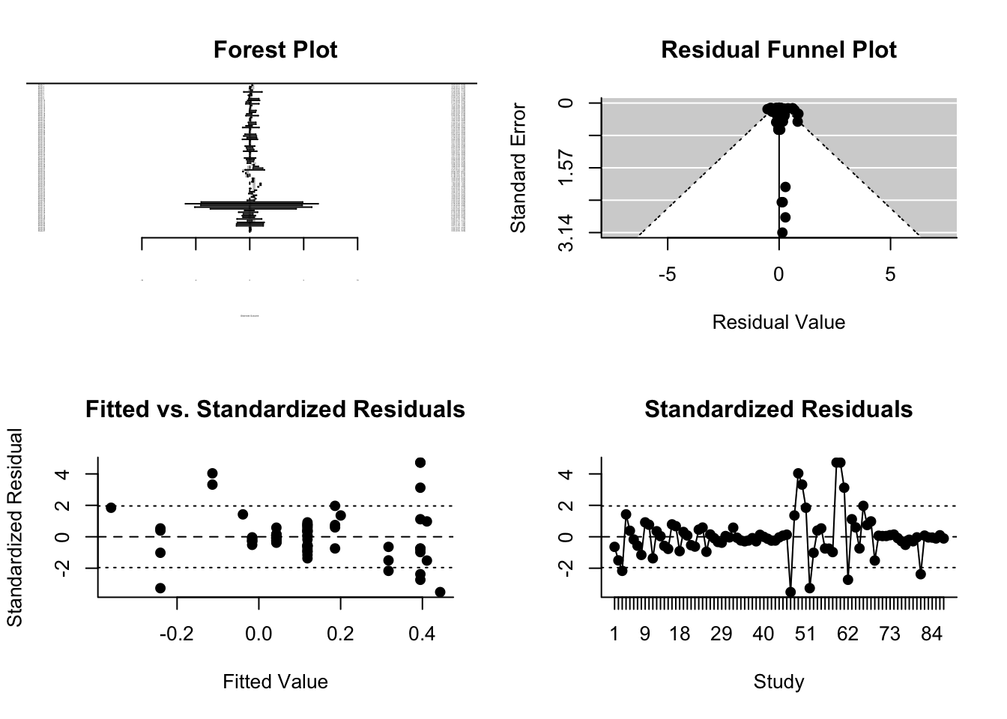

**Contrast of linear and non-linear meta-regression**

##

## df AIC BIC AICc logLik LRT pval QE tau^2

## Full 4 54.0338 63.8974 54.5216 -23.0169 11463.7988 0.0174

## Reduced 3 56.4715 63.8692 56.7607 -25.2358 4.4377 0.0352 11485.2400 0.0166

## R^2

## Full

## Reduced 0.0000%

**Permutation test for best fit model**

##

## Test of Moderators (coefficients 2:3):

## QM(df = 2) = 95.5023, p-val* = 0.0010

##

## Model Results:

##

## estimate se zval pval* ci.lb ci.ub

## intrcpt 0.1023 0.0187 5.4649 0.0310 0.0656 0.1390 *

## poly(n_species, 2)1 -1.4841 0.1601 -9.2717 0.0010 -1.7978 -1.1704 ***

## poly(n_species, 2)2 0.2312 0.1891 1.2226 0.2630 -0.1394 0.6018

##

## ---

## Signif. codes: 0 '***' 0.001 '**' 0.01 '*' 0.05 '.' 0.1 ' ' 1