GATE-RTion DoseActor validation procedure

Authors: Hermann Fuchs, Medical University of Vienna

Marta Bolsa-Ferruz, MedAustron  
Test release: 19-06-2018

**Test specifications**

Test name: Dose Actor

Type of test: Functional testing

Configuration: GATEv8.1, Geant4.10.3.patch3, Rootv6.12/06

**Background**

The Dose Actor is used to store deposited energy, dose, dose to water and dose to material in a given simulation volume. It uses the deposited energy, material type and density to calculate the dose, dose to water and dose to material based on stopping power conversions. For details, please refer to the [GATE manual](http://wiki.opengatecollaboration.org/index.php/Main_Page).

Content

Disclaimer 2

Purpose of the test 2

Overview of the test 2

PART A 4

A1. Energy deposition 4

A2. Normalise dose to Max/Integral 5

A2.2 Validate voxel size and resolution 6

A3. Dose deposition 7

A4. Dose to water/to other material 8

PART B. Dose calculation methods 10

B1. Volume Weighting Algorithm 11

B2. Mass-Weighting Algorithm 12

PART C. Dose scoring options: Pre/Post/Middle/Random HitType

# Disclaimer

This validation test aims at providing confidence that the Dose Actor works as specified and the installation is correct.

**This validation test does not cover all possibilities offered by the Dose Actor. It is recommended that the user adapt the test macros as closely as possible to its intended use, if different from the one proposed here.**

# Purpose of the test

This test validates that the Dose Actor works as specified:

* The simulated energy shall be as specified.
* Using the mass of the target, the deposited energy shall be converted into dose.
* Using the mass stopping power, the dose to water is converted into dose to other materials.
* The dose normalized to the maximum dose or to the dose integral shall be as the dose divided by the maximum dose or the dose integral.
* The various parameters available to configure the Dose Actor (voxel size, resolution, position and size) as well as the dose calculation methods (mass/volume-weighted algorithm) and the dose scoring (pre/post/middle/random hit type) in heterogeneous geometry shall work as specified.

# Overview of the test

The Dose Actor validation test is divided in three main parts:

* Part A contains four different geometries to verify the energy and dose deposition in different materials. Different set up parameters of the dose actor (voxel size, resolution, position and size) are tested.
* Part B is dedicated to the validation of dose calculation methods using a heterogeneous geometry.
* Part C is intended to validate the dose scoring according to the four different hit types (pre/post/middle and random)

Each simulation can be run individually using the corresponding file (e.g. mainA1.mac for test A1). Each test uses a different geometry and a different actor set up. The output files are saved in the corresponding folder (e.g. outputA1/ for test A1). The visualization preferences and material list are common to all the tests. The type of source can be modified in ‘mainXX.mac’. By default, a 250 MeV proton beam (TPS Source) is used. An excel calculation sheet is available for the validation of Test A2-A4, B1-B2 and C.

# PART A

## A1. Energy deposition

In a big enough target, all energy of a particle should be deposited.

**Test set-up:**

* Some energy loss is possible due to energy needed for nuclear interactions. Therefore, a physics list without nuclear interaction (electromagnetic – only) was selected (*emstandard_opt4*).
* A 250 MeV proton beam (TPS source) is starting in the centre of a 1x1x1 m lead block.
* 1000 particles were sent.
* A dose actor storing energy deposited was attached to the geometry.

**Result:**

The full energy of the particles was deposited.

Edep = 250000 keV

Edep2= 62500000 keV

***Test passed***

## A2. Normalise dose to Max/Integral

The normalised dose to the maximum value and the normalised dose to the dose integral can be obtained using the Dose Actor option normaliseDoseToMax and normaliseDoseToIntegral.

**Test set-up:**

* A 250 MeV proton beam (TPS source) impinges a 1x1x1 m water block. The source is located 1 cm above the water surface.
* 1000 particles were sent.
* The dose, the dose normalised to the maximum value and the dose normalised to the dose integral were obtained.
* A voxel size of 100x1x100 cm was used.

**Result:**

An excel file is provided to compute the normalised dose to the maximum value (or to the dose integral) from the scored dose. See Figure 1.

Figure 1. Comparison of normalised dose obtained with GATE and normalised dose computed from the scored dose. The normalised dose to the maximum value and to the integral dose is shown in the left and right panel respectively. (The plot was created using the Excel sheet)

***Test passed***

## A2.2 Validate voxel size and resolution

The voxel size and resolution can be validated using the macro from test A2. Test A2 uses a voxel size of 100x1x100 cm.

The voxel size and resolution are printed in the head of the dose output files. They are expressed in mm.

# Matrix Size= (1000,1000,1000)

# Resol = (1,100,1)

# VoxelSize = (1000,10,1000)

# nbVal = 100

Change the voxel size of the dose actor to (100, 0.3, 100) cm (mainA2.mac) and run the macro. Check the resolution in the output file.

# Matrix Size= (1000,1000,1000)

# Resol = (1,333,1)

# VoxelSize = (1000,3.003,1000)

# nbVal = 333

Since the voxel size we used (0.3 cm) does not allow to create an entire number of voxels within the geometry (100/0.3=333.333), the voxel size is automatically adjusted to 3.003 (100/0.3003=333.000).

Repeat the simulation with a resolution of 1 2 4 and then, 2 4 8. Check the voxel size in the output files.

# Matrix Size= (1000,1000,1000)

**# Resol = (1,2,4)**

**# VoxelSize = (1000,500,250)**

# nbVal = 8

And

# Matrix Size= (1000,1000,1000)

**# Resol = (2,4,8)**

**# VoxelSize = (500,250,125)**

# nbVal = 64

***Test passed***

## A3. Dose deposition

Based on the deposited energy and the mass, the correct dose should be calculated and stored.

**Test set-up:**

* A 250 MeV proton beam (TPS source) hits the centre of a thin target (100cm x 100cm x 10µm) consisting of G4_Water.
* 1 particle was sent.
* The physics list ‘QBBC_EMZ’ was used.
* The energy (Edep) and dose (D) deposited as well as their squared values are stored.

The conversion of Edep to dose is done using the following formula:

$Dose \left[\frac{J}{kg}\right]=\frac{E_{dep}[J]}{mass[kg]}=\frac{E_{dep}[MeV]}{density \left[\frac{kg}{{cm}^{3}}\right]x volume [{cm}^{3}]}x\frac{1.6022x{10}^{-13}J}{1 MeV}$ Equation 1

**Result:**

The calculated dose (line 9) based on the density of water [0.001kg/cm³] and the volume of the slab matches the dose scored by Gate (line 3) (see Figure 2).

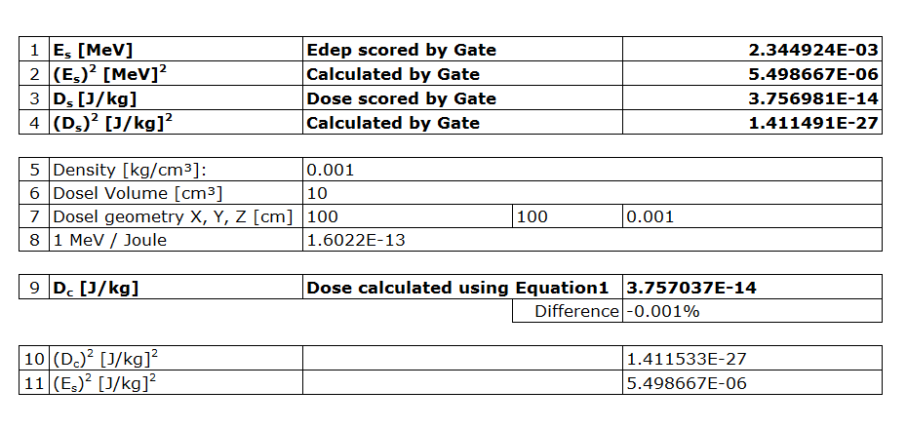

Figure 2. Conversion of Edep into Dose using the Excel sheet.

***Test passed***

## A4. Dose to water/to other material

Based on the mass stopping power ratios, dose shall be converted into dose to water or any other material. Particles without stopping power will be neglected. Exceptions: photons will be considered as electrons for this conversion.

**Test set-up:**

* A 250 MeV proton beam (TPS source) hits the centre of a thin target (100cm x 100cm x 10µm) consisting of G4_Water.
* 1 particle was sent.
* Physics list ‘QBBC_EMZ’ was used.
* The energy, dose, doseToWater and doseToOtherMaterial deposited is stored using the dose actor. Material for doseToOtherMaterial is set to PMMA.

The EmCalculatorActor allows to extracting EM properties for all materials defined in the simulation, like the stopping power. One can convert by hand the dose to a material (M1) to the dose to another material (M2) by applying the following equation:

${Dose}_{M2}={Dose}_{M1}×\frac{{SP}_{M2}/{density}_{M2}}{{SP}_{M1}/{density}_{M1}}={Dose}_{M1}×\frac{{DEDX}_{M2}}{{DEDX}_{M1}}$ Equation 2

SP = Stopping power, DEDX = Total mass stopping power from EmCalculatorActor, M1=Water and M2=OtherMaterial=PMMA.

**Result:**

The material in the geometry for ‘TestBox’ must be G4_Water, therefore dose and dose to water shall be identical. Scored dose to other material (PMMA) shall be obtained using the corresponding stopping powers. See Figure 3.

The doseToOtherMaterial may present up to 2% difference due to different nuclear cross-sections between PMMA and Water.

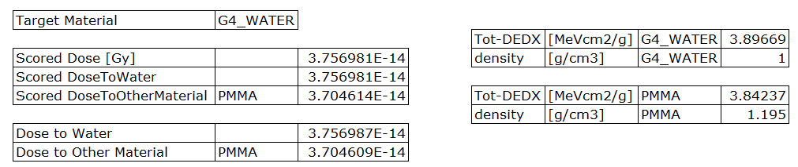

Figure 3. Dose to water and dose to material conversion from the Excel sheet.

***Test passed***

*Additionally,*

**Test set-up:**

Change target material to PMMA in mainA4.mac and run the macro again.

**Result:**

The material used is PMMA, therefore dose and dose to other material (PMMA) shall be identical. Dose to water scored shall be obtained using the corresponding stopping powers. See Figure 4.

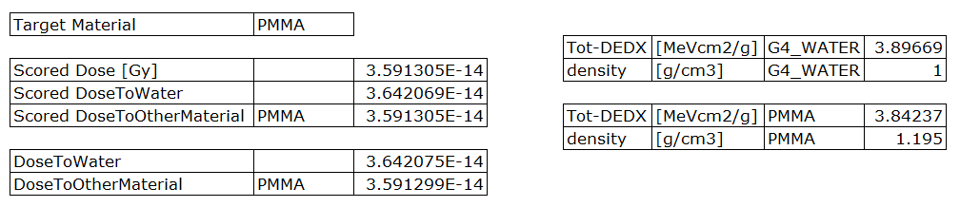

Figure 4. Dose to water and dose to material conversion from the Excel sheet.

***Test passed***

# PART B. Dose calculation methods

Two different methods for calculating the dose in a heterogeneous medium can be used.

* Volume-weighting algorithm
* Mass-weighting algorithm

Both methods are explained and validated below. By default, the Volume-Weighting algorithm is used.

**Test geometry**

* The file ‘geometryB.mac’ is used by the tests B1 and B2. It contains the following volumes (see Figure 5):

b

w

l1

l2

Bone

Water

Lung

100cm

100cm

0.001cm

Figure 5. Heterogeneous geometry used as example for the validation of dose calculation methods.

## B1. Volume Weighting Algorithm

The absorbed dose of each material (Di) inside the dosel is weighted by its volume fraction (Vi/Vdosel):

Equation 3

e.g.

$D_{dosel}=\left(\frac{E_{1}}{ρ_{1}V_{dosel}}+\frac{E_{2}}{ρ_{2}V_{dosel}}+\frac{E_{3}}{ρ_{3}V_{dosel}}=\right)\frac{V_{1}}{V_{dosel}}×D_{1}+\frac{V_{2}}{V_{dosel}}×D_{2}+\frac{V_{3}}{V_{dosel}}×D_{3}$ Equation 4

The Volume-Weighting algorithm is used by default.

* A 250 MeV proton beam (TPS source) hits the centre of our geometry.
* The dose inside the dosel with a resolution of (1,1,1) and (2,1,2) is calculated.
* The dose of lung and bone boxes are also scored.
* 1000 particle was sent.
* Physics list ‘QBBC_EMZ’ was used.

**Results:**

With the help of the excel file (see *Figure 6*) check that

* 1. Ddosel = Dl1*(Vl1/Vdosel) + Dl2*(Vl2/Vdosel) + Dw*(Vw/Vdosel) + Db*(Vb/Vdosel)
  2. Dlung = {Dl1*Vl1/(Vl1+Vl2)} + {(Dl2*Vl2/(Vl1+Vl2)}
  3. Dbone = Db
  4. Edosel = El1 + El2 + Ew + Eb
  5. Elung = El1 + El2
  6. Ebone = Eb

Where D=Dose ; V=Volume ; E=Energy

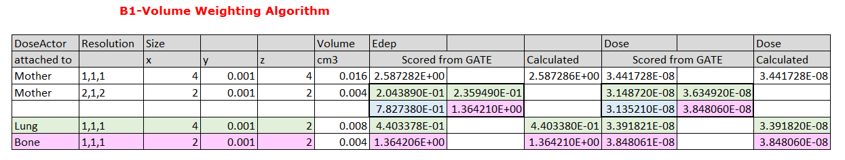

Figure 6. Volume Weighting Algorithm calculation from Excel sheet.

***Test passed***

## B2. Mass-Weighting Algorithm

The absorbed dose of each material (Di) inside the dosel is weighted by its mass fraction (mi/mdosel). This algorithm divides the total energy deposited in a dosel (Edosel) by its total mass (mdosel).

Equation 5

e.g.

$D_{dosel}=\frac{m_{1}}{m_{dosel}}×D_{1}+\frac{m_{1}}{m_{dosel}}×D_{1}+\frac{m_{1}}{m_{dosel}}×D_{1}=\frac{E_{dosel}}{m_{dosel}}$ Equation 6

* Select Mass-Weighting Algorithm and create a MassImage file containing the mass of each voxel.

/gate/actor/doseTest0/setDoseAlgorithm MassWeighting

/gate/actor/doseTest0/exportMassImage output/MassImageTest0.txt

The MassImage file can be exported if the geometry and resolution is maintained fixed to avoid extra-calculation time.

/gate/actor/doseTest0/importMassImage output/MassImageTest0.txt

**Results:**

With the help of the excel file (see 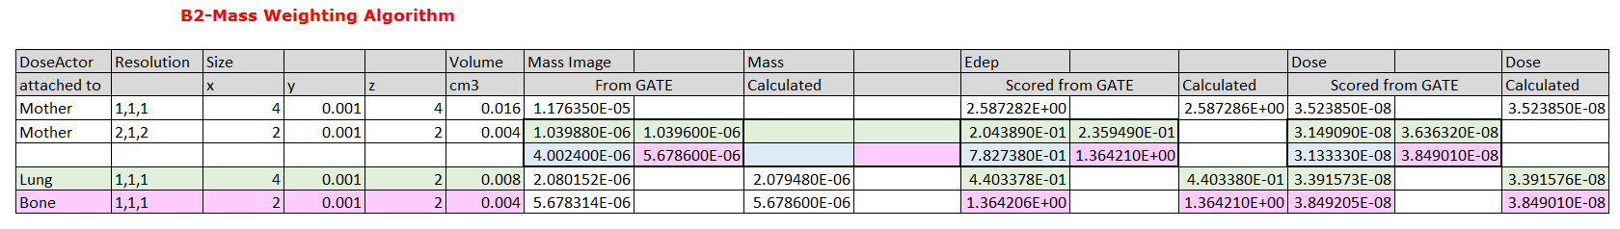

Figure 7) check that

1. Ddosel = Dl1*(ml1/mdosel) + Dl2*(ml2/Vdosel) + Dw*(mw/mdosel) + Db*(mb/mdosel)
2. Dlung = {Dl1*ml1/(ml1+ml2)} + {(Dl2*ml2/(ml1+ml2)}
3. Dbone = Db
4. Edosel = El1 + El2 + Ew + Eb
5. Elung = El1 + El2
6. Ebone = Eb

(MassImage-MI)

1. MIlung = dlung * Vlung
2. MIbone = dbone * Vbone
3. MIl1 = dlung * Vl1
4. MIl2 = dlung * Vl2
5. MIw = dwater * Vw
6. MIbone = dbone * Vb



Figure 7. Mass Weighting Algorithm calculation from Excel sheet.

***Test passed***

# PART C. Dose scoring: hit type

The term step is used in Geant4 to define the distance to the next interaction. The position along the step line in which the information provided by the Dose Actor (e.g. energy deposition, dose,…) is stored can be chosen by the user. Four positions, called hit types in Gate, are defined: ‘pre’ (at the beginning of the step), ‘post’ (at the end of the step), ‘middle’ (in between pre and post) and ‘random’ (for each particle, an arbitrary position is calculated along the step line and all the values are stored in the voxel that contains this position).

Because of the energy dependence of the cross section, the continuous energy loss forces the upper limit of the step size. The step size should be small enough, so that the cross section changes are small. However, the computing time increases as the step size decreases. The step line can be located inside a single voxel or cross several voxels regarding the matrix size defined by the user.

This test is intended to study how the maximum step size limit and the matrix size affects the output of our simulation regarding the four dose scoring positions (‘pre’, ‘post’, ‘middle’ and ‘random’). In particular, ‘pre’ and ‘post’ positions may lead to a discontinuity artifact in the border between two geometries.

**Test geometry**

A border in between two geometries of the same material (water) is simulated. For this purpose, a water box is created within a bigger water box.

border

Figure 8. A fictitious border in between two water boxes is used as an example for the validation of the dose scoring (hit type).

**Test set-up**

* A 250 MeV proton beam (TPS source) hits the water box.
* 5x105 particles were sent.
* A large particle production cut (20 cm) was selected.
* Three different maximum step sizes and voxel sizes (in the longitudinal direction, y) are tested for the four types of hit. They must be changed manually by the user before running the simulation.

|  |  |  |
| --- | --- | --- |
|  | Max. Step size | Voxel size |
| C1 | 0.1 mm | 1 mm |
| C2 | 1 mm | 1 mm |
| C3 | 1 mm | 0.1 mm |

C1) Max. step size = 0.1 mm ; Voxel size = 1 mm

In Figure 9, the energy deposition is plotted versus the depth. Since both geometries are made of the same material (water), no evidence of a geometry transition is expected. However, the user can observe an artifact in the boundary when using Pre or Post hit type (an excel sheet is provided for this test). The energy deposition at the boundary has been zoomed in *Figure 10*. The discontinuity in energy is more pronounced when using Pre hit type.

Figure 9. Energy deposition as function of depth using Pre and Random hit types. Maximum step size is 0.1 mm and voxel size, 1 mm.

Figure 10. Energy deposition as function of depth using Random, Pre, Post and Middle hit types. The boundary is located at 200 mm depth. Maximum step size is 0.1 mm and voxel size, 1 mm.

C2) Max. step size = 1 mm ; Voxel size = 1 mm

When the maximum step size is equal to the voxel size, the jump in energy (or dose) in the boundary is more pronounced (mainly for Pre hit type) (see Figure 11). For a better understanding of this phenomenon, the user can repeat the test using a maximum step size larger than the voxel size (see paragraph C3).

Figure 11. Energy deposition as function of depth using Random, Pre, Post and Middle hit types. The boundary is located at 200 mm. Maximum step size is 1 mm and voxel size, 1 mm.

C3) Max. step size = 1 mm ; Voxel size = 0.1 mm

*Figure 12* represents the energy deposited at the entrance channel. In this region, most of the energy deposited is due to continuous energy loss. The change in cross section with depth is small compared to the Bragg peak region and the step length in the entrance is restricted by the maximum step size that was chosen by the user.

In this plot (*Figure 12*) we can observe in which position the energy was stored regarding the hit type. The blue arrow indicates the step line. When selecting Pre hit type, the energy is deposited in the voxel that corresponds to the position at the beginning of the step line. When selecting Post hit type, the energy is scored in the voxel which position corresponds to the end of the step line. The energy is stored in the voxel at the middle of the step line when using middle hit type. The adjacent voxels do not receive any contribution from the continuous energy loss and a jump in energy is observed. When using random hit type, an arbitrary position for the energy deposition is calculated for each particle. In the latest case, all the voxels store some energy and no jump in between adjacent voxels is found.

Figure 12. Energy deposition as function of depth using Random, Pre, Post and Middle hit types. Maximum step size is 1 mm and voxel size, 0.1 mm.

In Geant4, all the particles are forced to perform a step before crossing the boundary towards the next geometry. When using ‘pre’ hit type, the energy due to continues energy loss is deposited 1 mm before the border (the maximum step length cross 10 voxels). On the contrary, when using ‘post’ hit type, the continuous energy loss is stored right before the border. Immediately after the boundary, all the particles start a new step with the same initial position. The energy is then deposited in the first voxel after the boundary with ‘pre’, and in the 10th voxel after the boundary with ‘post’. ‘Random’ hit type does not produce any discontinuity artifact since the energy is distributed along the step line.

*Figure 13. Energy deposition as function of depth using Random, Pre, Post and Middle hit types. Maximum step size is 1 mm and voxel size, 0.1 mm*.

It is recommended to use random type, especially when using different geometries and/or materials. The choice of maximum step size must be done regarding the matrix size and the energy dependence of the cross section.