LibFmCore

- List Of Files
1 – Files List

base/fm-app-info.h
base/fm-archiver.h
base/fm-dummy-monitor.h
base/fm-file-info.h
base/fm-file-info-list.h
base/fm-folder.h
base/fm-icon.h
base/fm-list.h
base/fm-mime-type.h
base/fm-monitor.h
base/fm-path.h
base/fm-path-list.h
base/fm-utils.h

2 - General Modules

base/fm-utils.h

Mount Unmount functions, Trash Can handling and misc file operation functions.

base/fm-list.h

A generic list container supporting reference counting.

base/fm-icon.h

GIcon container with cache.

base/fm-path.h
base/fm-path-list.h

Manages Paths, contains a link to the parent Path and Path Flags, that's the central object of the Library.

base/fm-file-info.h
base/fm-file-info-list.h

Manages File Information, contains a FmPath and a FmMimeType.

base/fm-mime-type.h
base/fm-folder.h
base/fm-app-info.h
base/fm-archiver.h

base/fm-monitor.h
base/fm-dummy-monitor.h

fmvala

fm-config.vala

Handles the configuration data stored in DConf.

Gtk Objects

gtk/fm-clipboard.h
gtk/fm-dnd-auto-scroll.h
gtk/fm-dnd-dest.h
gtk/fm-dnd-src.h
gtk/fm-file-menu.h
gtk/fm-icon-pixbuf.h
gtk/fm-thumbnail.h

Dialogs

gtk-dlg/app-global-ui.c

Contains XML dialog definitions

EXEC_FILE_DLG replaces exec-file.ui

APP_CHOOSER_DLG replaces app-chooser.ui

RENAME_DLG replaces ask-rename.ui

PROPERTIES_DLG replaces file-prop.ui

APPLICATIONS_DLG replaces

PROGRESS_DLG replaces progress.ui

TODO: move every def in each dialog file...

gtk-dlg/fm-file-properties.h
gtk-dlg/fm-app-chooser-combo-box.h
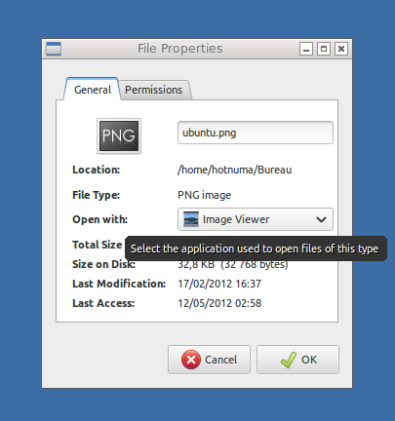

gtk-dlg/fm-app-chooser-dlg.h
gtk-dlg/fm-app-menu-view.h

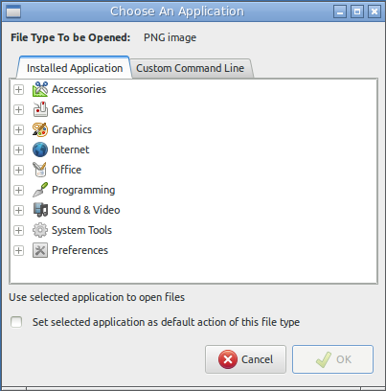
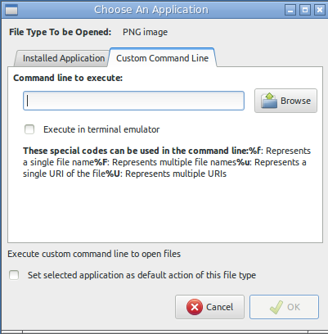

gtk-dlg/fm-gtk-launcher.h
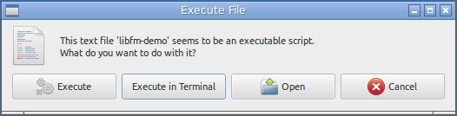

gtk-dlg/fm-progress-dlg.h

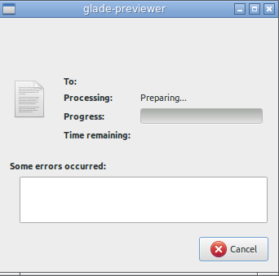

gtk-dlg/fm-dlg-utils.h

Jobs

job/fm-deep-count-job.c
job/fm-deep-count-job.h

job/fm-dir-list-job.c
job/fm-dir-list-job.h

job/fm-file-info-job.c
job/fm-file-info-job.h

job/fm-file-ops-job.c
job/fm-file-ops-job.h

job/fm-file-ops-job-change-attr.c
job/fm-file-ops-job-change-attr.h

job/fm-file-ops-job-delete.c
job/fm-file-ops-job-delete.h

job/fm-file-ops-job-xfer.c
job/fm-file-ops-job-xfer.h

job/fm-job.c
job/fm-job.h

job/fm-simple-job.c
job/fm-simple-job.h
Global Popup Menu

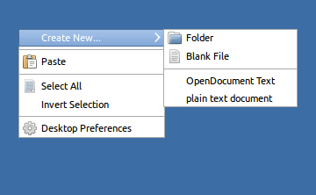

Create New... | Folder  Blank File
Programs... | Folder  Blank File
OpenDocument Text
Plain Text Document
Paste
Select All
Invert Selection
Run...
File Explorer
Terminal
Task Manager
Properties

