LibFmCore
deps...

fm-dnd-dest.c
#include "fm-file-ops.h"
#include "fm-trash.h"
#include "fm-msgbox.h"

fm-file-menu.c
#include "fm-archiver.h" // the menu is the only one that uses the archiver, the clipboard...
#include "fm-clipboard.h"
#include "fm-app-info.h" // file menu, archiver and launcher....

#include "fm-app-chooser-dlg.h"
#include "fm-file-properties.h"

#include "fm-trash.h"
#include "fm-file-ops.h"

fm-trash.c
#include "fm-jobs.h"
#include "fm-vala.h"
#include "fm-msgbox.h"
Base Objects

base/fm-app-info.h
base/fm-archiver.h
base/fm-dummy-monitor.h
base/fm-file-info.h
base/fm-file-info-list.h
base/fm-folder.h
base/fm-icon.h
base/fm-list.h
base/fm-mime-type.h
base/fm-monitor.h
base/fm-path.h
base/fm-path-list.h

FmList

A generic list container supporting reference counting.

(base/fm-list.h)

FmIcon

GIcon container with cache.

(base/fm-icon.h)

FmPath

Manages Paths, contains a link to the parent Path and Path Flags, that's the central object of the Library.

(base/fm-path.h, base/fm-path-list.h)

FmFileInfo

Manages File Information, contains a FmPath and a FmMimeType.

(base/fm-file-info.h, base/fm-file-info-list.h)

base/fm-mime-type.h
base/fm-folder.h
base/fm-app-info.h
base/fm-archiver.h

base/fm-monitor.h
base/fm-dummy-monitor.h

fm-vala

fm-config.vala

Handles the configuration data stored in DConf.

Global Configuration :

Type | Name | Description | Default Value
bool | use_trash_can | delete file to trash can | true
bool | confirm_delete | ask before deleting files | true
bool | show_thumbnail | show thumbnails | false
uint | thumbnail_size | size of thumbnail icons | 128
uint | thumbnail_max | show thumbnails for files smaller than 'thumb_max' KB | 2048
bool | thumbnail_local | show thumbnails for local files only | true
string | archiver
string | terminal
string | panel
string | run
string | taskmanager
bool | si_unit | use SI prefix for file sizes

gtk

gtk/fm-clipboard.h

gtk/fm-dnd-auto-scroll.h

gtk/fm-dnd-dest.h

gtk/fm-dnd-src.h

gtk/fm-file-menu.h

gtk/fm-icon-pixbuf.h

gtk/fm-thumbnail.h

gtk-dlg

Dialogs

gtk-dlg/fm-file-properties.h
gtk-dlg/fm-app-chooser-combo-box.h
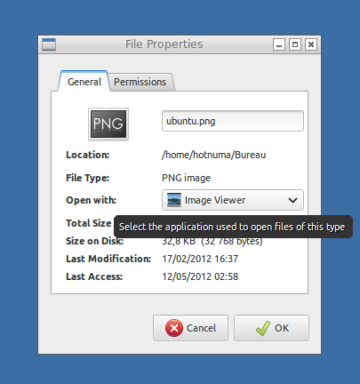

gtk-dlg/fm-app-chooser-dlg.h
gtk-dlg/fm-app-menu-view.h

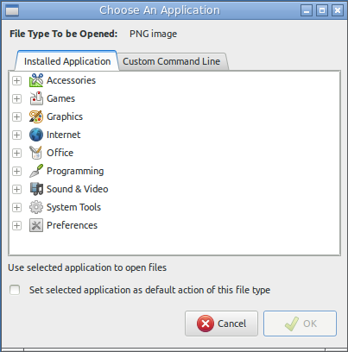
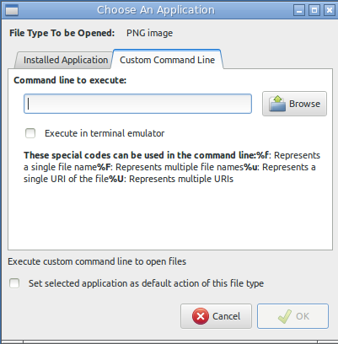

gtk-dlg/fm-gtk-launcher.h
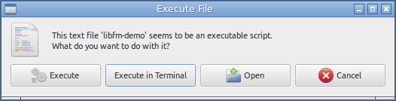

gtk-dlg/fm-progress-dlg.h

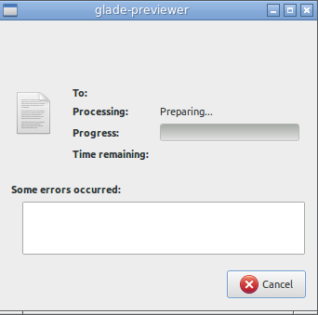

Job

job/fm-deep-count-job.h

job/fm-dir-list-job.h

job/fm-file-info-job.h

new job system...

job.vala

public abstract class Fm.Job : Object {}

file-job.vala

public abstract class FileJob : Job {}

delete-job.vala

public class DeleteJob : FileJob {}

trash-job.vala

public class TrashJob : FileJob {}

copy-job.vala

public class CopyJob : FileJob {}

ui/ui.vala

public interface UI : Object {}

public interface FileJobUI : Object, UI {}

ui/gtk-ui.vala

public class GtkUI : Object, UI {}

public class GtkFileJobUI : GtkUI, FileJobUI {}

ui/rename-dlg.vala

public class RenameDialog : Object {}

Utils (src/utils)

fm-debug.h

DEBUG(...)

This function prints formatted strings with printf if the library is configured with –enable-debug=yes, otherwise it won't show messages.

fm-file-ops.h

fm-mount.h

fm-msgbox.h

fm-select-folder-dlg.h

fm-trash.h

FmDeleteFlags :

FM_DELETE_FLAGS_NONE,
FM_DELETE_FLAGS_TRASH_OR_DELETE,
FM_DELETE_FLAGS_TRASH

void fm_delete_files (GtkWindow *parent, FmPathList *path_list, FmDeleteFlags delete_flags);

void fm_untrash_files (GtkWindow *parent, FmPathList *path_list);

void fm_empty_trash (GtkWindow *parent);

fm-user-input-dlg.h

fm-utils.h

