LxDesktop
Desktop Menu

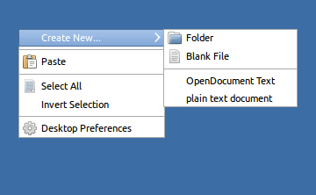

Create New... | Folder  Blank File
Programs... | Folder  Blank File
OpenDocument Text
Plain Text Document
Paste
Select All
Invert Selection
Run...
File Explorer
Terminal
Task Manager
Properties

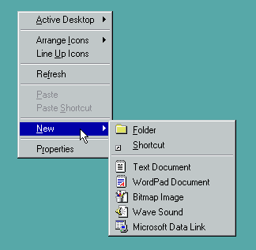

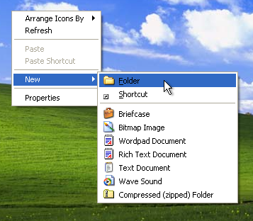

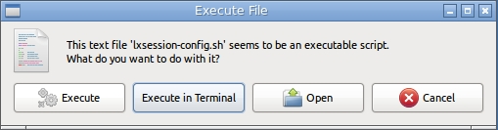
Execute File Dialog

