MARIAN COLLEGE KUTTIKANAM (AUTONOMOUS)
Bachelor of Computer Applications (BCA)

DIGITAL IMAGE PROCESSING
MINI PROJECT REPORT

Palm-Leaf Manuscript Restoration and Writing Segmentation Using Digital Image Processing

Submitted by
AFIN SABU
Register Number: 24UBC206
Programme: BCA

Marian College Kuttikanam Autonomous
Academic Year 2026

TABLE OF CONTENTS
(In Microsoft Word, right-click this area and choose “Update Field”, or press F9, to generate the page-numbered table of contents.)
TABLE OF CONTENTS 1
1. ABSTRACT 1
2. PROBLEM STATEMENT 1
3. OBJECTIVES 1
4. PROBLEM RELEVANCE 1
5. DATASET / IMAGE DESCRIPTION 1
5.1 Dataset Source 1
5.2 Number of Images 1
5.3 Image Characteristics 1
5.4 Preprocessing Requirements 1
5.5 Dataset Limitations 1
6. TECHNIQUES AND ALGORITHMS USED 1
6.1 Grayscale Conversion 1
6.2 Median Filtering 1
6.3 Illumination Correction (Background Estimation and Division) 1
6.4 CLAHE (Contrast Limited Adaptive Histogram Equalisation) 1
6.5 Otsu Thresholding 1
6.6 Adaptive Gaussian Thresholding 1
6.7 Morphological Opening 1
6.8 Morphological Closing 1
6.9 Connected Component Analysis 1
6.10 Final Segmentation Mask and Overlay 1
7. METHODOLOGY 1
8. IMPLEMENTATION 1
8.1 Dataset Loading and Image Selection 1
8.2 Noise Reduction with Median Filtering 1
8.3 Illumination Correction 1
8.4 Contrast Enhancement with CLAHE 1
8.5 Otsu Thresholding 1
8.6 Adaptive Gaussian Thresholding 1
8.7 Morphological Post-processing 1
8.8 Connected Component Analysis 1
8.9 Final Mask, Overlay and Saving Results 1
9. RESULTS AND DISCUSSION 1
9.1 Comparison of Otsu and Adaptive Thresholding 1
10. EVALUATION 1
11. LIMITATIONS 1
12. FUTURE SCOPE 1
13. CONCLUSION 1
14. REFERENCES 1

1. ABSTRACT
Palm-leaf manuscripts are among the most important carriers of historical and cultural knowledge in South Asia, yet the images captured from them are frequently affected by uneven illumination, background noise, low contrast, and faded or degraded writing. These conditions make it difficult to isolate the manuscript's written content from its background using simple visual inspection or basic thresholding alone. This mini project presents a Digital Image Processing (DIP) pipeline for the restoration and segmentation of palm-leaf manuscript images, implemented in Python using the OpenCV and Matplotlib libraries within the Google Colab environment.
The project uses a custom dataset of 20 palm-leaf manuscript images collected by the student. Each image is first converted to grayscale and denoised using median filtering. An estimate of the uneven background illumination is then used to correct the image through a division-based normalisation, after which Contrast Limited Adaptive Histogram Equalisation (CLAHE) is applied to enhance the local visibility of the manuscript writing. The enhanced image is segmented using both global Otsu thresholding and local adaptive Gaussian thresholding, and the two outputs are compared. Morphological opening and closing operations are then used to clean the segmented output, and connected component analysis is applied to identify individual writing regions. The final output consists of a binary segmentation mask and a colour overlay highlighting the detected writing regions on the original manuscript image, both of which are saved to disk.
The objective of this project is not to build a complete manuscript-reading or OCR system, but to demonstrate how classical digital image restoration and segmentation techniques can be combined to improve the visibility and machine-readability of degraded manuscript images, as a preparatory step for digital preservation and future archival or OCR-based analysis. The results show a clear qualitative improvement in contrast and visibility after enhancement, along with the expected trade-offs between global and local thresholding methods under uneven illumination conditions.

2. PROBLEM STATEMENT
Palm-leaf manuscripts are physical documents made from dried and treated palm leaves, traditionally inscribed by hand and bound together using a string passed through one or more punched holes. When such manuscripts are digitised through scanning or photography, the resulting images commonly exhibit several imaging problems that hinder direct analysis:
- Uneven illumination across the manuscript surface, caused by the curvature of the leaf, scanning conditions, or lighting angle.
- Background texture and fibrous noise inherent to the palm-leaf material itself.
- Low contrast between the inscribed writing and the surrounding leaf surface, particularly where the writing has faded with age.
- Physical degradation such as punch holes, stains, and surface irregularities that can be visually confused with writing strokes.
- Variation in image format, orientation and resolution across a manually collected dataset.
These factors make it difficult to directly separate manuscript writing from the background using a single, simple thresholding step. Digital Image Processing offers a structured way to address this problem: restoration techniques (denoising and illumination correction) can be used to normalise the image and reduce the impact of noise and lighting variation, while contrast enhancement techniques can make faint writing more visible. Once the image has been restored and enhanced in this way, segmentation techniques such as thresholding, morphological filtering and connected component analysis can be used to isolate candidate writing regions from the background. This project applies exactly this restoration-then-segmentation pipeline to the palm-leaf manuscript dataset provided.

3. OBJECTIVES
The specific objectives of this mini project are as follows:
- Load and inspect the palm-leaf manuscript images collected for the project.
- Convert the manuscript images from colour (RGB) to grayscale for further processing.
- Reduce unwanted noise in the grayscale image using median filtering.
- Correct uneven illumination across the manuscript surface using a background-estimation and division-based normalisation approach.
- Improve the local contrast of the manuscript writing using Contrast Limited Adaptive Histogram Equalisation (CLAHE).
- Segment the manuscript writing using global Otsu thresholding.
- Compare the Otsu segmentation result with local adaptive Gaussian thresholding.
- Improve the segmentation output using morphological opening and closing operations.
- Detect connected writing regions in the cleaned binary image using connected component analysis.
- Generate and save the final segmentation mask and a visual overlay of detected regions on the original manuscript image.
- Evaluate the restoration and segmentation outputs qualitatively, given the absence of ground-truth reference data.
- Analyse the limitations of the current implementation and identify possible directions for improvement.

4. PROBLEM RELEVANCE
Palm-leaf manuscripts represent a fragile and historically significant category of documents, many of which are at risk of physical deterioration over time due to age, humidity, insect damage and handling. Digitisation is a widely used first step in preserving the content of such manuscripts, but a plain digitised image is not, by itself, sufficient for effective long-term preservation or analysis. Restoration and segmentation techniques of the kind implemented in this project are relevant to several practical concerns:
- Digital preservation: enhancing the visibility of faded or low-contrast writing helps produce a clearer digital record of the manuscript's content before the physical original degrades further.
- Historical and document analysis: isolating writing regions from the background is a useful preparatory step for scholars studying manuscript layout, script density, or physical condition.
- Improving visibility of degraded writing: contrast enhancement techniques such as CLAHE can make faint or unevenly lit characters easier to see for a human reader, even without automated recognition.
- Assisting later OCR or archival processing: a clean, well-segmented binary image of the writing regions is a more suitable input for future Optical Character Recognition (OCR) or manuscript-recognition systems than a raw, noisy scan.
It should be emphasised that the present system does not perform manuscript reading, transliteration or OCR; its role is limited to restoration and segmentation. The relevance of the project lies in demonstrating that these preparatory image processing steps can meaningfully improve the quality and structure of manuscript images, which is a necessary foundation for any later, more advanced analysis.

5. DATASET / IMAGE DESCRIPTION

5.1 Dataset Source
The dataset used in this project is a custom collection of palm-leaf manuscript images gathered by the student, rather than a public or third-party dataset. The images were uploaded to the working directory of the Google Colab notebook and read directly from there using OpenCV's image-loading functions.

5.2 Number of Images
The dataset consists of 20 palm-leaf manuscript images. A verification step in the notebook loads the images from the dataset folder and displays a sample grid of them to confirm that the files have been read correctly, as shown in Figure 1. The filenames observed in the dataset follow an inconsistent naming and extension pattern (for example IMG11.png, IMG15.PNG, 5.jpg, IMG14.jpg, 3.jpg and IMG19.jpg were among the files displayed), reflecting the fact that the images were collected manually rather than generated with a uniform naming convention.

5.3 Image Characteristics
The manuscript images are colour (RGB) photographs of physical palm-leaf strips. For the sample image used to demonstrate the pipeline (IMG11.png), the original image shape was measured in the notebook as (512, 3494, 3), i.e. a wide, horizontally elongated strip 512 pixels tall and 3494 pixels wide with three colour channels; after grayscale conversion the shape becomes (512, 3494). Visually, the images share the following characteristics:
- A long, narrow horizontal strip layout typical of a photographed palm leaf.
- Dense, continuous curvilinear South Indian-style manuscript script running across the width of the leaf.
- One or more circular punch-hole marks used for binding the leaves together, visible as blank circular regions in the middle of the strip.
- Visible background fibre texture and mild variation in tone across the leaf surface, consistent with natural material and lighting variation.
- At least one image in the dataset (IMG19.jpg) is arranged as a multi-line block of text rather than a single horizontal strip, indicating that the dataset is not perfectly uniform in layout.
The dataset does not include manually created ground-truth segmentation masks for the manuscript writing. This is an important characteristic of the dataset that directly affects how segmentation quality can be evaluated in this project (see Section 10, Evaluation).

5.4 Preprocessing Requirements
Because the raw manuscript images exhibit noise, uneven illumination and low contrast, they cannot be segmented reliably using thresholding alone. The dataset therefore requires the following preprocessing before segmentation: grayscale conversion (to reduce the problem to a single intensity channel), noise reduction (to remove small fibre-level artefacts), illumination correction (to compensate for uneven lighting across the leaf), and contrast enhancement (to make faint writing more distinguishable from the background). These requirements directly motivate the pipeline described in Section 8 (Methodology).

5.5 Dataset Limitations
- The dataset is relatively small, containing only 20 images, which limits the ability to draw general conclusions about performance across a wide variety of manuscript conditions.
- There is variation in image format, file naming and possibly resolution across the dataset, which was collected manually rather than through a standardised acquisition process.
- No ground-truth segmentation masks are available, which restricts evaluation to qualitative visual assessment rather than quantitative accuracy metrics.

6. TECHNIQUES AND ALGORITHMS USED

6.1 Grayscale Conversion
What it is: Grayscale conversion transforms a three-channel colour (RGB) image into a single-channel intensity image, where each pixel represents brightness rather than colour.
Why it is used in this project: Manuscript writing is distinguished from its background primarily by brightness contrast rather than colour information, so working in grayscale simplifies the remaining processing steps and reduces computational cost.
What happens to the image: The three-channel colour image (512, 3494, 3) is converted into a single-channel intensity image (512, 3494), on which all subsequent filtering and thresholding steps are performed.

6.2 Median Filtering
What it is: Median filtering is a non-linear spatial filter that replaces each pixel's value with the median value of its neighbouring pixels within a defined window.
Why it is used in this project: It is used to suppress small, isolated noise artefacts (such as fibre texture or speckle noise on the leaf surface) while preserving the edges of the manuscript writing better than a simple averaging filter would.
What happens to the image: Small noisy pixel variations are smoothed out, producing a cleaner grayscale image while keeping the boundaries of the written strokes relatively intact, as shown in Figure 3.

6.3 Illumination Correction (Background Estimation and Division)
What it is: Illumination correction in this project estimates the slowly varying background brightness of the manuscript image and then divides the filtered image by this background estimate (scaled back to the 0-255 range using OpenCV's cv2.divide function).
Why it is used in this project: Because the palm-leaf surface is not uniformly lit, a single global threshold would otherwise treat naturally darker or brighter regions of the leaf inconsistently. Normalising against a local background estimate compensates for this uneven illumination before segmentation is attempted.
What happens to the image: Regions of the manuscript that were unevenly bright or dark due to lighting variation become more consistent in tone, producing an image where the writing-to-background contrast is more uniform across the whole strip, as shown in Figure 4.

6.4 CLAHE (Contrast Limited Adaptive Histogram Equalisation)
What it is: CLAHE is an adaptive form of histogram equalisation that enhances local contrast within small regions (tiles) of the image, while limiting (clipping) the amplification of noise that standard histogram equalisation can introduce.
Why it is used in this project: After illumination correction, the writing may still have low local contrast in some areas. CLAHE is applied (via OpenCV's createCLAHE and apply functions) to boost the visibility of faint strokes without excessively amplifying background noise.
What happens to the image: The manuscript writing becomes visually clearer and more distinguishable from the background, as illustrated by the before/after comparison in Figure 5.

6.5 Otsu Thresholding
What it is: Otsu's method is a global thresholding technique that automatically determines an optimal intensity threshold by analysing the image histogram and maximising the between-class variance of the resulting foreground and background pixel groups.
Why it is used in this project: It provides a simple, automatic, parameter-free way to convert the enhanced grayscale manuscript image into a binary image separating candidate writing pixels from the background, using OpenCV's cv2.threshold function with the THRESH_OTSU flag.
What happens to the image: The enhanced grayscale image is converted into a binary (black-and-white) image. In the sample run, the Otsu algorithm selected a threshold value of 3.0, and the resulting binary image is shown in Figure 6.

6.6 Adaptive Gaussian Thresholding
What it is: Adaptive thresholding computes a separate threshold for each pixel based on the weighted (Gaussian) average of the intensities in its local neighbourhood, rather than using a single global threshold for the whole image.
Why it is used in this project: Because illumination correction may not perfectly equalise brightness everywhere, adaptive thresholding is used as a local alternative to Otsu's global threshold, and the two are compared to understand their relative behaviour on this dataset.
What happens to the image: Using OpenCV's cv2.adaptiveThreshold function with a block size of 31 and constant C of 8, a second binary image is produced whose thresholding decisions vary across the image based on local neighbourhood statistics, as shown in Figure 7.

6.7 Morphological Opening
What it is: Morphological opening is an erosion operation followed by a dilation operation, using a small structuring element (kernel).
Why it is used in this project: It is used to remove small, isolated noise specks from the binary thresholded image without significantly altering the shape of larger writing strokes.
What happens to the image: Small stray white pixels scattered across the binary image are removed, producing a visually cleaner mask, as part of the comparison shown in Figure 8.

6.8 Morphological Closing
What it is: Morphological closing is a dilation operation followed by an erosion operation, applied after opening, again using a small structuring element.
Why it is used in this project: It is used to fill small gaps or holes within the writing strokes that may have been introduced by thresholding, helping to reconnect broken parts of characters.
What happens to the image: Small internal gaps in the segmented strokes are closed, resulting in the final cleaned binary image used for connected component analysis, also shown in Figure 8.

6.9 Connected Component Analysis
What it is: Connected component analysis identifies groups of adjacent foreground pixels in a binary image and labels each group as a distinct 'component', along with statistics such as its bounding box and area.
Why it is used in this project: It is used to identify individual candidate writing regions within the cleaned binary image, using OpenCV's cv2.connectedComponentsWithStats function, so that very small (area ≤ 20 pixel) noise components can be filtered out and the remaining regions can be visually marked.
What happens to the image: Bounding boxes are drawn around detected components with an area greater than 20 pixels. In the sample run, the algorithm reported a total of 2914 connected components for the single manuscript strip analysed, as shown in Figure 9.

6.10 Final Segmentation Mask and Overlay
What it is: The final segmentation mask is the cleaned binary image representing detected writing regions, while the overlay is a visualisation that superimposes the detected regions (in colour) on top of the original manuscript image.
Why it is used in this project: These two outputs provide, respectively, a machine-readable binary representation of the writing regions (suitable for further processing such as OCR) and a human-interpretable visual check of how well the detected regions align with the actual manuscript writing.
What happens to the image: A three-panel comparison of the original manuscript, the final binary segmentation mask, and the colour overlay is produced and saved to disk, as shown in Figure 10 and Figure 11.

7. METHODOLOGY
The overall methodology follows a linear restoration-then-segmentation pipeline, implemented sequentially in the Colab notebook. Each stage takes the output of the previous stage as its input, and intermediate results are visualised at every step to verify correct behaviour before proceeding. The workflow is summarised below:
Stage | Operation
1 | Input Image — load a palm-leaf manuscript image from the dataset
2 | Grayscale Conversion — convert the RGB image to a single-channel intensity image
3 | Median Filtering — remove small noise artefacts using cv2.medianBlur
4 | Illumination Correction — estimate background brightness and normalise using cv2.divide
5 | CLAHE Enhancement — boost local contrast using cv2.createCLAHE
6 | Otsu Thresholding — global automatic binarisation using cv2.threshold with THRESH_OTSU
7 | Adaptive Thresholding — local binarisation using cv2.adaptiveThreshold
8 | Morphological Processing — opening then closing using cv2.morphologyEx
9 | Connected Components — label and filter regions using cv2.connectedComponentsWithStats
10 | Final Segmentation Mask — produce the cleaned binary writing mask
11 | Overlay / Result — superimpose detected regions on the original image
12 | Evaluation — qualitative visual assessment of restoration and segmentation quality

Each stage of this pipeline is explained below in the order it is executed in the notebook.
Stage 1 – Input Image: A manuscript image is selected from the dataset folder and loaded using OpenCV, then converted from BGR to RGB for correct display with Matplotlib.
Stage 2 – Grayscale Conversion: The RGB image is converted to a single-channel grayscale image, reducing the data to intensity values only and simplifying all subsequent operations.
Stage 3 – Median Filtering: A median filter is applied to the grayscale image to suppress small noise artefacts while preserving the edges of the writing strokes.
Stage 4 – Illumination Correction: The uneven background brightness of the filtered image is estimated and the image is normalised against this estimate using a division operation, reducing the effect of uneven lighting across the leaf.
Stage 5 – CLAHE Enhancement: Adaptive histogram equalisation is applied to the illumination-corrected image to further improve the local contrast of the manuscript writing.
Stage 6 – Otsu Thresholding: The enhanced image is converted to a binary image using Otsu's automatic global thresholding method.
Stage 7 – Adaptive Thresholding: As an alternative, the enhanced image is also thresholded using local adaptive Gaussian thresholding, and the two binary outputs are compared side by side.
Stage 8 – Morphological Processing: The adaptively thresholded binary image is cleaned using morphological opening (to remove small noise) followed by morphological closing (to fill small gaps in the strokes).
Stage 9 – Connected Components: The cleaned binary image is analysed using connected component labelling, and components with an area greater than 20 pixels are marked with bounding boxes.
Stage 10 – Final Segmentation Mask: The cleaned binary image is retained as the final segmentation mask representing the detected writing regions.
Stage 11 – Overlay / Result: The detected regions are superimposed on the original manuscript image to create a visual overlay, and the original image, mask and overlay are saved to disk.
Stage 12 – Evaluation: The restored and segmented outputs are assessed qualitatively, since no ground-truth masks are available for quantitative comparison (see Section 10).

8. IMPLEMENTATION
The project was implemented in Python within a Google Colab notebook titled “Palm-Leaf Manuscript Restoration and Writing Segmentation Using Digital Image Processing”. The implementation relies on the following libraries:
- Python 3 — the programming language used for the entire implementation, executed in the Colab runtime.
- OpenCV (cv2) — used for all core image processing operations, including colour conversion, filtering, thresholding, morphology and connected component analysis.
- Matplotlib (plt) — used to visualise intermediate and final results as side-by-side image comparisons within the notebook.
- os — used for dataset path handling, directory creation and file management when saving results.
No use of NumPy or scikit-image functions was visible in the portions of the implementation captured for this report; all image operations are performed using OpenCV and Matplotlib. The subsections below walk through the implementation stage by stage with short, representative code excerpts.

8.1 Dataset Loading and Image Selection
The manuscript images are read from a dataset directory in the Colab environment. A specific file (IMG11.png in the sample run) is selected and loaded with OpenCV, then converted to RGB for correct colour display, and its grayscale version is computed. The shapes of the original and grayscale arrays are printed to confirm correct loading, as shown below.
image = cv2.imread(image_path)
image_rgb = cv2.cvtColor(image, cv2.COLOR_BGR2RGB)
gray = cv2.cvtColor(image, cv2.COLOR_BGR2GRAY)

print("Selected image:", selected_file)
print("Original image shape:", image.shape)
print("Grayscale image shape:", gray.shape)

This produced the following confirmed output for the sample image used throughout the pipeline: Selected image: IMG11.png; Original image shape: (512, 3494, 3); Grayscale image shape: (512, 3494).

8.2 Noise Reduction with Median Filtering
# Median filtering for noise removal
median = cv2.medianBlur(gray, 5)

The grayscale image is filtered with a 5×5 median kernel, producing the denoised image compared in Figure 3.

8.3 Illumination Correction
corrected = cv2.divide(
median,
background,
scale=255
)

The median-filtered image is divided by an estimated background image and rescaled to the 0–255 range using cv2.divide, producing an illumination-corrected image, compared against the median-filtered result in Figure 4.

8.4 Contrast Enhancement with CLAHE
enhanced = clahe.apply(corrected.astype("uint8"))

A CLAHE object (created earlier in the notebook with cv2.createCLAHE) is applied to the illumination-corrected image, producing the enhanced manuscript image compared in Figure 5.

8.5 Otsu Thresholding
# Otsu thresholding for manuscript writing segmentation
otsu_threshold, otsu = cv2.threshold(
enhanced,
0,
255,
cv2.THRESH_BINARY_INV + cv2.THRESH_OTSU
)

print("Otsu threshold value:", otsu_threshold)

For the sample image, this produced the printed output: Otsu threshold value: 3.0, with the resulting binary image shown in Figure 6.

8.6 Adaptive Gaussian Thresholding
# Adaptive thresholding
adaptive = cv2.adaptiveThreshold(
enhanced,
255,
cv2.ADAPTIVE_THRESH_GAUSSIAN_C,
cv2.THRESH_BINARY_INV,
31,
8
)

Adaptive thresholding is applied with a block size of 31 and a constant C of 8, producing the binary image compared against the Otsu result in Figure 7.

8.7 Morphological Post-processing
cleaned = cv2.morphologyEx(
adaptive,
cv2.MORPH_OPEN,
kernel
)

cleaned = cv2.morphologyEx(
cleaned,
cv2.MORPH_CLOSE,
kernel
)

Morphological opening is applied first to remove small noise specks, followed by morphological closing to fill small gaps in the writing strokes. The before-and-after comparison is shown in Figure 8.

8.8 Connected Component Analysis
w = stats[i, cv2.CC_STAT_WIDTH]
h = stats[i, cv2.CC_STAT_HEIGHT]
area = stats[i, cv2.CC_STAT_AREA]

# Ignore very small regions
if area > 20:
cv2.rectangle(
result,
(x, y),
(x + w, y + h),
(0, 255, 0),
1
)

Connected components are computed using cv2.connectedComponentsWithStats on the cleaned binary image. Components with an area of 20 pixels or less are ignored as noise, and the remaining components are marked with green bounding boxes. This produced a total of 2914 connected components for the sample image, as shown in Figure 9.

8.9 Final Mask, Overlay and Saving Results
output_dir = "/content/results"
os.makedirs(output_dir, exist_ok=True)

cv2.imwrite(os.path.join(output_dir, "original.jpg"),
cv2.cvtColor(image_rgb, cv2.COLOR_RGB2BGR))
cv2.imwrite(os.path.join(output_dir, "restored.jpg"), enhanced)
cv2.imwrite(os.path.join(output_dir, "segmentation_mask.jpg"), final_mask)
cv2.imwrite(os.path.join(output_dir, "segmentation_overlay.jpg"),
cv2.cvtColor(overlay, cv2.COLOR_RGB2BGR))

print("Results saved successfully!")
print("Location:", output_dir)

The original image, the enhanced (restored) image, the final segmentation mask and the segmentation overlay are all written to disk in the /content/results directory. The notebook confirmed this with the printed output: “Results saved successfully! Location: /content/results”, as shown in Figure 11.

9. RESULTS AND DISCUSSION
This section presents the outputs produced at each stage of the pipeline, using screenshots captured directly from the Colab notebook execution. Each figure is followed by a short discussion of what changed, whether visibility or separation improved, and what artefacts or limitations remain.
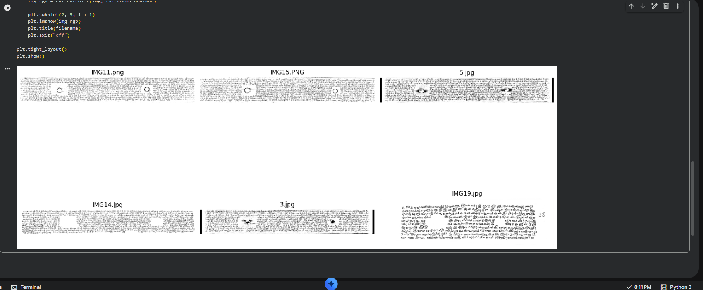
Figure 1: Sample palm-leaf manuscript images from the dataset
Figure 1 shows a grid of sample images loaded directly from the dataset folder, confirming that the files (including IMG11.png, IMG15.PNG, 5.jpg, IMG14.jpg, 3.jpg and IMG19.jpg) were read correctly. The samples confirm that most images share a similar horizontal-strip layout with visible punch-hole marks, while at least one image (IMG19.jpg) has a different, multi-line block layout, illustrating that the dataset is not perfectly uniform.
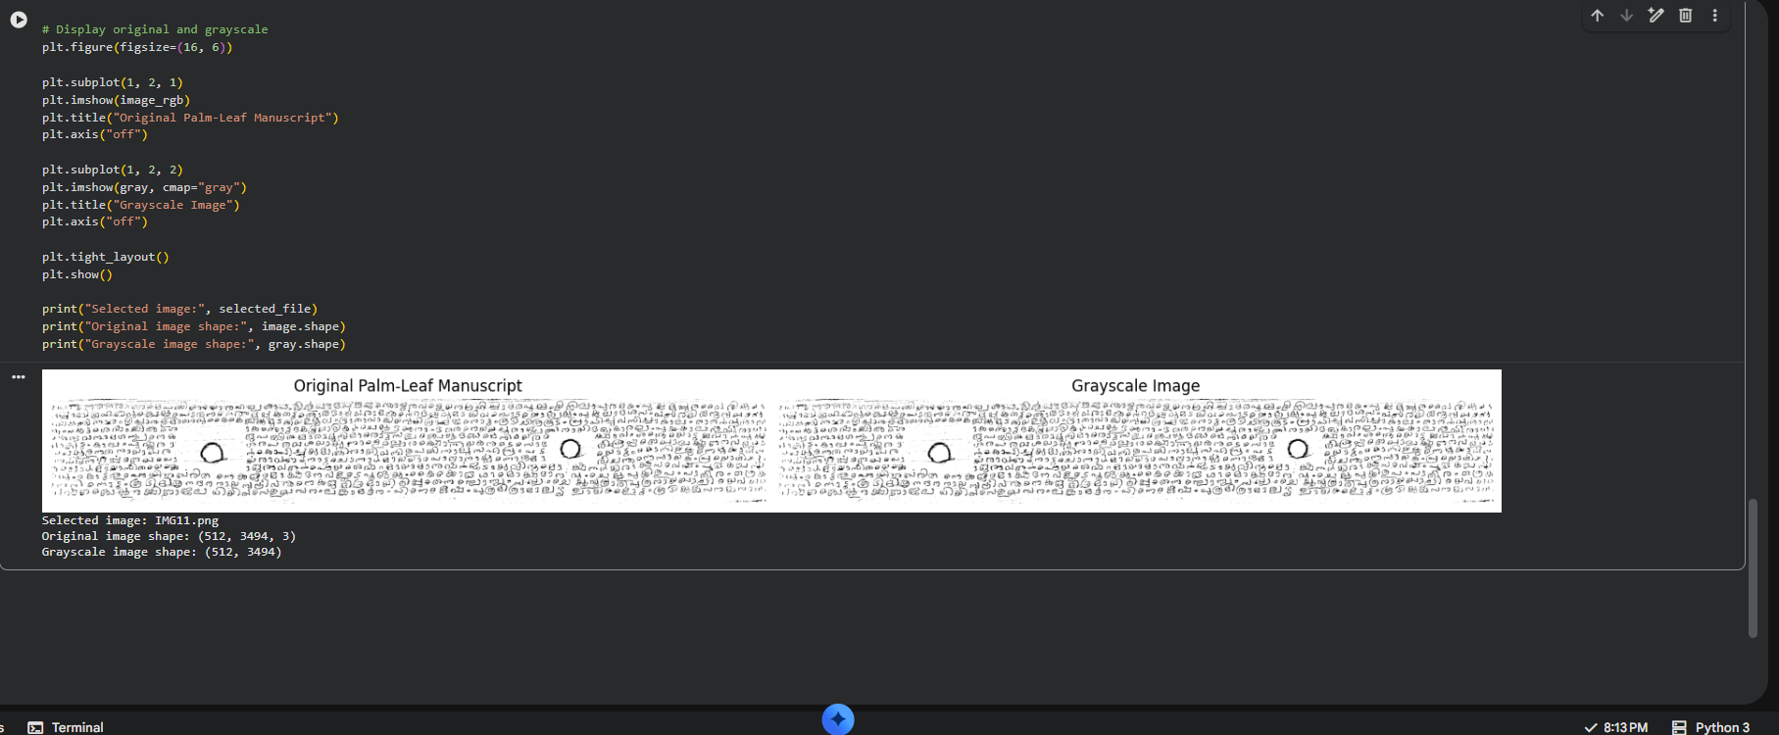
Figure 2: Original and grayscale palm-leaf manuscript image
Figure 2 compares the original colour manuscript image (IMG11.png) with its grayscale conversion. The grayscale version retains the visibility of the writing strokes and punch holes while discarding colour information that is not required for segmentation. The printed shapes confirm the conversion from a (512, 3494, 3) colour array to a (512, 3494) single-channel array.
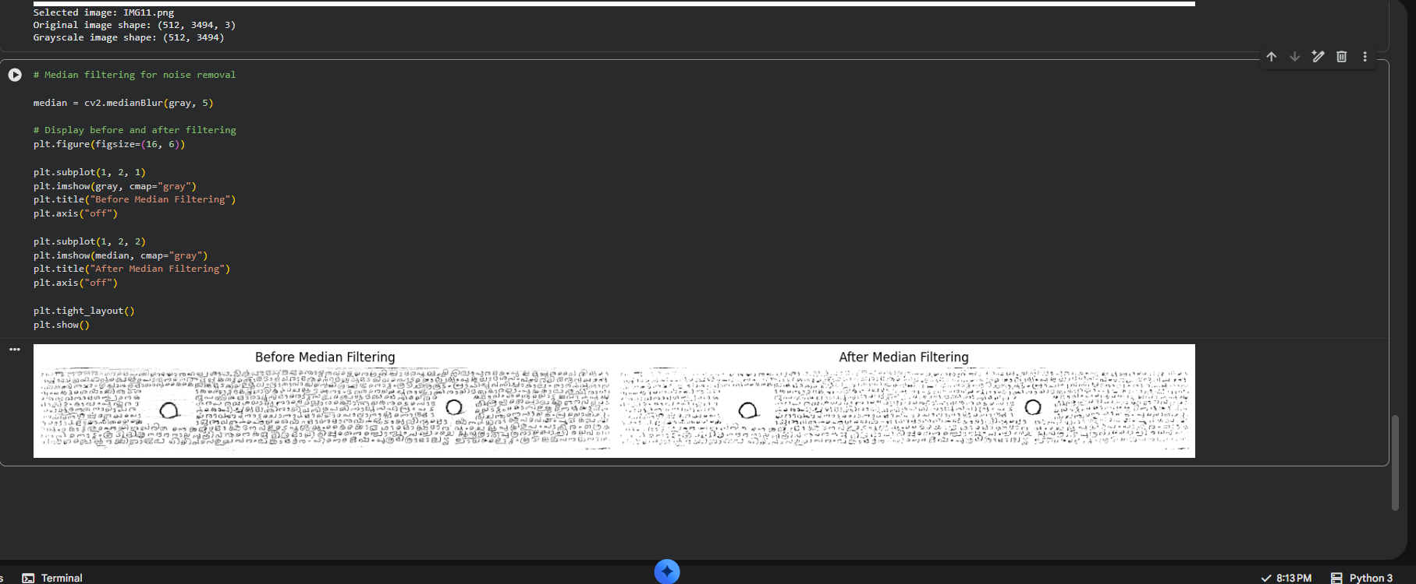
Figure 3: Noise reduction using median filtering
Figure 3 compares the grayscale image before and after median filtering. The filtered image shows a visibly smoother background with reduced small-scale speckle noise, while the overall shape of the writing strokes and the punch-hole regions remain recognisable. No new artefacts are introduced by this step; the main limitation is that a strong median filter can slightly soften fine stroke edges, which is an expected trade-off of noise-reduction filtering.
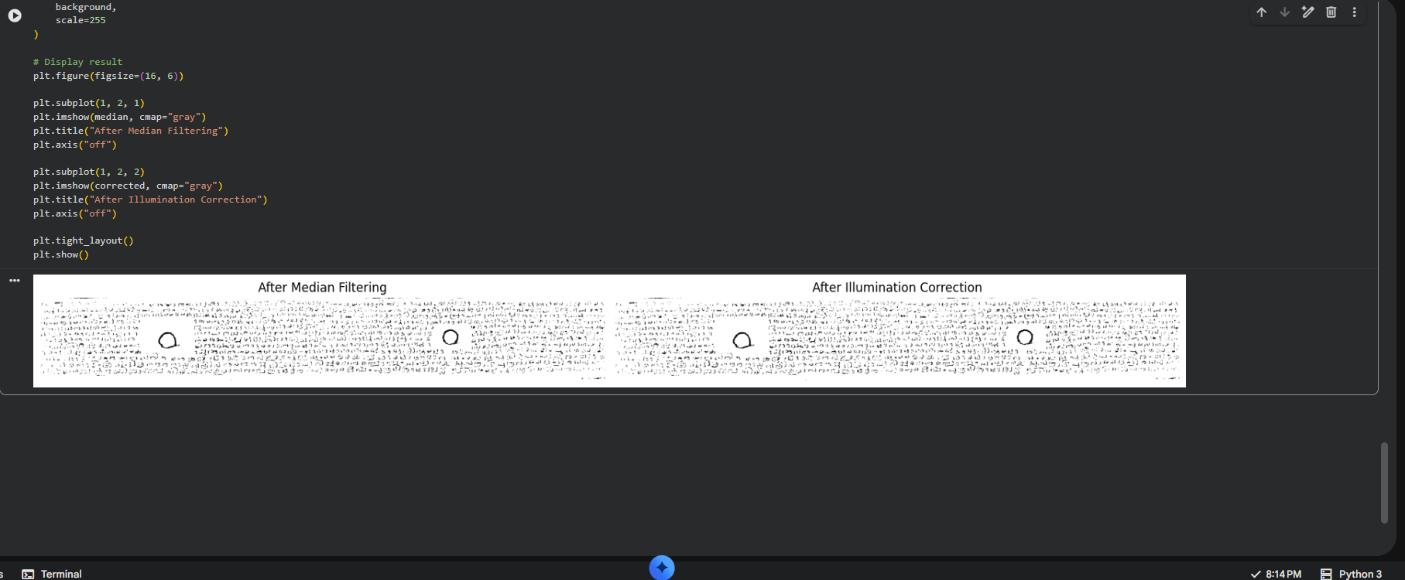
Figure 4: Illumination correction of the palm-leaf manuscript image
Figure 4 compares the median-filtered image with the result after illumination correction. The corrected image shows a more visually uniform background tone across the strip, which is the intended effect of dividing out the estimated background illumination. Some residual unevenness remains visible, indicating that the background estimation is an approximation rather than a perfect correction, which is a normal limitation of division-based illumination normalisation on real, non-uniformly lit surfaces.
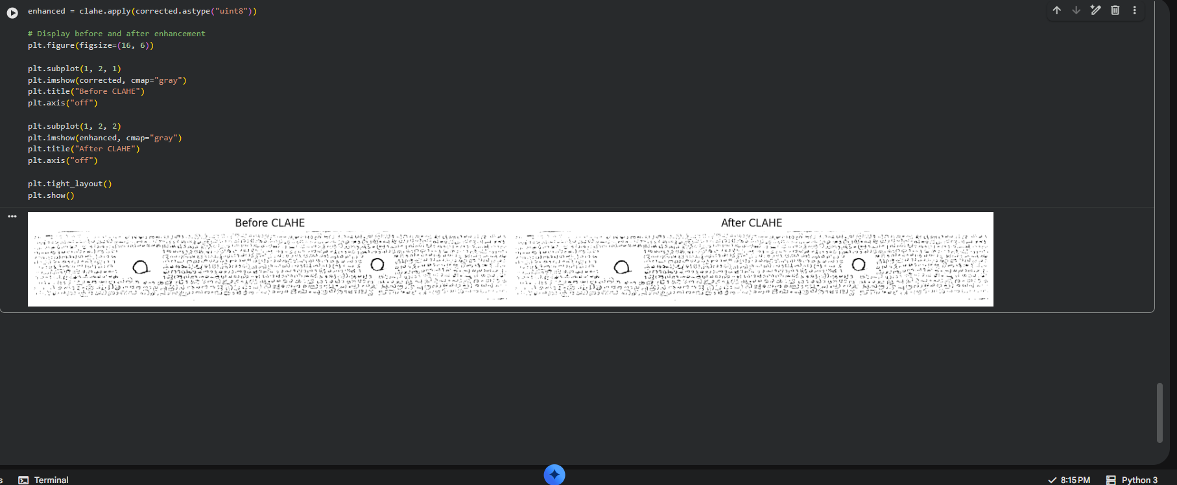
Figure 5: Contrast enhancement using CLAHE
Figure 5 compares the image before and after CLAHE enhancement. The writing strokes in the “After CLAHE” image appear noticeably sharper and higher-contrast relative to the background than in the “Before CLAHE” image. This supports the intended purpose of CLAHE: improving the local visibility of faint or unevenly contrasted writing. As with any contrast-enhancement step, background texture and noise are also mildly amplified along with the writing, which is a known trade-off of adaptive histogram equalisation.
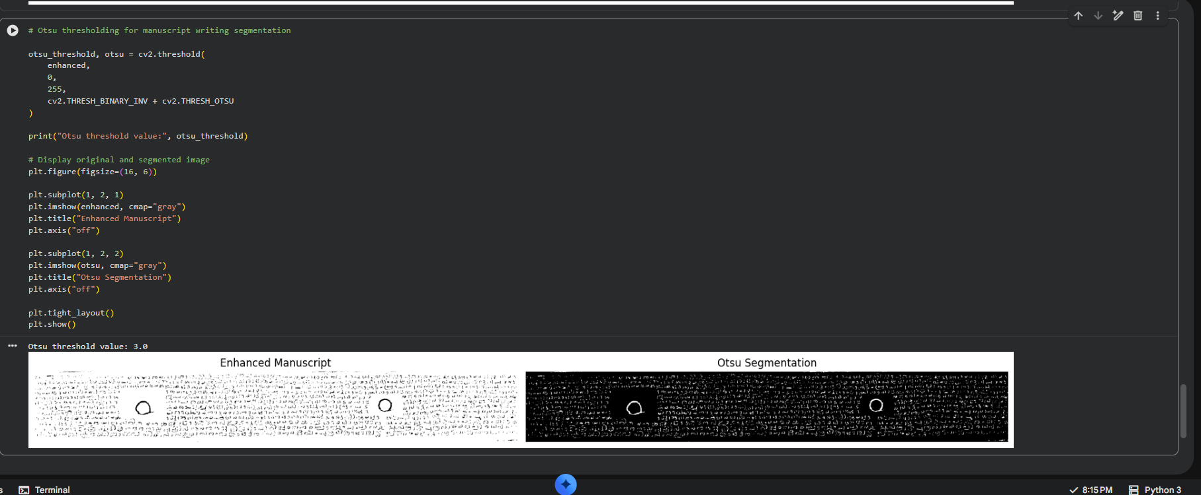
Figure 6: Manuscript writing segmentation using Otsu thresholding
Figure 6 shows the enhanced manuscript image alongside its Otsu-thresholded binary segmentation. The Otsu algorithm automatically selected a threshold value of 3.0 for this image. The resulting binary image separates a large amount of foreground (white) detail from the background, including the writing strokes, the punch-hole boundaries and a substantial amount of fine background texture. The very low threshold value indicates that, after CLAHE enhancement, most pixel intensities in this image were concentrated near the dark end of the range, causing Otsu's global method to pick almost all non-zero variation as foreground; this is discussed further as a limitation in Section 11.
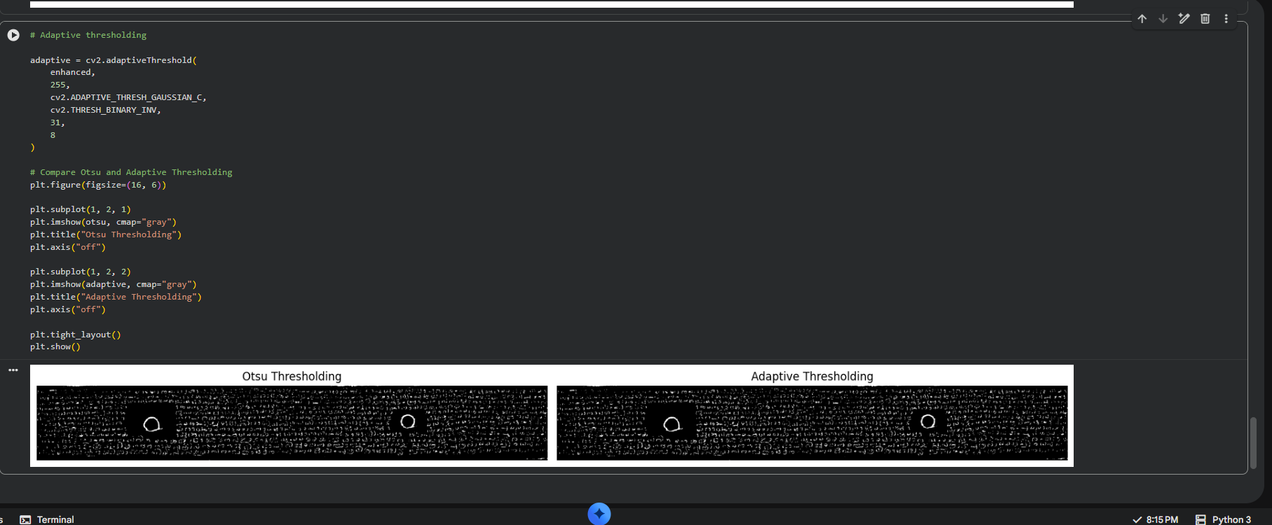
Figure 7: Comparison of Otsu and adaptive thresholding
Figure 7 places the Otsu segmentation side by side with the adaptive Gaussian thresholding result on the same enhanced image. Both methods detect the writing strokes, but they behave differently with respect to background texture: Otsu, being a single global threshold, is more sensitive to the overall intensity distribution of the whole image, whereas adaptive thresholding computes a local threshold for each neighbourhood and therefore responds to local contrast variations rather than a single global cut-off. Neither method perfectly isolates only the writing; both retain a visible amount of background texture as foreground, which is expected given the absence of ground-truth masks to tune the parameters against.
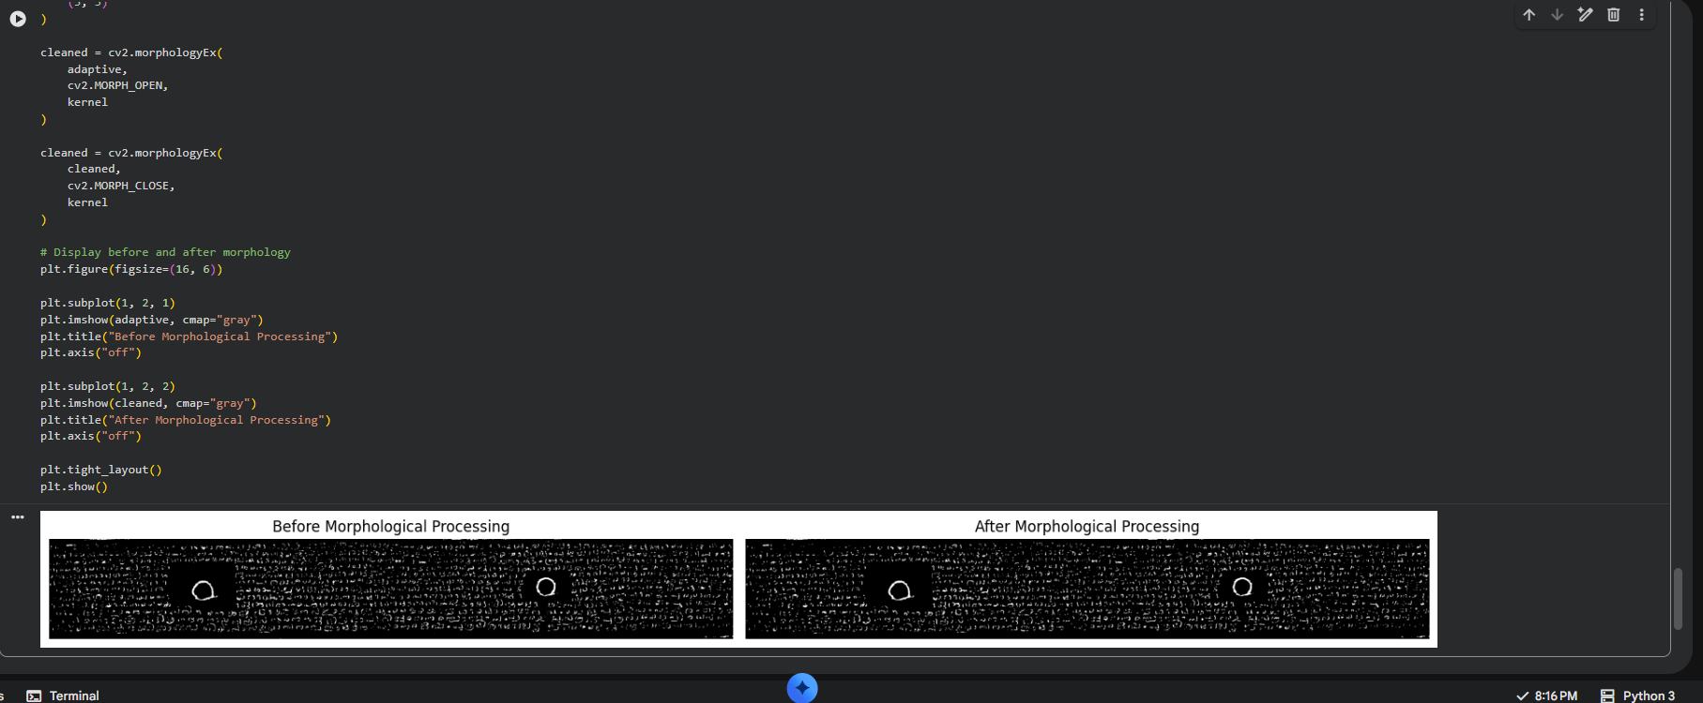
Figure 8: Morphological post-processing of the segmented manuscript
Figure 8 compares the adaptively thresholded image before and after morphological opening and closing. Visually, the “After Morphological Processing” image appears very similar to the input at this zoom level, since the changes made by a small structuring element mainly affect isolated single-pixel or few-pixel noise regions rather than the larger structures. This indicates that opening and closing provided a modest cleaning effect rather than a dramatic change, which is consistent with using a small kernel intended to preserve the fine detail of manuscript strokes.
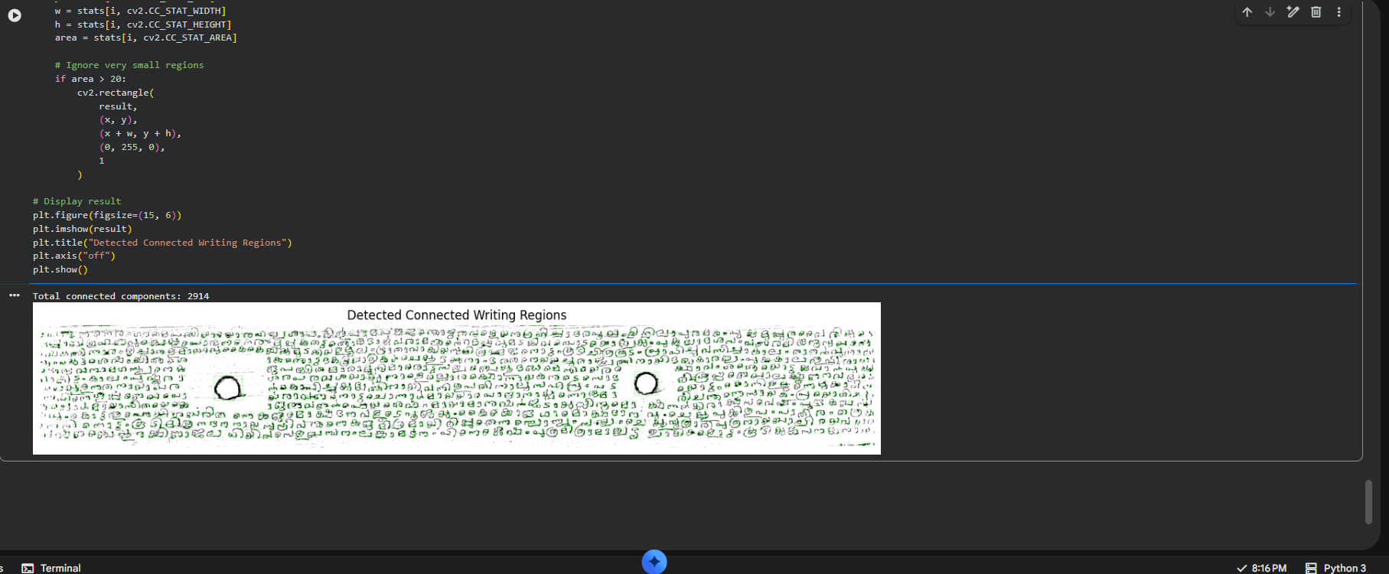
Figure 9: Connected-component analysis for detecting manuscript writing regions
Figure 9 shows the result of connected component analysis, with green bounding boxes drawn around all components with an area greater than 20 pixels. The notebook reported a total of 2914 connected components for this single manuscript strip. This is a very high count relative to the number of actual words or characters visible in the strip, indicating that many of the detected components correspond to fragments of characters, isolated noise regions, or disconnected pieces of background texture rather than whole, coherent writing units. This result highlights that, in its current form, the segmentation output is better suited to marking approximate regions of interest than to reliably counting or isolating individual characters or words.
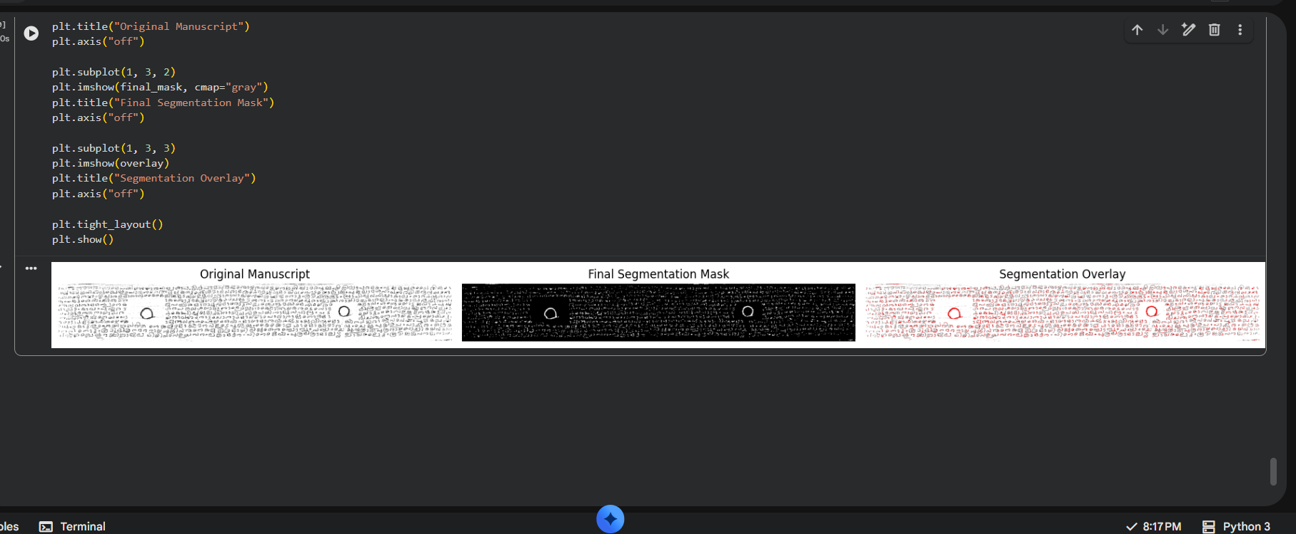
Figure 10: Final segmentation mask and overlay of manuscript writing regions
Figure 10 presents the three-panel final result: the original manuscript image, the final binary segmentation mask, and the colour overlay showing detected regions superimposed on the original image (shown in red). The overlay confirms that the great majority of the writing area is captured within the detected foreground regions, alongside the punch-hole boundaries and a visible amount of background texture. The mask successfully preserves the overall layout and density pattern of the manuscript writing, but, consistent with the connected-component count noted above, it does not cleanly separate individual characters from one another or from background noise.
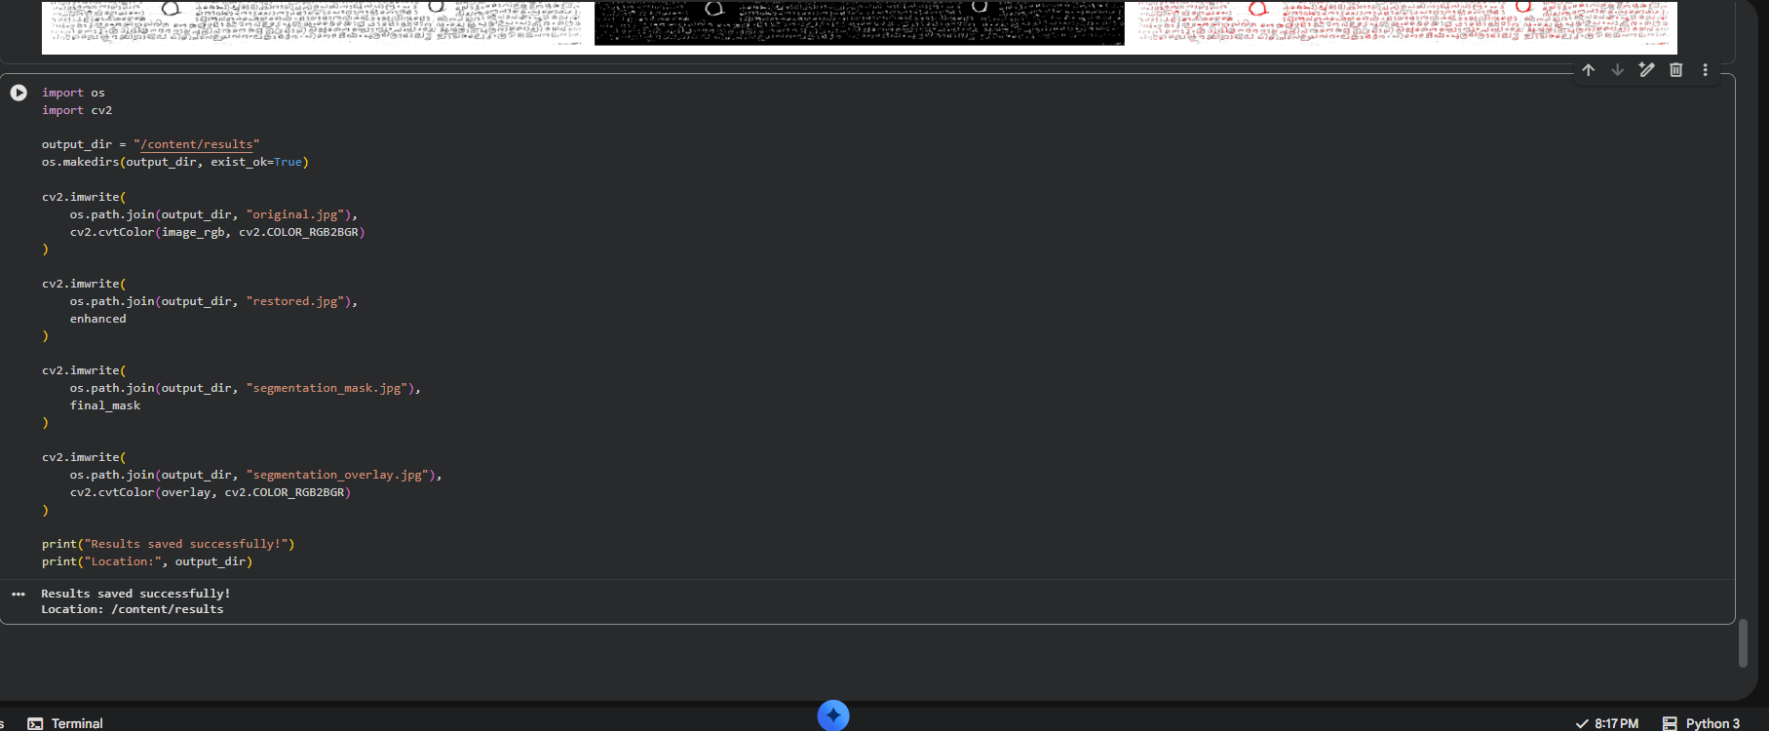
Figure 11: Saving of processed manuscript outputs
Figure 11 shows the code used to save the final outputs — the original image, the restored (CLAHE-enhanced) image, the segmentation mask and the segmentation overlay — to the /content/results directory, along with the confirmation message printed by the notebook: “Results saved successfully! Location: /content/results”. This confirms that the pipeline executes end to end and produces persisted output files rather than only in-notebook visualisations.

9.1 Comparison of Otsu and Adaptive Thresholding
Across the sample manuscript image, Otsu thresholding and adaptive Gaussian thresholding produced visually similar but not identical binary outputs. Otsu thresholding, being a single global threshold derived from the overall image histogram, is efficient and required no manual parameter tuning beyond the standard OpenCV flags, but it is more sensitive to global shifts in the intensity distribution — as seen in the unusually low threshold value of 3.0 selected for the enhanced image. Adaptive Gaussian thresholding, by computing a threshold from each pixel's local neighbourhood (using a block size of 31 and constant of 8), is inherently more robust to the kind of uneven illumination that motivated Section 6.3, since it adapts to local rather than global brightness levels.
Neither method can be declared universally superior based on the material examined in this project. Otsu's approach is simpler and computationally cheaper, but its global nature makes it more vulnerable to skewed intensity distributions after aggressive contrast enhancement. Adaptive thresholding is more resilient to local illumination variation but depends on the choice of block size and constant, which were fixed manually in this implementation rather than tuned systematically. The observed behaviour is consistent with the general, well-documented trade-off between global and local thresholding methods under uneven illumination conditions.

10. EVALUATION
Evaluation of restoration and segmentation quality is constrained by what is actually available from the implementation and dataset. The present implementation does not compute quantitative restoration metrics such as Mean Squared Error (MSE), Peak Signal-to-Noise Ratio (PSNR) or Structural Similarity Index (SSIM); no such values are present in the notebook outputs captured for this report. Accordingly, this report does not report any MSE, PSNR or SSIM figures. The current implementation focuses on visual restoration and segmentation, and quantitative restoration evaluation using metrics such as PSNR or SSIM can be added as future work (see Section 12).
Similarly, quantitative segmentation metrics such as Intersection over Union (IoU), the Dice coefficient, or pixel-wise accuracy require a ground-truth reference mask to compare against. As noted in Section 5.5, the dataset used in this project does not include manually created ground-truth segmentation masks. For this reason, no IoU, Dice or accuracy values are reported, and segmentation quality is instead assessed qualitatively by visual inspection of the segmentation mask and overlay, as discussed in Section 9. This is an honest and necessary limitation of the current evaluation, rather than an oversight: without labelled ground truth, any quantitative segmentation score would not be meaningful.
The qualitative evaluation of each major technique used in the pipeline is summarised in the table below.
Technique | Purpose | Observed Result | Limitation
Median Filtering | Remove small-scale noise from the grayscale image | Visibly smoother background with strokes preserved (Fig. 3) | Can mildly soften fine stroke edges
Illumination Correction | Normalise uneven background brightness | More uniform tone across the strip (Fig. 4) | Residual unevenness remains; background estimate is approximate
CLAHE | Enhance local contrast of faint writing | Sharper, higher-contrast writing strokes (Fig. 5) | Also amplifies background texture and noise
Otsu Thresholding | Automatic global binarisation | Global binary mask; threshold value 3.0 for sample image (Fig. 6) | Very sensitive to overall intensity distribution after enhancement
Adaptive Thresholding | Local, illumination-robust binarisation | Binary mask responsive to local contrast (Fig. 7) | Depends on manually fixed block size and constant
Morphological Opening/Closing | Remove noise and close small gaps | Modest cleaning effect at fine scale (Fig. 8) | Small kernel limits impact on larger noise regions
Connected Component Analysis | Identify individual writing regions | 2914 components detected for one manuscript strip (Fig. 9) | High fragmentation; components do not map cleanly to characters or words
Final Mask / Overlay | Summarise detected writing regions | Overlay captures overall writing layout and density (Fig. 10) | Includes background texture and punch-hole regions as false foreground

11. LIMITATIONS
- The dataset is limited to 20 images, restricting how broadly the observed results can be generalised across different manuscript conditions.
- There is variation in the quality, format and layout of the manuscript images collected, since the dataset was assembled manually rather than through a controlled acquisition process.
- Some characters and writing regions in the manuscripts are faded or physically degraded, which can reduce the effectiveness of contrast enhancement and thresholding in those areas.
- The segmentation results are sensitive to the specific threshold parameters chosen (for example, the Otsu threshold value of 3.0 observed on the enhanced image, and the fixed block size and constant used for adaptive thresholding), which were not systematically tuned against ground truth.
- The dataset does not include manually created ground-truth segmentation masks, which prevents quantitative evaluation of segmentation accuracy and restricts assessment to qualitative visual inspection.
- The connected component analysis produced a very high number of components (2914 for a single strip), indicating that the current pipeline detects fragmented regions rather than cleanly isolated characters or words, and may include false foreground regions such as background texture and punch-hole boundaries.
- The implementation was executed within the Google Colab environment, and the results are dependent on that computational environment; performance or behaviour on other hardware or software configurations has not been verified.

12. FUTURE SCOPE
The current implementation establishes a working restoration-and-segmentation pipeline, but several extensions could be explored in future work. These are proposed as future possibilities rather than features already implemented in this project:
- Expanding the dataset to include a larger and more diverse set of palm-leaf manuscripts, covering a wider range of degradation levels, scripts and lighting conditions.
- Creating manually annotated ground-truth segmentation masks for at least a subset of the dataset, to enable quantitative evaluation using metrics such as IoU, Dice coefficient, and pixel-wise accuracy.
- Integrating Optical Character Recognition (OCR) tailored to the manuscript's script, using the segmented writing regions produced by this pipeline as an input.
- Exploring more advanced restoration methods, such as adaptive or learned background-estimation techniques, to further improve illumination correction quality.
- Applying deep-learning-based restoration and segmentation approaches (for example, convolutional neural networks trained for manuscript image binarisation) and comparing their performance against the classical pipeline used here.
- Deploying the pipeline as a real-time or web-based tool, allowing manuscript images to be uploaded and processed through a simple interface for preservation or research use.

13. CONCLUSION
This mini project developed and demonstrated a Digital Image Processing pipeline for the restoration and segmentation of palm-leaf manuscript images, using a custom dataset of 20 manuscript images. The restoration stage combined grayscale conversion, median filtering, illumination correction and CLAHE-based contrast enhancement to reduce noise and improve the visibility of manuscript writing under uneven lighting conditions. The segmentation stage applied and compared Otsu global thresholding and adaptive Gaussian local thresholding, followed by morphological opening and closing to clean the binary output, and connected component analysis to identify candidate writing regions.
The main observed outcome was a clear qualitative improvement in the visibility and contrast of manuscript writing after the restoration stages, along with a working, end-to-end segmentation pipeline that produces a binary mask and a visual overlay of detected writing regions. At the same time, the results showed that the segmentation output remains highly fragmented — evidenced by the 2914 connected components detected in a single manuscript strip — and includes background texture and punch-hole regions as false foreground, reflecting the inherent difficulty of the problem and the absence of ground-truth data for parameter tuning and evaluation.
Through this project, practical experience was gained in applying classical image restoration and segmentation techniques using OpenCV, in comparing global and local thresholding approaches, and in critically evaluating image processing results in the absence of quantitative ground truth. The project also highlighted the importance of honest, qualitative evaluation when quantitative benchmarks are not available, and identified clear directions — such as ground-truth annotation and deep-learning-based methods — for extending this work in the future.

14. REFERENCES
[1] OpenCV Development Team, “OpenCV: Open Source Computer Vision Library — Documentation,” OpenCV.org. Available: https://docs.opencv.org/
[2] OpenCV Development Team, “Image Thresholding,” OpenCV Python Tutorials. Available: https://docs.opencv.org/master/d7/d4d/tutorial_py_thresholding.html
[3] OpenCV Development Team, “Smoothing Images,” OpenCV Python Tutorials. Available: https://docs.opencv.org/master/d4/d13/tutorial_py_filtering.html
[4] OpenCV Development Team, “Morphological Transformations,” OpenCV Python Tutorials. Available: https://docs.opencv.org/master/d9/d61/tutorial_py_morphological_ops.html
[5] OpenCV Development Team, “Histograms — 2: Histogram Equalization (CLAHE),” OpenCV Python Tutorials. Available: https://docs.opencv.org/master/d5/daf/tutorial_py_histogram_equalization.html
[6] R. C. Gonzalez and R. E. Woods, Digital Image Processing, 4th ed. New York: Pearson, 2018.
[7] Matplotlib Development Team, “Matplotlib: Visualization with Python — Documentation.” Available: https://matplotlib.org/stable/
[8] Department of Computer Applications, Marian College Kuttikanam Autonomous, “Digital Image Processing Mini Project — Assignment Guidelines,” Semester 5, Academic Year 2026 (internal college document).

