Organization

List of Tables

Login Module: index.php , Organization/admin.php, validationadmin.php,validationForm.php

1. admin_org
2. userprofile
3. company

Organization

List of Tables

1. employeeinformation
2. personalinformation
3. financialinformation
4. employeeimage
5. dept
6. branch

Registration module & Attendance Module & Overtime Module & Leave Module

1. Home.php
2. EditInformation.php
3. ChangePassword.php
4. CompanySettings.php
5. ManageAttendance.php
6. LeaveSettings.php
7. BranchList.php
8. Employees.php
9. EmployeeList.php
10. BranchList.php
11. DeptList.php
12. ManageEmployees.php
13. EmployeeList.php
14. fetch.php
15. insert.php
16. create.php
17. delete.php
18. select.php
19. updateEmail.php
20. DeptList.php
21. fetchDept.php
22. selectDept.php
23. deleteDept.php
24. createDept.php
25. insertDept.php
26. BranchList.php
27. insertBranch.php
28. deleteBranch.php
29. selectBranch.php
30. createBranch.php
31. fetchBranch.php
32. createCompany.php
33. CompanySettings.php
34. uploadLogo.php
35. updateCompany.php
36. ManageAttendance.php
37. AllEmployees.php
38. selectEmployeeAttendance.php
39. selectDeptById.php
40. selectAttendance.php
41. selectOvertime.php
42. select.php
43. selectDisplayAttendance.php
44. selectDisplayOvertime.php
45. ManageEmployees.php
46. AssignEmployees.php
47. UpdateEmployeesDept.php
48. select.php
49. LeaveSettings.php
50. updateLeave.php
51. fetchLeave.php
52. createLeave.php
53. updateLeave.php
54. deleteLeave.php

Employee

Registration Module

1. employeeProfile.php
2. employeeInformation.php
3. upload.php
4. updateInformation.php
5. ChangePassword.php
6. validationForm.php

Attendance Module & Overtime Module

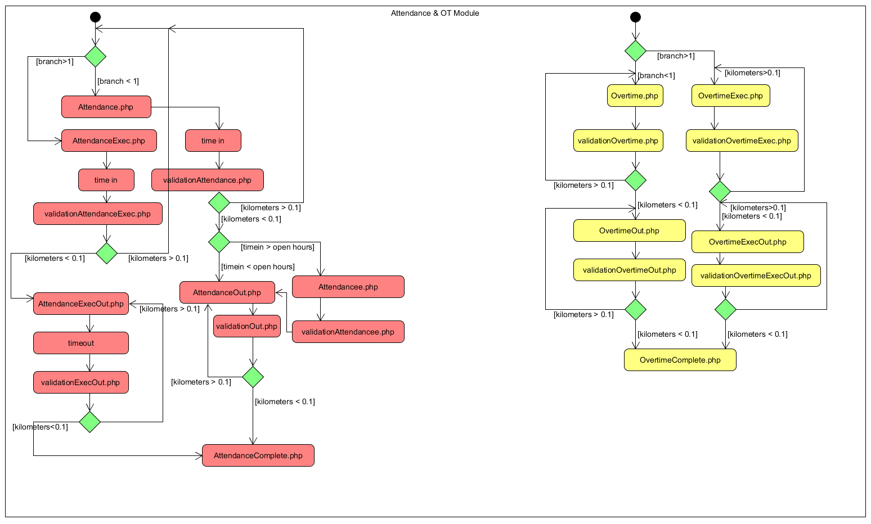

Attendance module tables : attendancerecord

Overtime module table : overtimerecord

Leave Module

List of tables : staffleave, staffleaveinfo, staffleaveapproval

1. LeaveHistory.php
2. ApplyLeave.php
3. getEntitlement.php
4. leaveForm.php
5. LeaveApproval.php
6. selectDetail.php
7. updateStaffLeave.php