[](http://www.siliconmotion.com/index.php)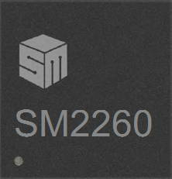

**SM2260**

**SSD Flash Controller**

SSD MP APPLICATION

Confidential

Version : 1.1

Contents

Update History - 3 -

Introduction - 4 -

Application - 4 -

Platform - 4 -

Functionality - 5 -

● **Device initial page(Fig. 1)** - 5 -

Test Flow - 6 -

Figures

Fig.1 Main Dialog - 6 -

Fig.2 Test Device Flow - 7 -

Fig.3 Select Configuration File - 8 -

Fig.4 Update LightSwitch Tool - 8 -

Fig.5 The Result of Success Testing - 9 -

Fig.6 The Result of Fail Testing - 9 -

# Update History

|  |  |  |  |
| --- | --- | --- | --- |
| Date | Version | Description | Editor |
| O0707 | 1.0.0 | First version | Ginny |
| O0717 | 1.1.0 | Add to update LS settings | Ginny |
| O0723 | 1.1.1 | 1. Fix LS CRC issue  2. Modify the flow to execute LS tool  3. Show message if LS file is updated. | Ginny |
| O0724 | 1.1.2 | Add "Create Image" button | Ginny |
| O1217 | 2.1.2 | Update DRAM Setting of Pretest option   1. Add size “1024M” 2. Add clock “400MHz” 3. Add Setting “Low Power DDR3” | Ginny |
| O1229 | 2.1.4 | 1. Add to keep SN and MN  2. Add to check RDT Result  3. Add auto-create image function | Ginny |

# Introduction

This user guide provides SMI’s recommendations for Mass Production. The application’s functionality and operation flow will be introduced by this document.

# Application

The application “TestAP_SM2260.exe” named “MP Tool” services special purpose for Mass Production. The MP Tool supports 4 devices at most on system. It allows PCIe-based host system to detect and initiate a SMI SM2260 SSD Flash device and only supports one port device initialization. Also, it provides a user-friendly interface to users.

# Platform

* **Windows 7**

# Functionality

* **Device initial page(Fig. 1)**

**Scan Drive:**  An icon as scantarget.jpg in Fig. 1. Pushing this icon will scan all drive devices on system. The status of drive icon will be changed as 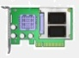 if there is a SM2260 device on system.

**Drive Selector**: An icon as  in Fig. 1. The drive device will be selected for operation by pushing the icon and the status of icon will become enabled.

**Config List**: A “ComboBox” could select the configuration which user wants to use. A “Config Save” button operation can save current settings to selected configuration.

A “Config Save As” button operation can save current settings to another file.

**Flash Select**: The SM2260 controller supports a lot of flashes. User should select the flash in used. A “Auto” button can automatic detect what flash on drive device.

**Download DRAM Setting and MPISP**: The MPISP package will be loaded to SM2260 device while start test procedure. The MPISP bin file should be selected in “firmware” folder.

**Do Pretest Function**: The flash on SM2260 device will be initiated while start test procedure.

**Program ISP**: The ISP package will be loaded to SM2260 device and LightSwitch settings will be replaced with selected file while start test procedure. The ISP and LightSwitch bin file should be selected in “firmware” folder.

**Setting Item**

Serial number: Select 「Update Serial」or「No Update Serial」of serial numbers.

1. 「Update Serial」 policy will write the serial number of “Begin” Text Item into the SM2260 device and automatic increase serial number after test procedure completed. 「No Update Serial」policy will not enable setting serial number.
2. Begin: Set the first serial number.
3. End: Set the end serial number.
4. Mask: The Mask item will limit the display of 「Begin」 and 「End」 items The specific character of 『#』 will be the increasing serial number set. For example, if the 「Mask」 set as 『AA###』, then the 「Begin」 will be between 『AA000』 and 『AA999』.

Other Setting Button: Pushing button can update the setting in LightSwitch bin file.

**Start Button**: Pushing button will start the initial device process.

**Create Image Button**: Pushing button will create the new ISP image with selected LightSwitch settings.

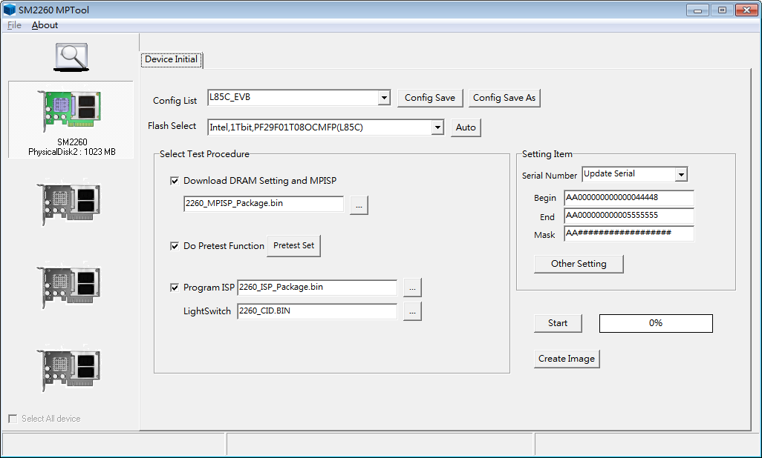

Fig.1 Main Dialog

# Test Flow

* Step 1: Plugging the prepared testing devices into system.
* Step 2: Push “Scan Drive” iconscantarget.jpg for device detection and select testing device. The device icon will light up and show the device information if there is a SM2260 device plugged within. Otherwise the device icon will be murky gray.
* Step 3: Select configuration file user used from “Config List” as Fig.3
* Step 4: Push “Auto” button for flash selection.
* Step 5: Enable “Download DRAM Setting and MPISP” and select DRAM and MPISP package bin file.
* Step 6: Enable “Do Pretest Function”.
* Step 7: Enable “Program ISP”. Select ISP package and LightSwitch settings bin file.
* Step 8: Select Serial Number policy and set “Begin”、”End” and ”Mask” values.
* Step 9: Push "Other Setting" button to update LightSwitch settings if needs. This step will execute LightSwitch tool as Fig.4 and update the LightSwitch file that user selected in Step7.
* Step10: Push “Start” button to start testing process according to the selected test items. When test procedure is completed, the progress bar will be 100% and the test result will be presented at status bar. The test result could be “Successful” as Fig.4 or some error message as Fig.

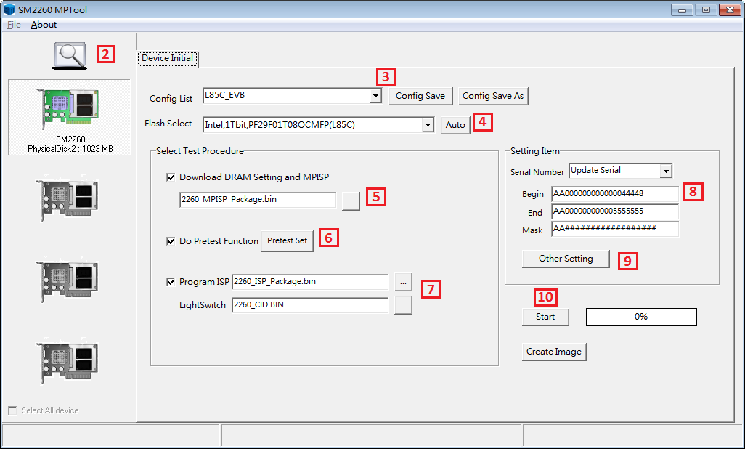

Fig.2 Test Device Flow

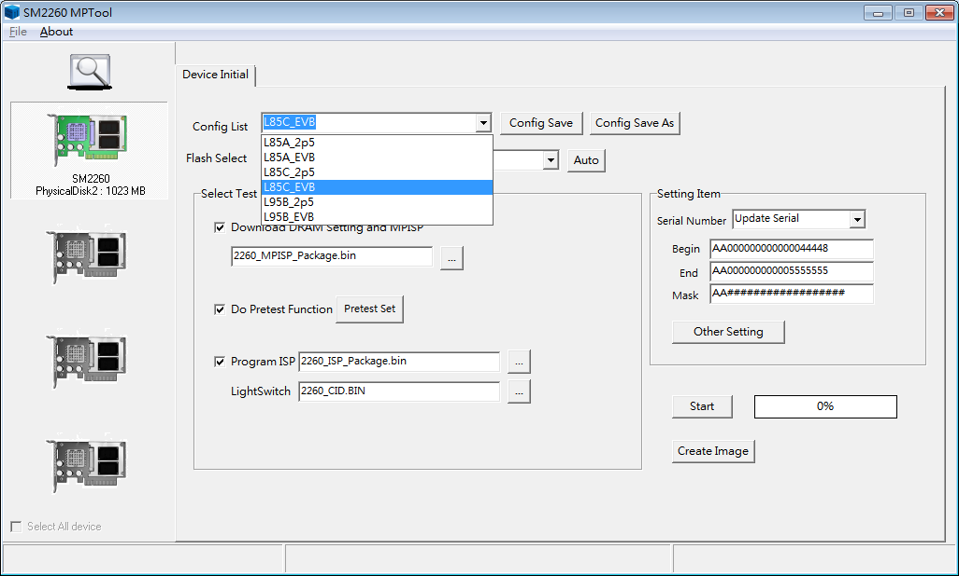

Fig.3 Select Configuration File

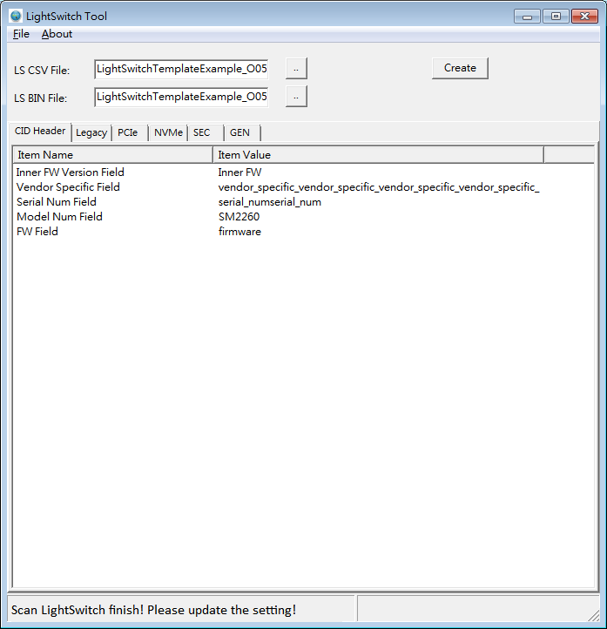

Fig.4 Update LightSwitch Tool

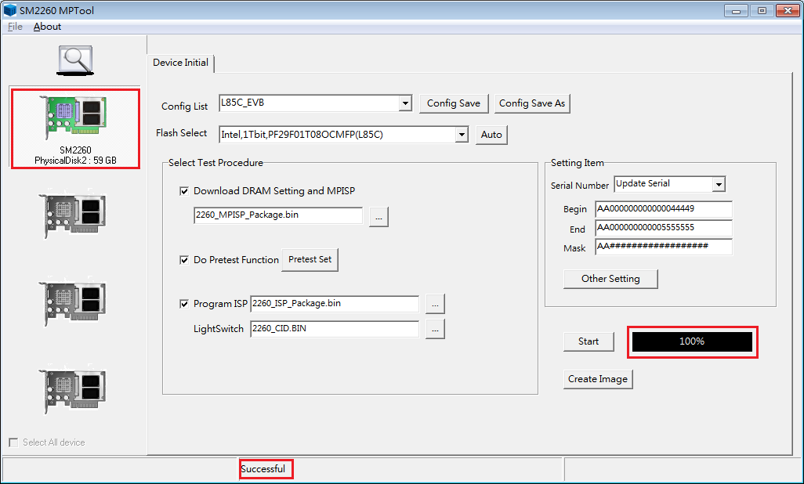

Fig.5 The Result of Success Testing

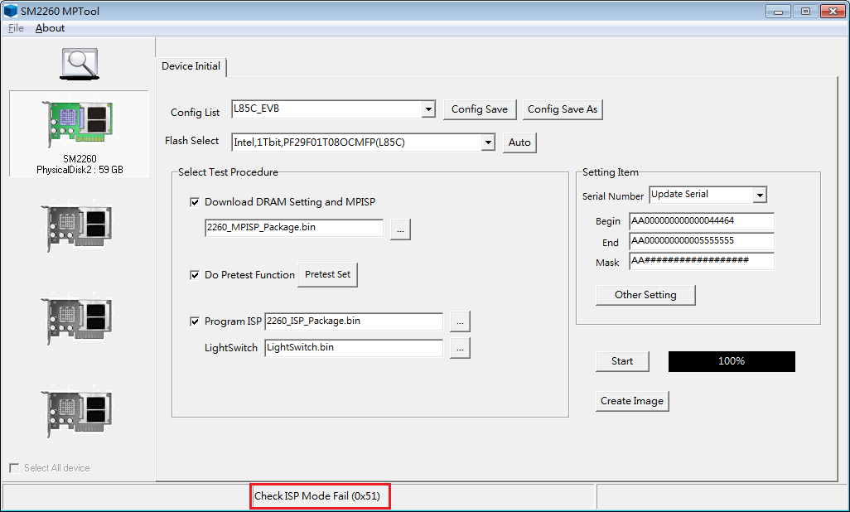

Fig.6 The Result of Fail Testing