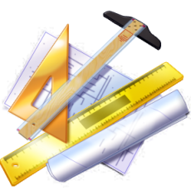C:\Program Files (x86)\Microsoft Office\MEDIA\CAGCAT10\j0292020.wmfStuyvesant High School Basic Technical Drawing   
Technology Department Mechanical drawing Instructor*: Mr. Griffith*

**Technical drawing assignment:**   
This is a drawing of a machine part. Your task is to name all the lines listed in this drawing in the space provided below the drawing in this word document.

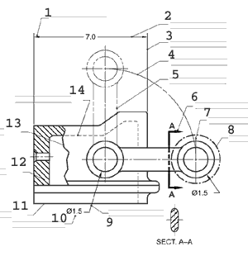

Leader Line

Dimension Line

Phantom Line

1:____________ 5:___________ 9:____________

Dimension Line

Object Line

Cutting Plane Line

2:____________ 6:___________ 10:___________

Object Line

Center Line

Extension Line

3:____________ 7:___________ 11:___________

Center Line (Moving)

Section Line

Section Lines

4:____________ 8:___________ 12:___________  
  
13:____________14:____________  
Please note: This worksheet may not work properly on a tablet PC.

Hidden Line

Break Line