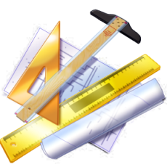
Stuyvesant High School Basic Technical Drawing
Technology Department Mechanical drawing Instructor: Mr. Griffith
Technical drawing assignment:
This is a drawing of a machine part. Your task is to name all the lines listed in this drawing in the space provided below the drawing in this word document.
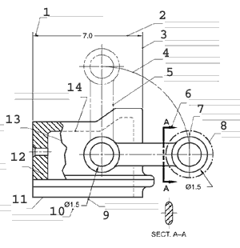

1:____________ 5:___________ 9:____________

2:____________ 6:___________ 10:___________

3:____________ 7:___________ 11:___________

4:____________ 8:___________ 12:___________
13:____________14:____________
Please note: This worksheet may not work properly on a tablet PC.

