[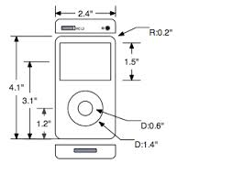](http://www.google.com/url?sa=i&rct=j&q=&esrc=s&source=images&cd=&cad=rja&docid=TB2vOzAYaiy4EM&tbnid=yS0ua_M_UB9FZM:&ved=0CAUQjRw&url=http://www.eazydraw.com/techDrawing.htm&ei=Czn8UrXPBsK80gH-zoGACw&bvm=bv.61190604,d.dmQ&psig=AFQjCNFMeQcXip5U3YZO4trc3dybKppfEQ&ust=1392347778052539)C:\Program Files (x86)\Microsoft Office\MEDIA\CAGCAT10\j0292020.wmfStuyvesant High School Basic Technical Drawing   
Technology Department Mechanical drawing Instructor*: Mr. Griffith*

**Technical drawing:**This is the graphical form of communicating ideas. It allows people to accurately acquire data about a particular object with a high degree of precision. In order to comprehend the drawing the drafter must be able to read the lines in the drawing.  
  
Below are some of the most common lines used in technical drawing:

1. **Hidden lines:**These lines are used to illustrate the various surfaces, edges ,corners, or sections of an object that would normally not be seen.

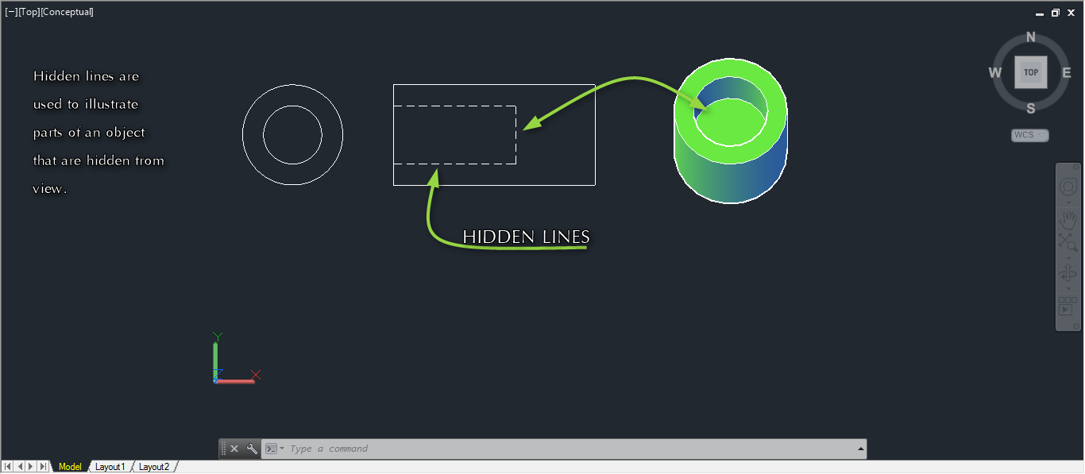

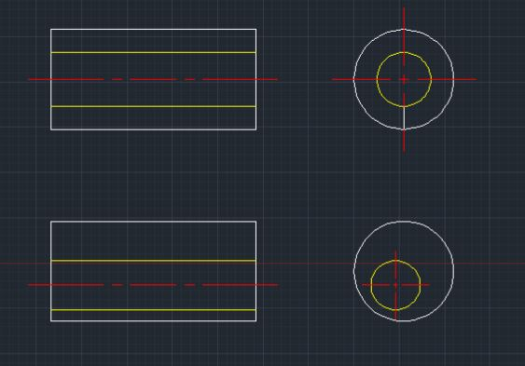**2. Center lines:**Center lines are used to illustrate the center of holes or the symmetry of an object.

**3. Object lines:**

These lines represent the outer body of an object:  
Object lines otherwise known as *visible* lines shows all the visible edges of an object in the drawing. These lines are always the darkest lines in the drawing.  
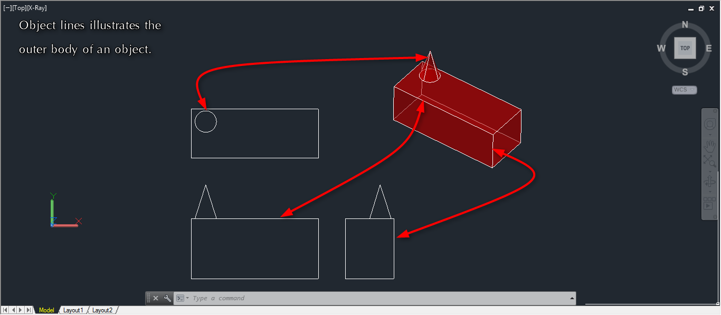

**4. Lines that are used to show measurement:**  
 4A. Extension lines:  
 These lines are used to illustrate the absolute boundaries that represent various sections of the  
 object. Extension lines never make contact with the outer boundary of the object.  
 4B. Dimension lines:  
 These lines are used in conjunction with extension lines to give the true size of a   
 particular section in the drawing.

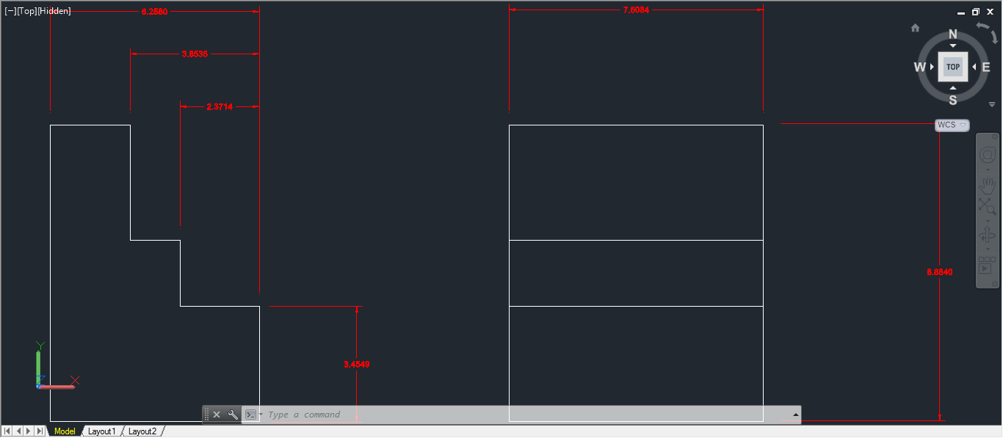

Extension lines

The dimension line shows the measurement

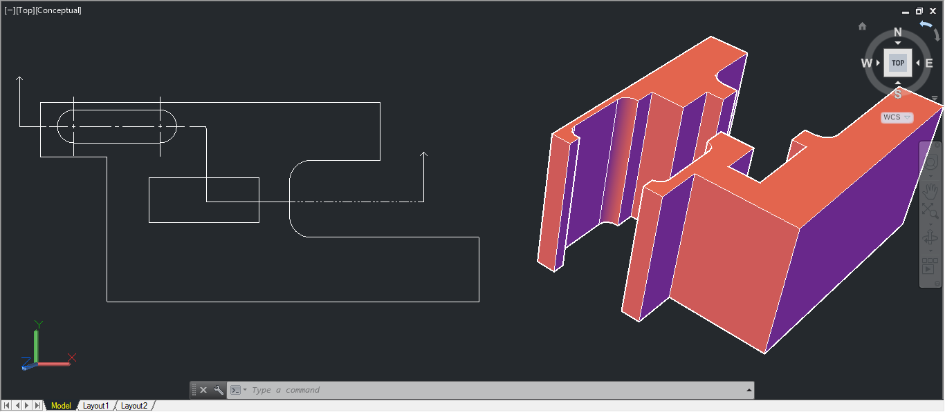**5. Cutting-plane line:**This line is used to show sectional views of a drawing. Cutting-plane lines also designate where the imaginary slicing of that object took place.

Cutting Plane line.

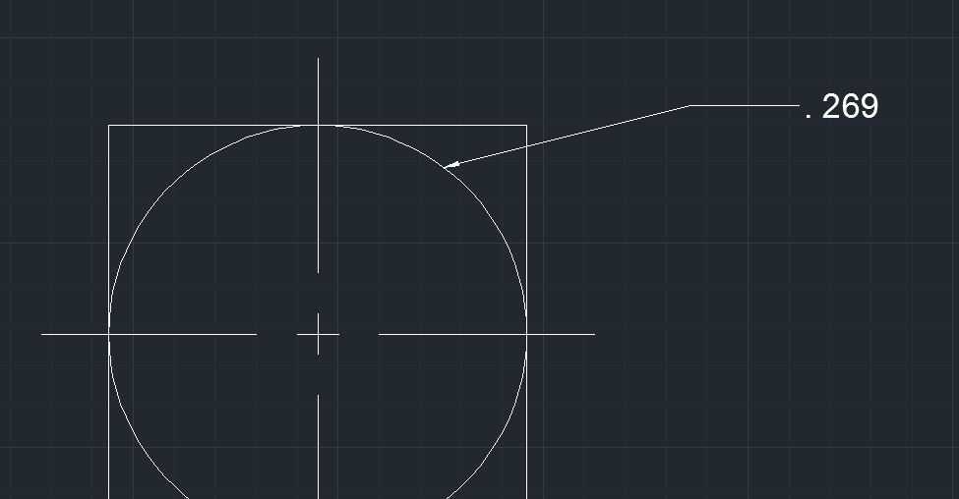**6. Leader lines:**Leader lines give specific information about a particular part of the object it is pointing to. The information could be in the form of a note of some kind or even simple numerical data. 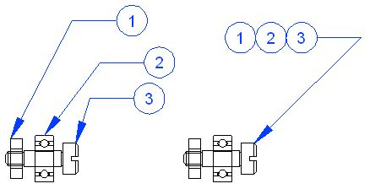

This is a leader line.

**7. Break lines:**These lines are used in situations when drawing a part of an object in its entirety is unnecessary. Break lines are used after the objects signature features have been shown.

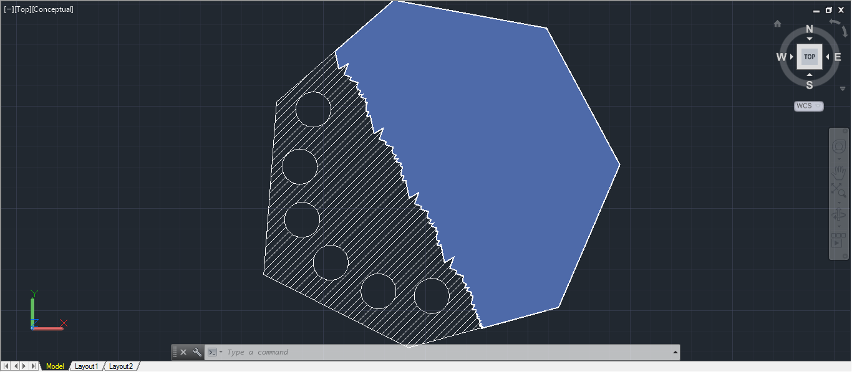

Break line

**8. Section lines:**These lines are used to indicate when an object has been sliced. Section lines will appear as angled line patterns that are usually drawn at Forty-five degrees.   
Section lines are drawn only at areas that have been *virtually cut by the cutting-plane.*

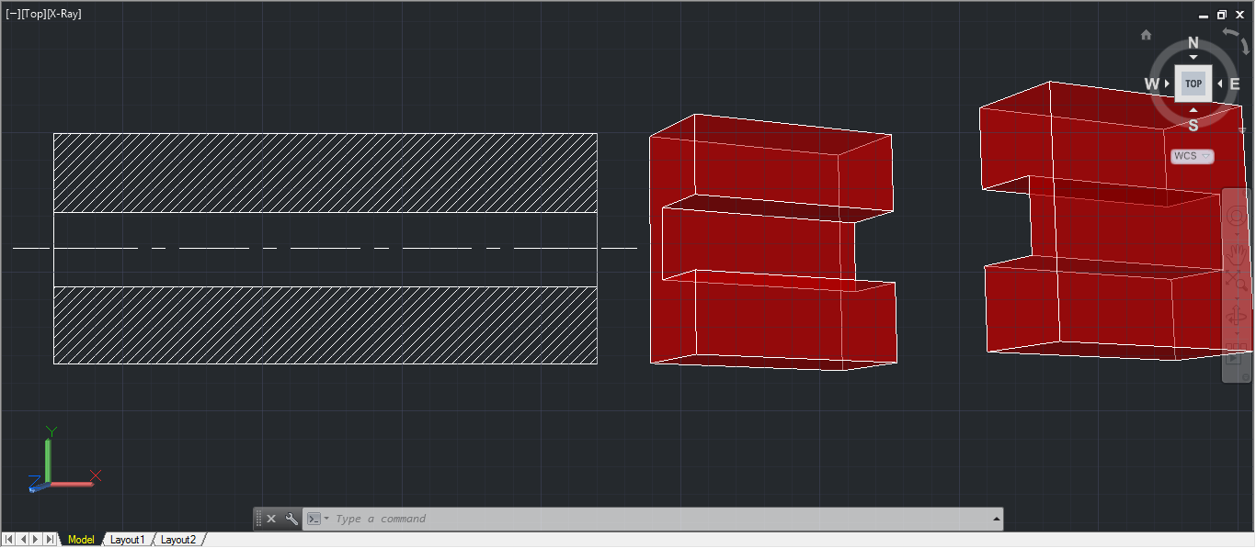

These areas are cut by the virtual cutting*-plane.*

These are section lines.

**9. Phantom lines:**Phantom lines are used to indicate the movement of an object in a drawing.  
The original part of the object is drawn using standard *object lines* where as the alternate position are drawn using phantom lines:

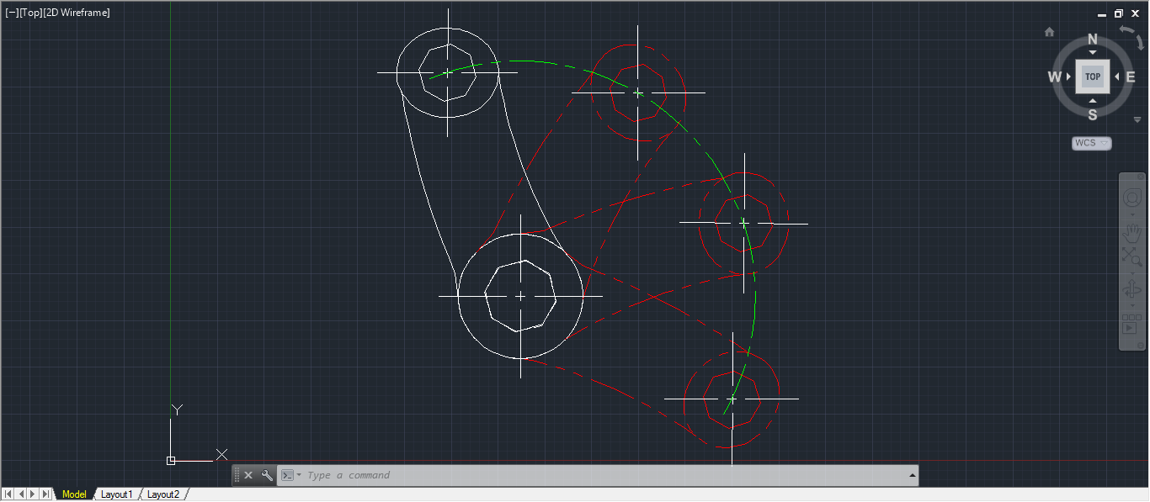

Phantom lines