

+91

-

62

82995306



ansarafitha

@gmail.com

**AFITHA M JABBAR**



**Career Objectives**

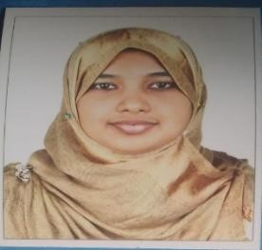

To work in a good environment by exposing my skills effectively with sincere hard work and following professional ethics, work for the development of your company and also for my professional growth.



**Education**

**Bachelor of Computer Application** Graduated, March 2014 M E S College , Marampally Marks 80%

**Higher Secondary Computer science** March 2011

J.K.H.S.S Pulluvazhy Marks 88%

**S S L C** March 2009

N.I.V.H.S.S Marampally Marks 82%



**Skills**

* Proficient in Python,Django,HTML,CSS,Javascript and MySQL

* Average experience in C,C++,Core Java, MySQL, MS office packages and computer networking.



**Work Experience**

* Fresher



**Interpersonal Skills**

* Ability to rapidly build relationship and set up trust.
* Confident and Determined
* Ability to cope up with different situations.
* Ability to work with a team



**Personal Details**

* **Father’s Name** M S Jabbar
* **Prescent Address** Pallath House, Thuruth, Aluva P.O

Ernakulam, 683101

|  |  |  |
| --- | --- | --- |
| ❖ **Date of Birth** |  | 19-01-1993 |
| ❖ **Language Known** |  | English , Malayalam |
| ❖ **Marital Status** |  | Married |
| ❖ **Nationality/Religion** |  | Indian / Muslim |
| ❖ **Interest & Hobbies** |  | Internet browsing ,Writing, Reading Books |



**Declaration**

**I affirm that the information given in this resume are true and correct to the best of my knowledge.**

**Place: AFITHA M JABBAR**

**Date:**