**REPORT**

POWER BI PROJECT NO- 3

MEMBERS-

2019UCS2009-2019UCS2062-2019UCS2045

**Cryptocurrency Historical Prices**

## **About Dataset**

**CONTEXT-**

1. How many cryptocurrencies are there and what are their prices and valuations?
2. Why is there a sudden surge in the interest in recent days?

**CONTENT-**

The dataset has one csv file for each currency. Price history is available on a daily basis from April 28, 2013. This dataset has the historical price information of some of the top crypto currencies by market capitalization.

* Date: date of observation
* Open: Highest price on the given day
* Low: Lowest price on the day
* Close: Closing price on the given day
* Volume: Volume of transactions on the given day
* Market Cap: Market capitalization in USD

**Acknowledgements**

This data is taken from [coinmarketcap](https://coinmarketcap.com/) and it is [free](https://coinmarketcap.com/faq/) to use the data.

**Inspiration**

1. How did the historical prices / market capitalizations of various currencies change over time?
2. Predicting the future price of the currencies
3. Which currencies are more volatile and which ones are more stable?
4. How does the price fluctuations of currencies correlate with each other?
5. Seasonal trend in the price fluctuations

**DASHBOARD**

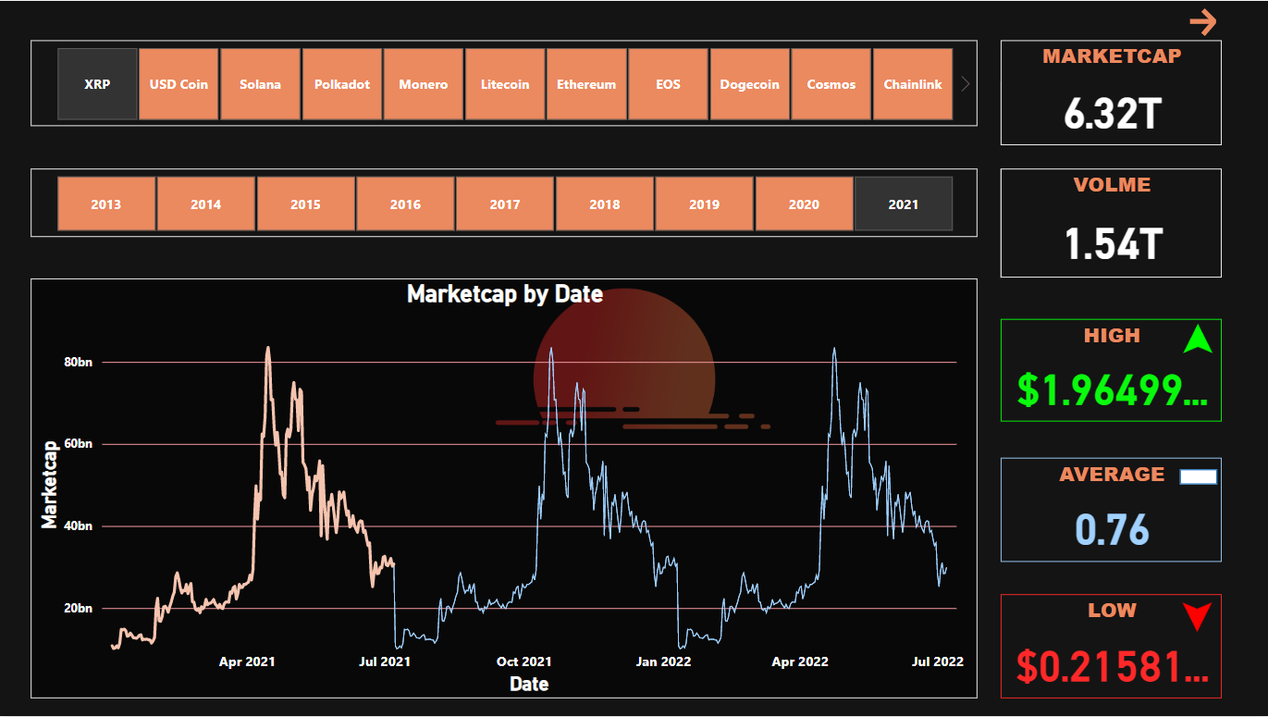

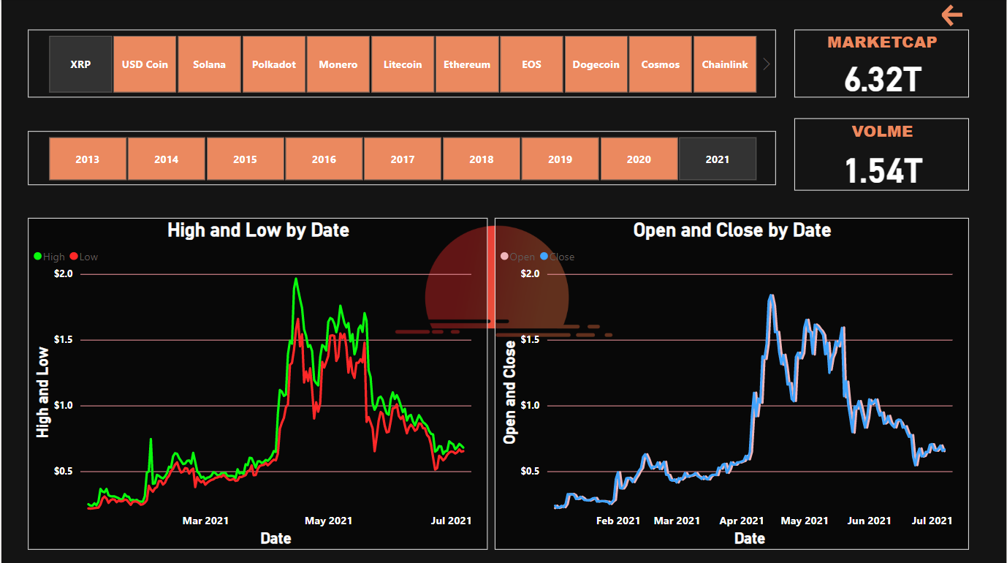

**INFORMATION**

**COINS CONSIDERED**

* **XRP -2013-2021 launch - 2012**
* **USD COIN -2018-2021 launch - 2018**
* **SOLANA -2020-2021 launch - 2020**
* **POLKADOT -2020-2021 launch - 2020**
* **MONERO -2014-2021 launch - 2014**
* **LiteCoin -2013-2021 launch -2011**
* **Ethereum -2015-2021 launch -2015**
* **EOS -2017-2021 launch -2017**
* **Dogecoin -2013-2021 launch -2013**
* **Cosmos -2019-2021 launch -2019**
* **Chain link -2017-2021 launch -2017**
* **Cardano -2017-2021 launch -2017**
* **Bitcoin -2013-2021 launch -2009**
* **BinanceCoin-2017-2021 launch -2017**

**FACTORS-**

* **MARKETCAP**
* **VOLUME**
* **HIGH**
* **AVERAGE**
* **LOW**