Technical Report:
Churn Prediction & Data Drift Management

Project Framework: Offline MLOps | Date: 26 February 2026

Submitted by
Paramathma Sriganeshkumar
Subramani Ragul Kumar
Aflah Salim

Executive Summary

This project addresses the challenge of customer churn in a non-stationary environment. By implementing an end-to-end scikit-learn pipeline, we analyzed 24 periods of data to account for target and covariate drift. The final solution utilizes a fixed retraining strategy with a 3-month window and a business-optimized threshold to minimize financial loss.

Problem Statement & Dataset

The objective is to anticipate customer churn to trigger proactive retention actions.

- Dataset: 5,000 rows across 24 monthly periods
- Features: Tenure, Monthly Amount, Support Calls, and Contract type
- Constraints: Temporal integrity is paramount — random train/test splits are strictly forbidden to prevent temporal leakage
- Missing values: Monthly Amount (13.4%) and Support Calls (9.9%) are Missing Not at Random (MNAR)

Drift Analysis (EDA)

Data drift was identified as a significant risk to model decay. Four types were analysed across all 24 periods:

- Target Drift: Churn rates fluctuated between ~25% and ~50% across the 24 periods, confirming the target variable is non-stationary.
- Covariate Drift: Significant shifts in Monthly_Amount and Support_Calls distributions over time, reflecting pricing changes and evolving customer behaviour.
- Distribution Shift: Visible differences in feature shapes when comparing early vs recent periods.
- MNAR Missingness: Customers with missing Monthly_Amount exhibited different churn behaviour. Binary missingness indicators were added as features to preserve this predictive signal.
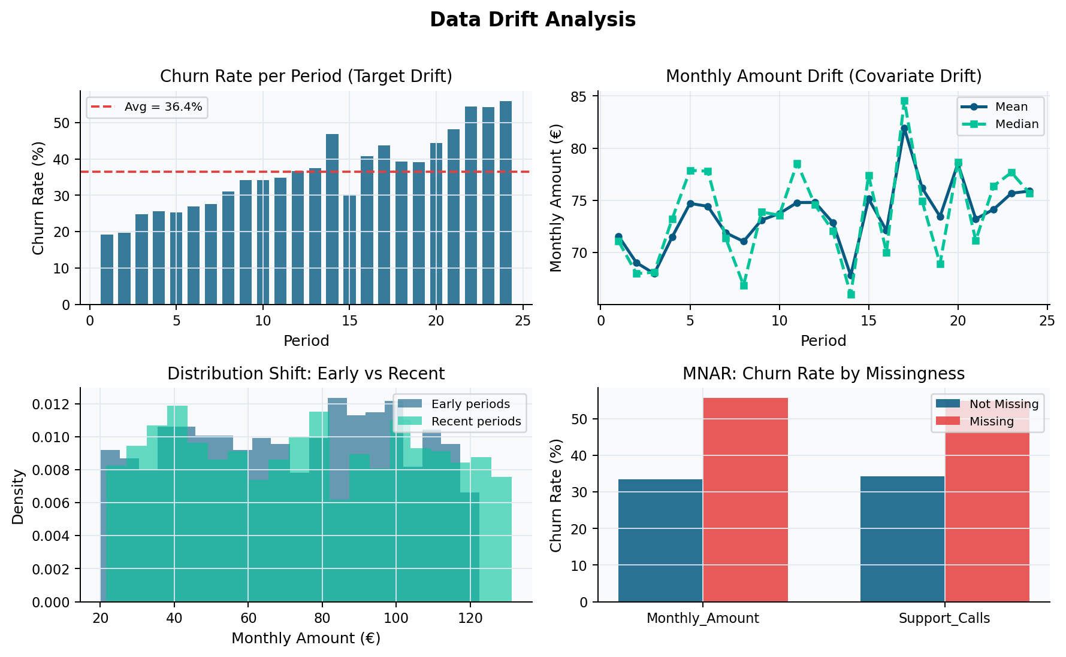
Figure 1. Drift dashboard: (top-left) churn rate per period — target drift; (top-right) Monthly Amount trend — covariate drift; (bottom-left) early vs recent distributions; (bottom-right) MNAR — churn rate differs by missingness status.

Methodology & Pipeline Construction

To ensure a leakage-free production environment, a modular scikit-learn pipeline was implemented. The preprocessor is always fitted on training data only and applied to the test set without refitting.

- Numeric Processing: Median imputation (robust to outliers) followed by StandardScaler for Tenure, Monthly_Amount, Support_Calls, and the two MNAR binary indicators.
- Categorical Processing: Constant-fill imputation with a dedicated 'MISSING' category, followed by OneHotEncoder(handle_unknown='ignore') for the Contract feature
- Validation: Walk-forward evaluation — train on all periods before t, test on period t — to simulate real-world deployment and prevent any form of temporal leakage

Model Evaluation & Retraining Policies

Logistic Regression and Random Forest were compared under different retraining strategies using walk-forward evaluation.

- Window Selection: History lengths W ∈ {3, 4, 5, 6, 8, 10, 12, 15, 18} periods were back tested.
- Findings: A fixed window of W = 3 periods outperformed all longer histories, achieving a Mean AUC of ~0.87. Under high drift, the model benefits more from recent data than from a larger volume of stale historical data
- Model Comparison: Logistic Regression (~0.87 AUC) and Random Forest (~0.86 AUC) performed comparably. Logistic Regression is preferred for its stability and interpretability.

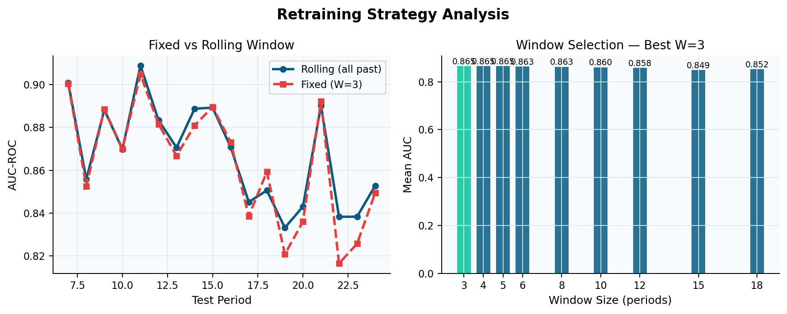

Figure 2. (left) Fixed W=3 vs Rolling window AUC over test periods; (right) Mean AUC per candidate window size — W=3 highlighted as optimal.

Business Cost Optimization

The default classification threshold of 0.5 was rejected in favor of a cost-sensitive framework reflecting the asymmetric consequences of prediction errors:

- False Negative (FN) Cost: €200 — cost of a lost customer who received no retention attempt.
- False Positive (FP) Cost: €20 — cost of an unnecessary retention offer sent to a loyal customer.

By minimizing Total Cost = (FP × €20) + (FN × €200) across all thresholds from 0.05 to 0.95, the optimal threshold was found to be approximately 0.09. This aggressive threshold prioritizes capturing churners — accepting more false positives in exchange for far fewer missed churns — significantly reducing total business cost compared to the default threshold of 0.5.
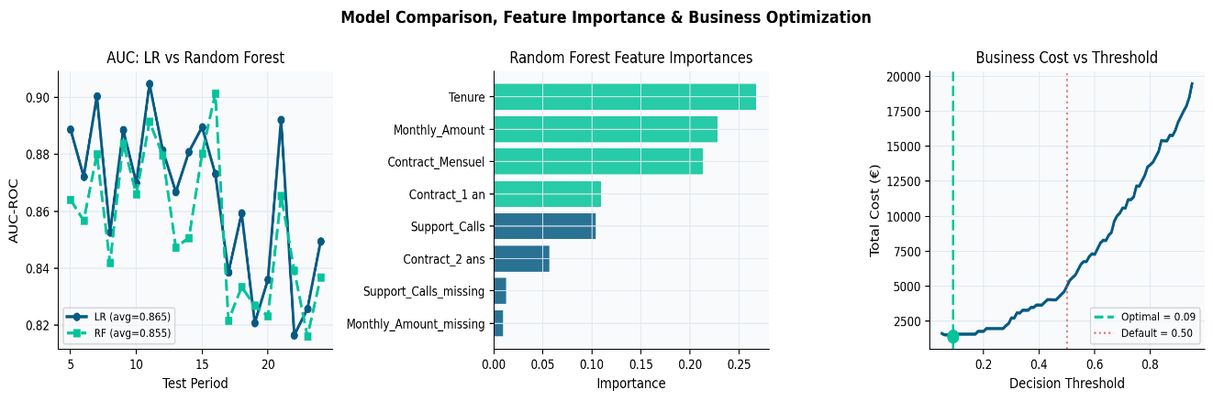
Figure 3. (left) LR vs Random Forest AUC over time; (center) Random Forest feature importances — Tenure and Monthly_Amount dominate; (right) Business cost vs decision threshold — optimal threshold at ~0.09 marked in teal.

Conclusion

This project demonstrates that MLOps is not just about model accuracy, but about monitoring drift and aligning technical thresholds with business costs. Key takeaways:

- Data drift is real and measurable — periodic retraining with W = 3 is essential
- MNAR missingness carries predictive signal and must be preserved as features, not discarded through imputation.
- Business threshold tuning (0.09 vs 0.5) delivers a meaningful reduction in total financial cost.
- The full pipeline is reproducible — running the notebook from the CSV regenerates all results and figures automatically.

