Data Resource Profile: A Florida-scale simulated dataset for developing and benchmarking record-linkage software for cancer data systems
Abraham D. Flaxman
Anders Alexandersson
Abstract
Introduction … Methods … Results … Conclusion …
Author affiliations
Abraham D. Flaxman (corresponding author), ORCID 0000-0001-6033-4713
Institute for Health Metrics and Evaluation, University of Washington, Population Health Building/Hans Rosling Center, 3980 15th Ave. NE, UW Campus Box #351615, Seattle WA 98195, USA
Email: abie@ihme.washington.edu
Anders Alexandersson
Florida Cancer Data System, University of Miami Miller School of Medicine, Miami FL, USA

Key Features
- What is unique: a large, fully simulated, multi-file dataset for linking individual people, with cross-file ground truth (every record carries a simulant_id, so missed-match and false-match rates of any method can be computed exactly rather than estimated), designed to capture the record matching challenges faced by a Florida-scale cancer data system.
- Why created: linkage software for cancer registries must be developed and tested on names, dates of birth, addresses and SSNs, which are exactly the identifiers that confidentiality rules prevent registries from releasing.
- Details: a simulated Florida drawn from the 50,518,675 simulated people recorded as residents in the simulated 2020, 2030 or 2040 censuses, including a simulated registry of 5,000,002 records whose age and sex distribution is that of the cases reported by the Florida Cancer Data System, and researcher finder files of 500,000 and 100,001 records drawn from residents in 2040.
- Data linkage: the larger finder file includes 100,000 people who are also in the registry and the smaller finder file includes 20,000. There is no overlap between the finder files.
- Main categories of data: simulated person-level identifiers including name, date of birth, sex, street-address fields, SSN, race/ethnicity, and a diagnosis date on each registry record, carrying realistic synthetic noise (typos, nicknames, month/day swaps, blanks, duplications).
- Access: direct download under a permissive licence with a DOI.

1. Background
…

2. Methods

2.1 Generating simulated records with pseudopeople
import pseudopeople as psp
census = psp.generate_decennial_census() # bundled ~10k-simulant sample
census.head()
 | simulant_id | household_id | first_name | middle_initial | last_name | age | date_of_birth | street_number | street_name | unit_number | city | state | zipcode | housing_type | relationship_to_reference_person | sex | race_ethnicity | year
0 | 0_2 | 0_7 | Diana | P | Kofron | 25 | 05/06/1994 | 5112 | 145th st | NaN | Anytown | WA | 00000 | Household | Reference person | Female | White | 2020
1 | 0_3 | 0_7 | Anna | A | Kofron | 25 | 09/29/1994 | 5112 | 145th st | NaN | Anytown | WA | 00000 | Household | Other relative | Female | White | 2020
2 | 0_923 | 0_8033 | Gerald | R | Butler | 76 | 11/03/1943 | 1130 | mallory ln | NaN | Anytown | WA | 00000 | Household | Reference person | Male | Black | 2020
3 | 0_2641 | 0_1066 | Loretta | T | Carley | 61 | 07/71/1958 | NaN | delacorte dr | NaN | Anytown | WA | 00000 | Household | Reference person | Female | White | 2020
4 | 0_2801 | 0_1138 | Richard | R | Jones | 73 | 03/03/1947 | 950 | caribou lane | NaN | Anytown | WA | 00000 | Household | Reference person | Male | White | 2020

3. Results

3.1 Structure, contents, and where the data are held
This data resource is a zip archive containing three comma-separated files, deposited on Zenodo under a DOI that will be minted before publication. The high-level characteristics of the files are described in Table 1: a simulated registry of 5,000,000 people and two finder files of 500,000 and 100,000 people. All three are drawn from Florida residents in the simulated 2020, 2030 or 2040 census, a pool of 50,518,675 distinct simulated people, counted across three censuses twenty years apart and including people who died or left the state between them.
Every row of each file carries a simulant_id, the identifier of the simulated person it describes; the same identifier in two files means the same person, and this is the ground truth against which any other linkage of the files can be scored. The files also contain the fields that record linkage typically relies on: first name, middle initial, last name, date of birth, sex, race/ethnicity, street number, street name, unit number, city, state, ZIP code and social security number (SSN). Registry rows also carry a diagnosis date, falling in one of three years, 2020, 2030 or 2040, the year of the census the record comes from (Section 2). Addresses carry real Florida cities and ZIP codes but simulated street addresses that are not real street locations. The registry has 5,000,002 rows for its 5,000,000 people, and the finder files have 500,000 and 100,001 rows for 500,000 and 100,000 people; the few people with two rows are duplicated records, two differently transcribed rows for one person (Section 2).
The larger finder file shares 100,000 people with the registry, 20% of its records, and the smaller shares 20,000, the same 20% share; the two finder files share no people with each other. The 20% overlap was chosen to mirror the finder files FCDS receives (Section 2).
The archive also includes a manifest of MD5 and SHA-256 digests (Table 1 gives the MD5) and a configuration file that names every seed and design target, and the pipeline that built them is archived under its own DOI. A second build from the same configuration and the same source population, which is available on request, reproduced all three files byte for byte.
Table 1: The released files: rows, people, people shared with the registry, size and MD5 digest. SHA-256 digests are in the manifest deposited with the files.
File | Rows | People | Shared with registry | MB | MD5
sim_fcds_benchmark_0.3.zip |  |  |  | 234 | 03fc7ff83ae5bedd3f71b73d667a463f
registry.csv | 5,000,002 | 5,000,000 | — | 565 | 0dd8e15bf7582324bbd1a713918617a1
finder_500k.csv | 500,000 | 500,000 | 100,000 | 50 | 6025e4065d9616864fc0519d31da211a
finder_100k.csv | 100,001 | 100,000 | 20,000 | 10 | ffbc3a53f3b34e0d69854b07139b322d

3.2 Population characteristics
The simulated registry has the age and sex distribution matching the cases reported to FCDS between 1995 and 2023 [1]: in each of the 36 age and sex strata its share of records is within 0.041 percentage points of FCDS’s share (Figure 1). 62% of registry records are people aged 65 or older at diagnosis and 4% are under 40; 48% are women. The finder files have the age structure of Florida’s residents in 2040 instead: 26% of the larger file are 65 or older, 43% are under 40, and 51% are female.
By race and ethnicity, people in the registry are 64% White, 17% Latino, 12% Black, 5% Asian and 3% other or multiracial (American Indian and Alaska Native, Native Hawaiian and Pacific Islander, multiracial, and unknown), compared with 55%, 21%, 12%, 7% and 4% in the larger finder file; the difference follows from the registry’s older ages (Section 4). The two finder files differ from each other by at most 0.3 percentage points on every share reported in this section.
Registry records come from three censuses: 27% of them are from 2020, 28% from 2030 and 46% from 2040, and a record’s diagnosis date falls in its census year. Every finder record is from 2040, and so is the registry record of every person who appears in a finder file; people last seen in 2020 or 2030 appear in the registry alone.
The three most common first names in each age group, printed at the ends of the bars in Figure 1, run from Liam, Noah, Oliver among boys under five to James, Robert, John among men of 85 and over, and from Olivia, Charlotte, Emma to Mary, Barbara, Patricia among girls and women.
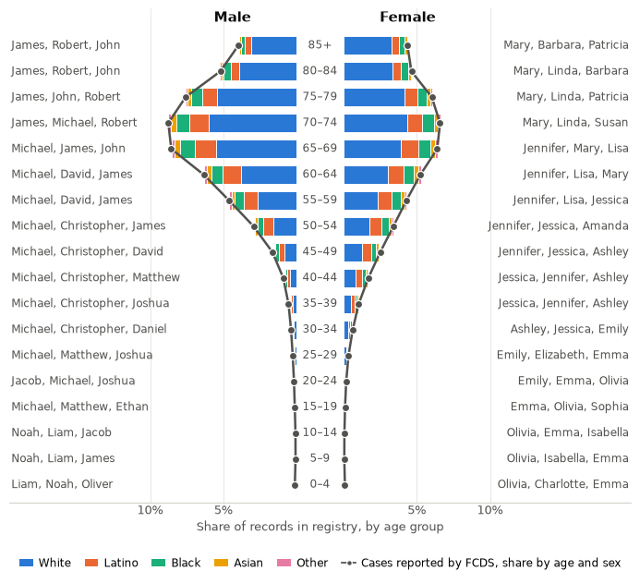
Figure 1: Who is in the simulated registry. Share of registry records by age group and sex, stacked by race/ethnicity. Dots are the age and sex distribution of cases reported to FCDS, which the registry was drawn to match, so they sit on the bar ends by construction. At the ends of the bars, the three most common first names in each group as they appear in the simulated registry file.
Figure 2 shows three of the 100,000 people who appear in both the registry and the larger finder file, chosen to show three kinds of error, with every field that differs between their two records marked: a first name recorded as a nickname, an address with several fields altered, and a swapped month and day of birth beside a swapped pair of SSN digits.
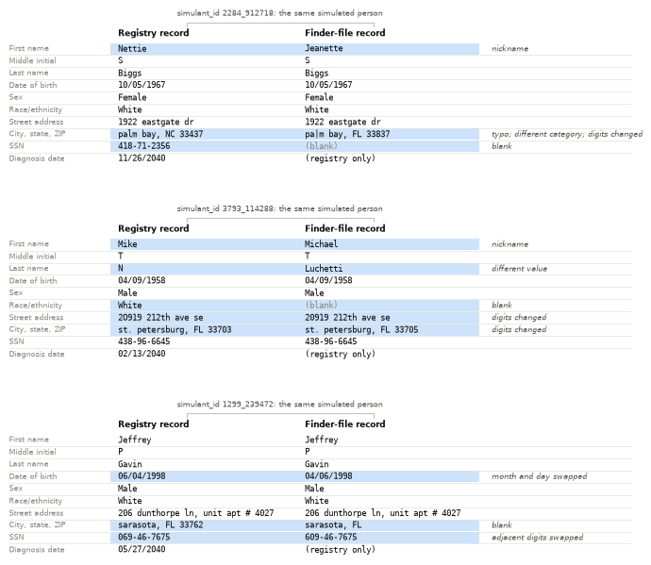
Figure 2: Simulated people as they appear in the registry and in the 500,000-record finder file. Highlighted fields differ between the two records, and the note names what the discrepancy looks like; the diagnosis date is a registry-only field. The two records of a pair come from the same census year, so every difference is noise rather than a change in the person’s life.

3.3 Error structure
Table 2 gives the error structure field by field: the share of values that are blank in the registry and in the larger finder file, against the blanking rate set for each, and, among the 100,000 true pairs, the share of pairs whose two records agree exactly when both have a value and the share with a blank on either side. The smaller finder file matches the larger on every figure in the table to within 0.8 percentage points.
SSNs are blank in 20.0% of finder records, the rate FCDS specified, and in 5.68% of registry records against a specified 5%; the excess is structural, since 4.18% of the people in the registry pool never held an SSN in the source population. Of the SSNs present in the larger finder file, 4,001 carry two adjacent digits swapped, and where a true pair has an SSN on both sides the two agree in 99.1% of pairs.
Names and dates of birth disagree more often than SSNs do. Among true pairs with both values present, first names agree in 94.0% of pairs, last names in 95.9% and dates of birth in 93.6%, and each of these fields is blank on one side in about 2.1% of pairs. Taken together, 79.3% of true pairs agree exactly on first name, last name and date of birth, and 77.9% have an SSN on both sides that agrees; these two shares bound what exact-match rules can find in Section 3.4. Address fields agree in 97.0% of pairs with both present and are blank on one side in 5.9%; the unit number is blank for 94% of registry records, because most addresses have none, and street numbers are blank above their set rates because some source addresses carry none.
Table 2: Error structure by field. Blank shares in the registry and the 500,000-record finder file, with the blanking rate set for each field in parentheses (FCDS’s specification for SSN and address fields, pseudopeople’s default elsewhere); and, among the 100,000 true pairs, the share of pairs whose two records agree exactly when both have a value and the share with a blank on either side.
Field | Blank, registry (set) | Blank, finder file (set) | True pairs: agree when both present | True pairs: blank on either side
First name | 1.0% (1%) | 1.0% (1%) | 94.0% | 2.1%
Middle initial | 1.0% (1%) | 1.0% (1%) | 99.7% | 2.0%
Last name | 1.0% (1%) | 1.0% (1%) | 95.9% | 2.0%
Date of birth | 1.0% (1%) | 1.0% (1%) | 93.6% | 2.0%
Sex | 1.0% (1%) | 1.0% (1%) | 98.0% | 2.0%
Race/ethnicity | 1.0% (1%) | 1.0% (1%) | 98.0% | 2.0%
Street number | 5.6% (1%) | 9.5% (5%) | 98.3% | 10.2%
Street name | 1.0% (1%) | 5.0% (5%) | 97.0% | 5.9%
Unit number | 94.2% (1%) | 94.3% (5%) | 98.2% | 94.4%
City | 1.0% (1%) | 5.0% (5%) | 97.2% | 6.1%
State | 1.0% (1%) | 5.0% (5%) | 98.1% | 6.0%
ZIP code | 1.0% (1%) | 5.0% (5%) | 97.5% | 5.9%
SSN | 5.7% (5%) | 20.0% (20%) | 99.1% | 21.4%

3.4 Linkage difficulty
Exact keys are less unique than they look. Among the 5,000,000 people in the registry, 97.0% have a first name, last name and date of birth that no one else in the file shares, 88.8% have a unique last name and date of birth, and 81.6% a unique ZIP code, date of birth and sex, while 47% share their full name with at least one other person.
Table 3 scores exact-agreement rules on the larger finder file against the key. Agreement on first name, last name and date of birth links 79.3% of true pairs at a precision of 99.81%, and the SSN alone links 77.9% at 99.97%. The two field sets FCDS’s Procedure Guide requires a submission to carry behave differently as exact rules: name, SSN and sex makes no false matches and finds 64.7% of true pairs, name with month and year of birth and sex admits 4,435 false matches, and either set finds 81.5%; the current layout’s two sets, which both require the full date of birth, find 71.7% together with no false matches. Name and date of birth or SSN, the best simple rule, reaches a recall of 95.4% at a precision of 99.82%, and last name with date of birth alone falls to a precision of 71.0%. These are exact-agreement rules on the field sets FCDS requires a submission to carry, not the registry’s own matching procedure.
Table 3: Exact-agreement rules on the 500,000-record finder file, scored against the identity key. The Guide and layout rows are exact agreement on the field sets FCDS requires a submission to carry, not the registry’s own matching procedure.
Rule | Predicted pairs | True | False | Precision | Recall | Missed-match
First name, last name, date of birth | 79,462 | 79,311 | 151 | 0.9981 | 0.7931 | 20.7%
SSN alone | 77,943 | 77,923 | 20 | 0.9997 | 0.7792 | 22.1%
Guide set: name, SSN, sex | 64,665 | 64,665 | 0 | 1.0000 | 0.6466 | 35.3%
Guide set: name, month and year of birth, sex | 80,963 | 76,528 | 4,435 | 0.9452 | 0.7653 | 23.5%
Either Guide set | 85,975 | 81,540 | 4,435 | 0.9484 | 0.8154 | 18.5%
Either current layout set (name, sex, date of birth, with SSN or with address) | 71,692 | 71,692 | 0 | 1.0000 | 0.7169 | 28.3%
Name and date of birth, or SSN | 95,581 | 95,410 | 171 | 0.9982 | 0.9541 | 4.6%
Last name and date of birth | 121,292 | 86,125 | 35,167 | 0.7101 | 0.8612 | 13.9%

Without blocking the two files present 2.5 trillion record pairs. Blocking on the full date of birth leaves 58 million candidate pairs and keeps 91.7% of true pairs; blocking on the first letter of the last name with the year of birth leaves 1.23 billion and keeps 90.7%.
Figure 3 splits three rules by the race/ethnicity recorded on the finder record. For first name, last name and date of birth the missed-match rate is alike across groups, from 20.5% to 20.9%, and the false-match rate stays below 0.28% in every group. The SSN rule differs by group: it misses 34% of true pairs for Asian people and 29% for Latino people against 19% for White people, and the difference carries into the best simple rule, which misses 7.2% of Asian true pairs against 3.9% of White ones.
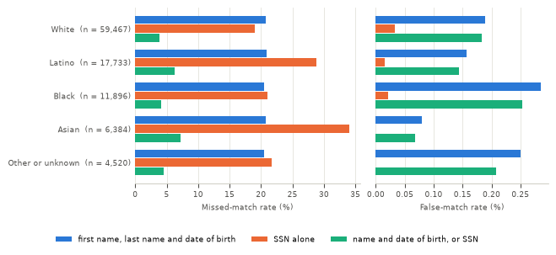
Figure 3: Missed-match and false-match rates of three exact-agreement rules on the 500,000-record finder file, by the race/ethnicity recorded on the finder record, with the number of true pairs in each group.
The 11 rules run in 3.8 seconds on the 500,000-record file with 8 threads on an eight-core allocation. The 100,000-record file gives the same picture: every rule’s recall is within 0.8 percentage points of the larger file’s.

4. Discussion
…

5. Data Access
…

6. Conclusions
…
1. Alexandersson A, Flaxman AD, Keyes O. Data access request: Comparing the accuracy and speed of Match*Pro, fastLink, and splink at the Florida Cancer Data System (pseudopeople issue #205) [Internet]. 2023--2026; Available from: https://github.com/ihmeuw/pseudopeople/issues/205

