

CRN: 50295

School of Computing, Science & Engineering

SEMESTER ONE EXAMINATION

PROGRAMMES:

BEng Control and Automation

BLOCK CODES:

E/CAU/F

AUTOMATION AND ROBOTICS

WARNING
Candidates who copy or take away any part of this question paper including any appendices or share any of its content with others, will be disqualified.

Date: 29th November 2024 Time: --:--:--

Instructions to Candidates

Time allowed 2 hours

Each question carries 25 marks

The use of approved electronic calculators is allowed

  - Briefly explain the main challenges and limitations associated with using the derivative (D) gain in PID control
(5 marks)

  - Given a system has the following transfer function:

$$G\left(s\right)=\frac{2s+3}{{10s}^{3}+5s^{2}+s}$$

    - Determine the poles and zeros of the system and sketch them on an s-plane graph.
- marks)

    - Identify the order of the system.
(5 mark)

    - Evaluate the stability of the system using the poles' locations
(5 mark)

  - The figure below illustrates two main types of industrial manipulators. Identify these two types and provide two advantages and two disadvantages for each.
(10 mark)
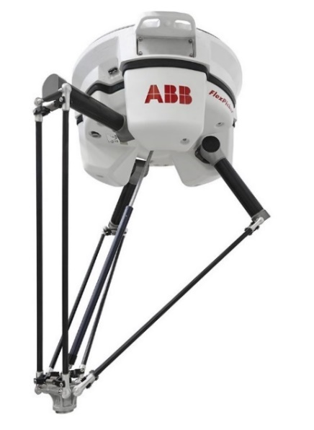 | 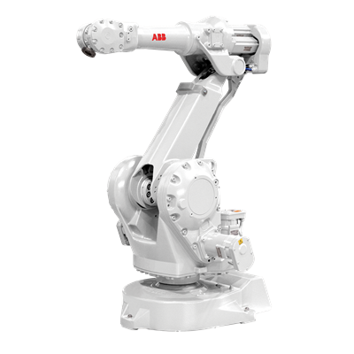
Two main types of industrial manipulators

  - For systems with the transfer functions

$$\frac{C(s)}{R(s)}=\frac{20s}{{s^{3}+12s}^{2}-20s+20K}$$

$$\frac{C(s)}{R(s)}=\frac{K}{{{Ks}^{3}+Ks}^{2}+Ks+5}$$

Determine the range of K resulting in a stable system.
(15 mark)

  - Sketch the workspace of a 2-link planar robotic arm, where the first joint is revolute, and the second joint is prismatic. Assume the following conditions:

- The first joint (revolute) angle θ1 has a range of 0° to 120°
- The second joint (prismatic) has a linear extension range from 0 meter to 2 meters.
- The length of the first link is 2 meters.

(10 mark)

  - A steel metal sheet weighing 20 kg is to be vertically lifted using a robot with an end effector made of 20 identical round vacuum cups. Calculate the minimum allowable diameter of each cup if:
- The maximum vertical acceleration of the robot is 10 m/s²
- The vacuum generator produces a pressure of -30 Kpa
(15 mark)

4.

        - Name three types of automation and specify which type involve robots. (8 mark)
        - Determine the position and orientation of the robotic arm's end effector using the provided link lengths and joint angles. (17 mark)

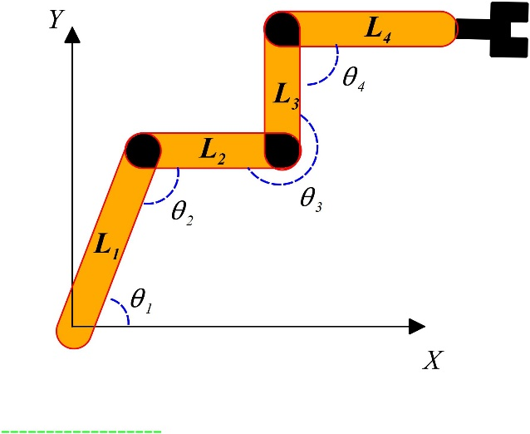
$$θ_{1}=60°, θ_{2}=120°, θ_{3}=270°,θ_{4}=90°$$
$$L_{1}=1 m, L_{2}=0.6 m, { L}_{3}=0.4 m, L_{4}=0.5 m$$

Solutions

1.

    - Noise Sensitivity: The derivative term amplifies high-frequency noise in the input signal, leading to unstable control actions. This is because the derivative gain reacts strongly to rapid changes, which may be caused by noise rather than actual process changes. (5 marks)

$$G\left(s\right)=\frac{2s+3}{{10s}^{3}+5s^{2}+s}$$

To find zeros:

2s+3 = 0 hence 2s = -3 and there is one simple zero at s = -1.5

(2 marks)

To find the poles:

10S3+5s2+s= 0

Hence:

- S = 0
- 10S²+5s+1 = 0

so applying$x=\frac{-b±\sqrt{b^{2}-4ac}}{2a}$ there are two complex roots of

$s= \frac{-1}{4}+i\frac{\sqrt{15}}{20})$ $s= \frac{-1}{4}-i\frac{\sqrt{15}}{20})$

(3 marks)

s-plane
jω

+1

X

0
X

X

-3 -2 -1

-1

(5 mark)

    - The order of the system is three. (5 mark)

    - Since the real part of the complex conjugate poles is negative, the system is generally stable. However, the presence of a pole at the origin (s = 0) indicates that the system might exhibit marginal stability or oscillatory behaviour depending on the nature of the input and system dynamics. (5 mark)

Parallel robot (1 mark)  (1 mark for each advantage and disadvantages)  Advantages  Faster  Higher acceleration  Better load distribution  Greater accuracy  Greater rigidity  Higher energy efficiency  High stiffness at low inertia  Disadvantages  Relatively expensive  Limited workspace  Small payload  Requires large framing and space | Serial (articulated) robot (1 mark)  Advantages:  Easier maintenance  Variable payload  Low cost  Durable  Large workspace  Disadvantages:  Relatively slow  Power consumption  Less accurate  Accumulative error

          - Regardless of the value of K, the system is always unstable. (5 mark)

$$\frac{C(s)}{R(s)}=\frac{K}{{{Ks}^{3}+Ks}^{2}+Ks+5}$$

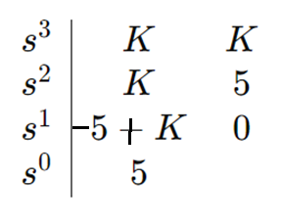 (5 mark)

For stability 5 < K (5 mark)

3.

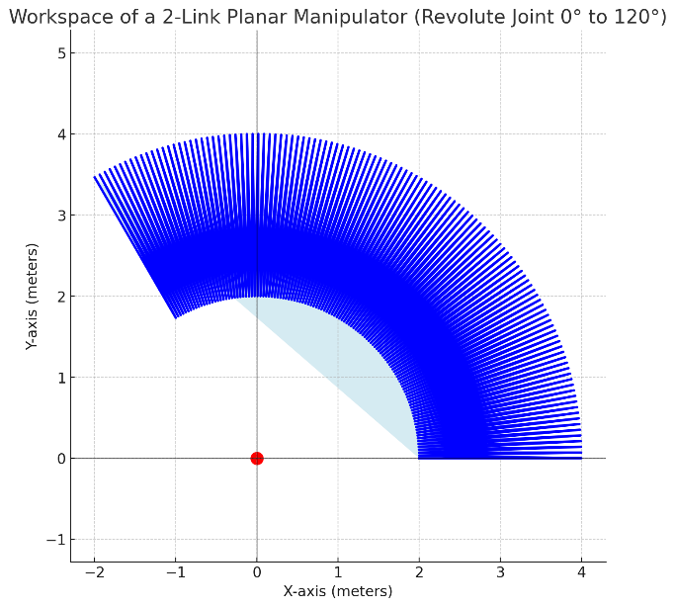

(5 marks) for the robot's coverage along the X and Y axes, and (5 marks) for limiting the angle between 0° and 120°.

m = 20 kg
a = 10 m/s²
F = ma = 20(10+9.81) = 396.2 N (4 mark)
F = PA hence A = F/P
A = 396.2/30000 = 0.0132m² (4 mark)
Acup = 0.0132/20 = 0.00066 m² (2 mark)
Acup = $\frac{πD^{2}}{4}$ D = $\sqrt{\frac{4A_{cup}}{π}}=0.0282m=28.2mm$ (5 mark)

4.

Fixed (hard) automation (2 mark)
Programmable automation (2 mark)
Flexible automation (2 mark)
Robots considered flexible automation (2 mark)

$x_{1}=1\cos{60}=0.5m$
$y_{1}=1\sin{60}=0.86m$ (3 mark)

$$x_{2}=0.6\cos{0}=0.6m$$
$y_{2}=0.4\sin{0}=0m$ (3 mark)

$$x_{3}=0.4\cos{90}=0 m$$
$y_{3}=0.4\sin{90}=0.4m$ (3 mark)

$$x_{4}=0.5\cos{(0)}=0.5m$$
$y_{4}=0.5\sin{(0)}=0m$ (3 mark)

The position and orientation of the end effector
$$x_{g}=x_{1}+x_{2}+x_{3}+x_{4}=1.6m$$
$$y_{g}=y_{1}+y_{2}+y_{3}+y_{4}=1.26m$$
${(x}_{g},y_{g})=(1.6m,1.26m)$ (5 mark)
$$θ_{g}=0°$$

