

CRN: 50295

School of Computing, Science & Engineering

SEMESTER ONE EXAMINATION SOLUTIONS

PROGRAMMES:

BEng Control and Automation

BLOCK CODES:

E/CAU/F

AUTOMATION AND ROBOTICS

  - Most modern automated processes use a combination of sensor, actuator and controller. Explain the function of each with examples that would be used in an automated system.
(6 marks)
Actuators do the work in the system. Most actuators respond proportionally with the signal they receive from a controller and would provide mechanical force to a system based on electrical, hydraulic or pneumatic actuation.

[2 marks]

Controllers control the actuators. They are analogue or digital devices that are incorporated into the feedback loop of the system to provide an optimal output to the actuators based on sensory feedback of the current requirements of the process. Most modern controllers are based on PLCs
[2 marks]

Sensors provide the feedback to the controller so it can monitor the effect of the actuators on the process. These can be simple switches but are often transducers which can measure a physical parameter such as temperature or pressure.
[2 marks]

  - Given a system has the following transfer function:

$$G\left(s\right)=\frac{s^{2}+s-2}{{4s}^{2}+2s+1}$$

    - Determine the poles and zeros of this system and sketch them on an s-plane graph.
(10 marks)

To find the zeros:
From numerator the term s²+s -2 must =0 so there will be two real zeros at +1 and –2. Apply $x=\frac{-b±\sqrt{b^{2}-4ac}}{2a}$ to get same result.

[3 marks]

To find the poles:
For Denominator 4s²+2s +1=0 so applying$x=\frac{-b±\sqrt{b^{2}-4ac}}{2a}$ there are two complex roots of -0.25, + 0.43i and -0.25, -0.43i

[3 marks]
X

s-plane
0

-0.25
jω
-0.43

+0.43

-2

+1
0

X

[4 marks]

    - Explain what a ‘pole’ and ‘zero’ mean in terms of the system response
(2 marks)
A ‘pole’ is where the response of the system tends to infinity and so can affect the stability and transient response of the system.
[1 mark]
A ‘zero’ is where the response of the system tends to zero and so can affect the delay of the system.
[1 mark]

    - What is the order of this system?
(1 mark)

The system is second order.
[1 mark]

    - Is the system stable and why?
(1 mark)

Yes, poles are on left of s-plane.
[1 mark]

  - Briefly describe the 6 design principles of industry 4.0.
(6 marks)

Interoperability: the ability of cyber-physical systems humans and Smart Factories to connect and communicate with each other via the Internet of Things and the Internet of Services.

Virtualization: a virtual copy of the Smart Factory which is created by linking sensor data with virtual plant models and simulation models.

Decentralization: the ability of cyber-physical systems within Smart Factories to make decisions on their own.

Real-Time Capability: the capability to collect and analyze data and provide the insights immediately.

Service Orientation: offering of services (of cyber-physical systems, humans and Smart Factories) via the Internet of Services.

Modularity: flexible adaptation of Smart Factories for changing requirements of individual modules.
[6 marks]

  - Given that the general transfer function for a second order closed loop control system is:

For the transfer function:

$$\frac{C(s)}{R(s)}=\frac{9}{s^{2}+3s+9}$$

    - Determine the un-damped natural frequency. (1 marks)

From the general form of the transfer function:

$ω_{N}^{2}$=9
$So ω_{N}^{}$=3rad/s
[1 marks]

    - Determine the damping ratio. (1 marks)

From the general form of the transfer function:

${2ζω}_{N}^{}$=3
$So ζ$=0.5
[1 marks]

    - Sketch the poles on an s-plane diagram. (4 marks)

Poles are given by the two roots:

So poles are:

-1.5+2.59j
-1.5-2.59j
X

s-plane
x

jω
[2 marks]

+2.59

-1.5

-2.59

[2 marks]

    - Determine the rise time of the system. (2 marks)

Rise time of system is given by:

$$t_{r}=\frac{π-θ}{ω_{n}\sqrt{1-ζ^{2}}}$$
$$θ=\tan^{-1}\left(\frac{ω_{n}\sqrt{ζ^{2}-1}}{ζω_{n}}\right)=\tan^{-1}\left(\frac{2.59}{1.5}\right)=1.047rad$$
$$t_{r}=\frac{3.141-1.047}{3x0.86}=0.81s$$

[2 marks]

    - Determine the peak time of the system. (2 marks)

Time at which output peaks is given by:
$$t_{p}=\frac{π}{ω_{n}\sqrt{1-ζ^{2}}}$$
$$t_{p}=\frac{3.141}{2x0.66}=1.21s$$

[2 marks]

    - Determine the percentage maximum overshoot. (2 marks)

Maximum overshoot is given by:

$$M_{p}=e^{- \frac{πζ}{\sqrt{1-ζ^{2}}}} x100$$
$$M_{p}=e^{- \frac{3.141 x 0.5}{0.86}} x100=16\%$$

[2 marks]

    - Determine the settling time to 2% of the steady state value. (2 marks)

Settling time to 2% is given by:

$$t_{s}=\frac{4}{ω_{n}ζ}=\frac{4}{3x0.5}=2.66s$$

[2 marks]

  - A vision system is required to provide quality control on the production line of a crumpet bakery. Crumpets emerge from an oven on a conveyor belt in a continuous process in rows of 6. Describe the elements of the simplest vision system you could use to detect if the crumpets were burnt. This should include details about the camera, lighting and optics you would use in the system. Justify your choices.
(6 marks)

Simplest vision system to use in this case is a line scan camera oriented to view across the conveyor. This is justified by the fact the only only parameter of interest is colour at fixed positions on the conveyor so no shape analysis is required.
[2 marks]

The lighting should be diffuse and coloured to the yellow/white part of the spectrum. The will avoid shadows creating false readings and will enhance the contrast between burnt and normal crumpets. A dark conveyor should be used to also enhance contrast.
[2 marks]

The optics should be wide angled to view the whole width of the conveyor and should also make use of a yellow filter to further enhance the contrast values.
[2 marks]

  - A SCARA type robot manipulator is required to extract the burnt crumpets using a pneumatic suction end effector. However, there is limited space by the production line to install a simple linear cartesian system, so a multi-link arm is required as indicated in figure 1. Produce an inverse kinematic solution to calculate the angular positions (θ₁ & θ₂ ) of the joints when the arm is at the maximum required reach.
(14 marks)

Figure 1: Multi-link arm for crumpet factory
1m
0.8m
(0,0)
(1.15,0.85)
Θ₁
Θ₂

1m (L₁)
0.8m(L₂)
(0,0)
(1.15,0.85) (X,Y)
Θ₁
Θ₂
B
K₁
K₂

[ Create geometric constructions from diagram: 3 marks]

Construct formula to provide inverse kinematics from application of geometry and cosine rule

B² = X²+Y²
[1 mark]
K₁=tan⁻¹(Y/X)
[1 mark]
K₂=cos⁻¹((L₁²-L₂²+B²)/2L₁B)
[2 marks]
Θ₁= K₁+ K₂
[1 mark]
Θ ₂=cos⁻¹((L₁²+L₂²-B²)/2L₁ L₂)
[2 marks]

Calculation of intermediates B=1.43, K₁=36.46deg, K₂=32.76deg
[2 marks]

Hence Θ₁=69.22deg, Θ₂=104.66deg
[2 marks]

  - A polar co-ordinate assembly arm as shown in figure 2 is required to lift a part of 2kg mass onto a production line at a vertical traverse angle of 45º. The gripper and radial traverse assembly doing this lift have a combined mass of 3kg. The maximum rate at which the traverse assembly can move must be limited to 0.5ms⁻¹ Given the forces of the actuator, arm damping and brake detailed below, with the aid of a force diagram calculate how long the arm takes to move the part over the 1m distance to the assembly position from a standing start to full stop. You may assume the forces due to friction are negligible.

Actuator force: 40N

Brake Force: 10N

Arm damping force (resists actuator): 1N

(14 Marks)
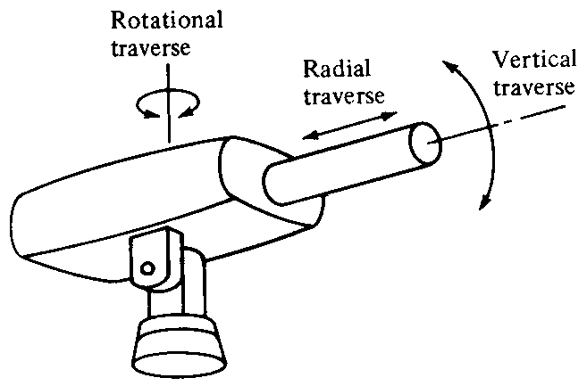

Figure 2: A polar co-ordinate assembly arm

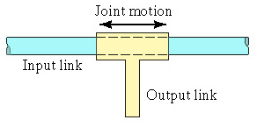
F→
←F_{F}
←F_{D}
←F_{B}
←F_{G}
45º

[3 marks]

Divide problem into 3 phases and calculate the time in each phase

Acceleration: Assume brake is off, so force available for acceleration is:
F_{a} = 40 - 1 -34.68=4.32N (34.68 is gravity component mgcosƟ)

So acceleration a is: a=4.32/5=0.864ms⁻²

Obtain t_{a} from: t= v_{f} /a=0.579s

Obtain d_{a} from: d= v_{i}t + ½ at² =0.145m
[4 marks]

Braking: Assume brake is on, actuator is off so total braking force is:

F_{b} = 10 + 1 +34.68=45.68N (34.68 is gravity component mgcosƟ)

So deceleration -a is: a=45.68/5=9.14ms⁻²

Obtain t_{b} from: t= v_{i} /a=0.0547s

Obtain d_{b} from: d= v_{i}t + ½ at²=0.0137m

[4 marks]

Distance cruising

d_{c} =1 -0.145-0.0137=0.843m

So the time in the cruising phase must be t_{c}= d_{c} /v=1.86s

Hence total time is: 2.32s
[3 marks]

  - Briefly describe some of the sensor options available to monitor the angular and linear position of the joints.
(4 marks)

Potentiometer: Where the position is proportional to the resistance which can be used to produce a measurable voltage.

Resolver: Where differential inductive coupling is used to provide a relative value of linear or angular displacement.

Incremental encoder: Where a slotted disk is used to count angular or linear increments and provide a value.

Absolute encoder: Where a grey code binary pattern is used to provide the absolute position.
[1 mark each]

  - If an absolute encoder is required to measure the vertical traverse joint angle to within 0.2º, how many bits resolution are required from this encoder?
(2 marks)

The resolution (R) of an encoder is: R=360/2^{N}

So an angle of 0.2 would require at least 11bits resolution.

[2 marks]

