

CRN: 50295

School of Computing, Science & Engineering

SEMESTER ONE EXAMINATION

PROGRAMMES:

BEng Control and Automation

BLOCK CODES:

E/CAU/F

AUTOMATION AND ROBOTICS

Date: 2nd December 2022 Time: _:_ -_:_

Instructions to Candidates

Time allowed 2 hours

Answer any THREE questions.

Each question carries 20 marks

The use of approved electronic calculators is allowed

Given a system has the following transfer function:

$$G\left(s\right)= \frac{s+1}{s^{2}+1}$$

    - Determine the poles and zeros of the open and closed loop systems shown in the figure below and sketch them on an s-plane graph. (10 marks)

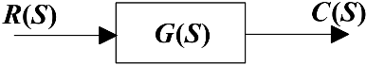

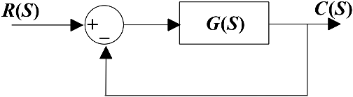

    - Are the systems stable and why? (4 marks)
    - Predict and draw the response of the systems to a unit step input. (6 marks)

(i)
Open loop

$$\frac{C(s)}{R(s)}=G\left(s\right)= \frac{s+1}{s^{2}+1}$$

Zeros:

$s+1=0→s= -1$ One simple zero

Poles:

$$s^{2}+1=0$$

$s^{2}=-1→s=±1j$ Two imaginary poles (4 marks)

Closed-loop

$$\frac{C(s)}{R(s)}=\frac{G(s)}{1+G\left(s\right)H(s)}=\frac{G(s)}{1+G\left(s\right)}=\frac{\frac{s+1}{s^{2}+1}}{1+\frac{s+1}{s^{2}+1}}=\frac{s+1}{s^{2}+s+2}$$

Zeros:

$s+1=0→s= -1$ One simple zero

Poles:
$s^{2}+s+2=0→s=\frac{1}{2}(-1±\sqrt{7}j)$ Two complex poles (6 marks)

(ii)

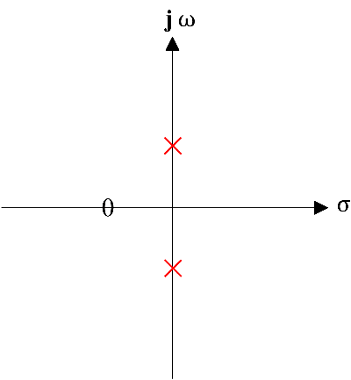

Two mirrored poles on the jw axis. Undamped unstable system. (2 marks)
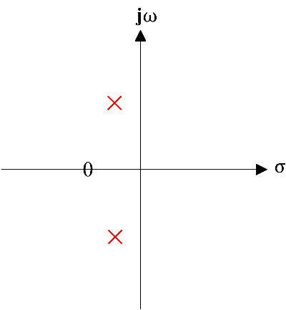

Two poles are lying on the left-hand side of the s-plane. A Stable system. (2 marks)

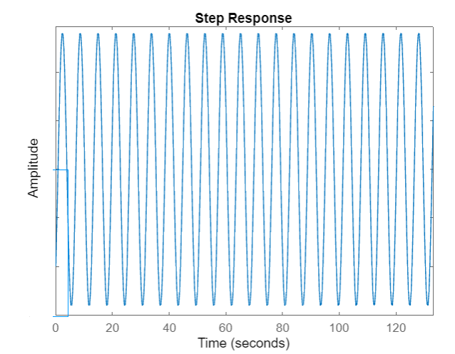
(3 marks)
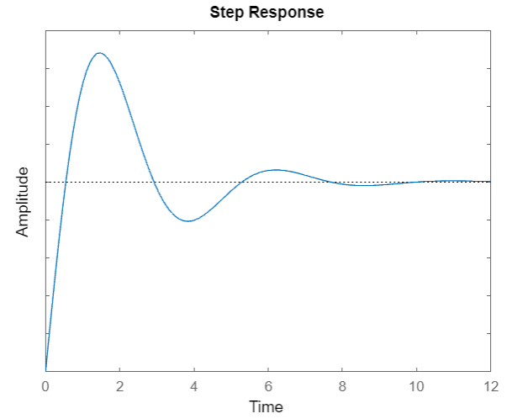
- marks)

        - A system has a characteristic equation

$$q\left(s\right)=s^{5}+s^{4}+2s^{3}+s^{2}+s+5=0$$

          - Using the Routh-Hurwitz method, determine whether the system is stable.
(5 marks)

          - If it is not stable, how many poles are in the right half-plane? (5 marks)

  - Calculate the position of the end effector of the arm below from the joint angles given. (10 marks)

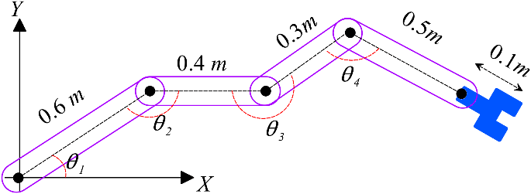

$$θ_{1}=30°, θ_{2}=150°, θ_{3}=210°,θ_{4}=120°$$

(a)

Examining the first column of the Routh array, the system is unstable.

$$\left.\begin{aligned}s^{5} \\ s^{4} \\ s^{3} \\ s^{2} \\ s^{1} \\ s^{0}\end{aligned}\right|\begin{aligned}1 \\ 1 \\ 1 \\ 5 \\ -5 \\ 5\end{aligned} \begin{aligned}2 \\ 1 \\ -4 \\ 5 \\ \\ \end{aligned} \begin{aligned}1 \\ 5 \\ \\ \\ \\ \end{aligned}$$
(5 marks)
(ii)
Two sign changes in the first column hence, two poles are in the right half-plane

(5 marks)

(b)

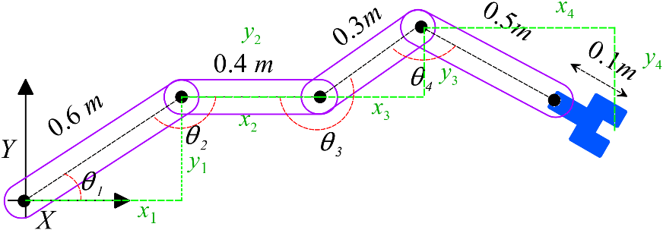

$$x_{1}=0.6\cos{30}=0.52m$$
$$y_{1}=0.6\sin{30}=0.3m$$

$$x_{2}=0.4\cos{0}=0.4m$$
$$y_{2}=0.4\sin{0}=0m$$

$$x_{3}=0.3\cos{30}=0.26m$$
$$y_{3}=0.3\sin{30}=0.15m$$

$$x_{4}=0.6\cos{(-30)}=0.52m$$
$$y_{4}=0.6\sin{(-30)}=-0.3m$$

The position of the end effector

$$x_{g}=x_{1}+x_{2}+x_{3}+x_{4}=1.7m$$

$$y_{g}=y_{1}+y_{2}+y_{3}+y_{4}=0.35m$$

${(x}_{g},y_{g})=(1.7m,0.15m)$ (10 marks)

The closed-loop speed control of a car is represented by the model shown in the Figure 1.

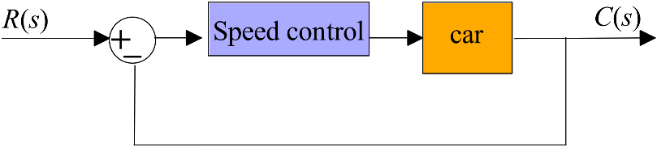
Figure 1. Closed-loop speed control of a car

Given the system has the following transfer function:

$$\frac{C(s)}{R(s)}=\frac{264}{s^{2}+10s+264}$$

and the general transfer function for a second order closed-loop control system is:

- Determine the un-damped natural frequency. (4 marks)

- Determine the damping ratio. (4 marks)

- Determine the peak time of the system. (4 marks)

- Determine the percentage maximum overshoot. (4 marks)

- Determine the settling time to 2% of the steady state value. (4 marks)

- From the general form of the transfer function:

$ω_{n}^{2}=264→ω_{n}=\sqrt{264}=16.25 rad/s$ (4marks)

- From the general form of the transfer function:

$$2ζω_{n}=10$$

So

$ζ=\frac{10}{2\sqrt{264}}=0.31$ (4 marks)

(iii)

$$t_{p}=\frac{π}{ω_{n}\sqrt{1-ζ^{2}}}$$

$t_{p}=\frac{3.14}{16.24\sqrt{1-0.0961}}=0.2s$ (4 marks)

(iv)

$M_{p}={100e}^{- \frac{πζ}{\sqrt{1-ζ^{2}}}}=36\%$ (4 marks)

(v)

Settling time to 2% is given by:

$t_{s}=\frac{4}{ω_{n}ζ}=\frac{4}{16.25×0.31}=0.79s$ (4 marks)

An object is grasped and lifted by a manipulator as shown in the Figure 2. The manipulator is made of one revolute joint J1, one linear joint J2 and a parallel jaw gripper. The total mass of the joint J2 is 8 kg including its gripper, arm and grasped object. Calculate the time takes to move the object 0.5 m along the direction shown in the figure 2.

Assuming:
The encoder of the J1 is showing $-45°$.
The maximum velocity of the actuator J2 is 0.2 m/s.
The maximum Force of the actuator J2 is 400 N.
Maximum braking force (300 N)
Friction force is (2 N)
Damping force (5N)

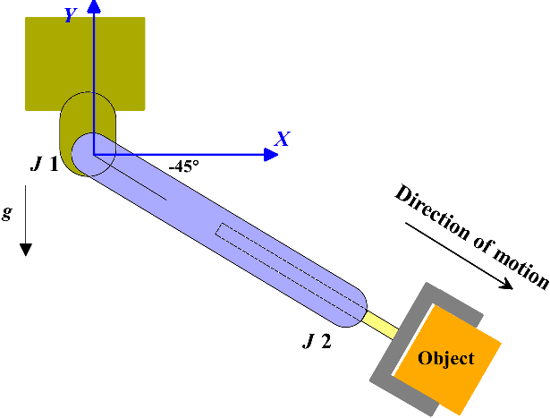
Figure 2.
(20 marks)

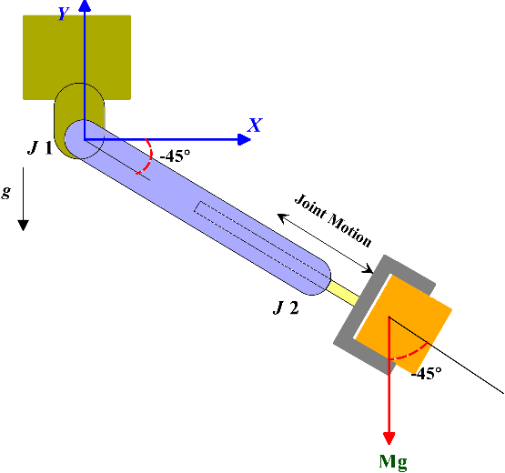

Acceleration mode: The brake is off so:

$$F_{a}=400-5-2+8×9.8×\cos{45}=448.4 N$$

So, acceleration can be calculated as
$$a=\frac{448.4}{8}=56 m/{s^{2}}$$

and
$$t_{a}={V_{f}}/a=0.0035 s$$

$$d_{a}=V_{i}t+\frac{1}{2}at^{2}=0.00034m=0.34mm$$
(5 marks)

Braking mode

$$F_{b}=300+2+5-8×9.8×\cos{45}=251.56N$$

$$a_{d}=\frac{251.56}{8}=-31.45 m/s^{2}$$

$$t_{b}=\frac{V_{i}}{a}=\frac{0.2}{31.45}=0.006s$$

$$d_{b}=V_{i}t+\frac{1}{2}at^{2}=0.2×0.006+0.5×\left(-31.45\right)×\left({0.006}^{2}\right)=0.00063m=0.63mm$$

(5 marks)

Distance cruising

$$d_{c}=0.5-0.00034-0.00063=0.499m$$

(5 marks)

The time in the cruising phase can be calculated as

$$t_{c}={d_{c}}/V=2.495 s$$

$$t=t_{a}+t_{b}+t_{c}$$

(5 marks)

