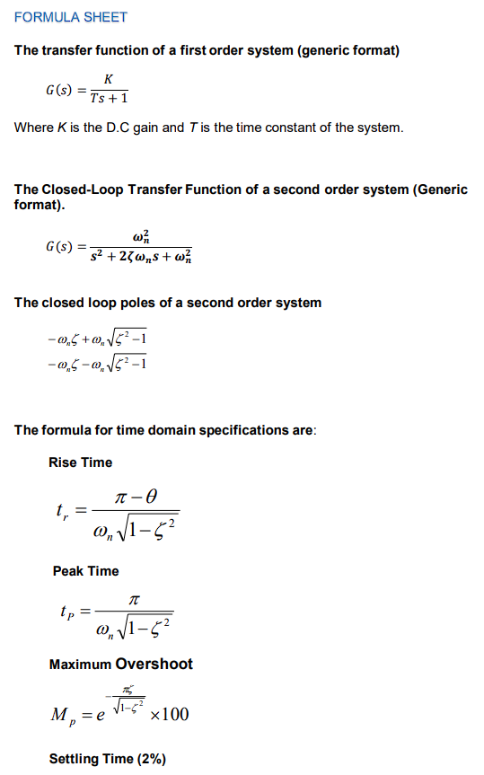
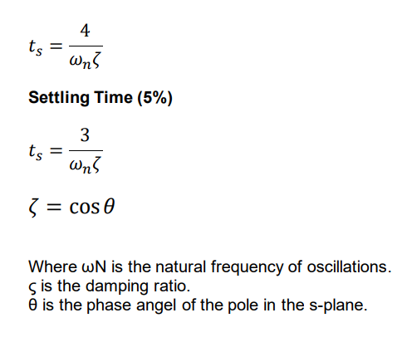
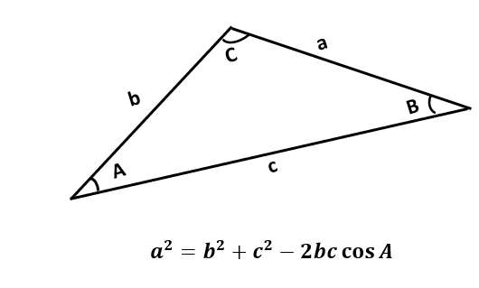

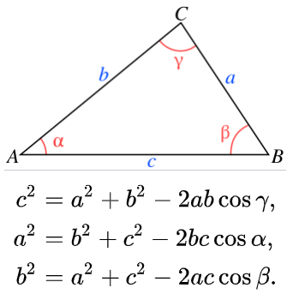

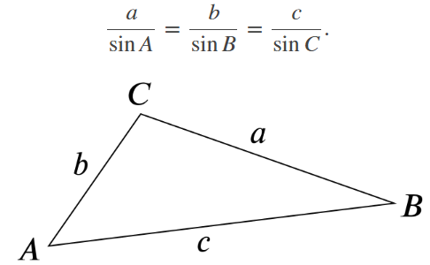

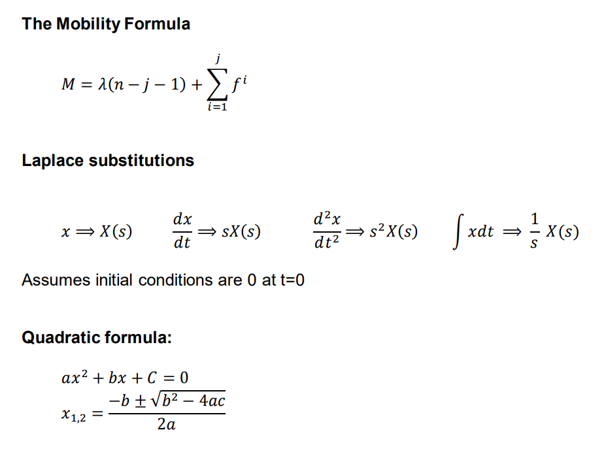
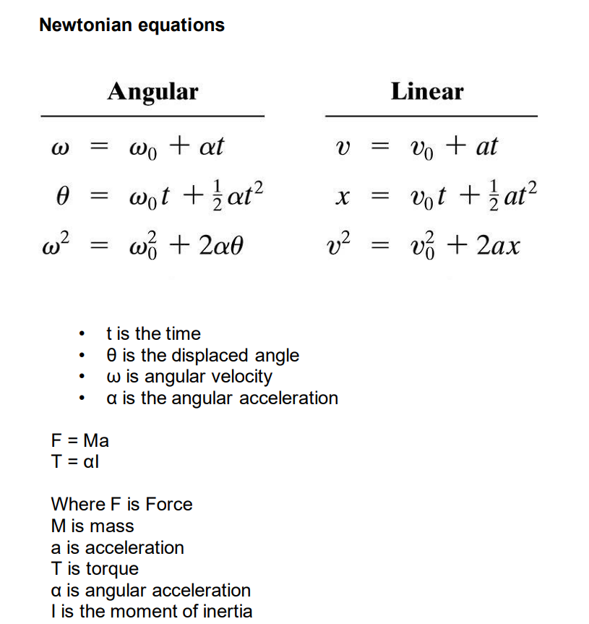
Routh-Hurwitz Table
aS³+bS²+cS+d=0
S³ | a | c | 0
S² | b | d | 0
S¹ | $$T=\frac{b×c-d×a}{b}$$ | $$\frac{b×0-0×a}{b}=0$$ | 0
S⁰ | $$\frac{T×d-0×b}{T}=d$$ | 0

$$τ=J^{T}F$$

F = PA
Acup = $\frac{πD^{2}}{4}$

