AUTOMATION AND ROBOTIC TUTORIAL 1

- Look at the following control functions. Are they linear/non-linear, time invariant/time variant?

$$y\left(t\right)+2u^{2}\left(t\right)+7u\left(t\right)+4t$$

$$y\left(t\right)+4u\left(t\right)+7c+4$$

$$y\left(t\right)+2tu^{3}\left(t\right)+3u\left(t\right)$$

- Feedback Calculation

Using the standard feedback arrangement from the lecture:

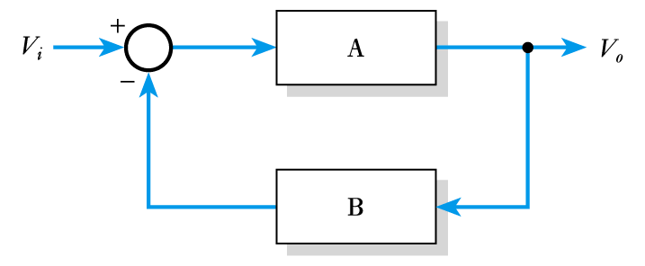

Calculate the required values to produce a stable voltage gain of 100 using a high-gain active amplifier with a gain of 100,000.

Determine the effect on the overall gain of the circuit if the gain of the active amplifier varies from 100,000 to 200,000.

