AUTOMATION AND ROBOTIC TUTORIAL 2 EXTRAS

- Derive the transfer function of a permanent magnet DC generator if the torque applied to the rotor is τ_{in} and the output from the coil is the current, i. Assume the rotor is frictionless and has a radius a as shown below.
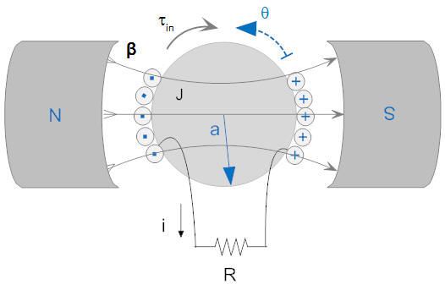
The free body diagram and schematic for this will be:

Mechanical Free Body Diagram |  | Electrical Schematic
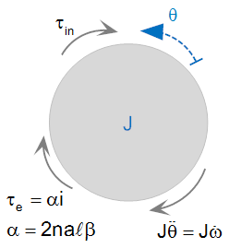 |  | 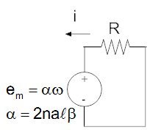
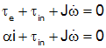 |  | 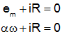
There are there torques involved.

τ_{in} is the external torque applied to the generator.
τ_{e} is the torque from the induces current in the coil that resists the input torque.
$J\dot{ω }$is the torque from the moment of inertia J of the rotor.

α is a term that accounts for the magnetic flux β passing through a coil of rectangular dimensions 2aℓ and of n turns

e_{m} is the emf generated by coil rotating at an angular velocity ω

We want to relate the Torque in to the current out so we are looking for the transfer function:

$$G=\frac{I(s)}{Τ_{in}(s)}$$

We have the equations:

$$αi+ τ_{in}+ J\dot{ω }=0$$

And

$$αω+ iR=0$$

The time varying quantities in these equations are i, ω and $τ_{in}$

So we need to make Laplace substitutions for each of these in the equations.

$$αI(s)+ Τ_{in}(s)+ JsΩ(s)=0$$

And

$$αΩ(s)+ I(s)R=0$$

(Ω is the capital form of ω.)

We want to keep $I(s)$ and $Τ_{in}(s)$ but eliminate $Ω(s)$

To do that make $Ω(s)$ the subject of one of the equations.

$$αI(s)+ Τ_{in}(s)+ JsΩ(s)=0$$
Subtract $JsΩ\left(s\right)$ from each side to give:

$$αI\left(s\right)+ Τ_{in}\left(s\right)=- JsΩ\left(s\right)$$

Then divide by $– Js$ to leave:

$$-\frac{αI\left(s\right)+ Τ_{in}\left(s\right)}{Js}=Ω\left(s\right)$$

Now substitute into the other equation

$$α-\frac{αI\left(s\right)+ Τ_{in}\left(s\right)}{Js}+ I\left(s\right)R= -\frac{α^{2}I\left(s\right)+ αΤ_{in}\left(s\right)}{Js}+ I\left(s\right)R=0$$

Multiply the equation by $-Js$

$$α^{2}I\left(s\right)+ αΤ_{in}\left(s\right)- I\left(s\right)RJs=0$$

Move term in $Τ_{in}\left(s\right)$ by subtracting from each side of the equation

$$α^{2}I\left(s\right)- I\left(s\right)RJs=- αΤ_{in}\left(s\right)$$

Extract $I\left(s\right)$as a common term

$$I\left(s\right)(α^{2}- RJs)=- αΤ_{in}\left(s\right)$$

Divide by $Τ_{in}\left(s\right)$ and $(α^{2}- RJs)$ to get your transfer function.

$$\frac{I\left(s\right)}{Τ_{in}\left(s\right)}=\frac{- α}{(α^{2}- RJs)}$$

- Consider the following transfer functions.
Determine
  - Whether the transfer function is proper or improper
  - Poles of the system
  - zeros of the system
  - Order of the system
- $G\left(s\right)=\frac{s^{2}+2s+1}{{3s}^{2}+s-4}$

Function is improper as denominator is not a higher order than numerator
As it is second order the number of poles and zeros must be 2
For numerator s²+2s +1=0 so applying$x=\frac{-b±\sqrt{b^{2}-4ac}}{2a}$ there are two real zeros of both at -1
For denominator 3s²+s-4=0 so applying$x=\frac{-b±\sqrt{b^{2}-4ac}}{2a}$ there are two real polls of 1
and -1.33
X
-1.33
s-plane
X
1
0

jω

0
-1
- $G\left(s\right)=\frac{2s+3}{s^{2}+2s+3}$

Function is proper as denominator has higher order than numerator
The numerator is first order so the must be 1 zero
The numerator is second order the number of poles must be 2
For numerator 2s+3=0 or s=-3/2 so a real zero at -1.5
For Denominator s²+2s+3=0 so applying$x=\frac{-b±\sqrt{b^{2}-4ac}}{2a}$ there are two imaginary roots of -1, 1.41i
and -1, -1.41i
X
-1.41
s-plane
0
-1.5
X
1.41
jω

-1
- $G\left(s\right)=\frac{4}{s^{2}-2s+1}$

Function is proper as denominator is not a higher order than numerator
There are no zeros
As denominator is second order the number of poles must be 2
For Denominator s²-2s+1=0 so applying$x=\frac{-b±\sqrt{b^{2}-4ac}}{2a}$ there are two real roots both at 1
X

s-plane
X
1
jω

